California Department of Education

Special Education Division

February 2025

# **Individualized Education Program Implementation Data Collection**

## **Technical Assistance Guide 2024–25 Version 3**

This Technical Assistance Guide (TAG) provides information on reporting and submitting data for the 2024–25 Special Education Individualized Education Program (IEP) Implementation data collection cycle. It includes the following information:

Section I – Background Information (Page 1)

Section II – Guidance for Reporting (Page 2)

Section III – Website Reporting (Page 3)

Section IV – Screenshots of website and reporting process (Pages 4-8)

Glossary of Acronyms and Initials (Page 9)

Data submissions are to be completed on the following website:

[https://www3.cde.ca.gov/iepimpsys/](https://www3.cde.ca.gov/iepimpsys/" \o "Login page for IEP Implementation website)

Data submitted must reflect total service minutes provided between March 3, 2025, and April 30, 2025. The completed electronic data submission and the electronic signature certifying data accuracy and validity are due to the California Department of Education (CDE) by **11:59 p.m. on Monday, June 30, 2025.**

**Please do not email copies of the report as proof of submission since the website submissions are recorded.**

Completed records must be submitted electronically through the IEP Implementation website. **Print and maintain report(s) submitted for your records since the reports will not be available after the reporting cycle concludes.**

Questions about the website and how to report should be directed by email to [IEPimplementation@cde.ca.gov](mailto:IEPimplementation@cde.ca.gov). Please include your direct phone number in your email if you would like someone to call you with a response.

## Section I – Background Information

* The CDE shall perform IEP Implementation Data Collection to fulfill its monitoring and enforcement responsibilities under the federal IDEA (Individuals with Disabilities Education Act) in 34 *Code of Federal Regulations sections* 300.600 and 300.323.
* **Identify systemic issues** with local educational agencies (LEAs) and help the CDE identify LEAs that are not providing the services prescribed in IEPs.
* Identify and categorize IEPs surveyed by three court designated percentage of completion ranges.
* Assess the validity and reliability of data submitted regarding an LEA's implementation of IEP services. For those LEAs who submit such data, the CDE will randomly select 10% of those LEAs and audit the data submitted by those LEAs regarding the LEA's implementation of IEP services.

The data collected are used by the CDE to assist special education local plan areas (SELPAs) and their LEAs for programmatic and improvement purposes.

## **Section II – Guidance for Reporting**

**Important Note:** Data collected are based upon total service minutes provided per student IEP over the specific time period of March 3, 2025, through April 30, 2025.

The CDE will provide to the LEAs a randomly selected group of students based upon the overall population size of students with disabilities (SWDs) for each LEA, up to a maximum of 500 students. LEAs will be responsible for gathering data for these students.

Report the IEP Implementation data based upon the percentage of actual service minutes provided during the reporting period defined above. This calculation is derived by providing total service minutes provided (numerator) divided by total service minutes prescribed (denominator).

**Example:**

**How to determine a student’s IEP Implementation Rate:**

Student IEP for Johnny Jones:

Total service minutes **provided** from March 3, 2025, and April 30, 2025: **2000**

Total service minutes **prescribed** from March 3, 2025, and April 30, 2025 **:2160**

Johnny Jones IEP Implementation Rate = **2000/2160 = 92.59%**

🡪 Johnny Jones would fall into **category B** (see Table A below)

Perform similar calculations for each student SSID (Statewide Student Identifier) provided by CDE. Aggregate the data and input into one of the three categories below as appropriate. Be sure to confirm the total count matches the total number of SSIDs provided by CDE.

Table A: IEP Implementation Rates

| Category | Number of Students |
| --- | --- |
| A. 100 to 95% of IEP services implemented | 400 |
| B. 94.9 to 90% of IEP services implemented | 60 |
| C. Less than 90% of IEP services implemented | 40 |
| Total | **500** |

## Section III – Website Reporting

Within the same SELPA, the SELPA and LEAs can submit the IEP Implementation data separately using the LEA drop-down list when accessing the data collection tool. Report submission period ends on **Monday, June 30, 2025, at 11:59 p.m.**

The IEP Implementation submission must include one data submission per active LEA in each SELPA. The data submission must be certified by Superintendents, SELPAs,and be documented and maintained in the SELPA or LEA offices for on-site verification by the CDE or other stateand federal agencies. **Print and maintain report(s) submitted for your records. Once the collection period is closed, LEAs and SELPAs will not have the ability to print the report.**

## Section IV – Directions for IEP Implementation Data Reporting

### LEA Data Entry and Submission Process

1. Follow the link provided by the CDE to access the IEP Implementation Data submission website: <https://www3.cde.ca.gov/iepimpsys/>
2. Enter the Access Code from CDE provided to the LEA by SELPA

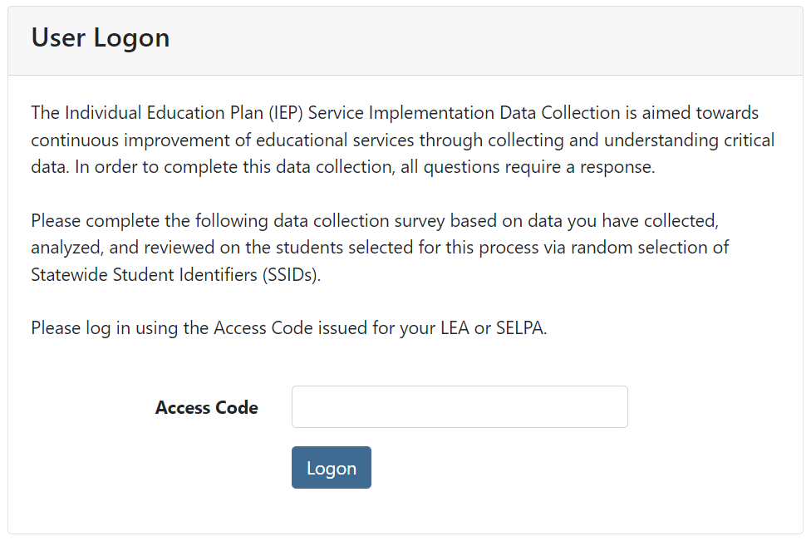

1. Under “User Actions”, select “Download Student Records”
2. After completing IEP reviews and rate calculations, input LEA aggregate counts per category in the SWD IEP Implementation Success Rates box
3. Verify the data is correct and the total matches the total number of SSIDs provided by CDE
4. Select the Save Data button, and then select the Submit IEP Data button

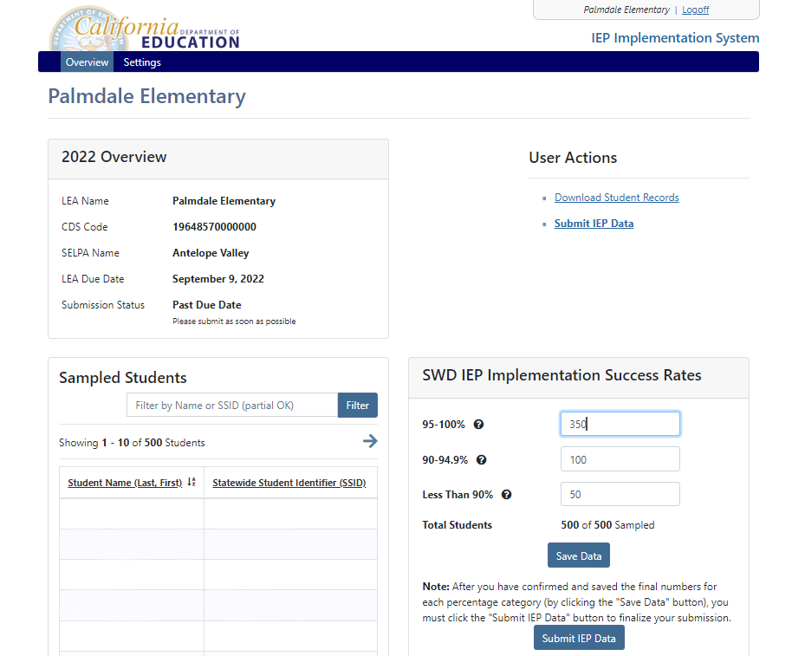

1. Complete contact information fields for person completing the data submission
2. Read and confirm certification language, and select “Submit IEP Implementation Data” to submit the data for your LEA. Please note that once data is submitted, it cannot be changed unless the SELPA rejects the submission

Image A: Confirm and Submit

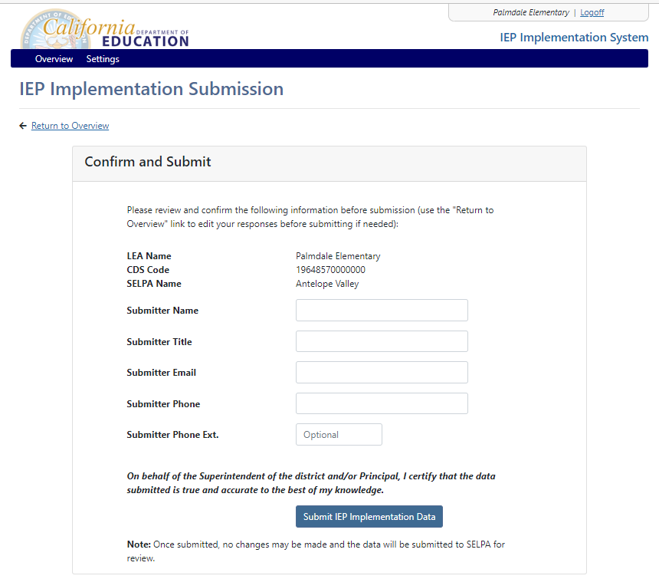

Link to long description of Image A: Confirm and Submit

1. Once submitted, user will be returned to the overview page, with the submission fields greyed out and an email is sent to the LEA submitter acknowledging the submission

Image B: LEA Submission Page

Image B: LEA Submission Page
Screenshot of LEA data submission confirmation page. Image is fully described in linked long description underneath image.

Link to long description of Image B: LEA Submission Page

1. Data submission is then sent to SELPA contact for review and approval

### SELPA Review and Approval Process

1. Follow the link provided by the CDE to access the IEP Service Implementation Data Collection website: <https://www3.cde.ca.gov/iepimpsys/>
2. Enter the Access Code provided to the SELPA by CDE



1. Review submissions sent by LEAs on the first screen presented by selecting “Review Submission”

Image C: SELPA Overview

Image C: SELPA Overview
Screenshot of IEP Implementation data collection website, SELPA view. Image is fully described in linked long description underneath image.

Link to long description of Image C: SELPA Overview

1. After reviewing data sent by LEAs, the SELPA contact may then approve or reject the submission accordingly. If a rejection is warranted, please check the box within the field for “Reject Submission” and add a brief description to provide actionable feedback to the LEA. An email notification of the approval or rejection (with reasons specified by the SELPA) will be sent to the LEA contact that submitted the data

Select the button “Save Data and Go To Overview”

Image D: SELPA Approval

Image D: SELPA Approval
Screenshot of IEP Implementation data collection website SELPA review/approval page. Image is fully described in linked long description underneath image.

Link to long description of Image D: SELPA Approval

1. Upon approval, a confirmation screen will appear indicating the LEA Status showing the number of LEAs that are approved for the Overview. Under the LEA Submission(s) it will show the LEA Name and CDS Code along with the submission status and approval date with the option of viewing the submission:

Image E: SELPA Confirmation

Image E: SELPA Confirmation
Screenshot of IEP Implementation data collection website, SELPA confirmation page. Image is fully described in linked long description underneath image. 

Link to long description of Image E: SELPA Confirmation

Table B: Glossary of Acronyms and Initials

| **Acronym** | **Term** |
| --- | --- |
| CDE | California Department of Education |
| IDEA | Individuals with Disabilities Education Act |
| IEP | Individualized Education Programs |
| LEA | Local Educational Agency |
| SELPA | Special Education Local Plan Area |
| SWD | Students with Disabilities |
| TAG | Technical Assistance Guide |

### Long Description of Images

Long description of Image A: Confirm and Submit

Screenshot displaying Confirm and Submit page for the LEA. LEA Name, CDS Code, and SELPA name are filled in. Fields for submitter information including name, title, email, phone, and phone extension. Button for "Submit IEP Implementation Data" is shown. Written above the button is "On behalf of the Superintendent of the district and/or Principal, I certify that the data submitted is true and accurate to the best of my knowledge." Below the button, a note states "Once submitted, no changes may be made and the data will be submitted to SELPA for review."

Long description of Image B: LEA Submission Page

Screenshot of LEA data submission confirmation page. LEA name "Palmdale Elementary" is shown at the top of the page. There is a box labeled "2022 Overview" that lists LEA name, CDS Code, SELPA name, LEA due date, and submission status. There is a search bar for "Sampled Students" where the user can search using student name or SSID. On the right side there is a field labeled "User Actions" and a link to "Download Student Records". Underneath is a table titled "SWD IEP Implementation Success Rates" and shows greyed out boxes with "95-100%", "90-94.9%", and "Less Than 90%" with total students underneath.

Long description of Image C: SELPA Overview

Screenshot of IEP Implementation data collection website, SELPA view. SELPA name "Antelope Valley" is shown at the top of the page. There is a box labeled "2022 Overview" that lists SELPA name, SELPA Code, and LEA status. On the right side there is a field labeled "User Actions" and a link to "Download LEA Records". Underneath there is a table titled "LEA Submission(s)" and it shows LEA Name and CDS Code, Submission Status, Contact Email, and Action.

Long description of Image D: SELPA Approval

Screenshot of IEP Implementation data collection website SELPA review/approval page. LEA name "Palmdale Elementary" is shown at the top of the page. There is a box labeled "2022 Overview" that lists LEA name, CDS Code, SELPA name, LEA due date, and submission status. There is a search bar for "Sampled Students" where the user can search using student name or SSID. On the right side there is a field labeled "User Actions" and a link to "Download Student Records". Underneath is a table titled "SWD IEP Implementation Success Rates" and shows greyed out boxes with "95-100%", "90-94.9%", and "Less Than 90%" with total students underneath. At the bottom there is a box labeled "SELPA Review" with two options to choose, one is "Approve Submission" and the other is "Reject Submission" with a text for reason for rejection. There is then a button "Save Data and Go To Overview".

Long description of Image E: SELPA Confirmation

Screenshot of IEP Implementation data collection website, SELPA confirmation page. SELPA name "Antelope Valley" is shown at the top of the page. There is a box labeled "2022 Overview" that lists SELPA name, SELPA Code, and LEA status. On the right side there is a field labeled "User Actions" and a link to "Download LEA Records". Underneath there is a table titled "LEA Submission(s)" and it shows LEA Name and CDS Code, Submission Status, Contact Email, and Action.