2026 Dashboard On Demand Session: English Learner Progress Indicator (ELPI)

Notetaking Guide

Important notes
- Each indicator and a few important additional topics will have videos available on-demand to watch at any time.
- On-Demand videos are available before the Dashboard is published.
- The 2026 ELPI Indicator On-Demand video associated with this Notetaking Guide can be found on the California Department of Education (CDE) Dashboard Toolkit web page.

California Accountability System Update

Presenters:
From the Analysis, Measurement and Accountability Reporting Division of the California Department of Education, the presenters are:
- Justin Lane, Educational Programs Consultant
- Irit Winston, Educational Programs Consultant

California School Dashboard on Demand
- Short, accessible videos which can be accessed at any time
- Covers each of the State Indicators PLUS other important topics

Agenda
- Overview of the California School Dashboard (Dashboard)
- The English Learner Progress Indicator (ELPI)
- Frequently Asked Questions (FAQs)
- Need additional Help with ELPI?
- Contacting/Reaching Us

Overview of the California School Dashboard (Dashboard)

Overview of the Dashboard
The California School Dashboard is an online tool that displays the performance of local educational agencies, or LEAs, schools, and student groups on a set of state and local measures to assist in identifying strengths, challenges, and areas in need of improvement.
The goal of the Dashboard is to help communities across the state access important information about students in kindergarten through grade twelve.
For an overview of the California School Dashboard (Dashboard), please check out the Dashboard 101 On Demand session found on the CDE Dashboard Communications Toolkit web page

English Learner Progress Indicator (ELPI)

What is the English Learner Progress Indicator?
The English Learner Progress Indicator (ELPI) is a measurement of how well your district or school is at moving current English Learner (EL) students towards English Language Proficiency (ELP).
- Based on performance on the Summative English Language Proficiency Assessments for California (ELPAC) and the Summative Alternate English Language Proficiency Assessments for California (ELPAC).
- ELPI Status measures the percent of EL students progressing towards ELP
- ELPI Change measures the rate of LEA and School improvement of moving their EL students towards ELP.

Dashboard for 30 or More Students
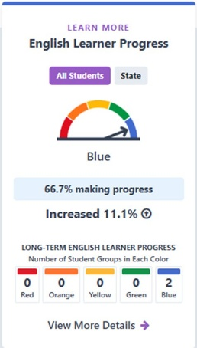
Description of ELPI Dashboard Card
- For the ELPI Dashboard card, the gauge is pointing to the color Blue. The current year status is 66.7% of students are making progress towards English proficiency with an increase of 11.1 percentage points from the previous year.
- At the bottom, the equity report shows the number of student groups in each of the performance level or colors for that particular school or LEA. In this example, 2 were in blue, 0 in green, 0 in yellow, and zero were in red or orange. This top-level report can assist schools and LEAs in looking at student group inequities that may be occurring.
- ​At the very bottom of the Dashboard cards, there is a link to view more details which provides more specific student group information and trends in data over time, when available.

Dashboard Card for 11 to 29 Students
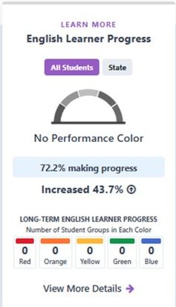
Description of ELPI Dashboard Card
- A Dashboard card will look different depending on the size of the denominator. If a LEA, School or student group between 11 to 29 students in the Denominator in the current or prior year, then no performance level is displayed and Only Status and change from the prior year is reported on the Dashboard. In this second sample card, the student group displays No Performance Color with a grayed-out gauge and an ELPI Status rate of 72.2 percent. It also reports an increase of 43.7 percentage points from the prior year. The number of students, or N-size, is 18.
- Additionally, groups with less than 30 students are not considered eligible for accountability determinations. However, as stated in the previous slide, only 15 Long-Term English learner students are required to hold districts and county offices of education accountable.

Dashboard for Less than 11 Students
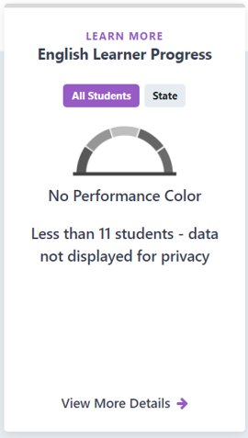
Description of ELPI Dashboard Card
- If there are Less than 11 students in the Denominator in the current or prior year, then No data is reported on the Dashboard to protect students’ privacy. In the sample card above, the student group displays No Performance Color, with a grayed-out gauge and ELPI rate. The number of students, or N-size, is 10.

The Long-Term English Learner Student Group (LTEL)

What is the definition of Long-Term English Learner (LTEL)?
The definition for the LTEL student group will report: “A pupil who has not attained English language proficiency within 7 years of initial classification as an English learner”
All EL students who reach their seventh year as an EL anytime during the academic year will be counted in the LTEL student group. For example, a student enrolls in a California public school in 2019-20 academic year and is determined to be an EL student. This student is still an EL student in the 2025-26 academic year, and, as a result, this student will be included in the LTEL student group.
Please keep in mind, this LTEL definition only applies to the Dashboard and does not apply to other reporting, such as DataQuest, which still uses the definition outlined in Education Code section 313.1

The LTEL in the ELPI
The number of LTEL students, or N-size, required to receive an ELPI Status, Change, and overall performance level:
Districts/COEs – 15 or more LTEL students with current year and prior year Summative or Summative Alternate ELPAC results
Schools – 30 or more LTEL students with current and prior year Summative and Summative Alternate ELPAC results.

LTEL Participation Rate
The LTEL n-size required for ELPAC participation rate is 15 for districts/COEs and 30 for schools.

LTEL Student Population
"All students" on the ELPI Baseball card are the EL students.
The LTEL student group is a subset of the EL student group.

Who is an LTEL?
Explore how Long-Term English Learner students are reported on the California School Dashboard by viewing the “Long-term English Learner Students on the California School Dashboard” flyer on the CDE Dashboard Toolkit web page.

Summative English Language Proficiency Assessments for California (ELPAC)

ELPI Levels Based on the Summative ELPAC Results
Each student receives one of four ELPAC performance levels. The four ELPAC performance levels are then divided into six ELPI levels to allow students enough time to make progress toward English language proficiency in the ELPI.
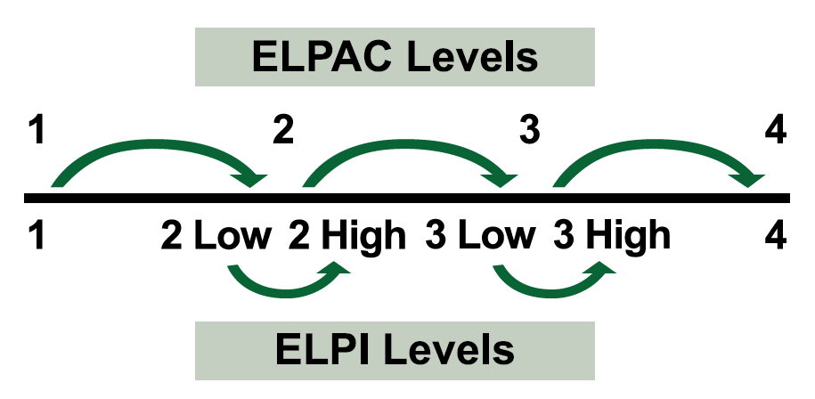

Determining Progress on the ELPI (Traditional ELPAC)
To show progress toward English language proficiency, EL students must increase at least one ELPI level from the previous year or maintain a Level 4 from one year to the next.
Table 1: Example of Progressing in ELPI Levels on the Summative ELPAC
Students | Year | Summative ELPAC Score
1 | 2025 | 2 High (2H)
1 | 2026 | 3 Low (3L)
2 | 2025 | 2 High (2H)
2 | 2026 | 2 High (2H)
- Example 1: A student in 2024 scored a Level 2 High (2H). In 2025, the same student scored a Level 3 Low (3L). This student advanced one ELPI level.
- Example 2: A student in 2024 scored a Level 2 High (2H). In 2025, the same student scored a Level 2 High (2H). This student did not advance one ELPI level.

Summative Alternate ELPAC

Summative Alt ELPAC Results in the ELPI
- Beginning on the 2024 California School Dashboard (Dashboard), the results of the Summative Alternate ELPAC were incorporated into the English Learner Progress Indicator (ELPI) for current year Status, Change which is the progress or lack of progress from the previous year, and overall performance color.

ELPI Levels Based on the Summative Alternate ELPAC Results
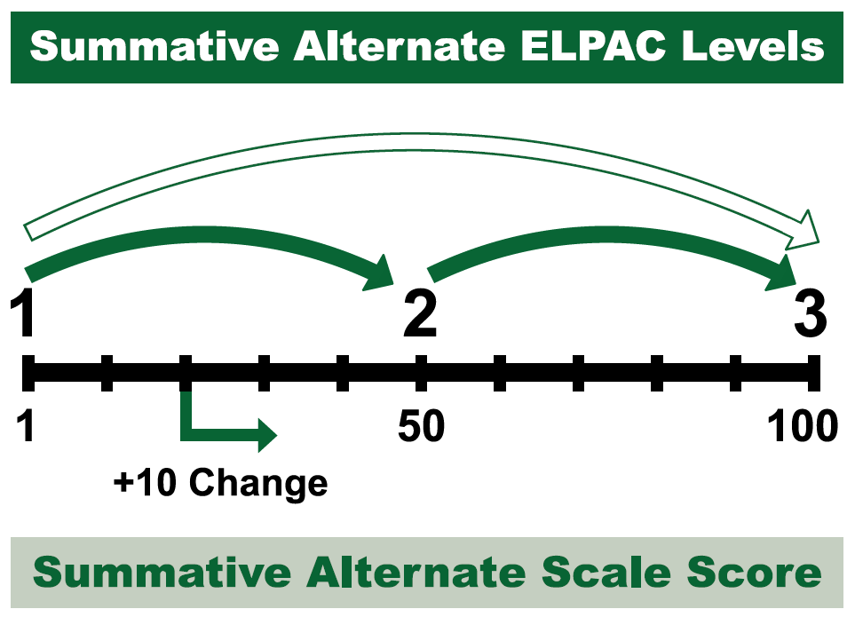
The Summative Alternate ELPAC has three Performance Levels that are used to determine progress on the ELPI:
• Level 1—Novice
• Level 2—Intermediate
• Level 3—Fluent English Proficient
EL students taking the Summative Alternate ELPAC have three paths to demonstrate progress towards ELP:
- Increasing at least one performance level on the Summative Alternate ELPAC;
or
- Maintaining Level 3 on the Summative Alternate ELPAC;
or
- Scale score change of 10 or more points from the prior year test administration;
EL students meeting at least one of the above criteria will be counted as progressing in the ELPI.

Example for Progress on the ELPI (Alternate ELPAC)
To calculate the scale score change, the first digit of the scale score is removed.
Table 2: Example of Progressing in ELPI Levels on the Summative Alternate ELPAC
Grade | Year | Summative Alt-ELPAC Scale Score
K | 2025 | 244
1 | 2026 | 359
- Example: In 2025, an EL student taking the Summative Alternate ELPAC had a scale score of 244 in kindergarten. In 2026, this EL student had a scale score of 359 in grade 1.
- Due to the difference between scale score range by grade level, the scale score of 244 in 2025 gets converted to 44 and the scale score of 359 in 2026 gets converted to 59. The difference between 59 and 44 is 15, a scale score change of +15.
As a result, this EL student would be counted as making progress towards English language proficiency.

Status and Change

ELPI Status
- ELPI Status measures the rate at which LEAs and schools are moving their EL students towards English language proficiency (ELP).
- ELPI Status requires two years of assessment results.
- For example, Kotel High School has an ELPI Status rate of 66.7%, this means that 66.7% of the EL students enrolled at Kotel High during the ELPAC testing window made progress towards ELP.

ELPI Status Cut Scores
ELPI has five Status levels. The cut scores for the Status levels are as follows:
Very Low: Less than 35%
Low: 35% to less than 45%
Medium: 45% to less than 55%
High: 55% to less than 65%
Very High: 65% or greater

ELPI Status Rate Formula
Number of EL students who made progress between 2025 and 2026*
Plus
Number of EL students who maintained the highest Level from the prior year
Divided by
Total number of EL students with prior and current year Summative ELPAC and Summative Alt ELPAC results
Equals
ELPI Status
*For EL students taking the Summative ELPAC, advancing at least one ELPI level. For EL students taking the Summative Alternate ELPAC, advancing at least one level on the Summative Alternate ELPAC or a scale score change of at least 10+.

ELPI Status Rate Formula for Long-Term English Learner (LTEL) Students
Number of LTEL students who made progress between 2025 and 2026*
Plus
Number of LTEL students who maintained the highest Level from the prior year.
Plus
Total number of LTEL students who reclassified to Fluent English Proficient (but did not take the current year Summative ELPAC)
Divided by
Total number of LTEL students with prior and current year summative ELPAC and Summative Alt ELPAC results and LTEL students who reclassified to Fluent English Proficient.
Equals
ELPI Status for LTELs
*For LTEL students taking the Summative ELPAC, advancing at least one ELPI level. For LTEL students taking the Summative Alternate ELPAC, advancing at least one level on the Summative Alternate ELPAC or a scale score change of at least 10+.

ELPI Change
- ELPI Change measures the year-to-year rate of change (e.g., measures LEAs’ ability to move their EL students towards ELP)
- Requires three years of assessment results.
- For example, Eastern Parkway Elementary had a prior year ELPI status of 59.0 percent. In the current year, this school has an ELPI status of 62.3 percent. The difference between the current year status and prior year status equals ELPI Change. In this example, the ELPI Change is +3.3 percentage points for Eastern Parkway Elementary.

ELPI Change Cut Scores
The ELPI has five Change levels. The cut scores for the Change levels are as follows:
Decreased Significantly: Declined more than 10 percentage points
Decreased: Declined by 2 to 10 percentage points
Maintained: Declined or increased by less than 2 percentage points
Increased: Increased by 2 to 10 percentage points
Increased Significantly: Increased more than 10 percentage points

ELPI Change Rate Formula
Current Year ELPI Status rate
Minus
Prior Year ELPI Status rate ​
Equals
ELPI Change

ELPI Participation Rate
Every spring, English learner (EL) students are required to take the Summative English Language Proficiency Assessments for California (ELPAC) or the Summative Alternate ELPAC. The purpose of the Summative ELPAC and the Summative Alternate ELPAC is to measure an EL student’s progress in learning English and to identify the EL student’s level of English language proficiency.
To ensure districts and schools are testing all of their current EL students, the California Department of Education (CDE) requires that they meet or exceed a participation rate of 95 percent on the Summative ELPAC and the Summative Alt ELPAC.
Districts and schools that do not meet the 95 percent participation rate on the Summative ELPAC or the Summative Alternate ELPAC and have at least 30 EL students enrolled, will be incorporated into the ELPI calculation as not making progress. The resulting number of the English Learner Progress Indicator (ELPI) will be reported on the 2026 California School Dashboard (Dashboard).

Who is Counted as Participating in the Summative ELPAC and the Summative Alternate ELPAC?
EL students who log on to at least one domain (i.e., Listening, Speaking, Reading, or Writing) in each composite are counted as participating in the Summative ELPAC.
- Oral Language Composite:
  - Listening
  - Speaking
- Written Language Composite:
  - Reading
  - Writing
Similarly, for the Summative Alt ELPAC, EL student must be administered at minimum
- One receptive item which includes:
  - Listening
  - Speaking
- One expressive item which includes:
  - Reading
  - Writing
Please note, that a mark of “no response” is also considered a valid response.

Summative ELPAC and Summative Alt ELPAC Participation Rate Formula
Number of EL or LTEL students who were tested on the 2026 Summative ELPAC and the Summative Alt ELPAC

Divided by

Total number of ​EL or LTEL students enrolled during the testing window

Equals

ELPAC Participation Rate
More information about Summative ELPAC can be found on the Summative ELPAC web page.

Frequently Asked Questions (FAQs)

What grades are included in the ELPI?
The ELPI includes students in grades 1 – 12.

Are reclassified fluent English proficient (RFEP) students included in the ELPI?
No. Students who are reclassified anytime before May 31st are not included in the ELPI because they are no longer current EL students and do not take the Summative ELPAC.

Who is counted as participating in the Summative ELPAC and the Summative Alt ELPAC?
EL students who log on to at least one domain (i.e., Listening, Speaking, Reading, or Writing) in each composite are counted as participating in the Summative ELPAC. for the Summative Alt ELPAC, EL student must be administered at minimum one receptive item which include: listening and Speaking and one expressive item which include Reading and Writing. Please note, that a mark of “no response” is also considered a valid response.

Do RFEP students count in the Participation Rate?
Yes, if the student was reclassified after the student took the 2025 ELPAC Summative.

Need Additional Help with the ELPI?
Extra resources Include:
- CDE ELPI web page
  - The ELPI mini guide can be found at the CDE California School Dashboard Technical Guide web page.
- CDE School Dashboard Additional Reports web page
  - School or student group comparison through the tables provided

General Rules About the Dashboard

District of Special Education Accountability (DSEA)
The District of Special Education Accountability (DSEA) rule is applied to all available state indicators for Students with Disabilities (SWDs) who receive special education services at another district or county office of education. These students will be “sent back” to the district of residence or DSEA and included in the DSEA’s Dashboard.
For example, the district where the student geographically resides is held accountable for the student’s graduation outcomes and that data is included in the district of residence’s Graduation Rate Indicator.
Please note that this rule applies to LEAs only. All schools, including charter schools, are held accountable for all SWDs.

A Rule About Charter Schools
Since charter schools are treated as local educational agencies, or LEAs, under the Local Control Funding Formula, or LCFF, their data are not included in their authorizer’s Dashboard report. This includes both direct and locally funded charters.
DataQuest reports have the toggle option to either include or exclude charters from the District reports.

Reporting for At Least 30 Students
- Performance Level (Color) gauge graphic is displayed
- Status & Change Levels are reported
- Held accountable for support determinations

Reporting for 11-29 Students
- Performance Level (Color) graphic is greyed out
- Status Level and Change Level is reported
- Not held accountable for support determinations

Reporting for Fewer than 11 Students
- Performance Level (Color) graphic is greyed out
- Status Level and Change Level is not reported
- Not held accountable for support determinations

Contacting/Reaching Us
- Dashboard@cde.ca.gov

