Introduction to the California Alternate Assessment for Science Item Content Specifications
Prepared for the California Department of Education by Educational Testing Service
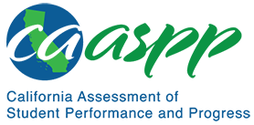
Presented August 31, 2020

This page is left blank intentionally.

Development of the Science Core Content Connectors
The California Alternate Assessment for Science was designed to assess the Science Core Content Connectors (Science Connectors). In 2016, a team of California educators along with contractors (edCount and ETS) developed the Science Core Content Connectors (Science Connectors). This group of experts examined each of the Performance Expectations (PEs) in the California Next Generation Science Standards (CA NGSS) and developed a Science Connector for each PE. These Science Connectors are differentiated into discrete Focal Knowledge, Skills, and Abilities (FKSAs), which describe what students should know and be able to do in science; and, at the simplest level, the Essential Understandings (EUs), which are the basic key ideas or concepts students should know in science. This is presented as a continuum in figure 1. More information on the complete list of Science Connectors can be found in the following Preliminary Science Core Content Connectors and Essential Understandings web document at https://www.cde.ca.gov/ta/tg/ca/documents/ngssaltconnectors.docx.
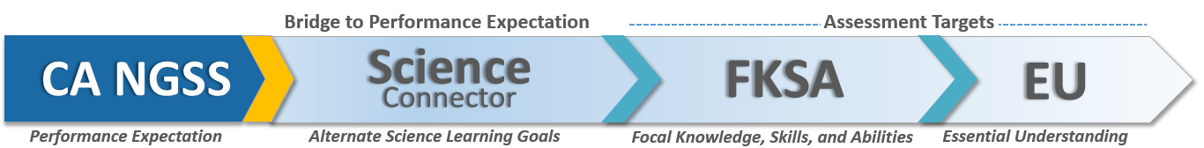
Figure 1. CAA for Science Standards Continuum
Descriptive text for the CAA for Science Standards Continuum graphic.

About the California Alternate Assessment for Science Item Content Specifications
The information in this document provides guidance to stakeholders on the California Alternate Assessment (CAA) for Science item content specifications. The CAA for Science item content specifications provide details on each assessed alternate science standard. Due to the structure of the CAA for Science test (i.e., performance tasks only), the Science Connectors covered on the assessment is a subset of the PEs. This subset of Science Connectors have been identified as appropriate for inclusion in the CAA for Science. More information about the construction of the CAA for Science can be found in the CAA for Science Blueprint document, (https://www.cde.ca.gov/ta/tg/ca/documents/caascienceblueprint.docx).
There are 83 item content specifications—one for each of the assessed Science Connectors (23 for grade five, 28 for grade eight, and 32 for high school). Originally, the specification documents were created as tools for item writers to ensure the new items are aligned with the Science Connectors. It became clear, however, that the item content specifications could be an important tool for educators when used in conjunction with the 2016 Science Framework for California Public Schools (Science Framework) and the Preliminary Science Core Content Connectors and Essential Understandings. With these specifications, educators will gain a better understanding of the nature of this assessment; however, the item content specifications are not intended to guide instruction. Educators can use the item content specifications and the Science Framework as resources for developing classroom assessments.

Sections of the Item Content Specifications
The CAA for Science item content specifications provide details on each assessed alternate science standard. The format of the item content specifications begins with the Science Connector. The item content specifications then provide examples of how students may demonstrate mastery of the Science Connectors. The item content specifications also provide relevant Environmental Principles and Concepts, examples of phenomena, and additional assessment boundaries and references. Each section of the item content specifications is discussed in detail below.

Science Connectors
The Science Connector, the FKSAs, and the EU that the item content specification is describing are provided in a table. Under the table is the CA NGSS PE from which the Science Connector was derived and includes the clarification statement and any applicable assessment boundaries.

Mastery Statements
The mastery statements describe the knowledge, skills, and abilities that students may be asked to demonstrate on a performance task. These descriptions are associated with the FKSAs and EUs.

Environmental Principles and Concepts
California’s Environmental Principles and Concepts (EP&Cs) examine the interactions and interdependence of human societies and natural systems. EP&Cs are used as context for some assessment items, but students are not directly assessed on environmental literacy beyond what is called for in certain Science Connectors.
The EP&Cs are associated with specific Science Connectors and provide basis for phenomena (or context) for assessing those Science Connectors. Not all Science Connectors will have an EP&C listed on the item content specifications. Refer to appendix 2 (https://www.cde.ca.gov/ci/sc/cf/documents/scifwappendix2.pdf)
of the 2016 Science Framework for California Public Schools for more information on the connections between the EP&Cs and PEs.

Possible Phenomena or Contexts
The Possible Phenomena or Contexts section provides general categories or specific examples of the kinds of scenarios and topics that might be appropriate for items developed for the Science Connector. This section is generated from cycles of development of the CAA for Science performance task items and from interactions with California teachers during professional development activities. The list of possible phenomena or contexts is not exhaustive, nor does the list imply that those phenomena or contexts are more likely to appear on the CAA for Science.

Additional Assessment Boundaries
Some Science Connectors may have assessment boundaries in addition to those described in the CA NGSS. These are listed in the Additional Assessment Boundaries section, when appropriate.

Additional References
All item content specifications documents list general references. Some item content specifications have additional references more specific to the Science Connector or suitable phenomena.

Appendix
This is a graphic of an arrow depicting the continuum from the California Next Generation Science Standards (CA NGSS) to the Essential Understandings (EUs). To build a bridge to the Performance Expectations (PEs) and the Assessment Targets, the group of experts examined each of the PEs from the CA NGSS and developed a Science Connector (i.e., alternate science learning goal) for each PE. The Science Connectors are differentiated into discrete Focal Knowledge, Skills, and Abilities (FKSAs), which describe what students should know and be able to do in science; and, at the simplest level, the EUs, which are the basic key ideas or concepts students should know in science.

