2025 Dashboard Technical Guide:
Introduction
An Introduction to California’s Accountability System and the General Rules Applied to the 2025 California School Dashboard.

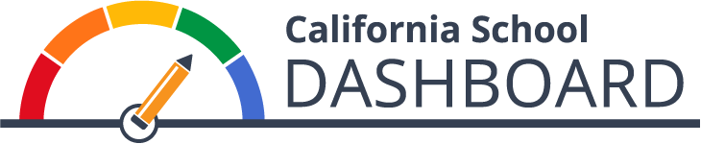

Prepared by the California Department of Education
Available on the CDE California School Dashboard
and System of Support Web Page.
November 2025

Table of Contents
About the Guide, Resources, and Contacts 1
California’s Integrated Accountability and Continuous Improvement System 3
Who Receives a Dashboard? 7
How Performance is Determined for State Indicators 7
Frequently Asked Questions about the Three-by-Five 14
Who receives a performance level/color on the 2025 Dashboard? 15
What Data Are Used for the 2025 Dashboard? 18
General Dashboard Rules 19
How to Navigate through the Dashboard 31
What’s New on the Dashboard? 37
School Dashboard Additional Reports 39
A Look at Next Year: What Data May Be Used for the 2026 Dashboard? 40
Frequently Asked Questions 41
Appendix A: Descriptive Text for Images in Guide 43

About the Guide, Resources, and Contacts

What is the Dashboard Technical Guide?
The California School Dashboard (Dashboard) Technical Guide, which is divided into several “mini-guides”, provides technical information on California’s accountability system, specifically the state and local indicators reported on the Dashboard. The guide is intended for Dashboard Coordinators at local educational agencies (LEAs) to access the calculation methodology and business rules used to produce each of the state indicators. It also provides an overview of the local indicators, available resources that are related to the Dashboard, information on the systems of support under the Local Control Funding Formula (LCFF) and details the identification of schools for comprehensive and targeted support under the Every Student Succeeds Act (ESSA). Because California’s accountability system is founded on meeting requirements under both state and federal law, the guide reflects the requirements that have been met for both. In particular, under federal law, the requirements have to be approved by the U.S. Department of Education (ED) within the state’s ESSA State Plan. The latest version is available through the California Department of Education (CDE) ESSA web page.
The guide is not intended to serve as a substitute for state and federal laws or regulations. The guide should be used in conjunction with information provided through the CDE California School Dashboard and System of Support web page, as well as from emails and correspondence disseminated by the CDE to Dashboard Coordinators.

Accessing All the “Mini-Guides”
As mentioned above, the Dashboard Technical Guide is split into several “mini-guides”. To ensure that you do not miss important information and business rules pertaining to the entire Dashboard, we encourage you to review as many of the mini-guides as possible.
You can access the full guide through the CDE Dashboard Technical Guide web page.

Resources
- The Dashboard Communications Toolkit was developed to support LEAs, parents and communities bring the 2025 Dashboard closer to home.
- The Dashboard Resources web page contains general and technical information, tools for educators, translations, downloadable data files, dedicated state and local indicator web pages, and access to the rules used to determine support for LEAs and schools.

Contacts
Questions about:
- State Indicators (Academic, Chronic Absenteeism, College/Career, English Learner Progress, Graduation Rate, Suspension Rate and Science), contact the Analysis, Measurement, and Accountability Reporting Division by email at Dashboard@cde.ca.gov.
- Local indicators, logging onto the Dashboard, submitting local indicators into the Dashboard, and the Local Control and Accountability Plan (LCAP), contact the Local Agency Support Systems Office (LASSO) by email at LCFF@cde.ca.gov.
- California’s System of Support (Differentiated Assistance and Comprehensive School Support), contact the System of Support Office (SSO) by email at CASystemofSupport@cde.ca.gov.
- California Longitudinal Pupil Achievement Data System (CALPADS), contact the CALPADS Office by email at calpads@cde.ca.gov.
Material in this publication is not copyrighted and may be reproduced.

California’s Integrated Accountability and Continuous Improvement System

Background
On September 8, 2016, the State Board of Education (SBE) approved key elements of a new integrated accountability and continuous improvement system that evaluates LEA and school performance in areas critical to students’ preparedness for college and career. These areas are founded on the LCFF ten state priorities and include graduation rates, suspension rates, chronic absenteeism rates, college/career preparedness, assessment scores, and the progress of English learners.
With the implementation of the LCFF in 2014, LEAs are held accountable for improving student performance. Specifically, state law requires ten priority areas that school districts and charter schools must report in their LCAP with two of the priority areas limited to county offices of education. These priority areas range from student achievement (performance on standardized tests and percent of English learners [ELs] that become English proficient); school climate (administer a Local Climate Survey annually); student engagement (graduation rates, chronic absenteeism rates, etc.); and parent and family engagement. Information on the LCFF priority areas can be accessed on the CDE State Priority Related Resources web page.
In December 2015, the ESSA was signed into federal law, which reauthorized the Elementary and Secondary Education Act and replaced the No Child Left Behind Act of 2001. One of the requirements under this law is for states to have a new multiple measures accountability system in effect by the 2017–18 school year based on the following five areas:
- Achievement as measured by proficiency based on annual state assessments;
- Four-year cohort graduation rates for high schools or an extended year graduation rate;
- Another academic indicator for elementary and middle schools (e.g., chronic absenteeism)
- Progress in English language proficiency for ELs; and
- At least one other indicator of school quality or student success that is valid, reliable, comparable, and statewide (e.g., postsecondary readiness, student engagement, etc.)
For more information, refer to the CDE Every Student Succeeds Act web page.

An Integrated Accountability System
Rather than developing two accountability systems––one that meets state requirements (LCFF) and another that meets federal requirements (ESSA)––an integrated local, state, and federal accountability and continuous improvement system founded on the LCFF priority areas that also aligns to ESSA requirements has been developed.
The accountability system, based on multiple measures, uses the Dashboard, which includes state and local performance standards for all LCFF priorities, to report progress. These performance standards are used to:
- Support LEAs in identifying strengths, weaknesses, and areas for improvement;
- Assist in determining whether LEAs are eligible for technical assistance; and
- Assist the State Superintendent of Public Instruction in determining whether LEAs are eligible for more intensive state support/intervention.
Table 1 displays the ten LCFF priority areas on which California’s accountability system is founded.
Table 1: State and Local Indicators by Local Control Funding Formula Priority Area
Priority Area | State Indicator | Local Indicator
Priority 1: Basic Services and Conditions | N/A | Annual measurement of appropriately assigned teachers, access to curriculum-aligned instructional materials, and safe, clean and functional school facilities.
Priority 2: Implementation  of State Academic Standards | N/A | Annual measure of progress in implementing state academic standards.
Priority 3: Parent and Family Engagement | N/A | Annual measure of progress in seeking input from parents in decision making and promoting parental participation in programs.
Priority 4: Student  Achievement | - Academic: English Language Arts & Academic: Mathematics  - English Learner Progress | N/A
Priority 5: Student  Engagement | - Graduation Rate  - Chronic Absenteeism | N/A
Priority 6: School Climate | - Suspension Rate | Administration of a local climate survey, at minimum every year, that provides a valid measure of student perceptions of school safety and connectedness in at least one grade within each grade span(s) that the LEA serves (e.g., Transitional Kindergarten [TK]–5, 6–8, 9–12)
Priority 7: Access to a Broad Course of Study | N/A | Annual measure of progress on the extent students have access to, and are enrolled in, a broad course of study.
Priority 8: Outcomes in a Broad Course of Study | - College/Career | N/A
Priority 9: (COEs Only) Coordination of Services for Expelled Students | N/A | Annual measure of progress in coordinating instruction for expelled students.
Priority 10: (COEs Only) Coordination of Services for Foster Youth | N/A | Annual measure of progress in coordinating services for foster youth.
By reporting performance on multiple measures (or indicators) that impact student performance across the LCFF priorities, the accountability system provides a more complete picture of LEAs and schools, including their accomplishments and challenges. It also promotes equity by clearly identifying the achievement gaps among student groups. For LEAs and schools in need of additional assistance or intervention, the Dashboard helps identify specific areas in need of targeted assistance.

State Indicators
LCFF statute requires that the accountability system includes standards for all LCFF priorities. The criteria established for state indicators include: (1) being valid, reliable, and fair, (2) having comparable, state-level data, and (3) the ability to disaggregate data by student groups. These criteria ensure a common and comparable way of measuring performance on the indicators across the state. The state indicators apply to all LEAs, schools, student groups (e.g., race/ethnicity, socioeconomically disadvantaged, English learners, Long-Term English Learner, students with disabilities, Foster Youth, and Homeless) and progress on the indicators is reported through the Dashboard.
As referenced in Table 1, the state indicators are:
  - Academic Indicators (English Language Arts/Literacy and Mathematics)
  - Chronic Absenteeism Indicator
  - College/Career Indicator
  - English Learner Progress Indicator
  - Graduation Rate Indicator
  - Suspension Rate Indicator
  - Science – informational purposes only
The Dashboard Measures tab on the CDE Dashboard Resources web page details each of these indicators. They are also explained in each of the state indicator mini-guides, which include technical information, calculation methodologies, and business rules.

Source of Data for State Indicators
The data used for all state indicators, inclusive of student demographic information, comes from annual LEA submissions of data as well as Assessment information from testing vendors. Most data on the Dashboard is provided by LEAs through the California Longitudinal Pupil Achievement Data System (CALPADS) during the End-of-Year file submission process, as well as captured from the Operational Data Store (ODS). Each Indicator Guide provides detail on the specific data sources used to calculate the indicators.

Local Indicators
Local indicators reflect local data that are directly submitted to the Dashboard by LEAs, and they apply only to the LEA and charter schools; they do not apply to schools.
As referenced in Table 1, the local indicators are:
- Basic Services and Conditions
- Implementation of State Academic Standards
- Parent and Family Engagement
- School Climate
- Access to a Broad Course of Study
- Coordination of Services for Expelled Students (for county offices of education [COEs] only)
- Coordination of Services for Foster Youth (for COEs only)
Comprehensive information on local indicators can be accessed through the Local Indicators mini-guide and the CDE Local Indicators web page.

Source of Data for Local Indicators
LEAs are required to measure progress in each of the local indictors on an annual basis using data available at the local level. LEAs have flexibility to use any available local data to measure progress. LEAs then use this local data to evaluate their progress in each of the local indicators and use the SBE-adopted self-reflection tools to report their progress to the Dashboard through a submission in the myCDEconnect.org system. For Priority 1, the CDE prepopulates the LEA’s Teaching Assignment Monitoring Outcomes data in the Dashboard.

Annual Review of State and Local Indicators
In March of each year, the SBE annually reviews state and local indicators and performance standards. This annual review process determines whether any changes or improvements are necessary based on newly available data, recent research, and/or educational partner feedback. Based on feedback from the SBE, any changes are documented in the “What’s New” section in each applicable mini-guide.

Who Receives a Dashboard?
All LEAs and schools, including charter schools and DASS schools, receive Dashboard reports.

Alternative (DASS) and Charter Schools
All Dashboard Alternative School Status (DASS) schools are held accountable for the same indicators as non-DASS schools. These schools’ data are included in their LEA results.
Charter schools (both traditional and DASS; local and direct-funded) are treated as LEAs under the LCFF. Accordingly, charter schools’ data are not included in the charter authorizing agency’s results. Charter schools receive school-level reports on the Dashboard.
- The one exception is when the LEA oversees only charter schools or is a Statewide Benefit Charter, the charter schools’ data are included in the LEA’s Dashboard data.

How Performance is Determined for State Indicators
In May 2016, the SBE approved the methodology for calculating performance on state indicators. The adopted methodology is two-dimensional and uses two data components:
  - Status or current year data, and
  - Change or the difference from prior year data.
The SBE approved that both Status and Change would contribute to determining performance. The performance standards are based on the distribution of Status and Change for each indicator (much like grading on a curve) and cut scores have been approved by the SBE resulting in Status levels and Change levels as described in the following sections. The combination of Status and Change levels for state indicators are reported as Performance Levels (or colors). Note that the performance standards vary by state indicator and will generally remain fixed. However, per California’s ESSA State Plan, the SBE expects to revise the Performance Levels for state indicators every seven years based on new distributions.

Status Levels and Cut Scores
For each state indicator, there are five Status levels:
Five Status Levels
Very High
High
Medium
Low
Very Low
An LEA, school, or student group’s current year of data are used to assign a Status level for each applicable indicator. For example:
- A school is assigned a “High” Status level for the Graduation Rate Indicator if its most current year graduation rate falls in the range for the “High” level.
Five Status levels were established for each state indicator through the following process:
- The data used for each indicator were collected for all LEAs and charter schools statewide.
- These results were ordered from highest to lowest.
- Four cut scores were established based on the percentile distributions to create five Status levels.

Change Levels and Cut Scores
“Change” is defined as the numerical difference in percentage results from the current year to the prior year:

Change Levels
There are five Change levels for each state indicator:
Five Change Levels
Increased Significantly
Increased
Maintained
Declined
Declined Significantly
Every LEA, school, or student group is assigned a Change level for each applicable state indicator. For example:
- A school is assigned a “Declined Significantly” Change level for the Graduation Rate Indicator if its current graduation rate compared to the prior year falls in the range for the “Declined Significantly” level.
The five Change levels were established for each state indicator through the following process:
- The difference in performance was calculated for all LEAs and charter schools statewide.
- The calculated results were grouped into two separate distributions:
- Positive change (ordered from lowest to highest)
- Negative change (ordered from highest to lowest)
- The two distributions (positive and negative change) were combined.
- Four cut scores were established to create five Change levels based on percentile distributions.

Performance Levels (or Colors)
The combination of the five Status levels and the five Change levels results in 25 Performance Levels. Each of the 25 Performance Levels is represented by one of the five colors referenced in Figure 1 below.
Figure 1: Five Performance Levels (or Colors) Represented by Gauges (Refer to Appendix A for the descriptive text.)
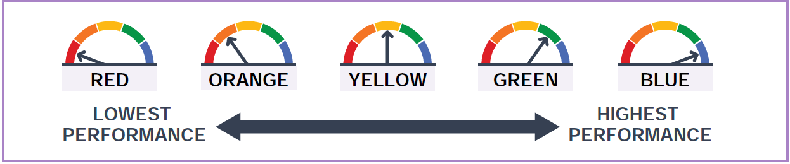

Gauges
Throughout the Dashboard, results of state indicators are reflected using gauges, as illustrated in Figure 1. Each gauge has five-colored segments ranging from Red, Orange, Yellow, Green, and Blue—with an arrow pointing to one of these colors. Referring to Figure 1, the first gauge points to red; the second gauge points to orange; the third gauge points to yellow; the fourth gauge points to green; and the fifth gauge points to blue. The Red Performance Level represents the lowest performance while the Blue Performance Level represents the highest performance.
To ensure that individuals who are color blind can distinguish the Performance Levels (or colors), and to allow all viewers to differentiate the Performance Levels if the Dashboard report is printed in black and white, the name of the color is written below the gauge.

How Performance is Determined: Five-by-Five Colored Tables
As noted earlier, the combination of the five Status levels and the five Change levels results in 25 Performance Levels or colors. These 25 Performance Levels are placed in a five-by-five colored table that the SBE has approved separately for each state indicator.
Table 3 on the following page provides an example of how the five-by-five table is used where an LEA or school with a “High” in Status and an “Increased” in Change receives an overall Performance Level of Green.

Figure 2: Five-by-Five Colored Table (Refer to Appendix A for the descriptive text.)
Level | Declined Significantly  from Prior Year | Declined  from Prior Year | Maintained  from Prior Year | *Increased  from Prior Year | Increased Significantly  from Prior Year
Very High  in Current Year | Yellow | Green | Blue | *Blue | Blue
*High  in Current Year | *Orange | *Yellow | *Green | *Green | Blue
Medium  in Current Year | Orange | Orange | Yellow | Green | Green
Low  in Current Year | Red | Orange | Orange | Yellow | Yellow
Very Low  in Current  Year | Red | Red | Red | Orange | Yellow
The CDE Five-by-Five Colored Tables web page provides you access to the Status cut scores for each Status level, Change cut scores for each Change level, and the five-by-five colored table that determines the performance for each state indicator. Note that the Status and Change cut scores are the same cut scores that have been approved by the SBE and used in prior Dashboard reporting cycles except for the:
- English Learner Progress Indicator (ELPI). In September 2023, the SBE determined Change cut scores and a five-by-five colored table for the ELPI Performance Levels. For more information, please reference the ELPI mini-guide on the Dashboard Technical Guide web page.
- Graduation Rate and Academic Indicators for DASS schools. Beginning with the 2022 Dashboard, the use of modified methods is no longer allowed due to concerns raised by the U.S. Department of Education regarding California’s use of modified methods for the Graduation Rate and Academic Indicators. Therefore, DASS schools no longer have modified cut scores for the Graduation Rate and Academic Indicators. This means that the same five-by-five colored tables are now used to determine Performance Levels (or colors) for both DASS and non-DASS schools. For more information about the DASS, refer to the mini-guide on the DASS on the Dashboard Technical Guide web page.

Automatic Assignment of Orange
As applied in prior Dashboards, LEAs and schools are automatically assigned an Orange Performance Level in the following instances:
- Suspension Rate Indicator: LEAs and schools are automatically assigned an Orange Performance Level if they:
  - Did not submit suspension data in CALPADS for the current or prior year, OR
  - Submitted suspension data in CALPADS but did not certify for the current or prior year
- Chronic Absenteeism Indicator: LEAs and schools are automatically assigned an Orange Performance Level if they:
- Submitted incorrect data for the current year
- Submitted attendance data but did not certify for the current or prior year
- Did not submit Student Absence Summary (STAS) data. Cumulative enrollment will be used to provide student group denominators for all student groups in place of attendance data.
- Submitted STAS data that is misaligned with their cumulative enrollment data submission
- Had more full-days of out-of-school suspensions than the number of days reported as absences. Recall that out-of-school suspensions are counted as absences. LEAs and schools meet this criterion if (for the current Dashboard cycle) the CALPADS student absence summary file reflected:
  - Full day out-of-school suspensions but there were zero absences reported.
A Red Performance Level is assigned if the LEA or school’s own chronic absenteeism data or suspension rate data place them at this performance color. In these instances, the LEA or school continue to receive a Red Performance Level and is not assigned an Orange color. In addition, if an LEA, school, or student group submits incorrect data for (marked with the DataErrorFlag) two or more consecutive years, then the LEA, school, or student group will automatically be assigned a Red Performance Level.

When there are Fewer than 150 Students
Based on the initial Spring 2017 Dashboard results, select LEAs and schools with small denominators were over identified with Red (or Blue) Performance Levels. In response, the CDE, in collaboration with various interest groups, reviewed multiple options to identify a method that would fairly assess LEAs and schools with small counts of students. In September 2017, the SBE approved an alternative methodology—known as the “Three-by-Five” — for assigning Performance Levels to LEAs or schools that have fewer than 150 students in the denominator of their state indicators. This methodology limits large swings in the Change data that can be triggered by just a few students.
Because over-identification in the Red or Blue Performance Levels is most prevalent for the Graduation Rate and Suspension Rate Indicators, the three-by-five methodology was only applied to these two indicators for the 2017 Dashboard. In 2018, with reporting of the Chronic Absenteeism Indicator for the first time, the SBE approved the application of the three-by-five for this indicator. In July 2019, the SBE approved the application of the three-by-five for the CCI.

How Fewer than 150 is Determined
The three-by-five methodology is applied whenever there are fewer than 150 students in the current year at the LEA, school, and/or student group levels. For example:
- If a school had 155 students in the denominator of the graduation rate for the current year and 130 students in the prior year, the school would not have the three-by-five applied since there is greater than 150 students in the current year.
The count of students is dependent on the denominator of the indicator rather than on the number of students enrolled:
- The n-size (or the number of students included in the denominator) for the Graduation Rate Indicator is based on the number of students in the combined four- and five-year graduation rate for high schools.
- The n-size (or the number of students included in the denominator) for the College/Career Indicator is based on the number of students in the four-year graduation rate and the number of fifth-year graduates who met Prepared.
- The n-size for the Suspension Rate Indicator is based on the number of students who are cumulatively enrolled during the school year.
- The n-size for the Chronic Absenteeism Indicator is based on the number of students who meet the chronic absenteeism eligibility enrollment requirements.

What Does the Three-by-Five Look Like?
The three-by-five methodology removes both the “Increased Significantly” and “Declined Significantly” Change levels from the five-by-five colored tables. Therefore, only one of the following three Change levels are used to determine the Performance Level for the Graduation Rate, Suspension Rate, College/Career Rate and Chronic Absenteeism Indicators:
  - Increased
  - Maintained
  - Declined
Although this methodology only contains three Change levels, LEAs, schools, and student groups can still receive any one of the five performance colors. Figures 3, 4, and 5 illustrate the change from a five-by-five colored table to a three-by-five colored table as described above.

Figure 3: Three-by-Five Colored Table for Suspension and Chronic Absenteeism Rate Indicators (Refer to Appendix A for the descriptive text)
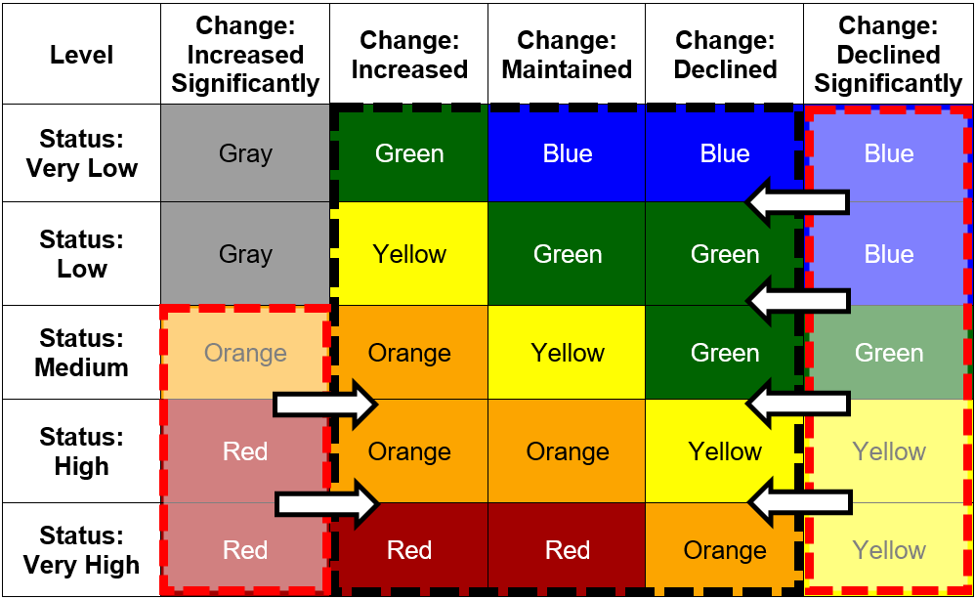
Figure 4: Three-by-Five Colored Table for Graduation Rate Indicator (Refer to Appendix A for the descriptive text)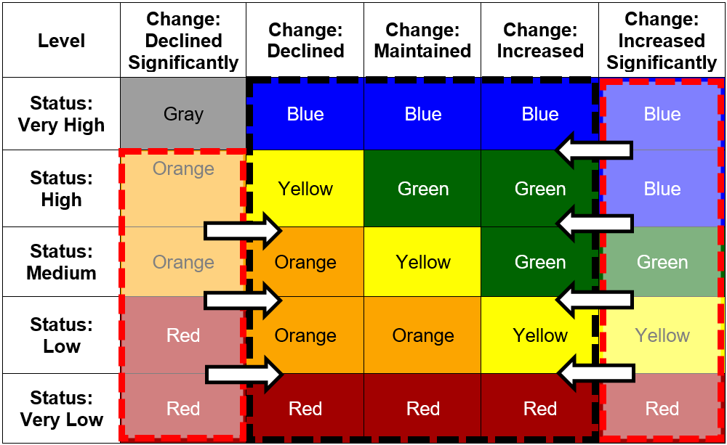
Figure 5: Three-by-Five Colored Table for College/Career Indicator (Refer to Appendix A for the descriptive text)
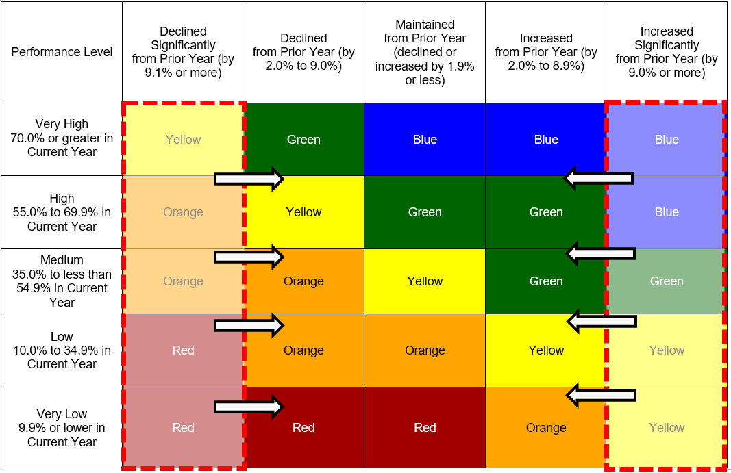

Frequently Asked Questions about the Three-by-Five
Q1. Can an LEA or school have both the five-by-five and three-by-five colored tables applied?
Yes. For instance, if, for the Graduation Rate Indicator, an LEA has over 150 total students then the five-by-five colored table will be applied to determine the LEA’s Performance Level (color). If the same LEA had one student group that had fewer than 150 students, then the student group will have the three-by-five colored table applied to determine the color.
Q2. Is the three-by-five applicable to student groups?
Yes. The three-by-five is applicable to all LEAs, schools, and student groups that have a student count of fewer than 150 students in the denominator.

Who receives a performance level/color on the 2025 Dashboard?
District/COEs and schools that do not meet specific accountability requirements are eligible to receive specific support:
- For District/COEs, the support is referred to as differentiated assistance and is an accountability requirement under state law (that is, Local Control Funding Formula [LCFF]).
- For schools, the support is referred to as Comprehensive Support and Improvement (CSI), Additional Targeted Support and Improvement (ATSI), and Targeted Support and Improvement (TSI) and are accountability requirements under federal law (that is, ESSA).
Detailed information on the eligibility criteria to receive support are referenced in the mini-guides titled “Differentiated Assistance Under the Local Control Funding Formula” and “Every Student Succeeds Act School Support” which are available on the CDE Dashboard Technical Guide web page.
Only District/COEs and schools meeting the required n-size are eligible for differentiated assistance state and federal support determinations. The following sections identify the number of students needed to receive a performance level/color, what the Dashboard will display, and what the Dashboard will not display when the threshold number is not reached.
All schools, including charter schools, that have the following number of eligible students in the denominator for the current and prior year receive a performance level/color:
- All students level – 30 or more students
- Student group level – 30 or more students
Example:
A school’s student group has 32 students in the denominator in the current year, but 27 students in the denominator in the prior year, Status and Change would be displayed for informational purposes only, but no performance level/color is calculated or displayed on the Dashboard Card.
All Districts or County Office of Education (COE) that have the following number of students in the current and prior year denominator will receive a performance level/color:
- All students level – 30 or more students
- Student group level:
  - Homeless, Foster Youth, Long-Term English Learner (LTEL) student groups – 15 or more students
  - All other student groups – 30 or more students
Example:
A COE has 16 LTELs in the denominator in the current year, and 19 LTELS in the denominator in the prior year. Status and Change would be displayed in addition to having a performance level/color calculated and displayed on the Dashboard Card.
The figures below illustrate how Dashboard Cards represent different student counts.
Figure 6: Example of When Number of Students is 30 or More (Refer to Appendix A for the descriptive text)
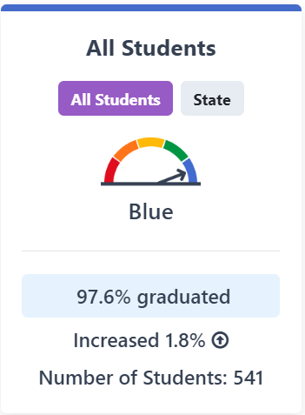
Table 4 identifies the data and data sources used to determine the n-size of “30 or more” for the state indicators.
Table 4: Data Used to Determine 30 or More Students
State Indicator | Data Used to Determine “30 or More” | Data Source
Academic  (Grades 3 through 8 and Grade 11 in ELA and mathematics) | All students who take the Smarter Balanced Summative Assessments or the California Alternate Assessments in grades 3 through 8 and grade 11 who are continuously enrolled* in addition to the number of students added if the federal 95 percent participation rate target is not met.** | CAASPP***file from testing vendor
Chronic Absenteeism | Eligible Cumulative Enrollment  (The total number of students enrolled in a school for at least 31 instructional days.)** | CALPADS
College/Career | All students in the four- year graduation rate and fifth-year graduates who met Prepared.** | CALPADS
English Learner Progress | All grades 1 through 12 students taking the ELPAC*** Summative Assessment or Summative Alternate ELPAC Assessment in the current year and having an overall Performance Level in both the current and prior year.** | ELPAC**** Summative Assessment and Summative Alternate ELPAC Assessment file from test vendor
Graduation Rate | All students in the combined four- and five-year graduation rate.** | CALPADS
Suspension Rate | Cumulative Enrollment  (All students enrolled for at least one day.)** | CALPADS
*Continuously Enrolled is defined as enrollment from Fall Census Day (first Wednesday in October)] to when the student logged on to any domain of the test without a gap of more than 30 consecutive calendar days.
**For complete information on how the denominator is determined for each of the state indicators, please refer to the state indicator mini-guides available on the CDE Dashboard Technical Guide web page.
***CAASPP: California Assessment of Student Performance and Progress
****ELPAC: English Language Proficiency Assessments for California

Figure 7: Example of When Number of Students is 11–29 (Refer to Appendix A for the descriptive text)
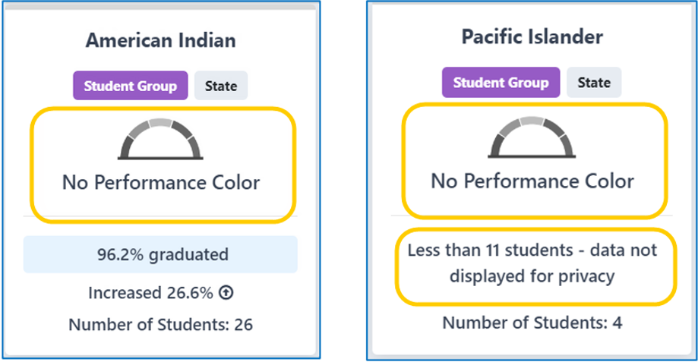
Figure 8: Example of When Number of Students is Less than 11 (Refer to Appendix A for the descriptive text)

What Data Are Used for the 2025 Dashboard?
Table 5 identifies the data that will be used to calculate Status and Change for each of the state indicators uploaded to the 2025 Dashboard by the CDE. Note that all indicators use the most current data available.
Table 5: Data Used for the 2025 Dashboard
Indicator | Data Used for  Status | Data Used for  Change
Academic:  Grades 3–8 and Grade 11 | 2025 Average Distance from Standard* for 2024-25 Summative Assessments* for ELA and Mathematics | 2025 Average Distance from Standard  minus  2024 Average Distance from Standard
Chronic Absenteeism: Grades TK–8 | 2024–25 Chronic Absenteeism Rate | 2024–25 Chronic Absenteeism Rate  minus  2023–24 Chronic Absenteeism Rate
College/Career:  Grades 9–12 | “Prepared” Graduates in 2024–25 combined four-and five-year graduation rate | 2024-25 College/Career Rate  minus  2023-24 College/Career Rate
English Learner Progress:  Grades 1–12 | 2023–24 and 2024–25 Summative ELPAC and Summative Alternate ELPAC Results | Current Year ELPI Status Rate (2023–24 and 2024–25)  minus  Prior Year ELPI Status Rate (2022–23 and 2023–24)
Graduation Rate: Grades 9–12 | 2024–25 combined four-and five-year graduation rate | 2024–25 combined four-and five-year graduation rate  minus  2023–24 combined four-and five-year graduation rate
Suspension Rate:  Grades TK–12 | 2024–25 Suspension Rate | 2024–25 Suspension Rate  minus  2023–24 Suspension Rate
Science:  Grades 5, 8 and High School | 2025 Average Science Points for 2024-2025 Summative Assessments for Science** | 2025 Average Science Points  Minus  2024 Average Science Points
* Summative Assessments include both the Smarter Balanced Summative Assessments and California Alternate Assessments for English Language Arts and Mathematics.
**Summative Assessment for Science include both California Science Test (CAST) and California Alternate Assessment (CAA) for Science.

General Dashboard Rules
This section reviews the common rules and definitions that are applied across all state indicators.

Adult Schools/Adult Centers
All adult schools/adult centers do not receive a Dashboard report and are removed from all calculations of state indicators.

Closed Schools
Any school that closed during the 2024–25 academic year will receive a Dashboard as long as the school has data that can be used to report state indicators.

County-District-School Code
In order to have data displayed for the indicators reported on the Dashboard by the CDE, an LEA must have a county-district (CD) code and a school must have a county-district-school (CDS) code. Information regarding CDS code assignments is located on the CDE Schools and Districts web page.

District of Residence
For LEAs only, an additional step—application of the district of residence rule (also known as the District of Special Education Accountability [DSEA] in CALPADS)—is taken to determine which SWDs receive special education services at another district or county office of education and should be “sent back” to the DSEA and included in the DSEA’s Dashboard. This rule ensures that the LEA that receives federal funding—under the Individuals with Disabilities Education Act—for a student will be held accountable for the outcomes of that student. (Note that at the school level, the school of attendance will continue to be held accountable for the student’s performance.)

Which LEA is Responsible for Reporting the District of Special Education Accountability Data?
Since SWDs often attend school in one LEA and receive services from another LEA or county office of education (COE), it can be unclear which LEA is required to report special education data to CALPADS. The responsible LEA for reporting enrollment and special education data to CALPADS is the “Reporting LEA” or the LEA where the student “attends school” or receives the majority of their instruction.
The DSEA is the LEA ultimately responsible for the student and held accountable for the student on the Dashboard. In most instances, the Reporting LEA and the DSEA are the same for accountability purposes, as are the DSEA and the District of Geographic Residence. However, note that the District of Geographic Residence field in CALPADS is used for LCFF funding purposes and is not the DSEA field.
Table 6 provides the most common scenarios for determining which LEA is responsible for reporting SWD data, and which LEA will be held accountable on the Dashboard. A full comprehensive list of scenarios is posted on the CDE Reporting Data for Students with Disabilities web page.
Table 6: Common Scenarios for Determining Which district/COE is Held Accountable
Scenario | If the student resides in: | And the student attends school and receives majority of educational instruction from: | And the student receives special education services from: | Then the LEA that reports data for the SWD is: | And the District of Special Education Accountability is:
1 | District A | District A | District A | District A | District A
2 | District A | District A | District B | District A | District A
3 | District A | District B  per the IEP | District B | District B | District A
4 | District A | District B  per an inter-district transfer agreement | District B | District B | District B

Frequently Asked Questions about the DSEA
- Does the district of residence/DSEA rule impact schools?
No. The rule is only applied at the district level. All schools (i.e., schools providing the special education service and where the student attends) are held accountable for their SWDs, and these students are included in their Dashboard reports.
- Which district is the DSEA when students transfer via a formal inter-district transfer, attend a charter school, attend a private school, or are wards of the court?
- For inter-district transfers, the DSEA is the district that the student transfers to. See Scenario 4 in Table 6.
- For charter schools, because charter schools are treated as LEAs under LCFF, the charter school is held accountable and is the DSEA. (Note that the charter school’s authorizer is not held accountable.)
- For juvenile court and court/community, the DSEA is the LEA serving the student while the student is incarcerated or institutionalized.
- Does the district of residence rule apply to all state indicators?
Yes. The rule applies to all state indicators:
- Academic Indicators
- Chronic Absenteeism Indicator
- College/Career Indicator
- English Learner Progress Indicator
- Graduation Rate Indicator
- Suspension Rate Indicator
- Science Indicator
- Does the district of residence rule apply only to students with disabilities? Or does the rule apply to all students?
The rule only applies to students with disabilities.
Table 7 below identifies which entity is held accountable for SWDs on the Dashboard.
Table 7: Which Entity is Held Accountable for Students with Disabilities?
State Indicator | School of Attendance | District of Residence  (District of Special Education Accountability) | District of Attendance | Charter School | Charter School Authorizer
Academic | Responsible | Responsible | Not Responsible | Responsible | Not Responsible
Suspension | Responsible | Responsible | Not Responsible | Responsible | Not Responsible
Chronic Absenteeism | Responsible | Responsible | Not Responsible | Responsible | Not Responsible
Graduation Rate | Responsible | Responsible | Not Responsible | Responsible | Not Responsible
CCI | Responsible | Responsible | Not Responsible | Responsible | Not Responsible
ELPI | Responsible | Responsible | Not Responsible | Responsible | Not Responsible
Science | Responsible | Responsible | Not Responsible | Responsible | Not Responsible
The CDE flyer District of Special Education Accountability Rule for Students with Disabilities is also available as an additional resource on this topic.

LEA and School Type
For some state indicators—such as Academic and Suspension Rate—different cut scores were set by the SBE based on the LEA and school type. For example, the:
- Suspension Rate Indicator has six different sets of cut scores for Status and Change: (1) three sets based on LEA type distributions and (2) three sets based on school type distributions.
- Academic Indicators has cut scores for grades 3–8 and cut scores for grade 11. Table 8 on the following page identifies the cut scores applied by type.
Table 8: Cut Scores by Type for Academic Indicators
Grades 3-8 Cut Scores | Grade 11 Cut Scores
Elementary School | High School (serving grades 7–12)
Middle School | High School District
TK–12 or K-12 School | (blank)
Elementary School District | (blank)
Unified School District | (blank)
Note that for unified school districts and K–12 schools, the grade eleven results are combined with the grades three through eight results to calculate one Academic Indicator for ELA and one Academic Indicator for mathematics.
Due to these differing cut scores, it is important that the correct “LEA type” and “school type” are identified for each LEA and school so that the appropriate Status and Change cut scores are applied. (An elementary school that is erroneously designated as “high school” will have the high school Status and Change cut scores applied when the elementary cut scores should be used.) The following section explains how the CDE determines these types.
For more information on specific cut scores for the Suspension Rate and Academic Indicators, please refer to their respective mini-guides.

LEA Type for Reporting Purposes
LEA type designations of Unified School District, Elementary School District, and High School District are based off the CDS database, which is sourced from the California School Directory. These data are extracted annually on June 30 and specifically, the “district ownership code (DOC)” is used to assign each LEA their type:
- DOC = 52, then the district is designated as an elementary school district
- DOC = 56, then the district is designated as a high school district
- DOC = 00, 03, or 54, then the district is designated as a unified school district
For Dashboard purposes, county offices of education are assigned a Unified School District type.
Single school districts are assigned an elementary or high school district type based on their school type. For example, if the school type for a single school district is “Elementary,” then their district type is “Elementary School District.”

School Type for Reporting Purposes
School type designations of elementary, middle, and high are also based off the California School Directory, which are extracted annually on June 30. The educational institution level (EIL) code is mainly used to assign each school their type.
Any school labeled in EIL as “Ungraded” or “Elementary High” will have their school type determined by the information in the “school ownership code (SOC),” which is also available in the California School Directory:
- SOC = 60 or 61, then the school is designated as elementary
- SOC = 62 or 64, then the school is designated as middle
- SOC = 66, 67, or 68, then then the school is designated as high
Schools that have no information in the “educational institution level code” or “school ownership code,” such as TK–12 schools, will be assigned the unified school district type.

New Schools
Schools that newly opened during the 2024–25 academic year, and have current data, will have only Status levels and Status data reported on the 2025 Dashboard.

Standard Rounding Rule
The CDE applies standard rounding rules to both Status and Change. These values are rounded to the nearest tenth before they are displayed throughout the Dashboard and the Five-by-Five Placement Report.
Change is calculated using the two years of Status results, prior to rounding:
Current Status (Not Rounded) minus
Prior Status (Not Rounded) = Change (Rounded)
Therefore, LEAs and schools should not use the rounded Status values to calculate Change, because it could result in a different performance level (or color) than what is reported on the Dashboard website.

Student Groups Defined
The Dashboard reports specific student groups as required in California Education Code Section 52052(a)(2):
Race/Ethnicity:
- Black or African American
- American Indian or Alaska Native
- Asian
- Filipino
- Hispanic or Latino
- Native Hawaiian or Pacific Islander
- White
- Two or More Races
Program Participation:
- English learner (EL)
- Long-Term English Learner (LTEL)
- Socioeconomically Disadvantaged (SED)
- Foster Youth (students whose well-being is the responsibility of a court)
- Student with Disabilities (SWD)
- Homeless

Long-Term English Learners
Beginning with the 2024 Dashboard, long-term English learners (LTELs) were added as a student group across all state indicators. EL students who have not been reclassified as fluent-English proficient within seven years are included in the LTEL student group. For accountability purposes, the definition of a LTEL is “A pupil who has not attained English language proficiency within 7 years of initial classification as an English learner.” This definition is different than the definition of LTELs in Education Code Section 313.1, which appears within reports on DataQuest. Similar to the EL student group, who is an LTEL can vary by state indicator. There are three distinct student populations:
- Cumulative Enrollment: Chronic Absenteeism and Suspension Rate Indicators
- Assessment Demographics: Academic – ELA, Academic – Mathematics, English Learner Progress, and Science Indicators
- Cohort: Graduation Rate and College/Career Indicator
Long-Term English Learners are considered an LTEL student seven years (or 2557 days) following their initial date of US school enrollment or initial date of EL classification, whichever is earlier.

14 Student Group Definitions and Data Sources
Table 9 identifies, at-a-glance, the rules used to determine which racial or ethnic student group, or program participation student group, to place students for each state indicator. Note that for the Graduation Rate Indicator and CCI, students are placed in the EL, LTEL, SWD, Homeless, and Foster Youth groups based on their status over the last four or five years and their status is not based on current year data. For example, if a student was Homeless in their sophomore year, but no longer so in their senior year, the student will be placed in the Homeless student group for the Graduation Rate Indicator and CCI.

Table 9: At-A-Glance: Rules Used to Place Students in Student Groups
CAA = California Alternate Assessments; EOY = End-of-Year; ODS = CALPADS Operational Data Store; N/A = Not Applicable
State Indicator | Race/  Ethnicity | SED | EL | LTEL | SWD | Homeless | Foster Youth
Academic – ELA and Mathematics  2025 Smarter Balanced Summative Assessments and CAAs | Most recent race/ ethnicity at the LEA in EOY 3 | SED any time during school year at the school or LEA in EOY 3 | EL any time during school year, including students reclassified within past 4 years (i.e., reclassified after June 15, 2021) in EOY 3. | Students who have been an EL for 7+ years during the current academic year | SWD any time during school year at the school or LEA in EOY 3, or took the CAA | Homeless any time during school year at the school or LEA in EOY 3 | Foster any time during school year at the school or LEA based on state match or from local match functionality
Suspension  2024–25 | Most recent race/ ethnicity at the LEA in EOY 3 | SED any time during school year at the school or LEA in EOY 3 | EL any time during school year at the school or LEA in EOY 3 | Students who have been an EL for 7+ years during the current academic year | SWD any time during school year at the school or LEA in EOY 3 | Homeless any time during school year at the school or LEA in EOY 3 | Foster any time during school year at the school or LEA based on state match or from local match functionality
Chronic Absenteeism  2024-25 | Most recent race/ ethnicity at the LEA in EOY 3 | SED any time during school year at the school or LEA in EOY 3 | EL any time during school year at the school or LEA in EOY 3 | Students who have been an EL for 7+ years during the current academic year | SWD any time during school year at the school or LEA in EOY 3 | Homeless any time during school year at the school or LEA in EOY 3 | Foster any time during school year at the school or LEA based on state match or from local match functionality
Graduation Rate  (Combined 4- and 5-Year)  2024-25 | Most recent race/ ethnicity at the LEA in ODS | SED any time during the last 4 or 5 years in high school in ODS | EL any time during the last 4 or 5 years in high school in ODS | LTEL any time during the last 4 or 5 years in high school in ODS | SWD any time during the last 4 or 5 years in high school in ODS | Homeless any time during the last 4 or 5 years in high school in ODS | Foster any time during the last 4 or 5 years in high school in ODS
CCI  (Combined 4- and 5-Year)  2024-25 | Most recent race/ ethnicity at the LEA in ODS | SED any time during the last 4 or 5 years in high school in ODS | EL any time during the last 4 or 5 years in high school in ODS | LTEL any time during the last 4 or 5 years in high school in ODS | SWD any time during the last 4 or 5 years in high school in ODS | Homeless any time during the last 4 or 5 years in high school in ODS | Foster any time during the last 4 or 5 years in high school in ODS
English Learner Progress  (EL and LTEL are the only student groups reported.)  2024-25 | N/A | N/A | Grade 1-12 ELs with an ELPAC Summative Assessment overall Performance Level in the current and prior year | Students who have been an EL for 7+ years with Summative ELPAC or Summative Alternate ELPAC results | N/A | N/A | N/A
Science  2024-25 | Most recent race/ ethnicity at the LEA in EOY 3 | SED any time during school year at the school or LEA in EOY 3 | EL any time during school year, including students reclassified within past 4 years (i.e., reclassified after June 15, 2021) in EOY 3. | Students who have been an EL for 7+ years during the current academic year | SWD any time during school year at the school or LEA in EOY 3, or took the CAA | Homeless any time during school year at the school or LEA in EOY 3 | Foster any time during school year at the school or LEA based on state match or from local match functionality

Student Group Definitions and Data Sources
Table 10 below identifies the full definitions and data sources for each student group.
Table 10: Student Group Definitions and Data Source
Student Group | Student Groups Definitions
Race/  Ethnicity | Students are placed in a specific race/ethnicity based on their most recent CALPADS record at the school/LEA. This information is derived from the Student Information (SINF) file and:  - Hispanic or Latino Ethnicity Indicator  - Race Category Code  The following steps are used to determine which race/ethnicity student group a student is included in:  - If the CALPADS student record shows Hispanic or Latino in any field, the student’s results are included in the Hispanic or Latino student group.  - If the CALPADS student record shows non-Hispanic or Latino and only one race, the student’s results are included in the student group of that racial category.  - If the CALPADS student record shows non-Hispanic or Latino and more than one race, the student’s results are included in the Two or More Races student group.  - If the CALPADS student record shows blank in all fields, the student’s results are included in the schoolwide, districtwide, and statewide data but not in any race/ethnicity student group.  Exception: For the Chronic Absenteeism and Suspension Rate Indicators, student CALPADS records that have blank race/ethnicity data are included in the Two or More Races student group. These students are also included once in the “ALL” student group at the schoolwide, districtwide, and statewide levels.  Note:  - Specific Asian groups (i.e., Chinese, Japanese, Korean, Vietnamese, Asian Indian, Laotian, Cambodian, Hmong, or Other Asian) are counted as Asian.  - Native Hawaiian or specific Pacific Islander groups (i.e., Guamanian, Samoan, Tahitian, or Other Pacific Islander) are counted as Native Hawaiian or Pacific Islander.  If multiple groups are marked in the same racial category (e.g., Chinese and Korean), the student is classified as that category (e.g., Asian), not Two or More Races.  *Consult the Technical Guides for Academic (ELA/Math) and Science Indicators for additional rules for race/ethnicity identification.
SED | Students are SED if they meet one or more of the following criteria at any time during the school year at the school/LEA:  - Student has a Student Program (SPRG) record with an Education Program Code of:  - 181 – Free Meal Program; or  - 182 – Reduced-Price Meal Program; or  - 135 – Title I Part C Migrant; or  - 191 – Homeless; or  - 193 – Tribal Foster Youth  - Student has been identified in a state-level match as:  - Directly certified to receive free or reduced-price meals through SNAP, TANF, Medi-Cal; or  - Foster Program Eligible - In foster family placement or in family maintenance; or  - Student has a SINF record where “Parent Guardian 1 Highest Education Level” AND “Parent Guardian 2 Highest Education Level” is “Not a High School Graduate” (Code 14). If only one parent education level is reported, that education level must be “Not a High School Graduate”; or  Student was enrolled in a Juvenile Court school as identified as JUV in the EdOpsCode in the California Public Schools Directory.  *Consult the Technical Guides for Academic (ELA/Math) and Science Indicators for additional rules for SED student identification.
EL | Students are EL based on the English Language Acquisition Status (ELAS) information in CALPADS.  For the Academic Indicator Only: A student is placed in the EL student group if they were marked as EL at any time during the school year. Students who were reclassified within the past 4 years (i.e., reclassified after June 15, 2021) are also included in this student group. The RFEP information can also be accessed using the English Language Acquisition Status information.  For the English Learner Progress Only: Students with an ELAS in CALPADS of EL during the ELPAC Summative Testing window (i.e., February 1 to May 31) are placed in the EL student group.  Learn the different ways that each state indicator measures ELs through the EL Students on the California School Dashboard flyer on the CDE Dashboard Communications Toolkit web page.  *Consult the Technical Guides for Academic (ELA/Math) and Science Indicators for additional rules for EL student identification.
LTEL | Students who have been an EL for 7+ years during the current academic year are placed in the LTEL student group. (This can be calculated as 2557 days since their ELAS date or Student Initial US School Enrollment Date K-12 in CALPADS, whichever date is earlier)  For the Graduation Rate and College/Career Indicators: Students who have been an EL for 7+ years at any point during the 4- or 5- year cohort period are placed in the LTEL student group.
SWD | Students are SWD if they:  - Took the CAA, or  Had a primary disability code in CALPADS at any time during the school year at the school/LEA.
Homeless | Students are placed in the Homeless student group if they have at any time during school year (at the school/LEA) a “191 – Homeless” record submitted within the SPRG file.  *Consult the Technical Guides for Academic (ELA/Math) and Science Indicators for additional rules for Homeless student identification.
Foster Youth | Students are placed in the Foster Youth student group if:  - The students have been identified in a state-level match as “in foster placement” or “in family maintenance” or through the local match functionality at any time during school year at the school/LEA; or  The students were Tribal Foster Youth. This is taken from Education Program Code 193 from the SPRG file.  *Consult the Technical Guides for Academic (ELA/Math) and Science Indicators for additional rules for Foster Youth identification.

Three Additional Student Groups Reported on the Academic Indicators
The Academic Indicators report three additional student groups that are not reported in other state indicators and are displayed for informational purposes only and do not receive Performance Levels (or colors):
- Current English Learners (ELs): Students who are learning to communicate effectively in English, typically requiring instruction in both the English language and in their academic courses are included in the EL Student Group for the Academic Indicators.
- Recently Reclassified English Learners (Reclassified Fluent-English Proficient [RFEP] Only): ELs who have sufficient English proficiency to be reclassified as a fluent English speaker, and have done so in the past 4 years, are included in the EL Student Group for the Academic Indicators.
- English Only: Students for whom the only language reported on the Home Language Survey (HLS) is English or American Sign Language.
Table 11 below identifies the rules used to place students in these three student groups. Note that the data used to determine placement in a student group are extracted from CALPADS.
Table 11: Three Additional Student Groups Defined
State Indicator | Current ELs | Recently Reclassified English Learners Only (RFEP Only) | English Only
Academic  2025 Smarter Balanced Summative Assessments and CAA (Grades 3–8 and Grade 11) | Students who are identified as EL at any time during the school year at the school or LEA in EOY 3. | Students who are included in the EL student group for the Academic Indicators and have reclassified within the past four years (i.e., reclassified after June 15, 2021) at the school or LEA in EOY 3. | Students who are identified as English Only at the school or LEA in EOY 3.

Student Group Calculations
For each student group reported in the Dashboard, the numerator is based on the number of students in the group that meet the performance standards of the indicator. The denominator is based on the total number of students in the group.

How to Navigate through the Dashboard
The Dashboard can be accessed on the CDE California School Dashboard and System of Support web page. Upon entering the website, to see the results for a district or school, type the name into the search bar. Alternatively, the search for a district or school can also be conducted by city or county. Next, select the year. Figure 9 below provides an image of the Dashboard landing page.
Figure 9: Dashboard Landing Page (Refer to Appendix A for the descriptive text)
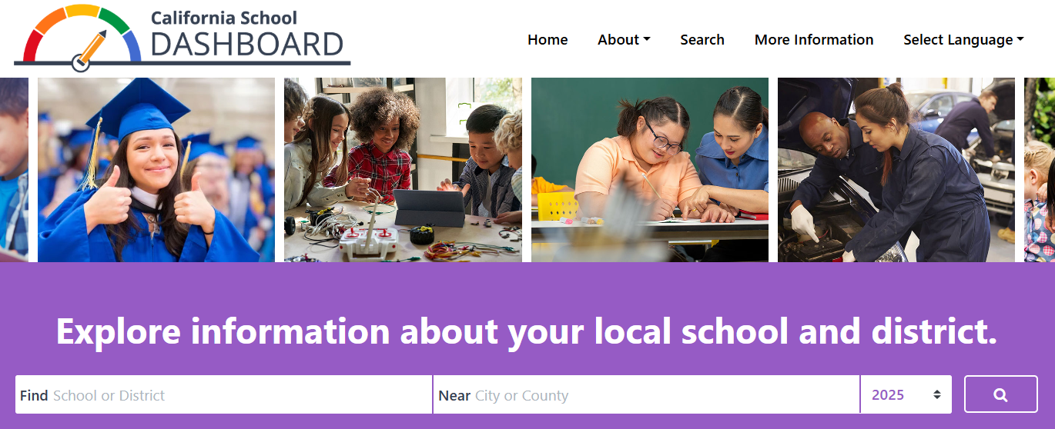

Performance on State and Local Indicators
Once you select your district or school, you’ll be able to see its performance on state and local indicators. Figure 10 below reflects an example for a district.
Figure 10: Performance on State and Local Indicators (Refer to Appendix A for the descriptive text.)
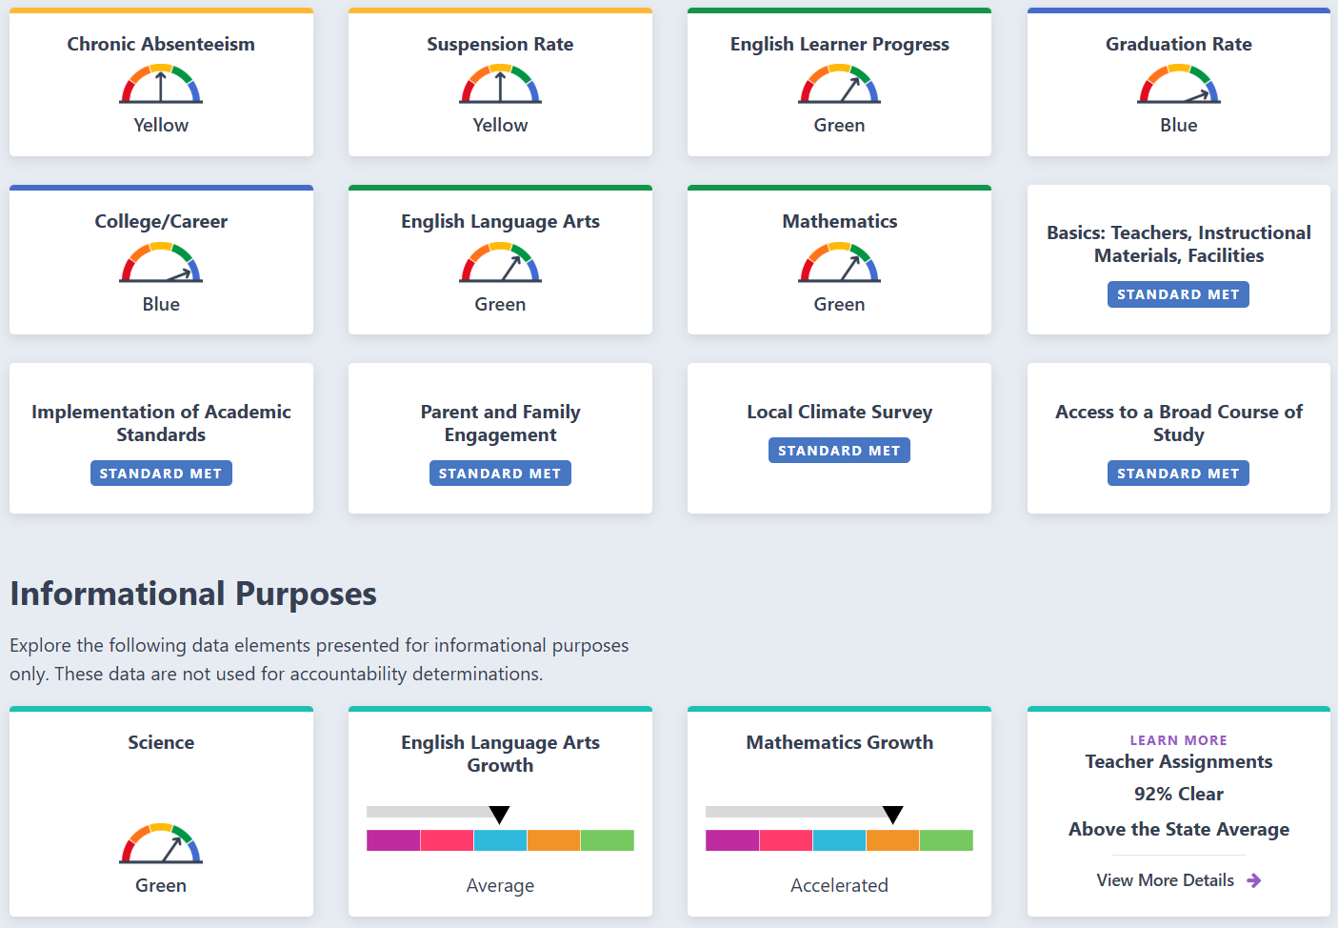
In Figure 10, the district received a Yellow Performance Level for both Chronic Absenteeism, College/Career and Mathematics. Suspension Rate, Graduation Rate and English Language Arts received a Performance Level of Green. The district also received an Orange for English Learner Progress. Finally, the district also satisfied the State Board of Education-adopted local indicator performance standard requirements.

Student Population
General student population data are also available on the main landing page of the Dashboard. Figure 11 below provides an example.
Figure 11: Student Population Data on Main Dashboard Landing Page (Refer to Appendix A for the descriptive text)
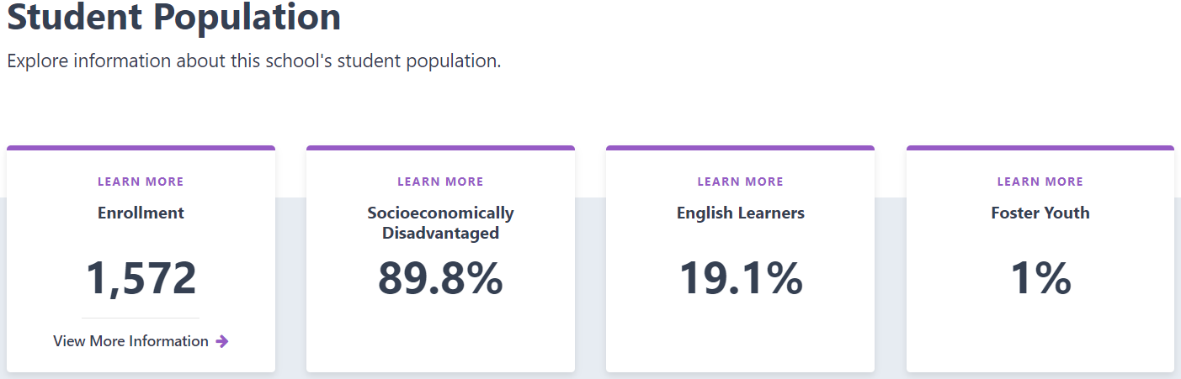
- Enrollment: These data are reflective of the CALPADS 2024 Fall Census Day data. At the LEA-level, the data excludes charter school data.
- View More Information: The link at the bottom of the Enrollment card details the demographic data, which includes race/ethnicity and program participation student groups. These data are also based on the 2024 CALPADS Fall Census Day data.
- Percentage of Students who are Identified as Socioeconomically Disadvantaged, English learners, and Foster Youth: These data are also reflective of the 2024 CALPADS Fall Census Day data. At the LEA-level, charter school data are excluded from the count.
- Learn More: By selecting the “Learn More” text which appears at the top of each card, viewers can access the definitions for enrollment, socioeconomically disadvantaged, English learners, and Foster Youth. This information is available in Figure 12 below.
Figure 12: Student Population Descriptions (Refer to Appendix A for the descriptive text).
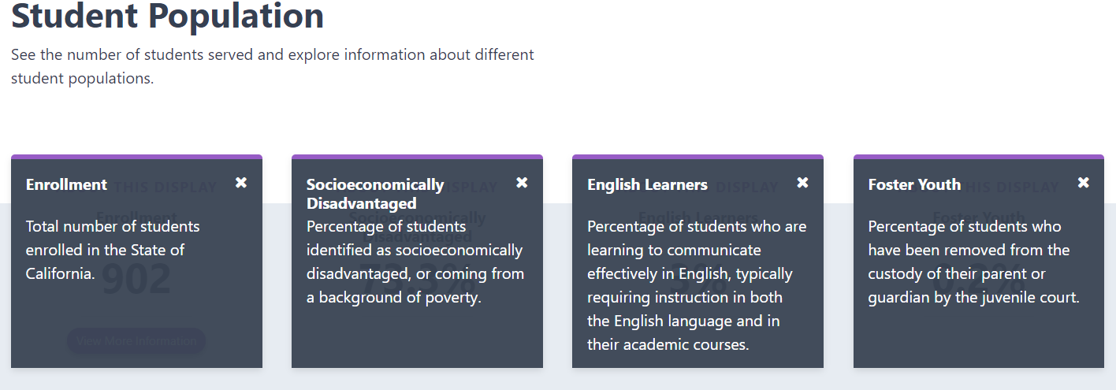

Compare Your Data to the State
Each of the state indicator cards include buttons at the top that allow you to compare your school or LEA’s data against statewide results. You can toggle back and forth between the “All Students” and “State” button as shown in Figure 13 below.
Figure 13: Example of Comparing District Data (i.e., All Students) versus State (Refer to Appendix A for the descriptive text.)
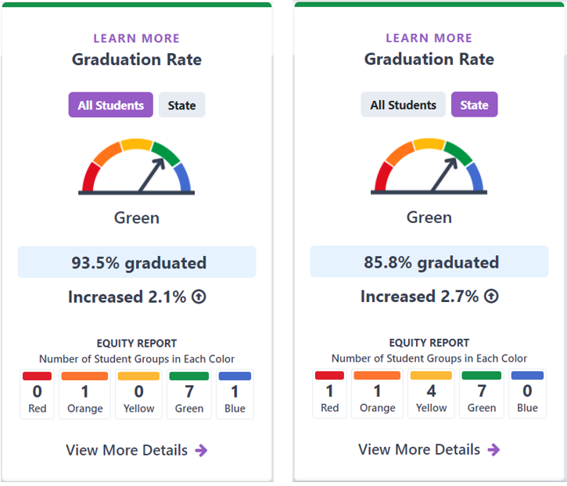

Equity Report
At the bottom of each card is an Equity Report. It identifies the number of student groups placed in each Performance Level. Figure 14 below reflects the Equity Report for a sample district’s graduation rate. It shows that zero student groups received a Red (the lowest Performance Level), one student group received an Orange, zero student groups received a Yellow, seven student groups received a Green, and one student group received a Blue (the highest Performance Level).

Figure 14: Equity Report (Refer to Appendix A for the descriptive text.)
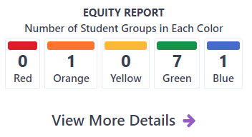

Student Group Performance
Selecting the “View More Details” link below the Equity Report connects the visitor to the Student Group Details page which informs how student groups performed on a state indicator. Figure 15 below reflects a sample of the “Student Group Details”.
Figure 15: Student Group Details (Refer to Appendix A for the descriptive text.)
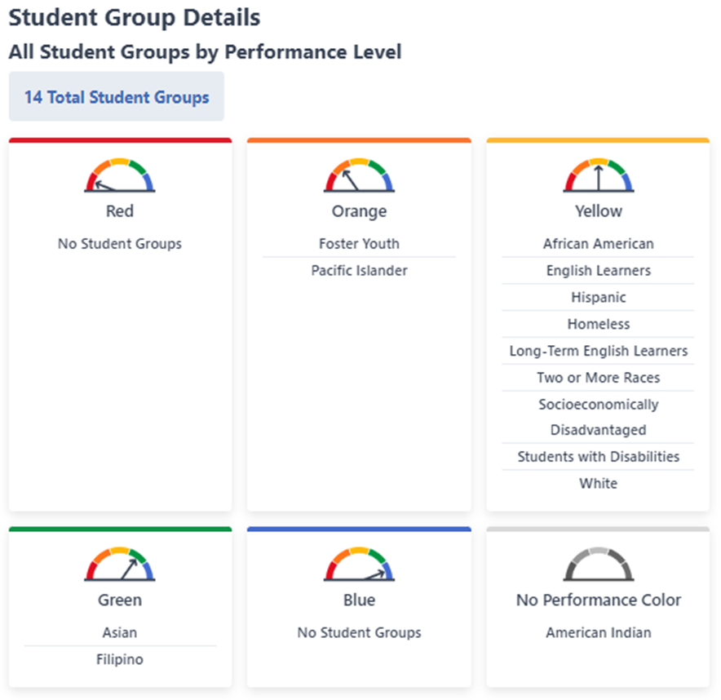

View All Schools
Selecting the “View All Schools” link at the top right of an LEA report connects the viewer to a page that gives a snapshot look at how all the schools in an LEA performed on each applicable indicator. Figure 16 illustrates an example.
Figure 16: Viewing All Schools’ Performance At-a-Glance (Refer to Appendix A for the descriptive text) 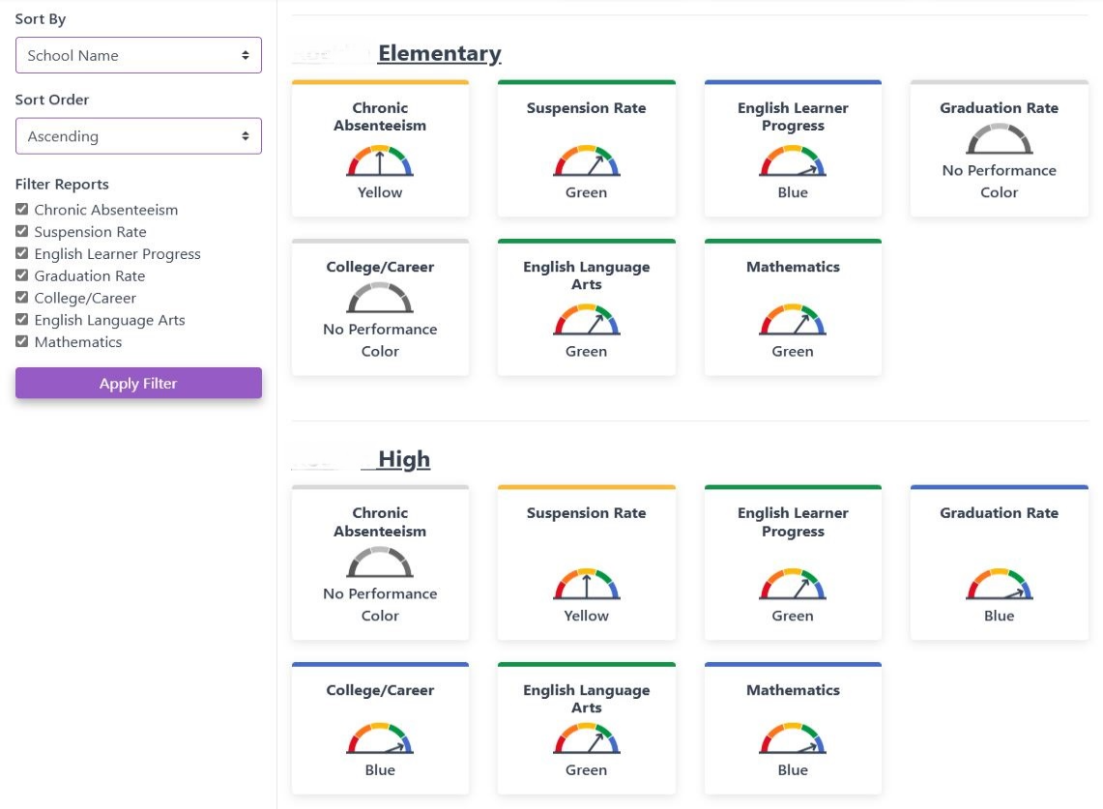

Local Indicators
As mentioned earlier, the SBE approved “local indicators,” which are based on information collected locally by LEAs. The local indicators apply only at the LEA level, which includes charter schools. These local indicators appear on the LEA and charter school Dashboard with a status of Met, Not Met, or Not Met for Two or More Years. Figure 17 on the following page identifies the local indicator cards for a district on the Dashboard.
Figure 17: Local Indicator Cards on the Dashboard (Refer to Appendix A for the descriptive text.)
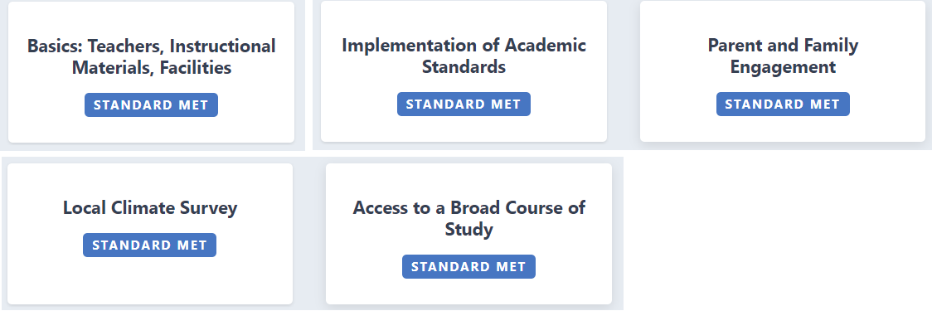
Further details about local indicators can be found within the Local Indicators web page and the Local Indicators mini-guide, which is available on the CDE Dashboard Technical Guide web page.

What’s New on the Dashboard?
The 2025 Dashboard now contains the following:
- Incorporation of the Student-Level Growth Model for Grades 4 through 8 in English Language Arts (ELA) and Mathematics (Math) into the Dashboard
- Performance Category Levels: The SBE adopted the names and cut scores for the five performance category levels from the lowest level of growth to highest level of growth as follows: Minimal Growth (growth scores less than 20 below), Moderate Growth (growth scores between 20 below and 5 below), Average Growth (growth scores between 5 below and 5 above), Accelerated Growth (growth scores between 5 above and 20 above), and Exceptional Growth (growth scores higher than 20 above).
- Growth Model Dashboard Display: The data box on the Growth Dashboard card will display the percent of students whose scores improved from the prior year. For example, 75 percent of students improved their score from the prior year.
- ELA and Math Growth Indicators: The inclusion of ELA and Math Growth Indicators on the Dashboard will be for informational purposes and the SBE affirmed that they should be used as additional information for charter school renewal purposes. The ELA and Math Growth Indicators will be displayed in the Informational Purposes section of the 2025 Dashboard.
- Science Indicator
- Informational Use Only: The Science Indicator, with its status levels, change levels, and color performance categories previously adopted at the SBE meeting in March 2025, will be used for informational purposes and will not impact Local Control Funding Formula (LCFF) Eligibility Determinations on the 2025 Dashboard.
- Dashboard Placement: The Science Indicator, with newly added performance colors, will continue to appear in the Informational Purposes section of the 2025 Dashboard, as it did with the 2024 Dashboard.
- College/Career Indicator (CCI) Measures
- Removal of ROC/P Participation: The SBE approved the removal of Regional Occupational Center/Program (ROC/P) participation from the State and Federal Job Programs measure of the College/Career Indicator.
- Inclusion of AP Course Passage: The SBE approved the inclusion of Advanced Placement (AP) course passage with a grade of C- or better in the CCI for both the Prepared and Approaching Prepared performance levels.
- Modification to Transition Classroom and Work-Based Learning Experiences: This measure has been updated to include students who are awarded a diploma in accordance with California Education Code sections 51225.31 and 51225.32.
- State Seal of Civic Engagement: The CDE will continue to collect and analyze data related to the State Seal of Civic Engagement for inclusion in the 2026 Dashboard.
- New Career Measures: The CDE will continue to collect and analyze data related to new career measures for potential inclusion in future Dashboards; Internships, Student Led Enterprises, Simulated Work-Based Learning, Armed Services Vocational Aptitude Battery.
- Differentiated Assistance (DA) Eligibility Based on California Longitudinal Pupil Achievement Data System (CALPADS) Submissions:
- Timeline for DA Eligibility Criteria: The SBE adopted a phased-in timeline for DA eligibility criteria related to the submission of data to the California’s student-level data system, CALPADS:
  - For the 2024–25 academic year, any district or CDE that fails to meet a CALPADS certification deadline for the Fall 1, Fall 2, or End-of-Year (EOY) 1, 2, 3, or 4 data submissions may be eligible for CALPADS Differentiated Assistance (CALPADS DA).
  - For the 2025–26 academic year, in addition to the eligibility requirements for districts and COEs that did not certify any one or more of the CALPADS data submissions by the certification deadline, districts and COEs that are identified as having a data quality issue will be eligible for CALPADS DA.
- Review of Priority 1 Teacher Assignment Data:
- Modifications to Priority 1: The SBE took the following actions for the 2025 Dashboard:
  - The SBE agreed to title the new LEA and school Dashboard cards “Teacher Assignments.” Additionally, recognizing the term “Clear” for describing teacher status may, by itself, be confusing, the SBE agreed to work with the CDE to ensure the teacher assignment data terminology on the Dashboard cards is accessible and aligned with the terminology used in the School Accountability Report Card, which clarifies “Clear” is in reference to Fully (Preliminary or Clear) Credentialed for Subject and Student Placement (properly assigned).
Figures 18a and 18b: Dashboard Cards for “Teacher Assignments” (Refer to Appendix A for the descriptive text.)

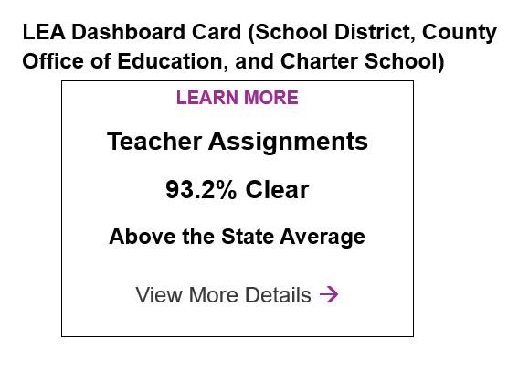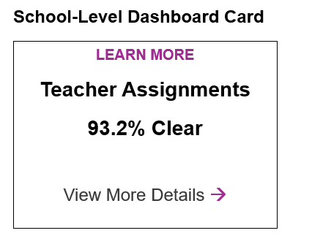
  - The SBE agreed to title the new LEA and school Dashboard cards “Teacher Assignments.” Additionally, recognizing the term “Clear” for describing teacher status may, by itself, be confusing, the SBE agreed to work with the CDE to ensure the teacher assignment data terminology on the Dashboard cards is accessible and aligned with the terminology used in the School Accountability Report Card, which clarifies “Clear” is in reference to Fully (Preliminary or Clear) Credentialed for Subject and Student Placement (properly assigned).
- Review of Long-Term English Learner (LTEL) Results on the Dashboard:
- Eligibility Criteria Priority 4: Modify the LCFF eligibility criteria for LTELs under Priority 4 to include Orange on English Learner Progress Indicator (ELPI), in addition to the current Red on the ELPI, and exclude performance on English Language Arts (ELA) and Mathematics.
- Dashboard Alternative School Status (DASS) Application/ Renewal Criteria
    - Revision to DASS Criteria Regarding Wards of the Court: Modify the DASS criteria to remove Wards of Court.

School Dashboard Additional Reports
Each year, the CDE publishes the School Dashboard Additional Reports to provide viewers additional data and insight to their Dashboard results. This site consists of the following reports:
- Five-by-Five Placement Reports - California's accountability and continuous improvement system is based on a five-by-five colored table that is used to determine the performance color, this report helps LEAs and schools quickly identify the exact performance color received for each state indicator.
- College/Career Measures Report displays the number and percentage of graduates who achieved the Prepared and Approaching Prepared levels in the CCI. These reports also have pie charts and heat maps that graphically represent how the individual measures contribute to the students being prepared and approaching prepared.
- Graduation Rate Report displays the number and percentage of students included in the combined four-and five-year graduation rate for all LEAs, schools, and student groups. This report also contains a dropdown menu to allow viewers to access a similar report for DASS schools that display the number and percentages of students included in the DASS one-year graduation rate for informational purposes.
- Participation Rate Reports provide the number of students included in the calculation of the participation rates for English language arts/literacy, mathematics and science. This report connects to the downloadable data file which can be used to determine if the DFS was adjusted (i.e., added LOSS scores) due to federal requirements.
- ELPAC Participation Rate Report provides the number of English learner students included in the calculation of the participation rates for the Summative ELPAC and Summative Alternate ELPAC. This report can be used to confirm if a school or district met the participation rate target of 95 percent and, as a result, were subject to the no progress participation rate penalty in the Current Status calculation.
- Student Groups Report displays, at-a-glance, the performance of all student groups across all state indicators. This report can be used when reviewing the data for Differentiated Assistance as the eligibility criteria is based on student group performance.
- District/Charter Performance by County Reports provide viewers with a list of all districts in a county and their performance on each state indicator. A student group filter is also available to allow for an instant look at overall performance for each district in a county by student group.
- Dashboard Navigator. The Navigator is an interactive mapping tool for visualizing school performance based on results reported from the Dashboard. The Navigator displays schools by their color-coded performance level for each of the Dashboard state indicators. Users can refine their searches by geographic area, charter status, DASS status and student group. A series of interactive charts provide a visual summary of the mapped results. Detailed Dashboard results for individual schools can be easily accessed by selecting a specific school on the map.

A Look at Next Year: What Data May Be Used for the 2026 Dashboard?
Table 12 identifies the data that may potentially be used to calculate Status and Change for each of the state indicators uploaded to the Dashboard by the CDE for the 2026 Dashboard. The information in the table is subject to change based on any actions by the SBE.
Table 12: Data that May Be Used for the 2026 Dashboard
State Indicator | Data Used for  Status | Data Used for  Change
Academic:  Grades 3–8 and Grade 11 | 2026 Average DFS* for 2025–26 Summative Assessments** for ELA and Mathematics | 2026 Average Distance from Standard  minus  2025 Average Distance from Standard
Chronic Absenteeism:  Grades TK–8 | 2025–26 Chronic Absenteeism Rate | 2025–26 Chronic Absenteeism Rate  minus  2024–25 Chronic Absenteeism Rate
College/Career:  Grades 9–12 | “Prepared” Graduates in 2025–26 combined four-and five-year graduation rate | “Prepared” Graduates in 2025–26  minus  “Prepared” Graduates in 2024–25
English Learner Progress:  Grades 1–12 | 2024–25 and 2025–26 Summative ELPAC and Summative Alternate ELPAC Results | Current Year ELPI Status Rate (2024–25 and 2025–26)  minus  Prior Year ELPI Status Rate (2023–24 and 2024–25)
Graduation Rate:  Grades 9–12 | 2025–26 combined four-and five-year graduation rate | 2025–26 combined four-and five-year graduation rate  minus  2024–25 combined four-and five-year graduation rate
Suspension Rate:  Grades TK–12 | 2025–26 Suspension Rate | 2025–26 Suspension Rate  minus  2024–25 Suspension Rate
Science | 2025-26 Average SPs for 2025-26 Summative Assessments for Science | 2025-26 Average SPs  minus  2024-25 Average SPs
* DFS and SPs calculations include the application of the LOSS when the 95 percent participation rate target is not met. For more information, refer to the Academic Indicators flyer on the CDE Dashboard Communications Toolkit web page.
** Summative Assessments include both the Smarter Balanced Summative Assessments and California Alternate Assessments.

Frequently Asked Questions
This section covers the most commonly asked questions from LEAs.
- I heard that a new student group, Long-Term English Learners (LTEL), is now required to be reported on the Dashboard. Is this going to be displayed on the 2025 Dashboard?
Yes, LTELs began being reported with the 2024 Dashboard release.
- Why do I see Status and Change data but no performance colors for some of the indicators on my school’s Dashboard?
LEAs, schools, and student groups that have 11–29 students in the denominator of the state indicator will have Status and Change data displayed but because the denominator contains less than 30 students, Performance Levels (or colors) are not displayed on the Dashboard.
- I know the CDE is required to publish the 2025 Dashboard on November 15, 2025. Will this release date be the same for future Dashboards?
No. With the passage of Senate Bill 114 in July 2023, the CDE is now required to publish the Dashboard by the following dates:
- 2026 Dashboard: October 15, 2026
Each year after the 2026 Dashboard, the Dashboard will be released on October 15th.
- Why does the student enrollment count on the landing page of my school’s Dashboard not match the denominator with the Suspension Rate Indicator?
Keep in mind that the enrollment count on the Dashboard landing page stems from Fall Census Day data whereas the count of students for the Suspension Rate Indicator is based on students who are cumulatively enrolled throughout the year (i.e., through CALPADS End-of-Year 3). “Cumulative enrollment” is the total number of students who were enrolled for at least one day at any time during the school year.
- Are data from adult schools included in my district’s Dashboard results?
No. Adult schools do not receive a Dashboard and therefore, these schools’ data are not included in their LEA results.
- Are charter school data included in my LEA’s Dashboard results?
No. Because charter schools are treated as LEAs under LCFF, their data are not included in their authorizer’s Dashboard report.
- Does the 2025 Dashboard reflect the data I recently updated in CALPADS on November 10, 2025?
No. All data extracted out of CALPADS for the 2025 Dashboard were based on End-of-Year (EOY) certified data. The amendment window closed on August 16, 2025.
  - If you updated data after the EOY certification deadline, the updates will not be reflected.
  - If you certified data and updated data without de-certifying and re-certifying, the updates you made before August 16, 2025, will also not be reflected in the Dashboard.

Appendix A: Descriptive Text for Images in Guide
This section contains the descriptive text to the images presented throughout this guide to ensure accessibility to individuals with disabilities as required by Section 508 of the federal Rehabilitation Act of 1973.
Figure 1: Performance Levels Represented by Gauges
There are five gauges lined up in a row which represent Performance Levels. Each gauge has five-colored segments ranging from Red, Orange, Yellow, Green, and Blue—with an arrow pointing to a specific color. Starting from the right, the first gauge points to blue (with the word Blue underneath); the second gauge points to green (with the word Green underneath); the third gauge points to yellow (with the word Yellow underneath); the fourth gauge points to orange (with the word Orange underneath); and the fifth gauge points to red (with the word Red underneath). Under these five gauges are the words Lowest Performance to the left and Highest Performance to the right with a double-ended arrow between these words.
Figure 2: Five-by-Five Colored Table
The table includes Performance Levels (or colors) which are determined using current year performance (or Status) and the difference from prior year (or Change) to show growth or decline. Change levels appear at the top row with a range from Increased Significantly through Declined Significantly. Status levels appear in the column on the left ranging from Very Low in current year through Very High in current year. The merge points of Status and Change create the Performance Levels. From highest to lowest, the Performance Levels are: Blue, Green, Yellow, Orange, and Red.
Figure 3: Three-by-Five Colored Table for Suspension Rate Indicator
This image reflects a modified version of the Suspension Rate Indicator five-by-five table known as the three-by-five table that is used to determine performance colors for small student populations with an n-size of fewer than 150 students. In the three-by-five methodology, the “Declined Significantly” and “Increase Significantly” Change columns are eliminated. To illustrate this modification, all the performance color boxes under the “Declined Significantly” and “Increased Significantly” columns found in a traditional five-by-five table are outlined with a red-dotted line indicating these columns are not used. There are arrows on both the left and right sides of the five-by-five to illustrate how it collapses to a three-by-five table.
Figure 4: Three-by-Five Colored Table for Graduation Rate Indicator
This image reflects a modified version of the Graduation Rate Indicator five-by-five table known as the three-by-five table that is used to determine performance colors for small student populations with an n-size of fewer than 150 students. In the three-by-five methodology, the “Declined Significantly” and “Increase Significantly” Change columns are eliminated. To illustrate this modification, all the performance color boxes under the “Declined Significantly” and “Increased Significantly” columns found in a traditional five-by-five table are outlined with a red-dotted line indicating these columns are not used. There are arrows on both the left and right sides of the five-by-five to illustrate how it collapses to a three-by-five table.
Figure 5: Three-by-Five Colored Table for College/Career Indicator
This image reflects a modified version of the College/Career Indicator five-by-five table known as the three-by-five table that is used to determine performance colors for small student populations with an n-size of fewer than 150 students. In the three-by-five methodology, the “Declined Significantly” and “Increase Significantly” Change columns are eliminated. To illustrate this modification, all the performance color boxes under the “Declined Significantly” and “Increased Significantly” columns found in a traditional five-by-five table are outlined with a red-dotted line indicating these columns are not used. There are arrows on both the left and right sides of the five-by-five to illustrate how it collapses to a three-by-five table.
Figure 6: Example of When Number of Students is 30 or More
This image reflects a card for the Graduation Rate Indicator for “All Students”. There are two buttons at the top of the card: All Students and State. Because the All Students button is selected, this button is colored purple while the one for State is in gray. Underneath is a five-segmented color gauge with an arrow pointing to the blue color with the word “Blue” identified below the gauge. The card reflects that 97.6 percent graduated with an increase of 1.8 percentage points. There is a total of 541 number of students.
Figure 7: Example of When Number of Students is 11–29
This image reflects a baseball card for American Indian. The card shows two buttons at the top: one that is selected and highlighted in purple with the words Student Group and the other that is not selected and in gray with the words State. There is a grayed out color gauge below with the words No Performance Color underneath the gauge which is all highlighted with a yellow oval circle. Underneath the gauge, it reflects that 96.2 percent of American Indian students graduated with an increase of 26.6 percentage points from the prior year. Underneath this, it shows that the number of students is 26.
Figure 8: Example of When Number of Students is Less than 11
This image reflects a baseball card for Pacific Islander. The card shows two buttons at the top: one that is selected and highlighted in purple with the words Student Group and the other that is not selected and in gray with the words State. There is a grayed out color gauge below with the words No Performance Color underneath the gauge which is all highlighted with a yellow oval circle. Underneath this, it notes the words “Less than 11 students – data not displayed for privacy” with a light yellow circle around it. At the bottom of the card, it shows that the number of students was four.
Figure 9: Dashboard Landing Page
The image reflects the Dashboard Homepage. The top of the page has an image of the Dashboard logo consisting of a gauge with the arrow pointing to green with the words California School Dashboard. Tabs from left to right as follows:
- Home
- About
- State Summary
- Search
- More Information
- Select Language
Underneath the tabs, there are four pictures. From left to right: a photo of a student in a blue graduation cap and gown; a picture of students looking at a tablet; a teacher helping a student; an adult providing instructions to a student working on an automobile. Underneath the pictures, the following words are in bold: Explore information about your local school and district. Below this is a search tab with two search boxes: (1) Find School or District and (2) Near City or County. The box at the right of the search boxes allows the viewer to toggle for a specific year. The default is set at 2025. The button to the right of the year search box is a magnifying glass.
Figure 10: Performance on State and Local Indicators
The image is an example display of the performance on state and local indicators for an LEA. The cards showing from left to right:
First Row:
- Chronic Absenteeism: A five-segmented color gauge pointing to the yellow color with the word Yellow underneath the gauge.
- Suspension Rate: A five-segmented color gauge pointing to the yellow color with the word Yellow underneath the gauge.
- English Learner Progress: A five-segmented color gauge pointing to the green color with the word Green underneath the gauge.
- Graduation Rates: A five-segmented color gauge pointing to the blue color with the word Blue underneath the gauge.
Second Row:
- College/Career: A five-segmented color gauge pointing to the blue color with the word Blue underneath the gauge.
- English Language Arts: A five-segmented color gauge pointing to the green color with the word Green underneath the gauge.
- Mathematics: A five-segmented color gauge pointing to the green color with the word Green underneath the gauge.
- Basic Teachers Instructional Materials, Facilities: Local Indicator is Standard Met.
Third Row:
- Implementation of Academic Standards: Local Indicator is Standard Met.
- Parent and Family Engagement: Local Indicator is Standard Met.
- Local Climate Survey: Local Indicator is Standard Met.
- Access to a Broad Course of Study: Local Indicator is Standard Met.
Fourth Row – Informational Purposes:
- Science: A five-segmented color gauge with an arrow pointing to the green color with the word Green underneath the gauge.
- English Language Arts Growth: A five-color segmented bar with an arrow pointing to the blue color section with the word Average underneath the bar.
- Mathematics Growth: A five-color segmented bar with an arrow pointing to the orange color section with the word Accelerated underneath the bar.
- Teacher Assignments: 92% Clear, Above the State Average, below that there is the option to View More Details with a purple arrow next to it.
Figure 11: Student Population Data on Main Dashboard Landing Page
The image shows “Student Population” as the title along with “explore information about this school’s population.” There are four cards. These cards from left to right describe the following:
- Card 1: Learn More: Enrollment 1,572 with the words “View More Information” with an arrow pointing to the right.
- Card 2: Learn More: Socioeconomically Disadvantaged 89.8%
- Card 3: Learn More: English Learners 19.1%
- Card 4: Learn More: Foster Youth 1%
Figure 12: Student Population Descriptions
The image reflects the backside of the cards in Figure 8 after they are selected. The top of the image states Student Population along with the words “See the number of students served and explore information about different student populations”. Underneath are the following descriptions for each card (from left to right):
- Enrollment: Total number of students enrolled in the State of California.
- Socioeconomically Disadvantaged: Percentage of students identified as socioeconomically disadvantaged or coming from a background of poverty.
- English Learner: Percentage of students who are learning to communicate effectively in English, typically requiring instruction in both the English language and in their academic courses.
- Foster Youth: Percentage of students who have been removed from the custody of their parent or guardian by the juvenile court.
Figure 13: Example of Comparing District Data (i.e., All Students) versus State
This image reflects two cards for the Graduation Rate Indicator: one for All Students and the other for the State. Both cards have the words “Learn More” at the top and they both have two buttons below the words Graduation Rate: All Students and State. For the card to the left, because the All Students button is selected, the button is in purple while the one for State is in gray. The five-segmented color gauge points to the green color with the word Green displayed underneath. The card reflects that 93.5 percent graduated with an increase of 2.1 percentage points from the prior year. At the bottom of the card is the Equity Report: Number of Student groups in Each Level. There are five boxes in a row with the following number of groups in each color:
- Red: 0
- Orange: 1
- Yellow: 0
- Green: 7
- Blue: 1
Underneath the Equity Report states “View More Details” with an arrow pointing to the right.
For the State card to the right, because the State button is selected, this button is in purple while the one for All Students is in gray. The five-segmented color gauge points to the green color with the word Green underneath. The card reflects that 85.8 percent graduated with an increase of 2.7 percentage points from the prior year. Below the card is the Equity Report: Number of Student groups in Each Level. There are five boxes in a row with the following number of groups in each color:
- Red: 1
- Orange: 1
- Yellow: 4
- Green: 7
- Blue: 0
Underneath the Equity Report it states “View More Details” with an arrow pointing to the right.
Figure 14: Equity Report
An image of the Equity Report with words “Number of Student groups in Each Level”. There are five boxes in a row with the following number of students in each:
- Red: 0
- Orange: 1
- Yellow: 0
- Green: 7
- Blue: 1
Underneath the Equity Report it states “View More Details” with an arrow pointing to the right.
Figure 15: Student Group Details
The image shows an example of Student Group Details. It contains the words “All Student Groups by Performance Level”. There are a total of 14 student groups identified in the image. There are six cards that reflect the data - starting from left to right:
- Red: A five-segmented color gauge with an arrow pointing to the red color with the word Red underneath the gauge. There are no student groups is listed in this card.
- Orange: A five-segmented color gauge with an arrow pointing to the orange color with the word Orange underneath the gauge. The Foster Youth and Pacific Islander student groups are listed in this card.
- Yellow: A five-segmented color gauge with an arrow pointing to the yellow color with the word Yellow underneath the gauge. The African American, English Learners, Hispanic, Homeless, Long-Term English Learners, Two or More Races, Socioeconomically Disadvantaged, Students with Disabilities and White student groups are listed in this card.
- Green: A five-segmented color gauge with an arrow pointing to the green color with the word Green underneath the gauge. The Asian, and Filipino student groups are listed in this card.
- Blue: A five-segmented color gauge with an arrow pointing to the blue color with the word Blue underneath the gauge. There are no student groups listed in this card.
- No Performance Level: A grayed out five-segmented color gauge with the words No Performance Color underneath. The American Indican student groups is listed in this card.
Figure 16: Viewing All Schools’ Performance At-a-Glance
This image reflects how a user can access the performance of all schools in a district in one viewing. Filters are available to the left of the report so that schools can be ordered by ascending or descending order. A specific indicator can also be selected and ordered by ascending or descending performance. The image itself identifies:
- An elementary school where for the:
- Chronic Absenteeism card, the five-segmented colored gauge points to the yellow color with the word Yellow underneath.
- Suspension Rate card, the five-segmented colored gauge points to the green color with the word Green underneath.
- English Learner Progress card, the five-segmented colored gauge points to the blue color with the word Blue underneath.
- Graduation Rate card, the five-segmented colored gauge is grayed out with the words No Performance Color underneath.
- College/Career card, the five Status level bars are grayed out with the words No Performance Level underneath.
- English Language Arts card, the five-segmented colored gauge points to the green color with the word Green underneath.
- Mathematics card, the five-segmented colored gauge points to the green color with the word Green underneath.
- A high school where for the:
- Chronic Absenteeism card, the five-segmented colored gauge is grayed out with the words No Performance Color underneath.
- Suspension Rate card, the five-segmented colored gauge points to the yellow color with the word Yellow underneath.
- English Learner Progress card, the five-segmented colored gauge points to the green color with the word Green underneath.
- Graduation Rate card, the five-segmented colored gauge points to the blue color with the word Blue underneath.
- College/Career card, the five-segmented colored gauge points to the blue color with the word Blue underneath.
- English Language Arts card, the five-segmented colored gauge points to the green color with the word Green underneath.
- Mathematics card, the five-segmented colored gauge points to the blue color with the word Blue underneath.
Figure 17: Local Indicator Cards on the Dashboard
This image has five cards representing the Local Indicators on the Dashboard.
In the first row, from left to right, reflects a card for:
- Basics: Teachers, Instructional Materials, Facilities with the words “Standard Met” underneath.
- Implementation of Academic Standards with the words Standard Met” underneath.
- Parent and Family Engagement with the words Standard Met” underneath.
In the second row, from left to right, reflects a card for:
- Local Climate Survey with the words Standard Met” underneath.
- Access to a Broad Course of Study with the words Standard Met” underneath.
Figures 18a and 18b: Dashboard Cards for “Teacher Assignments”
Figure 18a - LEA Dashboard Card (School District, County Office of Education, and Charter School). Learn More about Teacher Assignments. 93% Clear, Above the State Average. View more details with an arrow pointing to the right.
Figure 18b - School-Level Dashboard Card. Learn More about Teacher Assignments, 93% Clear. View More Details with an arrow pointing to the right.

