Parent Guide to the California School Dashboard
(Updated March 2020)

What Is the California School Dashboard?
The California School Dashboard (or the Dashboard) is an online tool that shows parents and communities how well schools and districts are meeting the needs of all students. It reports performance on both state and local measures. These multiple measures reflect California’s accountability system, which is based on the ten priority areas of the Local Control Funding Formula (LCFF), which are discussed on the California Department of Education (CDE) web page at http://www.cde.ca.gov/fg/aa/lc/lcffoverview.asp.

State Measures
These measures are based on information collected statewide and allow parents to compare schools and districts across California.

Six State Measures:

- Chronic Absenteeism (for grades K–8)
- Suspension Rate (for grades K–12)
- English Learner Progress (for grades 1–12)
- Graduation Rate (for high school only)
- College/Career (for high school only)
- Academic (for grades 3–8 and grade 11)
  - English Language Arts
  - Mathematics

You can learn more about each of these indicators in Appendix A: What More Should We Know about the State Measures?

Local Measures
While state measures are based on information collected statewide, local measures are based on information collected by districts. These measures include basic conditions (teacher qualifications, safe and clean buildings, and textbooks for all students); implementation of academic standards; access to a broad course of study; school climate surveys; and parent and family involvement and engagement.

How Is Performance Measured?
Performance on the state measures is based on results for both the current and prior years.

For each state measure, schools and districts receive one of five performance levels. Each performance level is identified by a different color:

Performance Colors | Performance Levels
Blue (Highest Performance) | Very High
Green | High
Yellow | Medium
Orange | Low
Red (Lowest Performance) | Very Low

How Is Performance Reported on the Dashboard?

On the Dashboard reports, the performance levels appear as semi-circle gauges that are divided into color segments: red, orange, yellow, green, and blue. An arrow points to the color that represents the performance level for that measure.

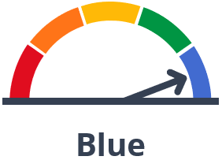

In the example above, the arrow is pointing to the far right segment, which is the Blue performance level. This is the highest performance level.

How to View Performance of a School or District on the 2019 Dashboard
- The Dashboard can be viewed on the CDE California School Dashboard and System of Support web page, at https://www.cde.ca.gov/ta/ac/cm/.

- To see the results for a school or district, type the name into the search bar.

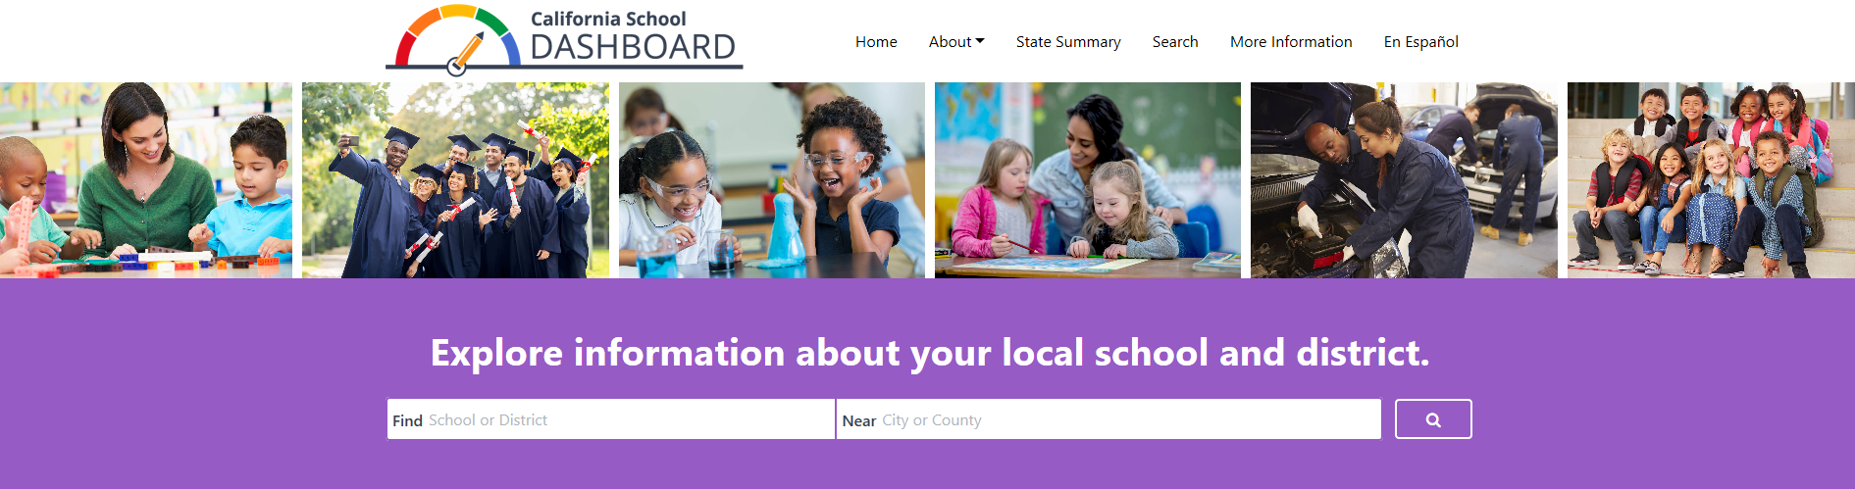

- Once you select your school or district, you’ll be able to see its performance on state and local measures.

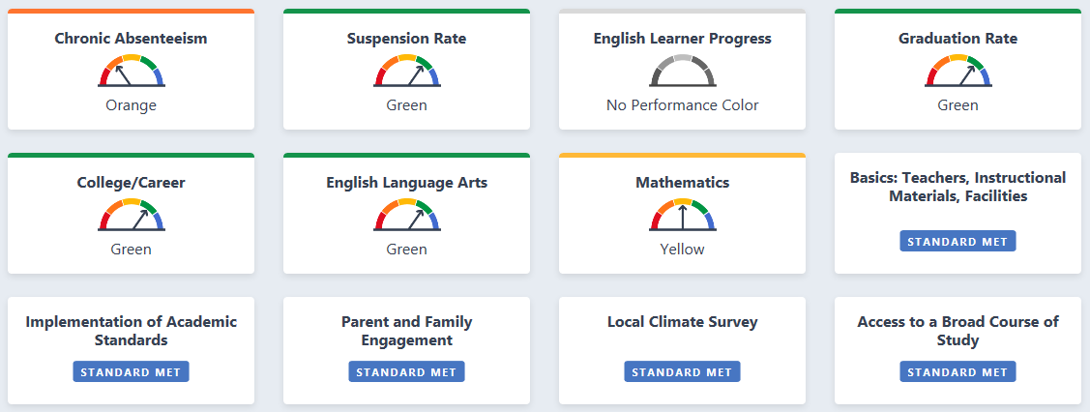

In the example above, we see that the district received an Orange performance level for the Chronic Absenteeism Indicator, a Yellow performance level for Mathematics, and a Green performance level for the remaining state measures—Suspension Rate, Graduation Rate, College/Career, and English Language Arts. (Note that schools and districts will not receive a color for English Learner Progress in 2019.) The district also met the standard for all five local indicators.

- Below the at-a-glance view of the school’s or district’s performance, you will find information about the student population.
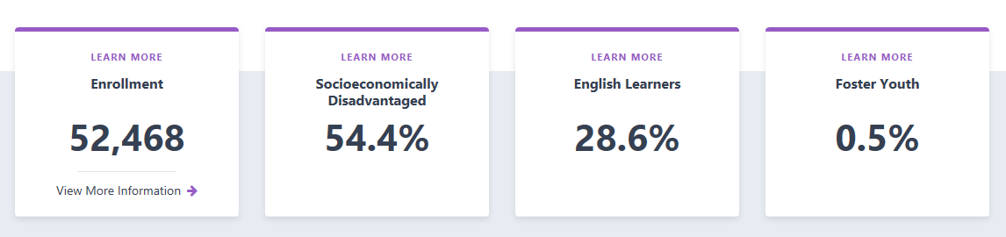

If you continue to scroll down the page, you’ll find additional data on each measure, such as school or district results for the current year and whether improvement was made from the prior year. The state and local measures are organized into three areas:

- Academic Performance
- Academic Engagement
- Conditions & Climate

Let’s look at the state measures that appear under Academic Performance for our sample district.
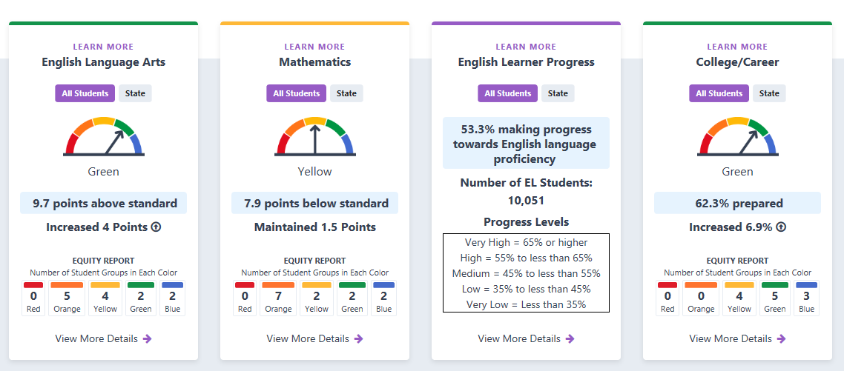

We see that the district performed 9.7 points above the standard for English Language Arts. This represents an increase (+4 points) from its prior year performance.

The district also made progress on the College/Career measure, with 62.3 percent of its high school students reported as prepared for college or a career upon graduation. This represents an increase of 6.9 percent from the prior year.
Although schools and districts do not receive a color for the English Learner Progress measure in 2019, the Dashboard does report the percent of students who are making progress toward English language proficiency. In this example, we see that 53.3 percent of all English learners in the district made progress in obtaining English Language proficiency in 2019.

Notice that you can toggle back and forth between “All Students” and “State,” allowing you to compare student results for your school or district with statewide results.

- An Equity Report is displayed at the bottom of the card for each state measure. This shows the number of student groups placed in each performance level (color) for that measure. Below is the sample district’s Equity Report for English Language Arts.
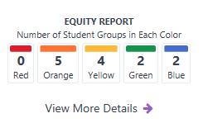

Looking at the data above, we see that no student group received a Red color (the lowest performance level) for English Language Arts, and two student groups received a Blue color (the highest performance level) for this measure.

- If you click the “View More Details” link below the Equity Report, you will be brought to a page that gives detailed information on how student groups performed on that measure. For every measure, student group data are presented in two ways:

- Student Group Details: View the performance color for all student groups at once

- Explore Groups by Performance Level: Select a color and see which student groups received the color, and why

Below are the Student Group Details for English Language Arts:

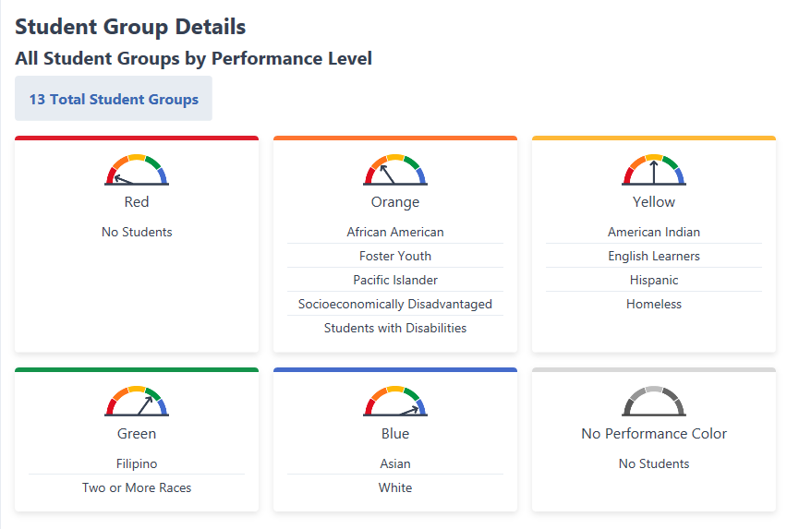

In this example, we see that the district has a total of 13 student groups that received a color for this measure. While the Equity Report showed the number of student groups that received each color, the Student Group Details present the specific student groups that received each of the colors.

In the example above, the following student groups received an Orange performance level for English Language Arts:

- African American
- Foster Youth
- Pacific Islander
- Socioeconomically Disadvantage
- Students with Disabilities

If we want to dig even deeper, we can scroll down to Explore Groups by Performance Level, which allows us to select a specific color and view more detailed information on the performance of each student group that received that color.

In the example below, the color Orange has been selected. For each of the student groups that received an Orange for English Language Arts, we can see:

- The number of students in the group

- The average distance between the group’s performance and the standard

- How the group’s performance changed from the prior year

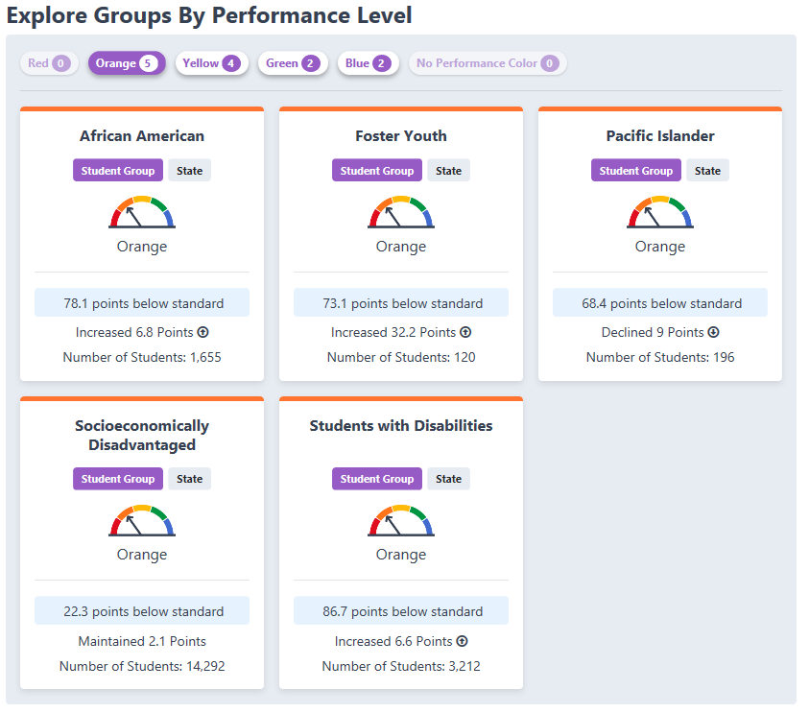

These are just some of the data you can find on the 2019 Dashboard.
Appendix A: What More Should We Know About the State Measures?

Now let’s look at each of the state measures in more detail.

- Chronic Absenteeism

The Chronic Absenteeism measure shows how many students were absent for 10 percent or more of the total instructional school days. For example, most schools have 180 instructional days; if a student is absent 18 or more of those days, the student would be considered chronically absent. Students who are chronically absent miss out on important classroom instruction. Capturing this information in the Dashboard allows parents and educators to see if chronic absenteeism is a problem at a school or across a district.

- Suspension Rate

The Suspension Rate measure shows the percent of students who were suspended anytime during the school year. Students who are suspended from school miss out on important classroom instruction. Capturing this information in the Dashboard allows parents and educators to see if there is a suspension problem at a school or across a district and whether certain student groups are suspended more than others. (Note: A student is counted only once for this measure even if he or she has multiple suspensions throughout the year.)

- English Learner Progress

Proficiency in the English language is a first step for students to do well in other subject areas, such as reading, writing, mathematics, and science. The English Learner Progress measure looks at the progress that English learners (e.g., students who don’t speak English as their first language) are making toward English proficiency. Each spring, English learners take the English Language Proficiency Assessments for California, or ELPAC, which measures how well they know and understand English. Results from the ELPAC are used to calculate the English Learner Progress measure. (Note: Because only two years of ELPAC data were available in fall 2019, the 2019 Dashboard reported only the percent of students making progress toward English languages proficiency. No performance level, or color, was available.)

- Graduation Rate

The Graduation Rate measure applies only to schools and districts that serve high school students. For traditional schools, this measure is based on the number of students who graduate with a regular high school diploma in four years or five years. (Note: Students who earn a Special Education Certificate of Completion or a general equivalency diploma are not counted as graduates.) Regardless of whether students go on to college, a high school diploma is the minimum requirement for most entry-level jobs in today’s economy. It represents mastery of foundational skills in mathematics, reading, and writing.

- College/Career Readiness

The College/Career measure shows how many students graduate from high school better prepared for college or a career. It uses many different measures of college and career preparedness, looking at the courses students completed in high school or the exams they passed. For additional information about how schools help students become prepared, please view the College/Career measure informational flyers:

- College/Career Indicator
https://www.cde.ca.gov/ta/ac/cm/documents/collegecareer.pdf

- Understanding the College/Career Readiness Measure: Prepared
https://www.cde.ca.gov/ta/ac/cm/documents/understandcciprepared.pdf

- Understanding the College/Career Readiness Measure: Approaching Prepared
https://www.cde.ca.gov/ta/ac/cm/documents/understandcciapproach.pdf

- Academic: English Language Arts and Mathematics

The Academic measure shows how well students are meeting grade-level standards in English Language Arts and mathematics. It is based on student performance on the Smarter Balanced Summative Assessments and the California Alternate Assessments, which are taken each spring by students in grades 3–8 and grade 11. Note: If less than 95 percent of all students are not tested, performance on this measure is adjusted downward.

Appendix B: Descriptive Text for the Images in this Document

Image 1:
A picture of the five analog gauge meters used on the California School Dashboard. Each gauge meter is a half-circle dial that has 5 segments. Each segment represents a different performance level. The colors read from left to right: Red, Orange, Yellow, Green, and Blue. Red represents the lowest performance level while Blue represents the highest performance level. A needle indicates the performance level for the measure.
Image 2:
A screenshot of the Dashboard Homepage. The top of the page has an image of a performance gauge with the arrow pointing to green. Tabs from left to right as follows:
- Home
- About
- State Summary
- Search
- More Information
- En Espanol
Explore information about your local school and district with a search tab.

Image 3:
A screenshot of the Dashboard landing Page showing tabs from left to right:
- Chronic Absenteeism – Orange performance color
- Suspension Rate – Green performance color
- English Learner Progress – No performance color
- Graduation Rates – Green performance color
- College/Career – Green performance color
- English Language Arts – Green performance color
- Mathematics – Yellow performance color
- Basics: Teachers, Instructional Materials, Facilities – Standard Met
- Implementation of Academic Standards – Standard Met
- Parent and Family Engagement – Standard Met
- Local Climate Survey – Standard Met
- Access to Broad Course of Study – Standard Met

Image 4:

A screenshot of what the Student Enrollment Population section looks like on the Dashboard. It gives you total enrollment count followed by the enrollment percentages of socioeconomically disadvantaged students, English learners, and Foster Youth. In this example, the tabs read from left to right in the following order:
- Enrollment 52,468
- Socioeconomically Disadvantaged 54.4%
- English Learners 28.6%
- Foster Youth 0.5%

Image 5:

A screenshot of the Dashboard provides an example of a school under the “Academic Performance” section. Under this section are the details of how this school performed in English Language Arts and Mathematics, as well as on the English Learner Progress and College/Career measures. The details include the performance color, current year performance, performance difference from prior year, and the number of student groups that received each performance color. You can explore deeper by selecting the “View More Details.” For our example school, the performance is detailed below:

English Language Arts – The school received a Green performance rating by scoring 9.7 points above Standard for the current year, which was an increase of 4 points from the prior year. There are no students groups that received a Red performance rating, five student groups that received an Orange performance rating, four student groups that received a Yellow performance rating, two student groups that received a Green performance rating, and two student groups that received a Blue performance rating.

Mathematics – The school received a Yellow performance rating by scoring 7.9 points below Standard for the current year, which was an increase of 1.5 points from the prior year. There are no students groups that received a Red performance rating, seven student groups that received an Orange performance rating, two student groups that received a Yellow performance color, two student groups that received a Green performance rating, and two student groups that received a Blue performance rating.

English Learner Progress – 53.3 % of the school’s 10,051 English learners made progress toward English proficiency. Based on the progress levels provided in the chart, the school met the “Medium” status level.

College/Career – The school received a Green performance rating, with 62.3% of its students placing in the Prepared level, and an increase of 6.9% over the prior year. There are no student groups that received a Red performance rating, no student groups that received an Orange performance rating, four student groups that received a Yellow performance rating, five student groups that received a Green performance rating, and three student groups that received a Blue performance rating.

Image 6:

Screenshot of the Equity Report that depicts the number of Student Groups in each of the performance color. In this example, there are no student groups in the Red performance level, five student groups in the Orange performance level, four student groups in the Yellow performance level, two student groups in the Green performance level, and two student groups in the Blue performance level.

Image 7:

A screenshot of the Student Group Details section, which indicates how each of the students groups placed in terms of their performance color. In this example, the following student groups are listed under each of the performance colors:

- Gauge Indicator arrow pointing to Red
    - No Students

- Gauge Indicator arrow pointing to Orange
    - African American
    - Foster Youth
    - Pacific Islander
    - Socioeconomically Disadvantaged
    - Students with Disabilities

- Gauge Indicator arrow pointing to Yellow
    - American Indian
    - English Learners
    - Hispanic
    - Homeless

- Gauge Indicator arrow pointing to Green
    - Filipino
    - Two or More Races

- Gauge Indicator arrow pointing to Blue
    - Asian
    - White

- Gauge Indicator with No Performance Color
    - No Student (Group)

Image 8:

A screenshot of the “Explore Groups By Performance Level” section, which allows us to select a specific color for an indicator and view detailed information on the performance of each student group that received that color. In the example below, the color Orange has been selected. Four student groups received an Orange performance color for this indicator:

- African Americans: The group (1,655 students) scored 78.1 points below standard, which represented an increase of 6.8 points from the prior year.

- Foster Youth: The group (120 students) scored 73.1 points below standard, which represents an increase of 32.2 points from the prior year.

- Pacific Islander: The group (196 students) scored 68.4 points below standard, which represents a decline of 9 points from the prior year.
- Socioeconomically Disadvantaged: The group (14,292 students) scored 22.3 points below standard, which represents an increase of 2.1 points from the prior year.

- Students with Disabilities: The group (3,212 students), scored 86.7 points below standard, which represents an increase of 6.6 points from the prior year.

