Parent Guide for the 2022 California School Dashboard
Prepared by: California Department of Education
December 2022

What Is the California School Dashboard?
The California School Dashboard (or the Dashboard) is an online tool that shows parents and communities how well schools and districts are meeting the needs of all students. It reports performance on both state and local measures. These multiple measures reflect California’s accountability system, which is based on the ten priority areas of the Local Control Funding Formula (LCFF), which are discussed on the California Department of Education (CDE) web page at http://www.cde.ca.gov/fg/aa/lc/lcffoverview.asp.

State Measures
The state measures are based on information collected statewide and allow parents to compare schools and districts across California.

Six State Measures:

- Chronic Absenteeism (kindergarten through grade eight)
- Suspension Rate (kindergarten through grade twelve)
- English Learner Progress (grades one through twelve)
- Graduation Rate (high school only)
- College/Career (high school only)
- Academic (grades three through eight and grade eleven)
  - English language arts/literacy
  - Mathematics

You can learn more about each of these indicators in Appendix A: What More Should We Know about the State Measures?

Please note, the College/Career Indicator will not be reported on the 2022 Dashboard.

Local Measures
Local measures are based on information collected by districts, county offices of education, and charter schools. These measures include:
- Basic Conditions
- Teacher assignments, safe and clean buildings, instructional materials for all students
- Implementation of Academic Standards
- School Climate Surveys
- Student safety, connection to the school
- Parent Involvement and Family Engagement
- Access to Courses

How Is Performance Reported on the Dashboard?

For the 2022 Dashboard, the California Department of Education will report the most current year of data (also known as Status). This Dashboard will display performance levels using one of five Status levels (ranging from Very High, High, Medium, Low, and Very Low) for the following state measures:

- English Learner Progress
- Graduation Rate
- Academic
  - English language arts/literacy
  - Mathematics

The above state measures are based on the 2021–22 school year data. Refer to Figure 1 below and refer to Appendix B for descriptive text.

Figure 1: Five Status Levels

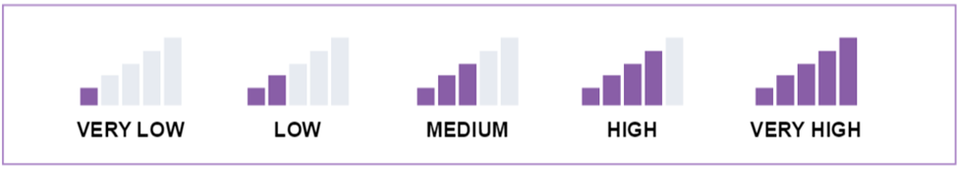

The Status level labels are reversed for both:
- Chronic Absenteeism; and
- Suspension Rate

Compared to the other state measures, the goal of these measures is to have a low rate of student absence and suspension. Therefore, in Figure 2 below (refer to Appendix B for descriptive text), Very Low is represented by 5 colored bars and Very High is represented by one colored bar and five uncolored bars. For example, the goal for the Suspension Rate measure is to have a Very Low status because it means the school or district had a low rate of students who were suspended.

Figure 2: Reversed Status Levels

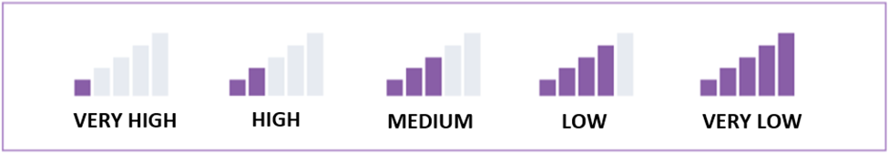

In prior years, the Dashboard reported performance levels through the use of colors: blue, green, yellow, orange, and red (as depicted in Figure 3 below). These performance levels were determined using two years of data utilizing current year performance and the difference from prior year to show growth or decline. However, due to requirements under Assembly Bill 130 (AB 130), the California Department of Education can only display the most current year of data (also known as Status) on the 2022 Dashboard.

Figure 3: Prior Dashboard

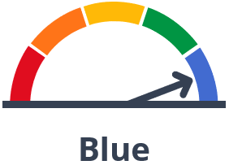

How to View Performance of a School or District on the 2022 Dashboard
- The Dashboard can be viewed on the CDE California School Dashboard and System of Support web page, at https://www.cde.ca.gov/ta/ac/cm/

- To see the results for a district or school, type the name into the search bar as illustrated in Figure 4 below and refer for Appendix B for descriptive text.

Figure 4: Dashboard Home Page

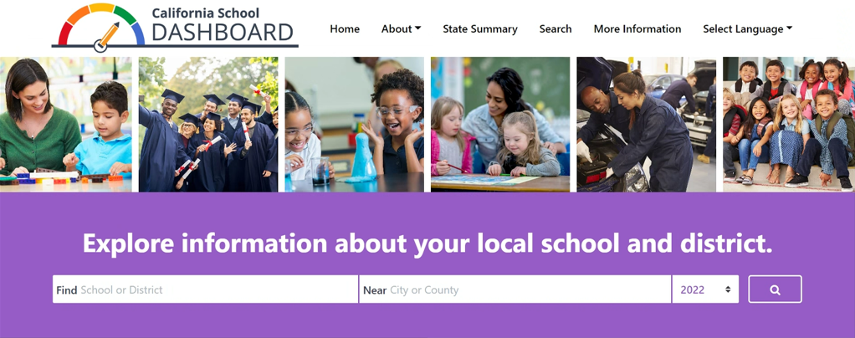

- A. Once you select a school, its overall performance on state measures will be displayed.

B. Once you select a local educational agency (LEA), which can be a charter school, district, or a county office of education, its overall performance on local measures will be displayed in addition to state measures. (Note that school and student group information are not available for local measures; figure 5 (refer to Appendix B for descriptive text) provides an example of the local measures.).

Figure 5: Local Measures

In Figure 5 above, charter schools, districts, and county offices of education receive one of two ratings for each of the local measures: Met or Not Met.

- View the district’s or school’s performance for information about the student population as reflected in Figure 6 below and refer to Appendix B for descriptive text.

Figure 6: Student Population Data
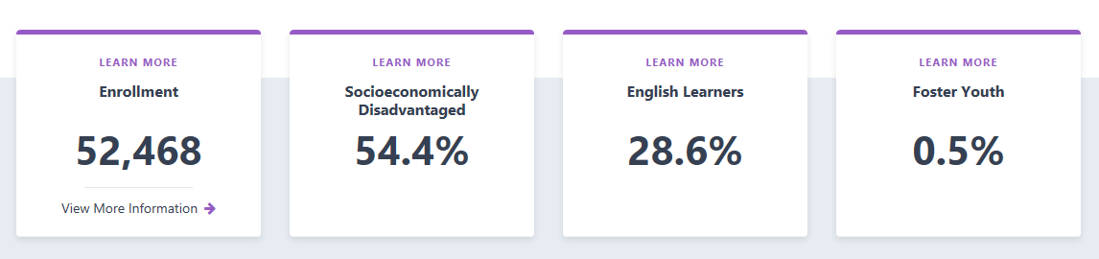

- If you continue to scroll down the page, you’ll find additional data on each measure, such as school or district results for the current year. The state and local measures are organized into three areas:

- Academic Performance: English Language Arts (ELA), Mathematics, English Learner Progress, and College/Career.
- Academic Engagement: Chronic Absenteeism and High School Graduation Rate.
- Conditions & Climate: Suspension Rate.

Let’s look at the state measures that appear under Academic Performance for our sample district as depicted in Figure 7 below and refer to Appendix B for descriptive text.

Figure 7: State Measures Under Academic Performance
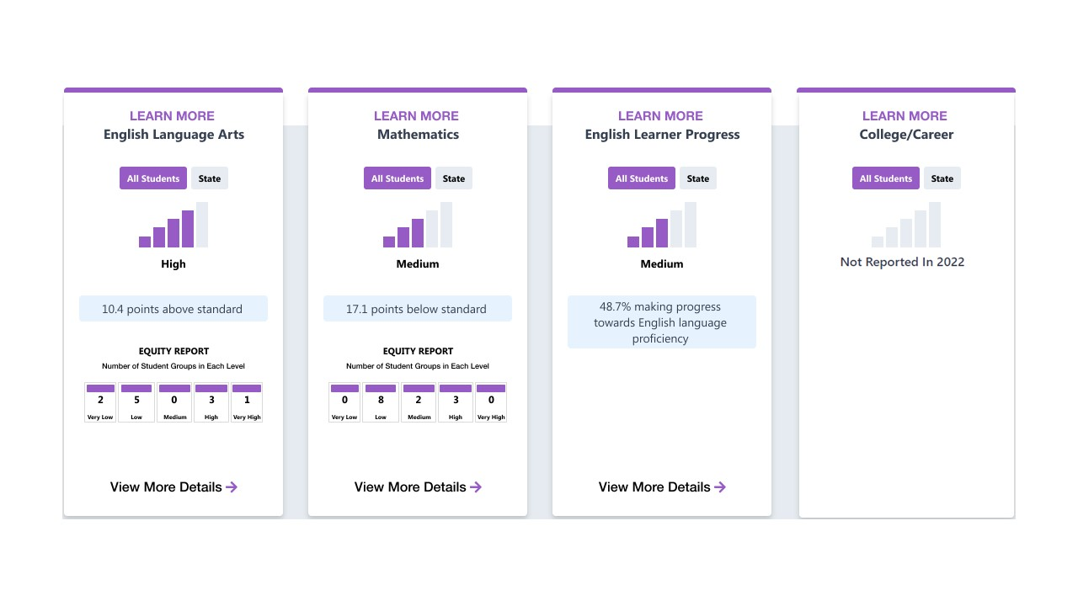
In Figure 7, the district performed 10.4 points above standard in English Language Arts, which is a Status level of High. In Mathematics, the district’s Status level is Medium at 17.1 points below standard. For the English Learner Progress Indicator (ELPI), the percent of English learner students in the district who made progress toward English language proficiency was 48.7 percent, which is a Status level of Medium. Lastly, the College/Career Indicator (CCI) is not reported in the 2022 Dashboard. It will resume with the 2023 Dashboard.

Notice that you can toggle back and forth between “All Students” and “State,” allowing you to compare student results for your school or district with statewide results.

- At the bottom of each state measure is an Equity Report as demonstrated in Figure 8 below (refer to Appendix B for descriptive text). The equity report shows the number of student groups placed in each performance (or Status) level for a particular state measure.

Figure 8: Sample Equity Report

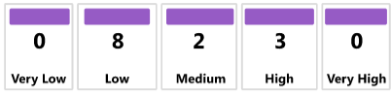

The sample equity report above shows that zero student groups received a Status of Very Low (the lowest performance level), eight student groups received a Status of Low, two of the student groups received a Status of Medium, three student groups received a Status of High, and zero student group received a Status of Very High (the highest performance level).

- If you click the “View More Details” link below the Equity Report, you will be brought to a page that gives detailed information on how individual student groups performed on the selected measure. For every measure, student group data are presented in two ways:

- Student Group Details: View the performance for all student groups at once.

- Explore Groups by Performance Level: Select a student group and see which Status level each group received.

Figure 9 below (refer to Appendix B for descriptive text) reflects the Student Group Details for English Language Arts:

Figure 9: Student Group Details

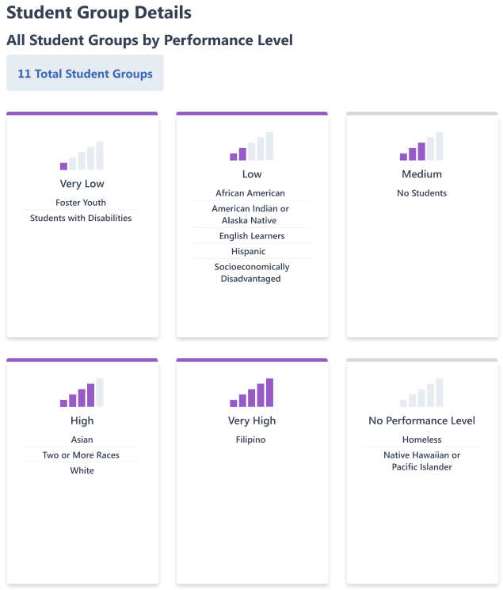

In the example above, we see that the district has a total of 11 student groups that received performance levels (or Status levels). The following student groups received a High performance level for English Language Arts:

- Asian
- White
- Two or more races

If we want to dig even deeper, you can scroll down to Explore Groups by Performance Level, which allows us to view more detailed information on the performance of each student group as illustrated in Figure 10 below (refer to Appendix B for descriptive text).

Figure 10: Performance (or Status) Level for Each Student Group

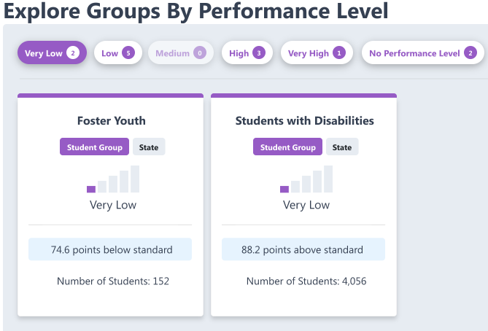

In Figure 10 above, the performance (or Status) level “Very Low” has been selected. For each of the student groups that received a “Very Low” performance level for English Language Arts, we can see:

- The number of students in the group.

- The average distance between the group’s performance and the standard.

These are some of the data you can find on the 2022 Dashboard.

Appendix A:
What More Should We Know About the State Measures

Now let’s look at each of the state measures in more detail.

Chronic Absenteeism

The Chronic Absenteeism measure shows how many students were absent for 10 percent or more of the instructional days they were enrolled to attend. For example, if a student was enrolled to attend 180 instructional days and is absent 18 or more of those days, the student would be considered chronically absent. Students who are chronically absent miss out on important classroom instruction. This information in the Dashboard allows parents and educators to see if chronic absenteeism is a problem at a school or across a district.

Suspension Rate

The Suspension Rate measure shows the percent of students who were suspended for at least one cumulative full day during the school year. Students who are suspended from school miss out on important classroom instruction. This information in the Dashboard allows parents and educators to see if there is a suspension problem at a school or across a district and whether certain student groups are suspended more than others. (Note: A student is counted only once for this measure even if they have multiple suspensions throughout the year.)

English Learner Progress

Proficiency in the English language is a first step for students to do well in other subject areas such as reading, writing, math, and science. The English Learner Progress measure looks at the progress that English learner students are making toward achieving English language proficiency. Each spring, English learner students take the English Language Proficiency Assessments for California, or ELPAC, which measures how well they know and understand English. Results from the ELPAC are used to calculate the English Learner Progress measure.

Graduation Rate

Regardless of whether students go on to college, a high school diploma is the minimum requirement for most entry-level jobs in today’s economy. It represents mastery of foundational skills in mathematics, reading, writing, and the completion of a course of study. The Graduation Rate measure shows the number of students who received a diploma at the end of grade twelve.

College/Career Readiness

The College/Career Readiness measure shows how many students graduate from high school better prepared for college or a career. It uses many different measures of college and career preparedness, looking at courses students completed in high school or the exams passed. For additional information about how schools help students become prepared for college or a career, please view the following informational flyers:

- https://www.cde.ca.gov/ta/ac/cm/documents/ccicollege.pdf and
- https://www.cde.ca.gov/ta/ac/cm/documents/ccicareer.pdf

As noted earlier, the College/Career measure is not reported on the 2022 Dashboard. Reporting of this measure will resume in 2023.

Academic: English Language Arts and Mathematics

Academic Performance contains two measures: English Language Arts and mathematics. These measures show how well students are meeting grade-level standards. They are based on student performance on the Smarter Balanced Summative Assessments and the California Alternate Assessments, which are taken each spring by students in grades 3–8 and grade 11.

Appendix B:
Descriptive Text for the Images in this Document

Figure 1:
A picture of five “cell phone bars” that are used to represent Status on the California School Dashboard. Each image included 5 columns, some are greyed out and some in purple color. The 2022 Dashboard reports performance levels using one of five Status levels, ranging from Very High, High, Medium, Low, and Very Low, for all state measures based on the 2021–22 school year data. Each segment represents a different performance level. The images read from left to right:
- Very Low: represents the lowest performance level, including 1 purple-colored bar, and 4 bars are greyed out.
- Low: 2 purple-colored bars, and 3 bars are grayed out.
- Medium: 3 purple-colored bars, and 2 bars are grayed out.
- High: 4 purple-colored bars, and 1 bar is grayed out.
- Very High: represents the highest performance level, including 5 purple-colored bars.

Figure 2:

An image of a reversed Status levels for two State indicators: Chronic Absenteeism and Suspension Rate. The Dashboard includes images with five “cell phone bars” that are used to represent Status on the California School Dashboard. Each image included 5 columns, some are greyed out and some in purple color. The 2022 Dashboard reports performance levels using one of five Status levels, ranging from Very High, High, Medium, Low, and Very Low, for all state measures based on the 2021–22 school year data. Each segment represents a different performance level. The images read from left to right:

- Very High: represents the lowest performance level, including 1 purple-colored bar, and 4 bars are greyed out.
- High: 2 purple-colored bars, and 3 bars are grayed out.
- Medium: 3 purple-colored bars, and 2 bars are grayed out.
- Low: 4 purple-colored bars, and 1 bar is grayed out.
- Very Low: represents the highest performance level, including 5 purple-colored bars.

Figure 4:
A screenshot of the new 2022 Dashboard Homepage. The top of the page has an image of a performance gauge with the arrow pointing to green. Tabs from left to right as follows:
- Home
- About
- State Summary
- Search
- More Information
- Select Language

Below the abovementioned menu, there are six pictures: first, a woman sits next to a child. They both smile and look at pieces of Legos that are on a desk. Second, six individuals smile and look toward a camera. They all wear graduation gowns and hats and hold rolled certificates in their hands. Third, two girls with clear glasses smile while doing a science experiment. Forth, a teacher sits between two girls and teaching them. Fifth, a man and a woman stand next to a car. Fifth, eight elementary student sit together and smile in a group picture.

Below the pictures there is a title in white: “Explore information about your local school and district” with search tabs: Find (School or District), Near (City or County), and a dropdown menu for the year (2022).
Figure 5:
Four white, rectangle boxes with definitions on each, and blue buttons stating “Standard Met”. The order of the definitions from left to right are as follows:
- Implementation of Academic Standards
- Parent and Family Engagement
- Local Climate Survey
- Access to a Broad Course of Study

Figure 6:
A screenshot of what the Student Enrollment Population section looks like on the Dashboard. It gives the total enrollment count followed by the Socioeconomically Disadvantaged, English Learners, and Foster Youth enrollment percentages. In this example, the tabs read from left to right in the following order:
- Enrollment 52,468
- Socioeconomically Disadvantaged 54.4%
- English Learners 28.6%
- Foster Youth 0.5%
The image also includes the text “Learn More” at the top of each tab which can be selected to reveal a detailed definition of enrollment, Socioeconomically Disadvantaged, English Learners, and Foster Youth.
Figure 7:
A screenshot of the 2022 Dashboard under the “Academic Performance” section. This section details how this school performed in English Language Arts, Mathematics, English Learner Progress, and College/Career. The details of each indicator is included in a card, which reflects the current year performance and the number of student groups that received each performance level. You can explore deeper by selecting “View More Details” that is located at the bottom of each card. You can also learn more about each indicator by selecting the hyperlinked text “Learn More” found at the top of each indicator card. Finally, you can toggle back and forth between “All Students” and “State,” allowing you to compare student results for your school or district with statewide results. For our example school, here is what each indicator card identifies:

English Language Arts – The school received High performance level and scored 10.4 points above Standard for the current year. Within the Equity Report that shows the number of students in each level, there are two student groups that received a Very Low performance level, five student groups that received a Low performance level, zero student groups that received Medium performance level, three student groups that received High performance level, and one student group that received a Very High performance level.

Mathematics – The school received Medium performance level and scored 17.1 points below Standard for the current year. Within the Equity Report that shows the number of students in each level, there are zero student groups that received a Very Low performance level, eight student groups that received a Low performance level, two student groups that received Medium performance level, three student groups that received High performance level, and zero student groups that received a Very High performance level.

English Learner Progress – 48.7% of the school’s English learners made progress toward English language proficiency. Based on the progress level, the school received a Medium performance level.

College/Career – the Status graphic is greyed out and no performance level is reported for the CCI. CCI is not reported on the 2022 Dashboard and it will resume with Status only in 2023 Dashboard.

Figure 8:
Screenshot of the Equity Report that depicts the number of Student Groups in each of the performance levels. In this example, from left to right, there are zero student groups in the Very Low performance level, eight student groups in the Low performance level, two student groups in the Medium performance level, three student groups in the High performance level, and zero student groups in the Very High performance level.

Figure 9:
A screenshot of the Student Group Details section, which indicates how each of the student groups placed in terms of their performance levels. In this example, there are a total of 11 Student Groups and the following student groups are listed under each of the performance levels:

- Very Low: an image with one purple-colored bar, and four bars are greyed out.
- Foster Youth
- Students with Disabilities.
- Low: an image with two purple-colored bars, and three bars are grayed out.
- African American
- American Indian or Alaska Native
- English learners
- Hispanic
- Socioeconomically Disadvantaged
- Medium: an image with three purple-colored bars, and two bars are grayed out.
- No Students
- High: an image with four purple-colored bars, and one bar is grayed out.
- Asian
- Two or More Races
- White
- Very High: an image with five purple-colored bars.
- Filipino
- No Performance Level: an image with five bars that are greyed out.
- Homeless
- Native Hawaiian or Pacific Islander

Figure 10:
A screenshot of the “Explore Groups by Performance Level” section, which allows us to select a specific status level for an indicator and view detailed information on the performance of each student group that received that status level. In this figure, the Status level Very Low has been selected reflecting “cell phone bars” with only one bar filled with purple and the other four bars in gray. Two student groups received a Very Low status level for this indicator:

- Foster Youth: The group had 152 Number of Students and scored 74.6 points below standard.

- Students with Disabilities: The group had 4,056 Number of Students and scored 88.2 points above standard.

If the viewer is interested in accessing the data for the other Status levels, they can select the buttons at the top of the figure from left to right:

- Very Low has two student groups
- Low has five student groups
- Medium has zero student group which is why the button is grayed out
- High has three student groups
- Very High has one student group
- No Performance Level has two student groups

