

An Investigation of the Factor Structures for the Summative English Language Proficiency Assessments for California
Contract #CN140284
Prepared for the California Department of Education by Educational Testing Service
Presented August 13, 2019


Table of Contents
Executive Summary 1
Introduction and Purposes 2
Significance 2
Theoretical Framework 3
Methods 4
Results 12
Conclusion 17
References 18

List of Tables
Table 1. Demographic Information for the ELPAC Summative Assessment Field Test Sample 4
Table 2. Summary of Fit Statistics for Lower Grades (Kindergarten Through Grade Two) 11
Table 3. Summary of Fit Statistics for Upper Grades (Grades Three Through Twelve) 12
Table 4. Correlations and Factor Loadings from Oral and Written Language Skills 13
Table 5. Correlations and Factor Loadings from Receptive and Productive Language Skills 13
Table 6. Factor Loadings from Four Language Skills (Listening, Speaking, Reading, and Writing) 14
Table 7. Correlations Among Latent Traits in Four Language Skills 14

List of Figures
Figure 1. Schematic Figure—Correlated Four-Factor Model (Listening, Speaking, Reading, and Writing) 6
Figure 2. Schematic Figure—Correlated Two-Factor Model (Oral and Written) 7
Figure 3. Schematic Figure—Correlated Two-Factor Model (Receptive and Productive) 8
Figure 4. Schematic Figure—Unidimensional Model (ELP) 9

Executive Summary
This report summarizes a multidimensional item response theory (MIRT) study conducted by Educational Testing Service to evaluate four competing models that represent the hypothesized factor structure for the Summative English Language Proficiency Assessments for California (ELPAC). Specifically, the study investigated whether the Summative ELPAC factor structure is consistent with the theoretical construct underlying the ELPAC design. Understanding the factor structure informed the Summative ELPAC scaling and score reporting plan. The study used data from the spring 2017 Summative ELPAC field test across seven grades and grade spans.
MIRT was used to analyze four competing models that include the following:
- Correlated four-factor model where Listening, Speaking, Reading, and Writing were considered unique language skills
- Correlated two-factor model where Listening and Speaking were defined as oral language skills and Reading and Writing were defined as written language skills
- Correlated two-factor model where Listening and Reading were defined as receptive language skills and Speaking and Writing were defined as productive language skills
- Single-factor model where all four language skills were psychometrically indistinguishable from one another
The evaluation criteria for the four competing models included model fit, model parsimony, correlations among latent factors, and reasonableness of individual item parameter estimates across the seven assessments investigated.
The results indicated that the correlated two-factor model, where Listening and Speaking were defined as oral language skills and Reading and Writing were defined as written language skills, was sufficient to support the theoretical construct of the underlying ELPAC design. Specifically, this model exhibited reasonable fit, and the correlation between the oral and written language skills was moderate across kindergarten through grade twelve, which made them distinct enough to be reported separately.

Introduction and Purposes
The ELPAC is aligned with California’s 2012 English Language Development (CA ELD) Standards. One of the important features of the new CA ELD Standards is to consider students’ English proficiency holistically, including a focus on many integrated language skills. Previous ELD assessments, such as the California English Language Development Test, attempted to measure and scale multiple language skills separately and did not promote use of integrated items because of measurement model concerns. The CA ELD Standards incorporate the multidimensional aspect of language proficiency; the newly developed ELPAC brings this feature into the assessment by implementing integrated test items that incorporate multiple domains of Listening, Speaking, Reading, and Writing.
To allow students’ progress to be compared over time, ELPAC item response theory (IRT) analysis and score reporting requires that continuous scales be constructed for the Summative ELPAC. To develop a stable continuous scale and individually reliable scores, it is desirable to have continuous scales that are based on more items; however, this approach could imply a longer test. To minimize the testing burden on students, schools, and local educational agencies, and to increase reliability, it is beneficial to combine domains in scaling analyses. Although it is theoretically reasonable to combine domains, it is important to also review empirical evidence prior to implementing this approach in scaling. This study investigates whether the factor structure of the ELPAC is consistent with the theoretical construct underlying the ELPAC design; further, it informs Summative ELPAC scaling and reporting.

Significance
The first operational administration of the Summative ELPAC occurred in spring 2018. The Every Student Succeeds Act maintains legislation that requires states to measure student English proficiency in Listening, Speaking, Reading, and Writing, and provide an overall measure of English language proficiency (ELP). Results from the current study served as important validity evidence to support decision-making for Summative ELPAC reporting options.

Theoretical Framework
Historically, researchers in language testing have evaluated several competing models of language ability that include multiple abilities that are distinct, correlated, or hierarchically related to an overall ability (Bachman & Palmer, 1982; Carroll, 1965; Kunnan, 1995; Oller, 1976; Sawaki, Stricker, & Oranje, 2008).
English language tests that contain multiple modalities, each measuring related but distinct latent factors, are commonly encountered in practice. In such cases, each item belongs only to one particular modality, and the assessments are designed such that each modality is assessed in isolation. For example, the Listening factor is explained only by Listening items, so they only contribute to the Listening score.
In the past, item response modeling of such tests has proceeded either by applying a unidimensional model to each of the scales separately or by ignoring the multidimensionality and treating the test as unidimensional.
Pooler and Wolf (2016) emphasized a recent shift in ELP standards, observing a movement away from standards focusing on discrete language skills toward standards that call for the integration of language skills, like the CA ELD Standards. For ELP standards, this transition occurs from treating isolated modalities in Listening, Speaking, Reading, and Writing, to treating these four modalities as necessarily integrated and intertwined when used authentically to communicate in academic contexts.
The CA ELD Standards used the Framework for English Language Proficiency Development Standards corresponding to the Common Core State Standards and the Next Generation Science Standards (2012) in their development and are quite different from ELD standards of the past. In effect, the integrated model of language present in the Common Core State Standards and the CA ELD Standards conceptualize language as something complex, dynamic, and interactive. The model focuses on how language is used in academic contexts by students to make meaning, interact with others, and learn academic content.
Bacher and Anderson (2016) pointed out that integrated skills in the new standards call for significant change in how ELP assessments are designed. Tasks within the ELP assessments should assess these integrated standards in multiple modes, such as collaborative and interactive language situations. In addition, there is a need to specify what the integrated tasks are intended to assess for making adequate inferences about students’ abilities. They pointed out that integrated task types potentially have a positive impact on measurement accuracy and instruction as they reflect authentic language uses.
Hansen and Winter (2016) reviewed measurement models and scoring issues related to measuring integrated language skills in English Language Proficiency Assessment for the 21st Century testing. They concluded that multidimensional measurement models can accommodate tasks that require language skills that have been previously assessed separately. Their study implies that it is not necessary to seek “pure” measures of each domain. With more integrated tasks, combined domains may clarify the overall test structure.

Methods
Empirical data obtained during the spring 2017 Summative ELPAC field test were used for this study.
The Summative ELPAC is configured into seven grades and grade spans targeting kindergarten and grades one, two, three through five, six through eight, nine and ten, and eleven and twelve. A sample of more than 41,000 English Learners (ELs) across California participated in the field test.
To assign students to take the field test, a geographically representative list of schools was first selected in the sample recruitment effort. Once schools accepted the invitation to participate, target student rosters and expanded student rosters were generated for each school to ensure that a representative sample of ELs were included.
Table 1 displays the demographic characteristics of the ELPAC field test sample compared to all EL students in the California Longitudinal Pupil Achievement Data System (CALPADS). It shows that the field test sample data are close to the demographic composition of the population of EL students in California. The ELPAC sample has a lower percentage of students with disabilities because students with specific disabilities that cannot be reasonably accommodated by the Summative ELPAC field test were not recruited to participate in the field test.
Table 1. Demographic Information for the ELPAC Summative Assessment Field Test Sample
Student Group | ELPAC Field Test Sample | CALPADS Total Data
Total Sample Size | 41,942 | 91,639
Gender—Female | 46.3% | 45.2%
Gender—Male | 53.7% | 54.8%
Race or ethnicity—American Indian or Alaska Native | 0.1% | 0.1%
Race or ethnicity—Asian | 9.2% | 7.9%
Race or ethnicity—Black or African American | 0.3% | 0.3%
Race or ethnicity—White | 4.5% | 4.1%
Race or ethnicity—Hispanic or Latino | 83.3% | 85.1%
Race or ethnicity—Native Hawaiian or Pacific Islander | 0.3% | 0.3%
Race or ethnicity—Two or more races | 0.3% | 0.3%
Special education services—Students with disability | 9.9% | 16.6%
Economic status—Economically disadvantaged | 84.4% | 85.8%
Table 1 (continued)
Student Group | ELPAC Field Test Sample | CALPADS Total Data
Home language—Spanish | 84% | 85.6%
Home language—Vietnamese | 1.8% | 1.7%
Home language—Chinese | 2.6% | 2.1%
Home language—Hmong | 0.6% | 0.6%
Home language—Arabic | 1.6% | 1.5%
Four field test forms were available for each grade or grade-span test. Two of the field test forms included vertical linking items from the grade or grade span below to facilitate the development of a continuous vertical scale.
Each of the four field test forms was assigned to approximately 1,500 students. The forms were spiraled at the school level, so students within a school were administered the same test form.
Each student was administered all four domains of the Summative ELPAC field test; therefore, interdomain relationships could be established using the data collected.
An item-level factor analytic approach, applying MIRT, was used to evaluate four competing models that represent the hypothesized factor structure of the Summative ELPAC. These four models were as follows:
- Correlated four-factor model, where Listening, Speaking, Reading, and Writing were considered unique language skills (shown in Figure 1)
- Correlated two-factor model, where Listening and Speaking were considered oral language skills and Reading and Writing were considered written language skills (shown in Figure 2)
- Correlated two-factor model, where Listening and Reading were considered receptive language skills and Speaking and Writing were considered productive language skills (shown in Figure 3)
- Single-factor model, where all four language skills were psychometrically indistinguishable from one another (shown in Figure 4)

To provide the context to interpret the results and assess the models, the number of items per each domain of each grade/grade span was reported in Table 2 below. It is noted that these numbers were taken from the first version of the ELPAC Summative Assessments Blueprints in 2017. The blueprints were recently revised (California Department of Education, 2019). However, the changes of the number of items for the domain were within only one or two items.
Table 2. Overview of Items and Points by Domain and Grade
Domain | K Items | K Points | Grade 1 Items | Grade 1 Points | Grade 2 Items | Grade 2 Points | Grades 3–5 Items | Grades 3–5 Points | Grades 6–8 Items | Grades 6–8 Points | Grades 9–10 Items | Grades 9–10 Points | Grades 11–12 Items | Grades 11–12 Points
Listening | 20 | 20 | 22 | 22 | 22 | 22 | 22 | 22 | 22 | 22 | 22 | 22 | 22 | 22
Speaking | 10 | 21 | 10 | 21 | 13 | 27 | 13 | 29 | 13 | 29 | 13 | 29 | 13 | 29
Reading | 14 | 17 | 20 | 20 | 26 | 26 | 26 | 26 | 26 | 26 | 26 | 26 | 26 | 26
Writing | 8 | 12 | 7 | 15 | 7 | 15 | 6 | 17 | 6 | 17 | 6 | 17 | 6 | 17
Totals | 52 | 70 | 59 | 78 | 68 | 90 | 67 | 94 | 67 | 94 | 67 | 94 | 67 | 94

Figure Caption: In Figure 1, the schematic shows a correlated four-factor model. The four factors—Listening, Speaking, Reading, and Writing—are represented by oval shapes. Each two-way arrow connecting the ovals represents the correlations between the factors. For each factor, there are items that measure the factor represented by rectangles for items 1, 2, and N. This is represented by a series of one-way arrows from the factor to each item.
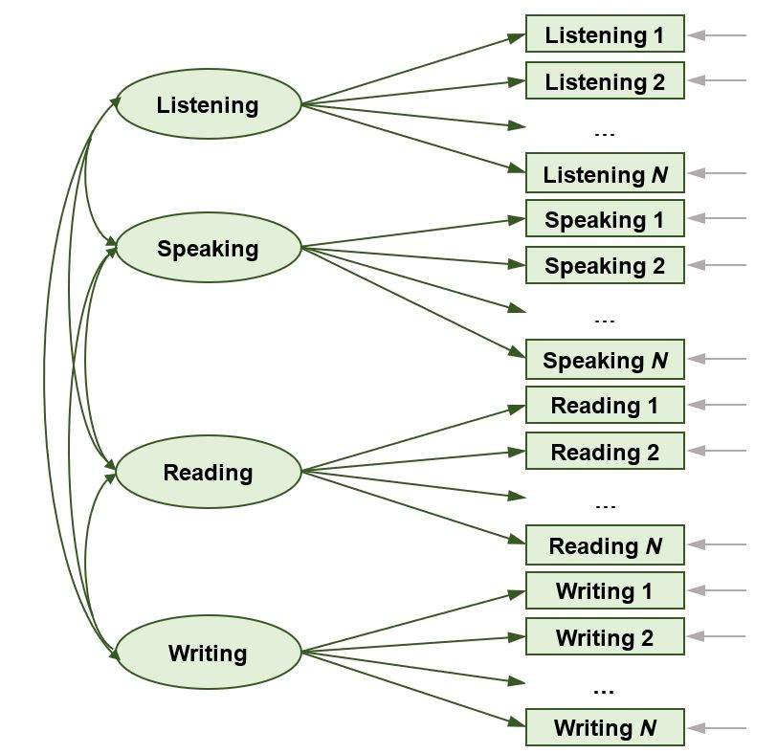

Figure 1. Schematic Figure—Correlated Four-Factor Model (Listening, Speaking, Reading, and Writing)
Figure Caption: In Figure 2, the schematic shows a correlated two-factor model. The two factors, oral language and written language, are represented by oval shapes. The two-way arrow connected to the ovals represents the correlations between the factors. For each factor, there are items that measure the factor represented by rectangles for items 1, 2, and N. This is represented by a series of one-way arrows from the factor to each item.
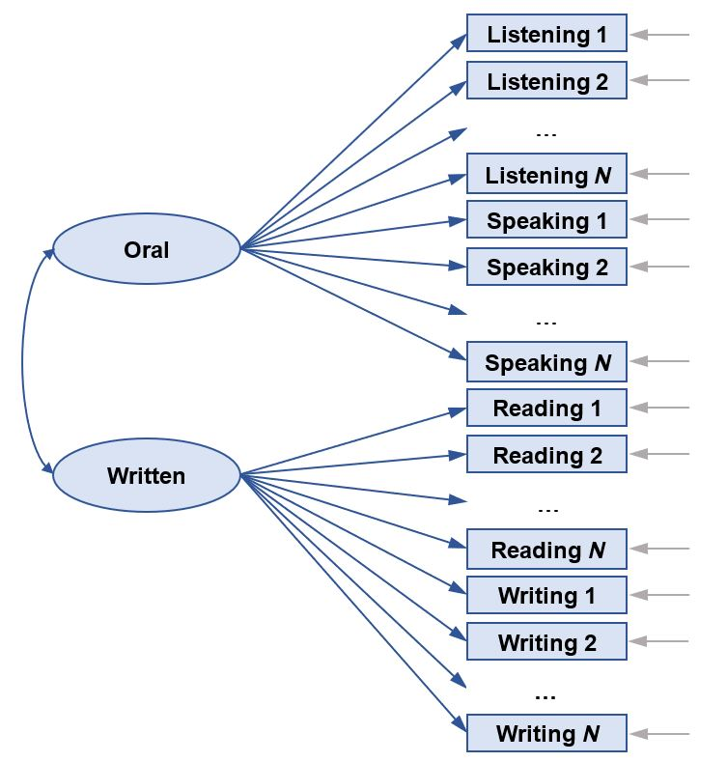

Figure 2. Schematic Figure—Correlated Two-Factor Model (Oral and Written)
Figure Caption: In Figure 3, the schematic shows a correlated two-factor model. The two factors, receptive language and productive language, are represented by oval shapes. The two-way arrow connected to the ovals represents the correlations between the factors. For each factor, there are items that measure the factor represented by rectangles for items 1, 2, and N. This is represented by a series of one-way arrows from the factor to each item.
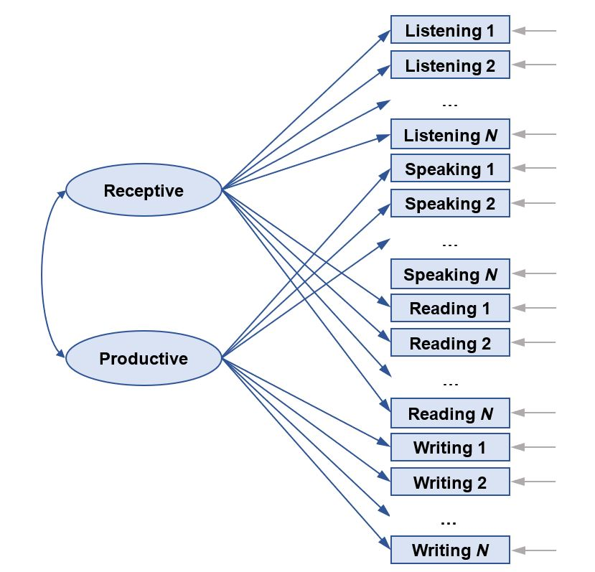

Figure 3. Schematic Figure—Correlated Two-Factor Model (Receptive and Productive)
Figure Caption: In Figure 4, the schematic shows a unidimensional factor model. The English language proficiency factor is represented by the oval. For this factor, all items measure this factor and are represented by rectangles for items 1, 2, and N. This is represented by a series of one-way arrows from the factor to each item.
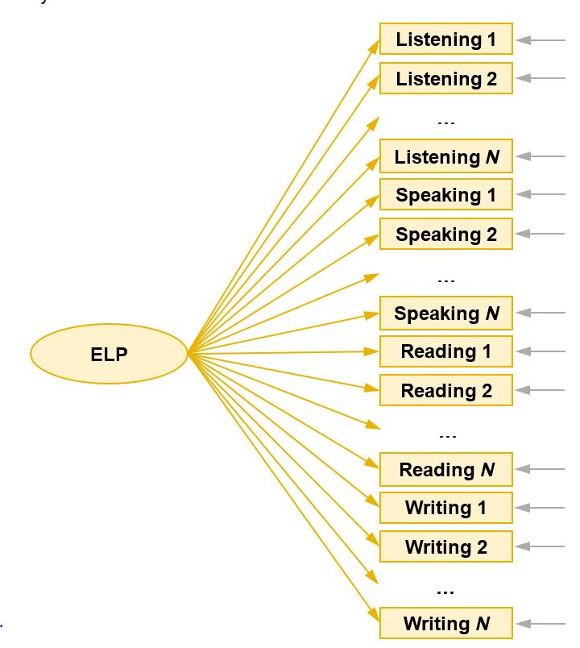

Figure 4. Schematic Figure—Unidimensional Model (ELP)
As illustrated in the schematic figures, instead of mapping to multiple domains, each ELPAC test item was associated with a single domain in Listening, Speaking, Reading, or Writing (Figure 1), written or oral language skills (Figure 2), receptive or productive language skills (Figure 3), or ELP (Figure 4). It is a best practice in score reporting to associate each test item to only one reporting category; the factor structures tested in this study were aligned to such a principal.
Because student responses from all four test forms within each grade and grade span were used in the grade and grade-span analyses, a sparse matrix of item responses, which included the whole pool of ELPAC field test items, was used in the grade and grade-span analyses.
To evaluate the four competing factor-analytic models, the Akaike information criterion (AIC), the Bayesian information criterion (BIC), and -2 log-likelihood (-2LL) were used. AIC and BIC are comparative measures of fit. Lower values indicate a better fit; the model with the lowest AIC and BIC is the best-fitting model.
Although a chi-square difference test might not be appropriate for the current study because of large sample size (>5,000), the difference of -2LL and the ratio of -2LL to the degree of freedom (DF) were also evaluated, with lower values indicating better model fit.
Despite considerable advances in the estimation of confirmatory factor models, there is no rule of thumb nor perfect-fit index for factor-model acceptance. In addition to the comparison of goodness-of-fit indices, model parsimony and the reasonableness of individual parameter estimates (statistical significance), as well as correlations among the latent factors, were considered in the evaluation of competing models.

Results
Analyses were carried out for each of the seven grade and grade-span assessments comprising the ELPAC item pools. The competing models were evaluated both on statistical criteria and practical considerations. Three statistical criteria used in the evaluation are presented: model fit, factor loadings, and correlation among latent domains. Model-fit indices comparing data-to-model fit are shown in Table 2 (for kindergarten through grade two) and Table 3 (for grades three through twelve).
Models in Table 2 and Table 3 were denoted as follows:
- 1F denotes the single-factor model.
- 2F (O+W) denotes the correlated two-factor model with oral and written language scales.
- 2F (R+P) denotes the correlated two-factor model with receptive and productive scales.
- 4F (L+S+R+W) denotes the correlated four-factor model.

Table 2. Summary of Fit Statistics for Lower Grades (Kindergarten Through Grade Two)
Grade | Model | DF | -2 Log Likelihood | AIC | BIC | Order of Fit *
K | 1F | 333 | 367,779 | 368,445 | 370,637 | 4
K | 2F (O+W) | 334 | 353,507 | 354,175 | 356,374 | 2
K | 2F (R+P) | 334 | 364,232 | 364,900 | 367,099 | 3
K | 4F (L+S+R+W) | 339 | 347,407 | 348,085 | 350,316 | 1
1 | 1F | 361 | 336,648 | 337,370 | 339,810 | 4
1 | 2F (O+W) | 362 | 328,357 | 329,081 | 331,528 | 2
1 | 2F (R+P) | 362 | 335,013 | 335,737 | 338,184 | 3
1 | 4F (L+S+R+W) | 367 | 324,944 | 325,678 | 328,158 | 1
2 | 1F | 418 | 408,755 | 409,591 | 412,414 | 4
2 | 2F (O+W) | 419 | 400,133 | 400,971 | 403,801 | 2
2 | 2F (R+P) | 419 | 406,056 | 406,894 | 409,724 | 3
2 | 4F (L+S+R+W) | 424 | 394,676 | 395,524 | 398,387 | 1
Note: *) Smaller values indicate better model-data fit

Table 3. Summary of Fit Statistics for Upper Grades (Grades Three Through Twelve)
Grade Span | Model | DF | -2 Log Likelihood | AIC | BIC | Order of Fit **
3–5 | 1F | 442 | 455,579 | 456,463 | 459,426 | 4
3–5 | 2F (O+W) | 443 | 452,188 | 453,074 | 456,043 | 2
3–5 | 2F (R+P) | 443 | 453,443 | 454,329 | 457,298 | 3
3–5 | 4F (L+S+R+W) | 448 | 448,248 | 449,144 | 452,147 | 1
6–8 | 1F | 427 | 466,630 | 467,484 | 470,319 | 4
6–8 | 2F (O+W) | 428 | 463,530 | 464,386 | 467,228 | 3
6–8 | 2F (R+P) | 428 | 463,336 | 464,192 | 467,033 | 2
6–8 | 4F (L+S+R+W) | 433 | 458,802 | 459,668 | 462,543 | 1
9–10 | 1F | 429 | 505,500 | 506,358 | 509,233 | 4
9–10 | 2F (O+W) | 430 | 500,863 | 501,723 | 504,605 | 3
9–10 | 2F (R+P) | 430 | 499,019 | 499,879 | 502,761 | 2
9–10 | 4F (L+S+R+W) | 435 | 492,963 | 493,833 | 496,749 | 1
11–12 | 1F | 429 | 429,173 | 430,031 | 432,839 | 4
11–12 | 2F (O+W) | 430 | 426,355 | 427,215 | 430,029 | 3
11–12 | 2F (R+P) | 430 | 424,588 | 425,448 | 428,263 | 2
11–12 | 4F (L+S+R+W) | 435 | 420,489 | 421,359 | 424,206 | 1
Note: **) Smaller values indicate better model-data fit
Three fit indices that were used for model-fit comparisons in Table 2 and Table 3 were the AIC, BIC, and -2LL. They are comparative model-fit indices; lower values indicate better model fit. As expected, the best-fitting model is the least restrictive four-factor model followed by the two two-factor models; the most restrictive single factor model shows the poorest fit.
The oral-and-written language model appeared to fit reasonably well across all seven grade and grade-span tests, while the receptive-and-productive model appeared to fit well for grades six through twelve.
Factor loadings, reported in Table 4 through Table 6, indicated how distinctively each hypothesized factor contributes to test structure. The results showed that reasonable factor loadings were derived from all three multifactor models. Table 4 and Table 5 also showed the correlations between two pairs of latent factors (oral versus written and receptive versus productive) respectively. Correlations between receptive and productive skills for the kindergarten and grades one, two, and three through five tests ranged between 0.8 to 0.84, while such correlations were lower for grade six and above. It indicates that the receptive and productive skills were not as distinct in kindergarten through grade five as they were in grades six and above. The oral and written language skills were more distinct for kindergarten through grade eight and less distinct in grades nine through twelve.
Table 4. Correlations and Factor Loadings from Oral and Written Language Skills

Grade or Grade Span | N Receptive Items | N Productive Items | Mean and (SD) of Receptive Nonzero Factor Loadings | Mean and (SD) of Productive Nonzero Factor Loadings | Correlations across Latent Factors
K | 78 | 61 | .55 (.14) | .61 (.23) | .62
1 | 70 | 82 | .54 (.14) | .66 (.09) | .62
2 | 83 | 92 | .51 (.11) | .67 (.13) | .58
3–5 | 86 | 96 | .47 (.12) | .45 (.15) | .70
6–8 | 88 | 85 | .47 (.18) | .39 (.12) | .72
9–10 | 89 | 85 | .50 (.19) | .46 (.13) | .75
11–12 | 89 | 85 | .48 (.18) | .43 (.14) | .77

Table 5. Correlations and Factor Loadings from Receptive and Productive Language Skills
Grade or Grade Span | N Receptive Items | N Productive Items | Mean and (SD) of Receptive Nonzero Factor Loadings | Mean and (SD) of Productive Nonzero Factor Loadings | Correlations across Latent Factors
K | 85 | 54 | .53 (.12) | .64 (.18) | .82
1 | 93 | 59 | .59 (.15) | .58 (.11) | .82
2 | 112 | 63 | .61 (.18) | .51 (.14) | .84
3–5 | 125 | 57 | .44 (.15) | .47 (.10) | .80
6–8 | 113 | 60 | .39 (.14) | .53 (.12) | .71
9–10 | 115 | 59 | .45 (.14) | .59 (.13) | .69
11–12 | 115 | 59 | .43 (.15) | .57 (.12) | .69
Table 6. Factor Loadings from Four Language Skills (Listening, Speaking, Reading, and Writing)
Grade or Grade Span | N Listening Items | N Speaking Items | N Reading Items | N Writing Items | Mean and (SD) of Listening Nonzero Factor Loadings | Mean and (SD) of Speaking Nonzero Factor Loadings | Mean and (SD) of Reading Nonzero Factor Loadings | Mean and (SD) of Writing Nonzero Factor Loadings
K | 48 | 30 | 37 | 24 | .57 (.12) | .70 (.07) | .54 (.14) | .85 (.06)
1 | 41 | 29 | 52 | 30 | .56 (.14) | .66 (.11) | .70 (.09) | .67 (.10)
2 | 48 | 35 | 64 | 28 | .58 (.15) | .59 (.08) | .71 (.14) | .67 (.10)
3–5 | 53 | 33 | 72 | 24 | .48 (.11) | .60 (.11) | .46 (.18) | .52 (.10)
6–8 | 52 | 36 | 61 | 24 | .43 (.15) | .66 (.09) | .40 (.13) | .51 (.09)
9–10 | 55 | 34 | 60 | 25 | .48 (.14) | .72 (.09) | .48 (.15) | .56 (.09)
11–12 | 55 | 34 | 60 | 25 | .44 (.15) | .70 (.07) | .46 (.16) | .55 (.10)
Intercorrelation among latent domains, displayed in Table 7, shows the correlation between latent traits in Listening, Speaking, Reading, and Writing for the correlated four-factor model.
Table 7. Correlations Among Latent Traits in Four Language Skills
Grade or Grade Span | Domain | Listening | Speaking | Reading | Writing
K | Listening | 1 | - | - | -
K | Speaking | .69 | 1 | - | -
K | Reading | .79 | .68 | 1 | -
K | Writing | .57 | .52 | .81 | 1
1 | Listening | 1 | - | - | -
1 | Speaking | .69 | 1 | - | -
1 | Reading | .65 | .55 | 1 | -
1 | Writing | .59 | .55 | .87 | 1
2 | Listening | 1 | - | - | -
2 | Speaking | .61 | 1 | - | -
2 | Reading | .71 | .48 | 1 | -
2 | Writing | .57 | .43 | .84 | 1
3–5 | Listening | 1 | - | - | -
3–5 | Speaking | .60 | 1 | - | -
3–5 | Reading | .74 | .54 | 1 | -
3–5 | Writing | .59 | .54 | .78 | 1
Table 7 Correlations Among Latent Traits in Four Language Skills (continued)
Grade or Grade Span | Domain | Listening | Speaking | Reading | Writing
6–8 | Listening | 1 | - | - | -
6–8 | Speaking | .59 | 1 | - | -
6–8 | Reading | .75 | .49 | 1 | -
6–8 | Writing | .61 | .60 | .68 | 1
9–10 | Listening | 1 | - | - | -
9–10 | Speaking | .61 | 1 | - | -
9–10 | Reading | .78 | .49 | 1 | -
9–10 | Writing | .65 | .69 | .70 | 1
11–12 | Listening | 1 | - | - | -
11–12 | Speaking | .61 | 1 | - | -
11–12 | Reading | .78 | .48 | 1 | -
11–12 | Writing | .69 | .68 | .68 | 1
The Reading and Writing traits were more highly correlated in the lower grades than in the higher grades. The Reading and Listening traits were highly correlated on nearly all grade or grade-span tests. The remaining pairwise correlations among the latent domains ([Speaking, Writing], [Speaking, Listening], [Speaking, Reading], and [Writing, Listening]) were moderate across grades or grade spans which indicates these domains measure distinct aspects of English language proficiency.

Conclusion
The primary purpose of this investigation for the factor structure of ELPAC was to inform decisions for IRT scaling and score reporting. Practical considerations in test length, test reliability, as well as ease in score-scale maintenance over future administrations, were also factors in model evaluation. First, the one-factor unidimensional model had the worse goodness-of-fit and will not be valid to be used in the assessment. Secondly, although the four-factor model had a slightly better model-fit than other models, the number of items, and score points associated with each domain varied from seven and 12 to 26 items and 29 score points, respectively, as shown in Table 2. These small numbers of items and score points may result in low reliability estimates for domain scores if items are calibrated separately at domain level.. This practical reason prevented us from choosing the four-factor model to build the scale for ELPAC.
The receptive-and-productive model shows relatively better fit for middle and high school grades (grades six through twelve) than the oral-and-written model. It should be noted, however, that receptive skills comprise all multiple-choice (objectively scored) items, and productive skills comprise all constructed-response (subjectively scored) items; therefore, the empirical results also can be interpreted as distinctions between the two item types instead of receptive and productive skills. In addition, the small number of items and score points in productive domain in some grades cannot meet the score reliability.
The oral-and-written model shows reasonable fit across kindergarten through grade twelve. And, it outperformed the receptive-and-productive model in four out of seven grades or grade spans in model fit. This model also had more balanced total number of items for each factor than the receptive-and-productive counterpart. For example, the oral and written measures for grade K had 30 and 22 items, respectively. Meanwhile, the receptive and productive measures for the same grade had 34 and 18 items, respectively. The imbalance of the number of items for the two measures in the latter configuration is likely to make the productive measure much less reliable than the receptive scale.
Finally, the oral-and-written model aligns well with the California ELD Standards (2012) which were developed as a curriculum framework for instructional purposes. Part I of the standards, which were used to develop the ELPAC, is organized into three aspects: collaborative, interpretive, and productive. Part I weaves the expectations of students’ oral and written language proficiency across these three aspects.
In summary, this study provides empirical evidence that oral and written language skills are distinct enough to be considered separately. It also provides validity evidence for the ELPAC scoring hierarchy that was approved by the California State Board of Education in September 2017 (California Department of Education, 2017) and will be used for reporting ELPAC scores.

References
Bacher, K., & Anderson, D. (2016, June). Development of integrated task types for the English language proficiency assessments for California. Paper presented at the National Conference on Student Assessment, Philadelphia, PA.
Bachman, L. F., & Palmer, A. S. (1982). The construct validation of some components of communicative proficiency. TESOL Quarterly, 16, 449–65.
California Department of Education. (2012). California English language development standards: kindergarten through grade 12. Retrieved from http://www.cde.ca.gov/sp/el/er/documents/eldstndspublication14.pdf
California Department of Education. (2017). California State Board of Education agenda, September 2017. Retrieved from http://www.cde.ca.gov/be/ag/ag/yr17/documents/sep17item18slides.pdf
California Department of Education. (2019). Proposed Adjustments to the Test Blueprints for Summative English Language Proficiency Assessments for California (March 7, 2019).
Carroll, J. B. (1965). Fundamental consideration in testing for English language proficiency of foreign students. In H. B. Allen (Ed.), Teaching English as a Second Language: A Book of Readings (pp. 364–72). New York, NY: McGraw-Hill.
Council of Chief State School Officers. (2012). Framework for English language proficiency development standards corresponding to the Common Core State Standards and the Next Generation Science Standards. Washington, DC: CCSSO. Retrieved from https://www.ccsso.org/sites/default/files/2017-11/ELPD%20Framework%20Booklet-Final%20for%20web.pdf (This link is no longer active)
Hansen, M., & Winter, P. (2016, June). Measurement models and scoring issues related to measuring integrated language skills in ELP assessments. Paper presented at the National Conference on Student Assessment, Philadelphia, PA.
Kunnan, A. J. (1995). Test taker characteristics and test performance: A structural equation modeling approach. Cambridge, England: Cambridge University Press.
Oller, J.W., Jr. (1976). Evidence of a general language proficiency factor: An expectancy grammar. Die Neuren Sprachen, 76, 165–74.
Pooler, E., & Wolf, M. (2016, June). Integrated language skills in College-and-Career Readiness Standards and in English Language Proficiency Standards. Paper presented at the National Conference on Student Assessment, Philadelphia, PA.
Sawaki, Y., Stricker, L., & Oranje, A. (2008). Factor structure of the TOEFL Internet-based test (iBT): Exploration in a field trial sample (TOEFL iBT Research Report No. TOEFLiBT-04). Princeton, NJ: Educational Testing Service.

The Summative ELPAC field test sample roster was selected from among students having a limited English proficiency status of “Yes” and obtained from CALPADS data on January 4, 2017.

