Item 3.A.1.
Attachment 1
VAPA SMC
July 26, 2018
California Department of Education

2019 Visual and Performing Arts Standards Revision Process
This chart shows the roles of the Instructional Quality Commission (IQC), the State Board of Education (SBE), and the public, as well as the major steps in the Visual and Performing Arts (VAPA) Standards revision process. All meetings are open to the public.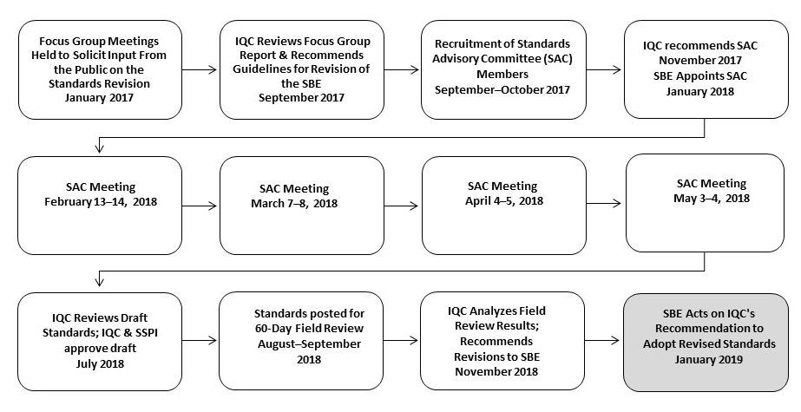
*This timeline is subject to change. The SBE will only take action on changes to the approved timeline if they affect IQC or SBE action dates.
Visit https://www.cde.ca.gov/be/cc/cd/vapastdsrevisionprocess.asp for a long description of this flowchart.

