California Department of Education
Charter Schools Division
Revised 5/2018
accs-feb21item03
ADVISORY COMMISSION ON CHARTER SCHOOLS
AN ADVISORY BODY TO THE STATE BOARD OF EDUCATION

February 2021 Agenda
Item #03

Subject
Petition for the Renewal of a Charter School Under the Oversight of the Local Educational Agency Designated by the State Board of Education Pursuant to California Education Code Section 47605(k)(2)(E): Consideration of Ross Valley Charter, which was denied by the Ross Valley Elementary School District.

Type of Action
Action, Information

Summary of the Issue
Ross Valley Charter (RVC) is seeking a renewal of its charter from the State Board of Education (SBE).
On November 10, 2020, the Ross Valley Elementary School District (RVESD) denied the RVC petition by a vote of five to zero.
The petitioner submitted the RVC petition on appeal to the SBE on November 30, 2020.

Proposed Recommendation
The California Department of Education (CDE) proposes to recommend that the SBE hold a public hearing to approve the request to renew RVC, a transitional kindergarten (TK) through grade five charter school, based on the CDE’s findings pursuant to California Education Code (EC) Section 47605 and California Code of Regulations, Title 5 Section 11967.5.
The CDE finds that the petitioner is able to successfully implement the intended program, and that the RVC petition is consistent with sound educational practice and meets the renewal criteria. Although the CDE finds that the RVC petition contains, overall, reasonably comprehensive descriptions of the required elements, the CDE has identified areas where the RVC petition could be strengthened. The CDE notes these areas in this item as well as in its analysis of the RVC petition (Attachment 1).

Brief History
RVC currently serves 195 pupils in TK through grade five at a private leased facility located at 102 Marinda Drive, Fairfax, California. The petition states that RVC plans to enroll 222 pupils each year through 2025–26; this is based on a TK enrollment of 40 pupils each year.
The RVC mission is to provide a public-school option that leverages a progressive education model emphasizing deep inquiry and exploration; hands-on, immersion-based experiences; and active learning-by-doing approaches to prepare pupils to collaborate effectively in teams, think critically, seek information to solve problems, and be lifelong learners and culturally competent members of their diverse global community.
The petition describes some of the successful practices that are emphasized at RVC such as multi-age classrooms, inquiry-based curriculum, educating the whole child, having a connected community, using authentic assessments, creating opportunities for collaboration and collective responsibility, differentiation, cultural competency, and service learning (Attachment 3, pp. 34–35).

Renewal Criteria
Under Assembly Bill 1505 two criteria are used to determine the performance category (i.e., high, middle, or low) of a charter school. The California School Dashboard measures performance for state indicators through a combination of current performance (Status) and improvement over time (Change), which both provide equal weight. A performance level (color) is assigned based on the Status and Change performance. Performance level (color) ranges from Red, Orange, Yellow, Green, and Blue, with Blue representing highest performance and Red representing lowest performance.
The modifications made to the charter school renewal process by AB 1505 include a presumption for renewal for high performing charters, a presumption for nonrenewal for low performing charters, and a standard for those charters who fall in between. Two criteria determine the performance category of a charter school (detailed information of the high, middle, and low performance criteria are presented in the CDE flyer, “Determining Charter School Performance Category,” which is posted at https://www.cde.ca.gov/ta/aC/cm/documents/determinecharterperf.pdf):
- Criterion 1 is based on the colors received by the school for all state indicators on the California School Dashboard.
- Criterion 2 is based on the status for all academic indicators with a color for the two previous California School Dashboard years.
Based on the aforementioned criteria, the CDE has designated RVC as middle performing (https://www.cde.ca.gov/sp/ch/documents/ab1505results2020.xlsx). A middle performing charter school qualifies for a five-year renewal term.
Pursuant to EC Section 47607.2(b)(2), the chartering authority shall provide greater weight to performance on measurements of academic performance in determining whether to grant a charter renewal of a charter school designated as middle performing. Measurements of academic performance include the test-based indicators for English language arts (ELA) and mathematics, the English Language Progress Indicator (ELPI), and the College and Career Indicator (CCI).
A chartering authority may deny renewal of a charter school in the middle tier only upon making a specific written finding that the school has failed to make sufficient progress towards meeting standards that provide a benefit to the school’s students, that closure of the school is in the students’ best interests, and that the decision provided greater weight to performance on measurements of academic performance—the test-based indicators in ELA and mathematics, ELPI, and CCI, pursuant to EC Section 47607.2(b)(3).

Performance Criteria

CDE Review of Performance Criteria
The CDE has determined that RVC has met the applicable academic renewal criteria pursuant to EC Section 47607(c). The CDE selected four schools, serving pupils in kindergarten through grade five, where pupils would otherwise attend and are comparable in that they have similar enrollment for similar significant subgroups.
The following table shows the percentage of pupils that met or exceeded standards on the 2017–18, and 2018–19 California Assessment of Student Performance and Progress (CAASPP) for ELA and mathematics for RVC and the CDE-chosen comparable RVESD schools. Due to a delay in opening the school in 2016, RVC only has CAASPP data for school years (SY) 2017–18 and 2018–19. The 2017–18 through 2018–19 CAASPP data show that RVC does perform, overall, comparable to equivalent RVESD schools.
CAASPP Results for CDE-Chosen Comparable Schools and RVESD (Percent Meets or Exceeds Standards)
School | 2017–18  ELA | 2017–18  Math | 2018–19  ELA | 2018–19  Math
RVC | 70 | 64 | 83 | 73
Manor Elementary | 66 | 53 | 74 | 58
Wade Thomas Elementary | 87 | 85 | 83 | 81
Brookside Elementary | 88 | 82 | 79 | 73
Hidden Valley Elementary | 72 | 73 | 76 | 81
RVESD | 78 | 70 | 78 | 69
The following tables show the percentage of pupils that met or exceeded standards on the 2017–18 through 2018–19 CAASPPs for ELA and mathematics for RVC, the CDE-chosen comparable RVESD schools that pupils would otherwise attend, and the RVESD.
Overall, RVC’s ELA and mathematics scores grew between SY 2017–18 and 2018–19. ELA scores grew approximately 13 percentage points and mathematics scores grew by approximately 9 percentage points.
The significant subgroup populations served by RVC are as follows: 26.7 percent Hispanic/Latino and 29.8 percent socioeconomically disadvantaged. Growth was seen by all subgroups that were reported. In cases where less than 10 pupils were assessed, the data have been suppressed in order to protect pupil privacy. The CDE notes that RVC assessed less than 10 African American pupils in SY 2017–18 and 2018–19; as such, a table of CAASPP results for this pupil subgroup is not provided.
An asterisk (*) indicates that less than 10 pupils were assessed.
CAASPP Results by Pupil Subgroups for Latino/Hispanic Pupils (Percent Meets or Exceeds Standards)
School | 2017–18  ELA | 2017–18  Math | 2018–19  ELA | 2018–19  Math
RVC | 19 | 25 | 48 | 48
Manor Elementary | 57 | 36 | 57 | 50
Wade Thomas Elementary | 79 | 84 | 88 | 64
Brookside Elementary | * | * | 55 | 73
Hidden Valley Elementary | 46 | 57 | 52 | 70
RVESD | 60 | 53 | 60 | 54
At RVC, Latino/Hispanic pupils’ scores increased significantly from SY 2017–18 to 2018–19, specifically, almost a 30-point increase in ELA and a 23-point increase in mathematics.
CAASPP Results by Pupil Subgroups for Special Education Pupils (Percent Meets or Exceeds Standards)
School | 2017–18  ELA | 2017–18  Math | 2018–19  ELA | 2018–19  Math
RVC | * | * | * | *
Manor Elementary | 46 | 17 | 32 | 5
Wade Thomas Elementary | 67 | 58 | 73 | 55
Brookside Elementary | 36 | 29 | 22 | 33
Hidden Valley Elementary | 20 | 24 | 26 | 35
RVESD | 34 | 24 | 38 | 25
CAASPP Results by Pupil Subgroups for English Learner Pupils (Percent Meets or Exceeds Standards)
School | 2017–18  ELA | 2017–18  Math | 2018–19  ELA | 2018–19  Math
RVC | 0 | 9 | 33 | 25
Manor Elementary | * | * | * | *
Wade Thomas Elementary | * | * | * | *
Brookside Elementary | * | * | * | *
Hidden Valley Elementary | * | * | * | *
RVESD | 21 | 25 | 10 | 15
At RVC, English learner pupils’ scores increased from SY 2017–18 to 2018–19, specifically, a 33-point increase in ELA and a 16-point increase in mathematics.
CAASPP Results by Pupil Subgroups for Socioeconomically Disadvantaged Pupils (Percent Meets or Exceeds Standards)
School | 2017–18  ELA | 2017–18  Math | 2018–19  ELA | 2018–19  Math
RVC | 18 | 29 | 47 | 37
Manor Elementary | 38 | 48 | 63 | 38
Wade Thomas Elementary | * | * | 62 | 57
Brookside Elementary | 69 | 69 | 79 | 73
Hidden Valley Elementary | 50 | 41 | 31 | 50
RVESD | 52 | 42 | 49 | 36
At RVC, socioeconomically disadvantaged pupils’ scores increased from SY 2017–18 to 2018–19, specifically, a 29-point increase in ELA and an 8-point increase in mathematics.

RVC’s Review of Performance Criteria
The petitioner completed CAASPP data comparison analyses for RVC and RVESD comparable schools for pupils schoolwide.
The following table shows the percentage of pupils that met or exceeded standards on the 2017–18 and 2018–19 CAASPPs for ELA and mathematics for all pupils schoolwide at RVC (Attachment 3, pp. 29–30).
CAASPP Results for RVC (Percent Meets or Exceeds Standards)
2017–18  ELA | 2017–18  Math | 2018–19  ELA | 2018–19  Math
70 | 64 | 83 | 73
The following table shows the percentage of pupils that met or exceeded standards on the 2017–18, and 2018–19 CAASPPs for ELA and mathematics for RVC, RVESD, and the State of California.
CAASPP Results for RVC, RVESD, and California (Percent Meets or Exceeds Standards)
Entity | 2018–19 ELA | 2018–19 Math
RVC | 83 | 73
RVESD | 78 | 69
California | 51 | 40
The following table shows the percentage of pupils that met or exceeded standards on the 2018–19 CAASPP for ELA and mathematics for RVC and for comparable schools that pupils would otherwise attend.
School | 2017–18 ELA | 2017–18  Math | 2018–19  ELA | 2018–19  Math
RVC | 70 | 64 | 83 | 73
Manor Elementary | 66 | 53 | 74 | 58
Wade Thomas Elementary | 87 | 85 | 83 | 81
Brookside Elementary | 88 | 82 | 79 | 73
Hidden Valley Elementary | 72 | 73 | 76 | 81

RVESD’s Review of Performance Criteria
The RVESD’s independent analysis of RVC’s academic performance data does demonstrate one year of improved scores from SY 2017–18 to 2018–19 for three of the seven grades served. RVC delayed opening from 2016 to 2017; therefore, RVC only has CAASPP data for grades three through five for SY 2017–18 and 2018–19 for comparison.
CAASPP Results for RVC (Percent Meets or Exceeds Standards)
2017–18  ELA | 2017–18  Math | 2018–19  ELA | 2018–19  Math
70 | 64 | 83 | 73

Verified Data
In addition to identifying standards of performance for charter schools, AB 1505 requires authorizers to consider verified data for renewals of charter schools that fall within the low-performing and middle-performing categories.
Pursuant to EC Section 47607.2, verified data is defined as follows:
Assessment data from nationally-recognized, valid, peer-reviewed, and reliable sources that are externally produced. It also includes postsecondary outcomes which are defined as college enrollment, persistence, and completion rates equal to similar peers.
Information regarding the “verified data” requirement was presented to and acted on by the SBE as Item 14 at its November 5–6, 2020, meeting. The item and its addendum are available at https://www.cde.ca.gov/be/ag/ag/yr20/documents/nov20item14.docx and https://www.cde.ca.gov/be/ag/ag/yr20/documents/nov20item14addendum.docx, respectively.

CDE’s Consideration of Verified Data
The CDE reviewed the following verifiable data that the petitioner included as criteria for charter renewal:
- 2019 California School Dashboard data for RVC for ELA, mathematics, Chronic Absenteeism, and Suspension Rates
The 2019 California School Dashboard reflects RVC’s performance under California’s Accountability System as follows: suspension rate of 0.6 percent (Yellow), and chronic absenteeism rate of 14.9 percent (Yellow) (Attachment 3, p. 21).
Suspension Rates
Entity | 2018 Suspension Rate | 2019 Suspension Rate
RVC | No color, 0 percent | Yellow, 0.6 percent
RVESD | Orange, 2.3 percent | Green, 1.7 percent
California | Yellow, 3.5 percent | Yellow, 3.4 percent
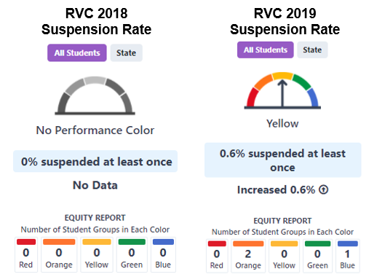
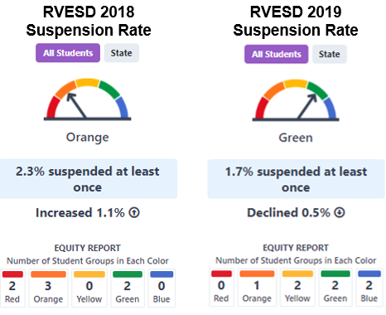
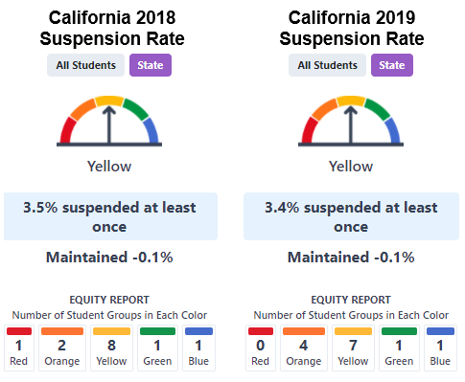
Chronic Absenteeism Rates
Entity | 2018 Chronic Absenteeism | 2019 Chronic Absenteeism
RVC | No color, 16.1 percent | Yellow, 14.9 percent
RVESD | Orange, 9 percent | Green, 7.7 percent
California | Yellow, 9 percent | Orange, 10.1 percent
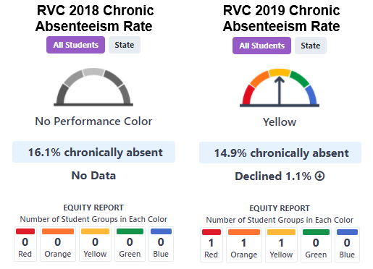
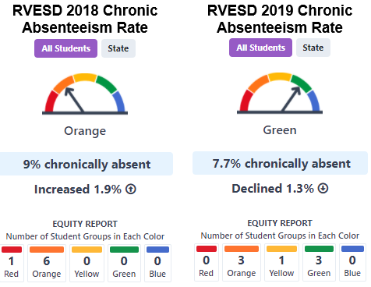
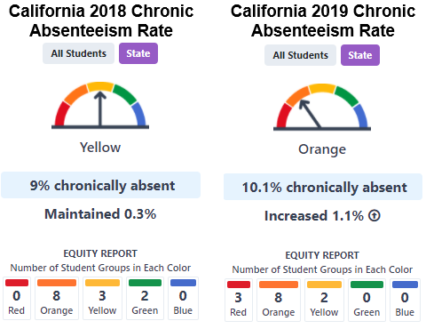

RVESD’s Consideration of Verified Data
The RVESD reviewed verifiable 2019 California School Dashboard data for RVC for ELA, mathematics, Chronic Absenteeism, and Suspension Rate (Attachment 3, p. 21).

Ability to Implement
The RVC multi-year projected budget includes the following projected pupil enrollment (Attachment 4):
- 222 TK through grade five in 2021–22
- 222 TK through grade five in 2022–23
- 222 TK through grade five in 2023–24
- 222 TK through grade five in 2024–25
- 222 TK through grade five in 2025–26
RVC has a good financial record under the SBE’s authorization. RVC’s fiscal year (FY) 2020–21 first interim report dated December 13, 2020, indicates that RVC is projecting a positive ending fund balance of $495,845 and reserves of 22 percent, which is above the recommended 5 percent in reserves outlined in the Memorandum of Understanding (MOU) between RVC and the SBE. The CDE reviewed audited financial data from the FY 2019–20 audit report that reflected an unqualified status with an ending fund balance of $248,997 and a reserve designated for economic uncertainty of 11.61 percent (Attachment 4).

Revenue
The RVC multi-year projected budget includes fundraising of $208,240 each year for FYs 2021–22 through 2025–26. Over the last three years, RVC has raised approximately $496,000 in donations. The CDE determined the projected fundraising for each year to be reasonable.
In addition, RVC’s cash flow statement reflects a Pacific Charter School Development loan of $355,000 and Revenue Anticipation Notes of $480,000. RVC has projected a positive ending cash balance for FYs 2020–21 through 2025–26.
The projected financial plan for RVC is fiscally sustainable. The CDE concludes that the RVC’s multi-year financial plan does provide for projected operating surpluses, increasing positive fund balances, and adequate reserves (Attachment 4).

Expenditures
RVC has a good financial record under the SBE’s authorization. RVC’s FY 2020–21 updated budget report dated September 23, 2020, indicates that RVC is projecting a positive ending fund balance of $363,555 and reserves of 16.43 percent, which is above the recommended 5 percent in reserves outlined in the MOU between RVC and the SBE.
The CDE reviewed audited financial data from the FY 2019–20 audit report that reflected an unqualified status with an ending fund balance of $248,997 and a reserve designated for economic uncertainty of 11.61 percent (Attachment 4).

Ross Valley Elementary School District Findings
On November 10, 2020, RVESD took action and denied the renewal charter petition for RVC based on the following findings (Attachment 5, pp. 7–37):
- The petitioner is demonstrably unlikely to successfully implement the program set forth in the petition due to substantial fiscal and governance factors.
- The petitioner is not equipped to and has not served all students who wish to attend.
- The petitioner did not propose or comply with corrective action and therefore did not successfully respond to the notice of violation (NOV).
- The petitioner is further demonstrably unlikely to successfully implement the program set forth in the petition as the petition is not supported by a reasonable fiscal plan and does not reflect the requisite understanding of relevant law to successfully administer the program.
- The petition does not contain reasonably comprehensive descriptions of the required charter elements.
The CDE notes the following concerns, which were detailed in the RVESD staff report:

Paycheck Protection Program
RVESD found fiscal mismanagement regarding the RVC Paycheck Protection Program loan received on May 8, 2020, in the amount of $270,653. On August 28, 2020, a letter of complaint was sent to the Marin County of Education (MCOE). MCOE referred the complaint to the Fiscal Crisis and Management Assistance Team (FCMAT). On September 18, 2020, the FCMAT responded to the MCOE concerns and allegations raised by RVESD and did not recommend that an extraordinary audit be conducted (Attachment 5, pp. 7–16).
CDE’s review of RVC’s petition did not support a finding of financial mismanagement.

Americans with Disabilities Act and Fire and Life Safety Requirements
The RVESD staff report finding regarding compliance with the Americans with Disabilities Act (ADA) and Fire and Life Safety Requirements was reviewed by the CDE along with the RVC petition and supporting documents.
The CDE found that the construction necessary for ADA compliance requirements was completed on October 2, 2020. On October 30, 2020, the CDE completed a facilities inspection and certified that the required construction was completed and that RVC met the requirements for Fire and Life Safety (Attachment 5, pp. 19–20).

Failure to Successfully Remedy Violations listed in the Notice of Violation from RVESD
RVESD issued an NOV on September 3, 2020, stating that the NOV was in accordance with EC Section 47607(e), which states the following:
EC Section 47607 (e) Notwithstanding subdivision (c) and subdivisions (a) and (b) of Section 47607.2, the chartering authority may deny renewal of a charter school upon a finding that the school is demonstrably unlikely to successfully implement the program set forth in the petition due to substantial fiscal or governance factors, or is not serving all pupils who wish to attend, as documented pursuant to subdivision (d). The chartering authority may deny renewal of a charter school under this subdivision only after it has provided at least 30 days’ notice to the charter school of the alleged violation and provided the charter school with a reasonable opportunity to cure the violation, including a corrective action plan proposed by the charter school.
According to RVC’s Response to the Findings for Denial by the RVESD, RVC states that even though RVC responded to the NOV in good faith, it did not believe RVESD has legal authority to invoke the NOV procedure as RVESD is not RVC’s chartering authority. RVC further asserts that none of the NOV findings may lawfully be relied upon to make a decision to deny the charter’s renewal (Attachment 5, p. 256).

Charter Elements
The CDE finds that the RVC petition does, overall, provide a reasonably comprehensive description of the following required charter elements. However, the CDE notes that the following elements could be strengthened.

Element A—Description of Educational Program
While the CDE finds that the RVC petition is consistent with sound educational practice and meets the renewal criteria, the CDE has concerns regarding the English Language Development (ELD) program described in the petition (Attachment 3, pp. 33–118).

Plan for English Learners
The RVC petition does present a reasonably descriptive plan for English learner (EL) pupils. The RVC petition states that RVC adheres to all applicable state and federal laws and regulations with respect to serving pupils who are ELs, including long-term ELs or ELs at risk of becoming long-term ELs.
The CDE notes some concerns regarding the ELD program that is described in the RVC petition. If approved by the SBE, as a condition of approval, the petitioner will be required to revise the petition to include necessary language for Element A—Description of Educational Program by updating the following:
- The Home Language Survey is completed when a student first enrolls in a California public school, not the first time they enroll in any school.
- The RVC petition currently states that to redesignate a pupil as English proficient, a score of a four or five on the English Language Proficiency Assessments for California (ELPAC) is required. The RVC petition will need to state that the requirement for proficiency is a score of a four on the ELPAC as there is no score of five.
- The RVC petition will need to be updated to include descriptions of the integrated and designated ELD instruction, as well as identify that integrated ELD and pupil monitoring is to occur across all subject matters.

Element J—Suspension and Expulsion Procedures
The RVC petition does present a reasonably comprehensive description of suspension and expulsion procedures.
However, the RVC petition does not specifically list the sections of Senate Bill 419 (Chapter 279, Statutes of 2019) that amended EC Section 48900(k) by extending the permanent prohibition against suspending students enrolled in kindergarten through grade three for disruption or willful defiance to include students in grades four and five. This prohibition has also been expanded to include students in grades six through eight until July 1, 2025 (Attachment 3, pp. 203–223).
Addressing evaluation criteria (E), the RVC petition states that when an appeal relating to the placement of the student or the manifestation determination has been requested by either the parent or the charter school, the student shall remain in the interim alternative educational setting pending the decision of the hearing officer in accordance with state and federal law, including 20 United States Code (USC) Section 1415(k), until the expiration of the 45-day time period provided for in an interim alternative educational setting, unless the parent and the charter school agree otherwise (Attachment 3, p. 221).
The RVC petition further states that in such an appeal, a hearing officer may do one of the following: (1) return a child with a disability to the placement from which the child was removed; or (2) order a change in placement of a child with a disability to an appropriate interim alternative educational setting for not more than 45 school days if the hearing officer determines that maintaining the current placement of such child is substantially likely to result in injury to the child or to others (Attachment 3, pp. 221–222).
While the preceding paragraph provided in the RVC petition follows the requirements set forth in 20 USC Section 1415(k)(3), this statement is not consistent with RVC’s prior statement providing for the automatic placement of a pupil in an interim alternative educational setting until the expiration of the 45-day time period. 20 USC Section 1415(k)(3) only gives a hearing officer the authority to order such a placement.
If approved by the SBE, as a condition of approval, the petitioner will be required to revise the petition to include necessary language for Element J—Suspension and Expulsion Procedures to include SB 419 that extended the permanent prohibition against suspending students enrolled in kindergarten through grade three for disruption or willful defiance to include students in grades four and five. Additionally, to expand this prohibition, to include students in grades six through eight until July 1, 2025. The petitioner will also need to revise the RVC petition to delete the statement that when an appeal related to the placement of a pupil or the manifestation determination has been requested by either the parent or RVC, the pupil can remain in the interim setting until the expiration of the 45-day time period provided for in an interim alternative educational setting. The RVC petition needs to be clear that when an appeal relating to the placement of a pupil or the manifestation determination has been requested by either the parent or RVC, the pupil shall remain in the interim alternative educational setting pending the decision of the hearing officer or until the expiration of the time provided in 20 USC Section 1415(k)(1)(C), whichever occurs first, unless the parent and RVC agree otherwise.

Conclusion
In summary, the CDE proposes to recommend that the SBE approve the request to renew the RVC petition.
A detailed analysis of the CDE’s review of the entire RVC petition is provided in Attachment 1.

Documents Reviewed by the California Department of Education
In considering the RVC petition, CDE staff reviewed the following:
- RVC petition (Attachment 3)
- Educational and demographic data of schools where pupils would otherwise be required to attend (Attachment 2)
- RVC budget and financial projections (Attachment 4)
- RVESD findings evidencing the denial of the RVC petition and petitioner’s response (Attachment 5)
- RVC articles of incorporation, bylaws, and conflict of interest policy (Attachment 6)
- RVC appendices and supporting documents (Attachment 7)
- RVESD supporting documents (Attachment 8)

Attachments
- Attachment 1: California Department of Education Charter School Petition Review Form: Ross Valley Charter (49 Pages)
- Attachment 2: Ross Valley Charter Data Tables (8 Pages)
- Attachment 3: Ross Valley Charter Petition (238 Pages)
- Attachment 4: Ross Valley Charter Budget and Financial Projections (13 Pages)
- Attachment 5: Ross Valley Elementary School District Findings Evidencing Denial of the Ross Valley Charter Petition and Petitioner’s Response (482 Pages)
- Attachment 6: Ross Valley Charter Articles of Incorporation, Bylaws, and Conflict of Interest Policy (22 Pages)
- Attachment 7: Ross Valley Charter Appendices and Supporting Documents (544 Pages)
- Attachment 8: Ross Valley Elementary School District Supporting Documents (165 Pages)

Descriptive Image Alternative Text

Page 8: 2018–19 Suspension Rates for RVC
California School Dashboard dial for Ross Valley Charter. 2018 Suspension Rate indicating No Performance Color, with No Data Reported; and 2019 Suspension Rate indicating Yellow, with 0.6 percent of students suspended once, a .6 percent increase (over 2018), and Equity Report data indicating two student groups in Orange and one student group in Blue.

Page 9: 2018–19 Suspension Rates for RVESD and the State of California

RVESD
California School Dashboard dial for Ross Valley Elementary School District. 2018 Suspension Rate indicating Orange, with 2.3 percent of students suspended at least once, and Equity Report data indicating two student groups in Red, three student groups in Orange, and two student groups in Green; and 2019 Suspension Rate indicating Green, with 1.7 percent of students suspended at least once, a .5 percent decrease (over 2018), and Equity Report data indicating one student group in Orange, two student groups in Yellow, two student groups in Green, and two student groups Blue.

State of California
California School Dashboard dial for the State of California. 2018 Suspension Rate indicating Yellow, with 3.5 percent of students suspended at least once, and Equity Report data indicating one student group in Red, two student groups in Orange, eight student groups in Yellow, one student group in Green, and one student group in Blue; and 2019 Suspension Rate indicating Yellow, with 3.4 percent of students suspended at least once, within .1 percent of 2018 data, and Equity Report data indicating four student groups in Orange, seven student groups in Yellow, one student group in Green, and one student group in Blue.

Page 10: 2018–19 Chronic Absenteeism Rate for RVC and RVESD

RVC
California School Dashboard dial for Ross Valley Charter. 2018 Chronic Absenteeism Rate indicating No Performance Color, with 16.1 percent of students chronically absent, and No Data Reported; and 2019 Chronic Absenteeism Rate indicating Yellow, with 14.9 percent of students chronically absent, a 1.1 percent decrease (over 2018), and Equity Report data indicating one student group in Red, one student group in Orange, and one student group in Yellow.

RVESD
California School Dashboard dial for Ross Valley Elementary School District. 2018 Chronic Absenteeism Rate indicating Orange, with 9 percent of students chronically absent, and Equity Report data indicating one student group in Red and six student groups in Orange; and 2019 Chronic Absenteeism Rate indicating Green, with 7.7 percent of students chronically absent, a 1.3 percent decrease (over 2018), and Equity Report data indicating three student groups in Orange, one student group in Yellow, and three student groups in Green.

Page 11: 2018–19 Chronic Absenteeism Rate for the State of California
California School Dashboard dial for the State of California. 2018 Chronic Absenteeism Rate indicating Yellow, with 9 percent of students chronically absent, and Equity Report data indicating eight student groups in Red, three student groups in Orange, and two student groups in Yellow; and 2019 Chronic Absenteeism Rate indicating Orange, with 10.1 percent of students chronically absent, a 1.1 percent increase (over 2018), and Equity Report data indicating three student groups in Red, eight student groups in Orange, and two student groups in Yellow.

