California Workforce Pathways Joint Advisory Committee
cwpjac-aug21item03
Page 1 of 2
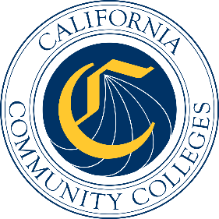

California Workforce Pathways
Joint Advisory Committee
August 6, 2021
Agenda Item 03
Posted by the California Department of Education

Subject
GENERAL PUBLIC COMMENT. Public comment is invited on any matter not included on the printed agenda.
Depending on the number of individuals wishing to address the California Workforce Pathways Joint Advisory Committee, the presiding officer may establish specific time limits on presentations.

Type of Action
Information

Summary of the Issue(s)
This is a standing Agenda Item which allows the members of the public to address the California Workforce Pathways Joint Advisory Committee (CWPJAC) on any matter that was not included on the posted August 6, 2021, meeting agenda.

Recommendation
Not applicable.

Brief History of Key Issues
Not applicable.

Summary of Previous California Workforce Pathways Joint Advisory Committee Discussion(s) and Action(s)
Not applicable.

Attachment(s)
None.

