California Workforce Pathways Joint Advisory Committee
cwpjac-feb24item07
Page 1 of 1
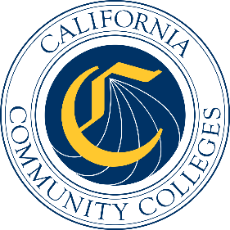

California Workforce Pathways
Joint Advisory Committee
February 9, 2024
Agenda Item 07
Posted by the California Department of Education

Subject
GENERAL PUBLIC COMMENT. Public comment is invited on any matter not included on the printed agenda.
Depending on the number of individuals wishing to address the California Workforce Pathways Joint Advisory Committee (CWPJAC), the presiding officer may establish specific time limits on presentations.

Type of Action
Information

Summary of the Issue(s)
This is a standing Agenda Item which allows the members of the public to address the CWPJAC on any matter that was not included on the printed February 9, 2024, meeting agenda.

