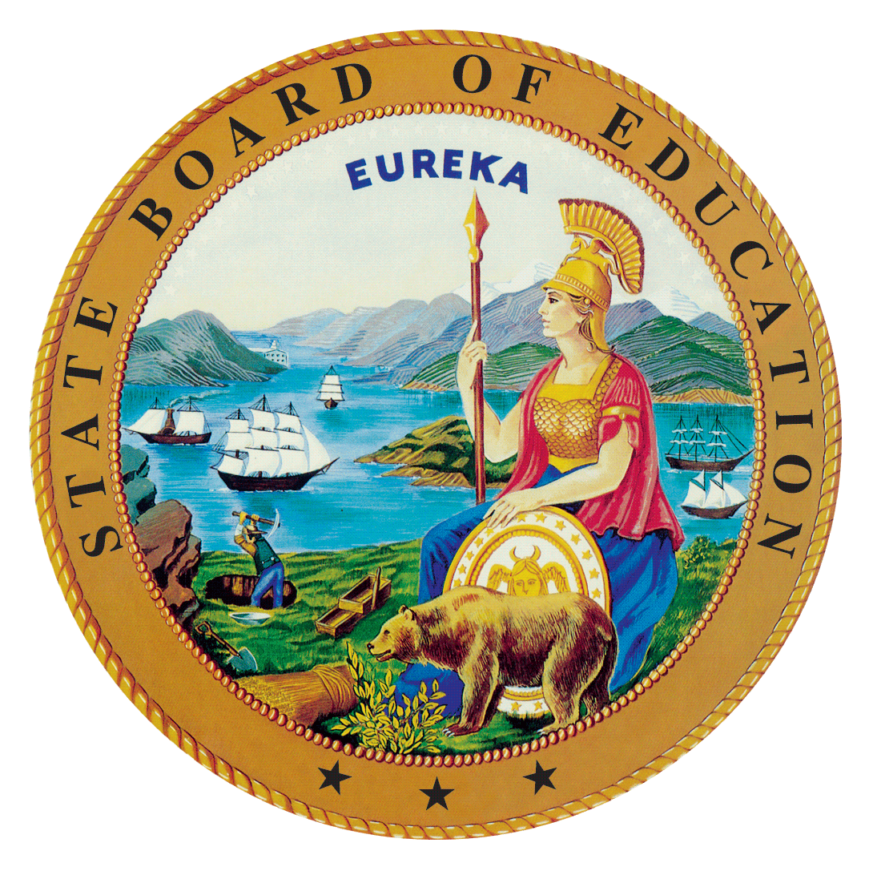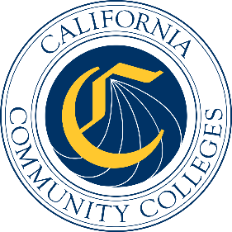

California Workforce Pathways
Joint Advisory Committee
February 2019
Agenda Item 01

Subject
Summary of Public Feedback on the Guiding Policy Principles to Support K–14+ Pathways, as approved by the California Workforce Pathways Joint Advisory Committee (CWPJAC) in 2018.

Type of Action
Information

Summary of the Issue(s)
This item is presented to share with CWPJAC members the public feedback that was received via an online survey, in its entirety. This item also recommends some revisions to the Guiding Policy Principles to Support K–14+ Pathways document based on the public feedback received from August to November 2018.

Recommendation
Staff of the CWPJAC recommends that the CWPJAC review the public input to the Guiding Policy Principles to Support K–14+ Pathways document to date.

Brief History of Key Issues
The CWPJAC reconvened in March, 2017. After several meetings of obtaining information about career technical education programs throughout California’s kindergarten through grade twelve and California community college systems, staff of the CWPJAC drafted the Guiding Policy Principles to Support K–14+ Pathways document to help focus its work, which the CWPJAC approved at the March and May 2018 meetings.

Summary of Previous California Workforce Pathways Joint Advisory Committee Discussion(s) and Action(s)
January 2019: A summary of the public feedback received was presented to the CWPJAC. Some of the committee members requested to review all of the feedback as a way to determine if possible revisions were necessary.
March/May 2018: The CWPJAC approved the Guiding Policy Principles to Support K–14+ Pathways document, and requested that staff obtain public feedback on the Guiding Policy Principles to Support K–14+ Pathways document. Subsequently, staff developed a survey to collect public comments which opened on August 24, 2018 and closed on November 30, 2018. Staff also conducted a public meeting to obtain feedback on August 22, 2018. On September 7, 2018, Chair Sun, and Vice Chair Haynes presented the Guiding Policy Principles to Support K–14+ Pathways document to the State Board of Education.

Attachment(s)
The supporting materials (e.g., attachments, addendums, SBE commentary, or related reports) will be listed below as they become available electronically.
Attachment 1: Public feedback on the Guiding Policy Principles to Support K–14+ Pathways. This document is available on the CWPJAC webpage at https://www.cde.ca.gov/ci/ct/gi/workpathjac.asp.

