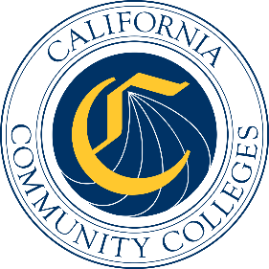

California Workforce Pathways
Joint Advisory Committee
January 2020
Agenda Item 02
Posted by the California Department of Education

Subject
Presentation on the California Community Colleges Career and Technical Education Employment Outcomes Survey.

Type of Action
Information

Summary of the Issue(s)
The California Community Colleges conducts an annual survey, the California Community Colleges Career and Technical Education Employment Outcomes Survey (CTEOS), to measure employment outcomes for former students. This survey is issued to approximately 150,000 students who met specified Career and Technical Education (CTE) coursework/training requirements and have exited the system.

Recommendation
The CCCCO staff recommends that the CWPJAC receive information on the CTEOS presentation by KC Greaney, of the RP Group, and Amil Gehrke, of the Santa Rosa Junior College.

Brief History of Key Issues
The CTEOS began as a pilot in 2012 with 15 California Community Colleges pooling resources to scale up a CTE Completer/Leaver Survey. In 2017, the California Community Colleges Chancellor’s Office began underwriting the costs of the survey administration so all colleges in the system could participate and benefit.
The CTEOS is designed to track and document outcomes for non-transferring CTE students who generally are employed. The survey is administered to former CTE students a year or more after they have exited the system, allowing sufficient time to measure whether their job status has been impacted by their CTE coursework and training. Former students are asked about their employment status, earnings, how closely related their job is to their field of study/training, and other related questions. Survey results are appended to an extensive administrative data set, which provides a rich source of information that is used for accountability, program improvement, compliance documentation, and more.
Approximately 150,000 former CTE students are surveyed annually, and the response rate has remained around 30 percent.

Summary of Previous California Workforce Pathways Joint Advisory Committee Discussion(s) and Action(s)
None.

Fiscal Analysis (as appropriate)
None.

Attachment(s)
Attachment 1: 2015–2019 Career and Technical Education Employment Outcomes Survey Overview (1 page)
Attachment 2: The Career and Technical Education Outcomes Survey Process: Putting Data to Work (1 page)
Attachment 3: Career and Technical Education Outcomes Survey Data Elements: Putting Data to Work (1 page)
Attachment 4: Career & Technical Education Employment Outcomes Survey: 2019 Statewide Report (2 pages)

