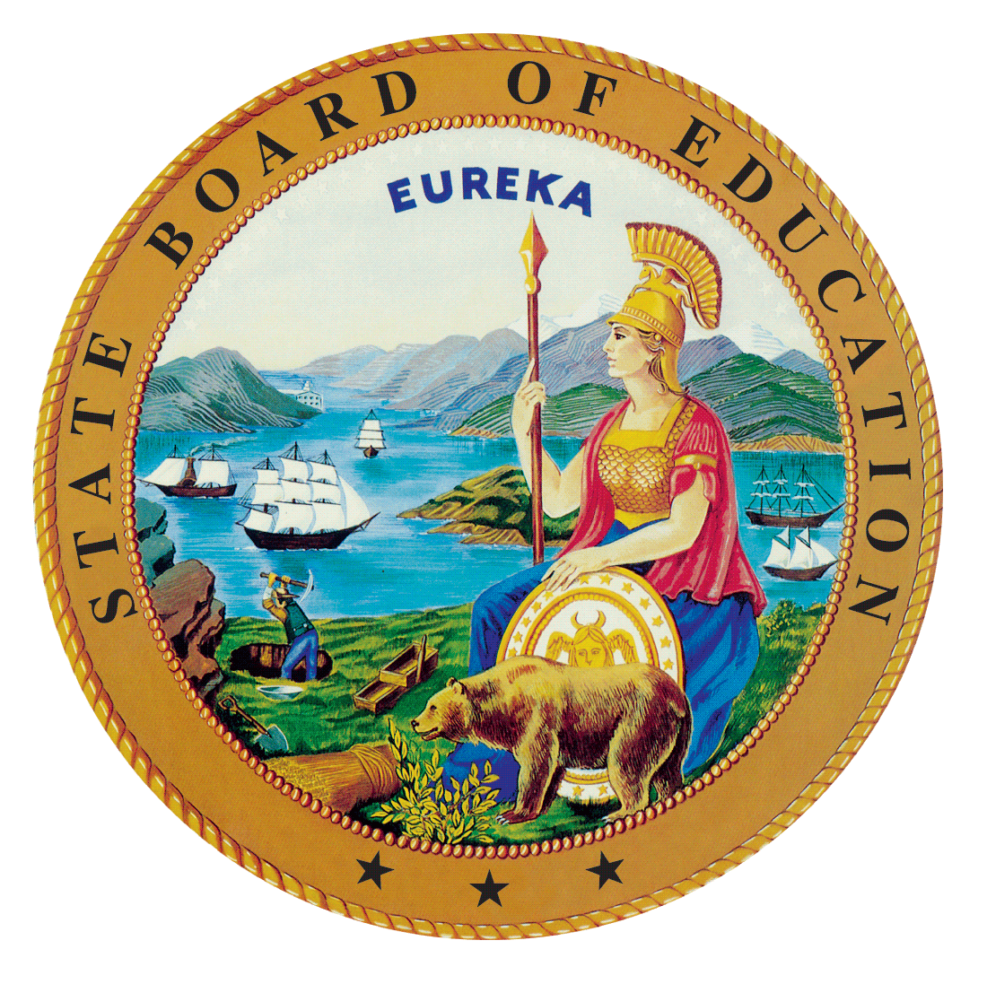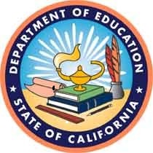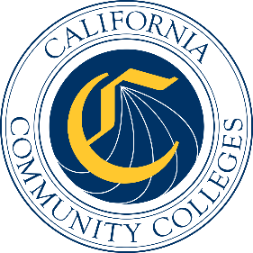

California Workforce Pathways
Joint Advisory Committee
January 2020
Agenda Item 04
Posted by the California Department of Education

Subject
The Strengthening Career and Technical Education for the 21st Century Act: Review and Approval of the Draft Federal Perkins V State Plan.

Type of Action
Action, Information

Summary of the Issue(s)
On July 31, 2018, the federal Strengthening Career and Technical Education for the 21st Century Act (Perkins V) was signed into law by President Trump, which reauthorized the federal Carl D. Perkins Career and Technical Education Act of 2006 (Perkins IV). As part of the transition to Perkins V, California elected to develop and submit a one-year transition plan in May 2019. The State Board of Education (SBE) approved the 2019–20 California Perkins V Transition Plan at its May 8, 2019, meeting, and the Board of Governors (BOG) of the California Community Colleges (CCC) received an update at its May 21, 2019, meeting. The California Department of Education (CDE) submitted the approved transition plan to the U.S. Department of Education (ED) on May 24, 2019. On July 2, 2019, the CDE received notification from the ED that the 2019–20 Perkins V Transition Plan had been approved, and Perkins V funding for California was available starting July 1, 2019. After submission of the transition plan, work began on developing the complete four-year Perkins V State Plan for Career Technical Education (CTE), which is due to ED no later than April 15, 2020.
The Federal Perkins V State Plan, once approved by the SBE and the ED, will be used to leverage state-funded CTE programs and support the development of a broader California State Plan for CTE. This is important because California intends to lead with state programming as stated in the California Workforce Pathways Joint Advisory Committee’s guiding principles. The focus of the California Comprehensive State Plan for CTE will target system alignment across the education and workforce development.
This agenda item provides an overview of the Draft Federal Perkins V State Plan, which in final form will serve as the application to the ED to fulfil the requirements for California receiving Perkins V funds. This is the third review of the Draft Federal Perkins V State Plan (Draft Federal State Plan). Once the California Workforce Pathways Joint Advisory Committee (CWPJAC) approves this Draft Federal State Plan, the plan will be forwarded to the SBE for approval at the March 2020 meeting. Following approval by the SBE, the Draft Federal State Plan will be presented to the Board of Governors (BOG) as an information item. Concurrently, the SBE-approved Draft Federal State Plan will be forwarded to the Governor’s Office for review and approval. The Governor’s approved Federal Perkins V State Plan will be submitted to the ED no later than
April 15, 2020.

Recommendation
The SBE, CDE, and CCCCO staff jointly recommend that the CWPJAC review and approve the Draft State Plan to be presented for approval to the SBE at their March 2020 meeting.
While feedback from the CWPJAC members is being requested for the entire document, it is suggested that members focus on two broad areas. First is a summary of the major themes of the public comments received. In addition, to a summary document of public comment is a report of all public comments received during the required public comment period of December 2, 2019, to January 3, 2020. In the public comment report, it specifies which comments were pertinent to the Draft Federal Perkins V State Plan, and if so, whether they were included in the draft federal plan. The report also indicates if comments were not specific in addressing the draft federal plan and therefore, considered to be a local or implementation concern.
Second, the accountability section has been completely revised, including an updated State Determined Performance Levels (SDPL) form. In addition to these two major discussion areas, changes and updates to the different major strands of the Draft State Plan will be highlighted.
Attachment 1 provides a revised version, in track changes, of the Draft Federal State Plan identifying the differences from the version presented to the CWPJAC on November 25, 2019. Attachment 2 provides an updated version of all the changes from the November 25, 2019, CWPJAC meeting that have been incorporated. Attachment 3 provides how the strands, major and minor prompts, and items are broken down, along with associated page numbers. Attachment 4 is a summary of the public comments and responses. Attachment 5 is a collation of all the public comments received, and corresponding State responses by strand, major and minor prompts, and items. A copy of Attachment 5 will be made available in hard copy form. A binder will be made available in Room 1101 on January 31, 2020, as well as in Suite 4202 at the California Department of Education (CDE) after January 31, 2020. Attachment 6 is an updated project timeline that specifies which tasks have been completed since the November 25, 2019, CWPJAC meeting, and which tasks need completion in the near future.

Plan Development
Developing a Federal Perkins V State Plan for a State as vast and diverse as California requires a broad range of expertise and knowledge as well as access to data from a number of sources. A primary source for developing the Draft State Plan is the CWPJAC’s Guiding Policy Principles to Support Student-Centered K–14+ Pathways (Guiding Policy Principles) as well as the Essential Elements of a High-Quality College and Career Pathway. The initial work undertaken by the CWPJAC to arrive at the Guiding Policy Principles has served the state well when the time came to develop the Draft Federal State Plan.
Under the direction from the CWPJAC, staff from the SBE, the CDE, and the California Community Colleges Chancellor’s Office (CCCCO), jointly managed the planning and coordination for developing the Draft State Plan through weekly meetings. Staff has also elicited help from the Comprehensive Center at WestEd (WestEd) to build capacity, and provide guidance for this endeavor. For brevity, this internal working team will be referred to as the Joint Management Team (JMT). The JMT has completed several inter-related tasks to date:
- Develop the content for the Draft Federal State Plan
- Organize the process by which feedback is obtained, both from stakeholders and the general public
- Refine and update the content of the Draft Federal State Plan after each CWPJAC meeting
- Update the Draft State Plan to reflect stakeholder feedback, and public comment
Since May 2019, staff from the SBE, the CDE, and the CCCCO have been working jointly to develop and refine the content of the Draft State Plan. The Draft Federal State Plan is laid out as responses to a series of prompts. Some of these prompts were addressed in the approved 2019–20 California Perkins V Transition Plan (Transition Plan) and have now been expanded further, while other prompts that were not required for the Transition Plan are addressed in the Draft Federal State Plan. The plan responds to prompts in the following strands:
- Plan Development and Consultation
- Program Administration and Implementation
- Meeting the Needs of Special Populations
- Preparing Teachers and Faculty
- Fiscal Responsibility
- Accountability for Results
The Draft Federal State Plan continues the foundational work of the CWPJAC’s Guiding Policy Principles for creating these interrelationships, and the expectation is that they will be developed more fully under the broader California State Plan for CTE.

Inclusion of Public Comment
The Comprehensive Center at WestEd developed a website which served as the portal for public comment. The public comment period commenced on December 2, 2019, and closed on January 3, 2020. After the public comment period, WestEd organized the public comments by the application’s major strands, major prompts, minor prompts, and items. Staff reviewed all comments and suggested responses to each comment, including assigning particular forms of disposition. Even as individual comments will be made available to the CWPJAC members to review, the intent is to provide, through presentation, a global view of the public comments across, and within, the major strands. The Draft Federal State Plan requires the public comments, where germane, be addressed within the body of the plan, as well as included as an appendix in a revised Draft Federal State Plan.

Brief History of Key Issues
In 2008, the SBE approved the 2008–2012 California State Plan for Career Technical Education. This comprehensive plan, which the CDE and the CCCCO created collaboratively, was developed to not only meet the federal Perkins IV requirements, but also to establish a vision and direction for CTE across California.
Staff from the CDE and the CCCCO have been working closely with staff from the SBE since spring 2017 to reconvene the CWPJAC, as required by California Education Code Section 12503, in preparation for developing a California State Plan for CTE.
On July 31, 2018, the federal Perkins V was signed into law which reauthorized the federal Perkins IV. As part of the transition to Perkins V, California elected to submit a one-year transition plan in May 2019, with the full State Plan due in April 2020. In April 2019, the Office of Career, Technical, and Adult Education (OCTAE) released the final guidance for the Perkins V, which can be found at the following web link, https://s3.amazonaws.com/PCRN/docs/1830-0029-Perkins_V_State_Plan_Guide-Expires_4-30-22.pdf.
The Transition Plan was approved by the SBE at its May 8, 2019, meeting, and the Board of Governors of the California Community Colleges received an update at its
May 21, 2019, meeting. The CDE submitted the approved Transition Plan to the ED on May 24, 2019. On July 2, 2019, the CDE received notification from the ED that the 2019–20 Transition Plan was approved and federal Perkins V funding for California was made available starting July 1, 2019. (https://www.cde.ca.gov/ci/ct/gi/workpathjac.asp)
Given that there has always been a short timeframe in developing, validating, and finalizing the Perkins V federal application, and after many conversations between the SBE, the CDE, and the CCCCO staff, three options were considered: (1) to only complete a Perkins V state plan, (2) to complete a comprehensive state plan for CTE, including the Perkins V requirements, or (3) to focus on the State Plan for CTE and continue working on the federal Perkins V requirements, making it become a fully comprehensive California State Plan for CTE. Staff presented the third option to the state advisory committee at its May 2019 meeting as a way to develop a comprehensive plan including all state CTE programs administered by both CDE and the CCCCO, and to ensure alignment to the Local Control Accountability Plans submitted by local educational agencies as well as the Student-Centered Funding Formula. Over subsequent meetings of the CWPJAC, the focus continued to be on the State Plan for CTE. At the October 2019 CWPJAC meeting, due to time constraints to submit the federal Perkins V State Plan, it was decided to focus on the Perkins V State Plan and then continue to develop the complete comprehensive State Plan for CTE after the submission of the federal Perkins V State Plan.

Summary of Previous California Workforce Pathways Joint Advisory Committee Discussion(s) and Action(s)
November 25, 2019: Incorporating Input from the CWPJAC members at their November 7, 2019, meeting, a revised Draft State Plan was presented to the CWPJAC. Using a facilitated discussion process, members provided further input, but recommended that further review occur after the public comment period. The CWPJAC approved a Draft Federal State Plan at its meeting on November 25, 2019, and moved the draft forward for public comment.
November 7, 2019: Following the October 2019 meeting a decision was made to first complete the Draft State Plan. The SBE, CDE, and CCCCO staff began putting together the Draft Federal State Plan. The version of the Draft Federal State Plan included material from the October 2019 version (known as the California State Plan for CTE) by drawing relevant content and placing it under the four stands, the major prompts, the minor prompts and the items that were listed in the Perkins State Plan Guide (see link above). The Draft Federal State Plan was presented to the CWPJAC members on November 7, 2019. After review and input, the members asked staff to continue working on the Draft Federal State Plan and present to the CWPJAC members an updated version at the November 25, 2019, meeting.

October 2019: A Draft Federal State Plan for CTE and a proposed timeline were provided to the CWPJAC members. A chapter-by-chapter review of the Draft Federal State Plan for CTE was presented, discussed, and input on each chapter was solicited. It was decided that the CWPJAC staff should work on the Perkins V federal application and present it to the CWPJAC members at the November meeting. A proposed draft timeline was presented. Completed and upcoming meetings with regard to the Perkins V federal application were discussed.

September 2019: A Draft Federal State Plan for CTE and a proposed draft timeline were provided to the CWPJAC members.

July 2019: The CWPJAC staff introduced an updated draft timeline and planned activities for completing a new California State Plan for CTE.

May 2019: The CWPJAC staff introduced a draft timeline and planned activities for completing a new California State Plan for CTE.
March 2019: The CDE and CCCCO staff presented the draft Transition Plan to the CWPJAC. The CWPJAC members provided feedback for staff to consider while continuing to work on the transition plan.
February 2019: The CDE and CCCCO staff presented responses to the Programs of Study, Special Populations, and Fiscal Responsibility sections of the Transition Plan to the CWPJAC. The CWPJAC members provided extensive feedback for staff to consider while continuing to work on the Transition Plan.
January 2019: The CDE and CCCCO staff presented the current requirements for the state’s 2019–20 Transition Plan for the new Perkins V legislation.
December 2018: The CDE and CCCCO staff presented a draft timeline to the CWPJAC that outlined when items need to be completed in order to meet the deadline for submission of the State’s 2019–20 Transition Plan to the ED.
November 2018: The CDE staff provided a brief update on the activities around the new Perkins V legislation.
September 2018: Michael Brustein, Brustein & Manasevit, PLLC, Attorneys at Law, provided an overview of the new Perkins V legislation, known as the Strengthening Career and Technical Education for the 21st Century Act.
March 2008: On March 12, 2008, the SBE unanimously approved the 2008–2012 California State Plan for CTE, as required by the Perkins IV, which had been previously approved by the BOG on March 3, 2008. The 2008–2012 California State Plan for CTE was subsequently approved by the ED on July 1, 2008.

January 2008: The SBE held a public hearing on the 2008–2012 California State Plan for CTE, as was required by the Perkins IV.

Fiscal Analysis (as allocated)
In 2018–19 the Perkins IV allocation was $120,196,084; for 2019–20, the Perkins V allocation is $127,058,834.

Attachment(s)
Attachment 1: Draft Federal Perkins V State Plan with Track Changes
Attachment 2: Draft Federal Perkins V State Plan
Attachment 3: Draft Federal Perkins V State Plan Page References (3 pages)
Attachment 4: Summary of Public Comments and Responses for the Draft Federal Perkins V State Plan
Attachment 5: Public Comment Report for the Draft Federal Perkins V State Plan
Attachment 6: Updated California State Plan for CTE Working Timeline (3 pages)

