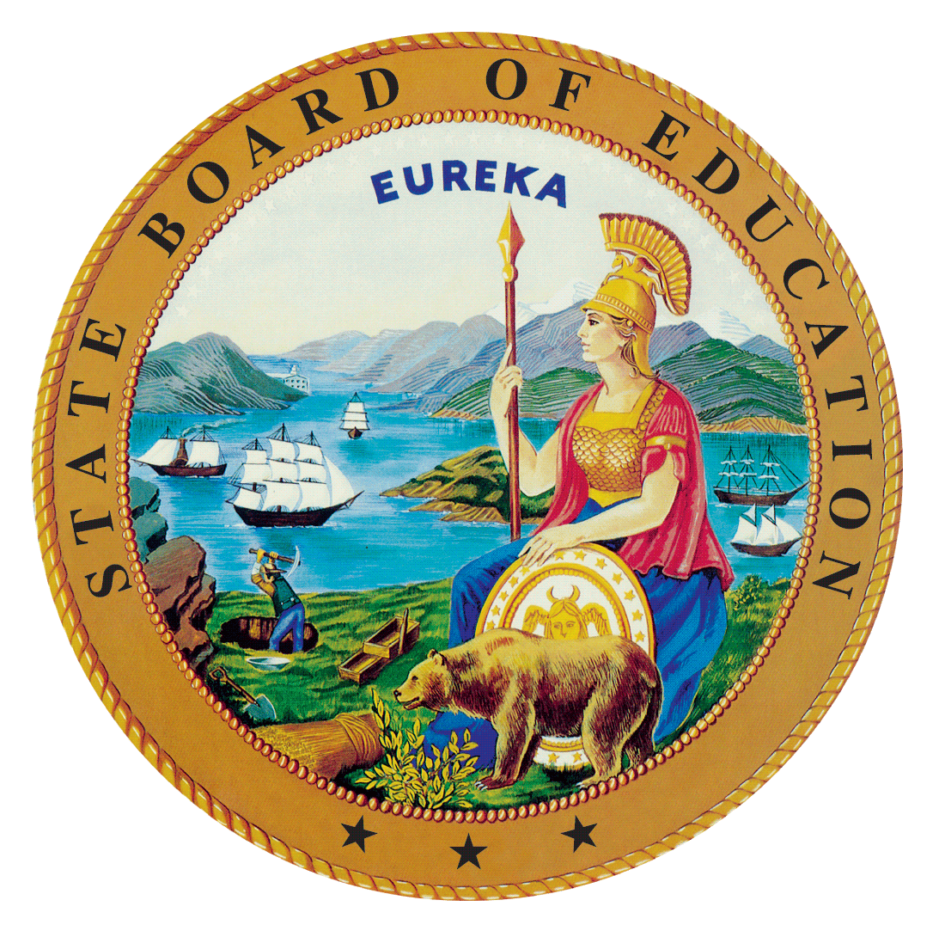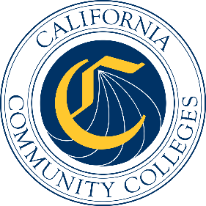

California Workforce Pathways
Joint Advisory Committee
July 2019
Agenda Item 01
Posted by California Department of Education

Subject
California Career Technical Education (CTE) Initiatives: Update on the Career Technical Education Incentive Grant (CTEIG) and the K–12 Strong Workforce Program (K–12 SWP) Metrics.

Type of Action
Action, Information

Summary of the Issue(s)
This is an update on the work of implementing the CTEIG and the K–12 SWP State CTE funding legislation focusing on student outcome metrics.

Recommendation
Staff from the California Department of Education (CDE) and California Community Colleges Chancellor’s Office (CCCCO) recommend that the California Workforce Pathways Joint Advisory Committee (CWPJAC) receive an update and provide feedback on student outcome metrics for the CTEIG and the K–12 SWP, as deemed necessary.

Brief History of Key Issues
After the first year of implementing the CTEIG and the K-12 SWP as complimentary programs to one another, CDE and CCCCO staff came together to do common planning for both programs and determine key objectives for moving forward. During the December 2018, CWPJAC meeting, metrics for both the CTEIG and the K-12 SWP were reviewed by the CWPJAC. The CWPJAC recommended to keep all metrics with the exception of metric (i) High School Cohort Graduation Rate. The CWPJAC recommended to change this metric in the CTEIG language to be consistent with the language in the same K-12 SWP metric and rename the metric as the following: (i) High School Graduation Rate.

Summary of Previous California Workforce Pathways Joint Advisory Committee Discussion(s) and Action(s)
The CWPJAC, per Education Code sections 53071 and 88828, has the annual responsibility for making recommendations regarding the use of metrics for the CTEIG and the K–12 SWP.
May 29, 2019: The CWPJAC received an update on the CTEIG and the K–12 SWP activities.
February 19, 2019: The CWPJAC received an update on the CTEIG and the K–12 SWP, including a brief demonstration of the NOVA platform.
January 11, 2019: The CWPJAC received an update on CTEIG and the K–12 SWP, including information on the December 19, 2018 release of the CTEIG Request for Applications (RFA), the development of the RFA for the K–12 SWP, and the regional information meetings held around the State.
December 14, 2018: Final review and approval of the metric recommendations for both the CTEIG and the K–12 SWP was unanimously approved by the CWPJAC. Final recommendations were submitted to the Department of Finance for consideration and were reflected in the January budget proposal language.
November 26, 2018: The CDE and CCCCO staff provided an in-depth review of proposed metrics, and their alignment to the CWPJAC Guiding Policy Principles to support K–14+ Pathways document. Based on direction from CWPJAC, the CDE and CCCCO staff revised the proposed metrics to operationalize the data, as well as provide information on the source of data collection.
September 28, 2018: The CDE and CCCCO staff jointly presented an initial overview of the CTEIG and the K–12 SWP metrics and received feedback, guidance and direction on appropriate metrics for measuring CTE program quality, and student achievement in kindergarten through grades fourteen (K–14) CTE programs.

Fiscal Analysis (as appropriate)
Funding available to eligible recipients under the CTEIG is $150 million annually, and on-going. Funding available under the K–12 SWP is $164 million, of which $150 million is available to eligible recipients. The remaining $14 million is for K–14 Technical Assistance Providers in support of both CTEIG and K-12 SWP initiatives.

Attachment(s)
Attachment 1: California Workforce Pathways Joint Advisory Committee Metric Recommendations

Slides 1: Career Technical Education Incentive Grant and K-12 Strong Workforce

