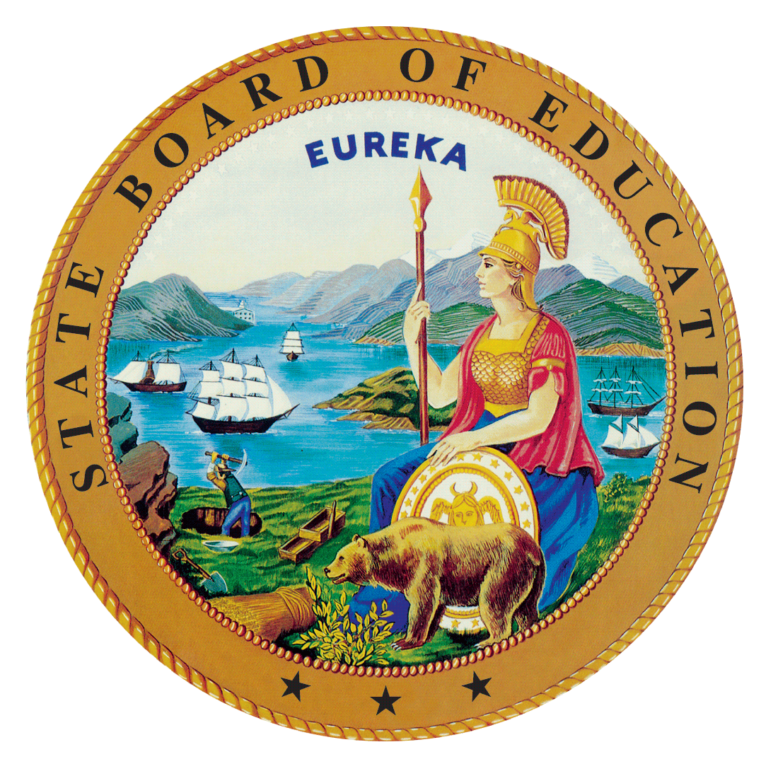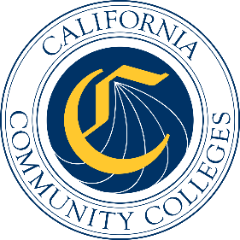

California Workforce Pathways
Joint Advisory Committee
November 2019
Agenda Item 03
Posted by the California Department of Education

Subject
First Reading of the Draft California Federal Perkins V State Plan to fulfil the requirements for the Strengthening Career and Technical Education for the 21st Century Act (Perkins V).

Type of Action
Action, Information

Summary of the Issue(s)
Draft California Federal Perkins V State Plan to fulfil the requirements for Perkins V will be presented. The Draft California Federal Perkins V State Plan responds to prompts under four different but inter-related strands: (1) plan development and consultation; (2) program administration and implementation; (3) fiscal responsibility; and (4) accountability for results. Input received from the different stakeholder groups has been included within the Draft California Federal Perkins V State Plan. What is not included within the Draft California Federal Perkins V State Plan are the comments provided by the public when the Draft California Federal Perkins V State Plan is posted for review. Once those comments are included within the federal state plan, a complete Draft California Federal Perkins V State Plan will be submitted for approval to the State Board of Education (SBE), the Board of Governors (BOG), and the Governor’s Office.

The federal state plan is an extension and refinement of the 2019–20 Perkins V transition plan, which was approved by the State Board of Education (SBE) at its May 8, 2019 meeting. The Board of Governors (BOG) of the California Community Colleges received an update on the Perkin V transition plan at its May 21, 2019 meeting. Submission of the federal state plan is required to fulfil the state’s obligation for receiving annually the over $127 million dollars in federal funds for career and technical education (CTE).

The information presented will summarize the federal state plan, highlighting key areas that relate to the four strands: (1) plan development and consultation; (2) program administration and implementation; (3) fiscal responsibility; and (4) accountability for results. While feedback from California Workforce Pathways Joint Advisory Committee (CWPJAC) members is being requested for the entire document, it is suggested that CWPJAC members focus on the following areas within each of these four strands: programs of study; size, scope and quality; comprehensive local needs assessment; local application plan; dual enrollment, work-based learning; budget and finance; and accountability. Overarching the four strands and the several focus areas are: the vision; the goals; the Guiding Policy Principles; and essential elements of a college and career pathway.
Draft California Federal Perkins V State Plan should be considered as part of a yet-to-be developed overall State Plan for Career Technical Education (CTE). At the October 2019 CWPJAC meeting, when it was still the intent to have a California State Plan for CTE as well as the federal state plan in one single draft document, members were provided a chapter-by-chapter review of an initial draft of the California State Plan for CTE and input from each member was solicited for each chapter. At the October 2019 meeting the decision to complete first the federal state plan that was approved by the CWPPJAC, discussion of the federal state plan was postponed to the November 2019 CWPJAC meeting. As a result, relevant content from the California State Plan for CTE was transferred into the Draft Federal California Federal Perkins V State Plan and it is that information that will be presented to the CWPJAC members.

In addition, a project timeline describes what tasks have been completed, and what tasks need completion in the near future. The timeline reflects the inclusion of separate meetings, since completed, with teacher and community college administrators of occupational administrators. Included among this latter group are community personnel that have responsibility for CTE on their campuses. Also discussed is the process for how the state will incorporate public comment feedback, and how the state will complete the final required steps that includes SBE, BOG, and the Governor’s Office approval, before submitting the federal state plan on or before the April 15, 2020 deadline.

Recommendation
The Draft California Federal Perkins V State Plan was jointly completed by the staff from the SBE, the CDE, and the California Community Colleges Chancellor’s Office (CCCCO). The SBE, the CDE, and the CCCCO staff jointly recommends that the CWPJAC receive information, provide input, and acts on the Draft California Federal Perkins V State Plan to the ED to fulfil the requirements for the Perkins V. Draft California Federal Perkins V State Plan has been provided as a separate attachment. The timeline is presented as a second separate attachment. An outline of the California State Plan for CTE is presented as third attachment.

Brief History of Key Issues
In 2008, the SBE approved the 2008-2012 California State Plan for Career Technical Education. This comprehensive plan, which the CDE and the CCCCO created collaboratively, was developed to not only meet the federal Carl D. Perkins Career and technical Education Act of 2006 (Perkins IV) requirements, but also to establish a vision and direction for CTE across California.
Staff from the CDE and the CCCCO have been working closely with staff from the SBE since spring 2017 to reconvene the CWPJAC, as required by California Education Code Section 12503, in preparation for developing a California State Plan for CTE.
On July 31, 2018, the federal Perkins V was signed into law which reauthorized the federal Perkins IV. As part of the transition to Perkins V, California elected to submit a one-year transition plan in May 2019, with the full State Plan due in April 2020. In April 2019, the Office of Career, Technical, and Adult Education (OCTAE) released the final guidance for the Perkins V, which can be found at the following web link, https://s3.amazonaws.com/PCRN/docs/1830-0029-Perkins_V_State_Plan_Guide-Expires_4-30-22.pdf.
The 2019–20 transition plan was approved by the State Board of Education (SBE) at its May 8, 2019 meeting, and the Board of Governors of the California Community Colleges received an update at its May 21, 2019 meeting. The CDE submitted the approved transition plan to the ED on May 24, 2019. On July 2, 2019, the CDE received notification from the ED that the 2019–20 transition plan was approved and Perkins funding for California was made available starting July 1, 2019. (https://www.cde.ca.gov/ci/ct/gi/workpathjac.asp)
Given that there has always been a short timeframe in developing, validating, and finalizing the California Federal Perkins V State Plan, and after many conversations between the CDE, the CCCCO, and the SBE staff, three options were considered: (1) to only complete a Perkins V state plan, (2) to complete a comprehensive state plan for CTE, including the Perkins V requirements, or (3) to focus on the State Plan for CTE and continue working on the federal Perkins V requirements, making it become a fully comprehensive California State Plan for CTE. Staff presented the third option to the state advisory committee at its May 2019 meeting as a way to develop a comprehensive plan including all state CTE programs administered by both CDE and the CCCCO, and to ensure alignment to the Local Control Accountability Plans submitted by local educational agencies as well as the Student-Centered Funding Formula. Over subsequent meetings of the CWPJAC, the focus continued to be on the State Plan of CTE
Throughout the state plan development process, staff anticipates adjustments and will be updating the CWPJAC, the SBE, and BOG members. The purpose here is to keep CWPJAC, the SBE, and BOG members abreast of any changes that are deemed necessary as a result of public response, stakeholder input, and member comments serving on the CWPJAC, the SBE, BOG, and the Governor’s Office.

Summary of Previous California Workforce Pathways Joint Advisory Committee Discussion(s) and Action(s)

October 2019: A draft California State Plan for CTE (as of the end of August 2019) has been provided to the CWPJAC members as well as a proposed draft timeline was provided. A chapter-by-chapter review of the draft State CTE Plan was presented, discussed, and input on each chapter was solicited It was decided that the CWPJAC staff should work on the California Federal Perkins V State Plan and present it to the CWPJAC members at November meeting. A proposed draft timeline was presented. Completed and upcoming meetings with regard to the California Federal Perkins V State Plan were discussed.

September 2019: A draft State Plan for CTE (as of the end of August 2019) has been provided to the CWPJAC members as well as a proposed draft timeline was provided.

July 2019: The CWPJAC staff introduced an updated draft timeline and planned activities for completing a new California State Plan for CTE.

May 2019: The CWPJAC staff introduced a draft timeline and planned activities for completing a new California State Plan for CTE.
March 2019: Joint Advisory received updates on the Career Technical Education Incentive Grant (CTEIG) and the K-12 Strong Workforce Program (K–12SWP).

February 2019: Joint Advisory received updates on the CTEIG and the K-12SWP.

January 2019: Joint Advisory received updates on the CTEIG and the K-12SWP.

December 2018: The CTEIG and the K-12SWP initiatives were discussed and the metrics were aligned to the Committee’s guiding policy principles.

March 2008: On March 12, 2008, the SBE unanimously approved the 2008–2012 California State Plan for Career Technical Education, as required by the Perkins IV, which had been previously approved by the BOG on March 3, 2008. The State Plan was subsequently approved by the ED on July 1, 2008.

January 2008: The SBE held a public hearing on the 2008–2012 California State Plan for Career Technical Education, as was required by the Perkins IV.

Fiscal Analysis (as allocated)
In 2018–19 the Perkins IV allocation was $120,196,084; for 2019–20, the Perkins V allocation is $127,058,834.

Attachment(s)
Attachment 1: Draft California Federal Perkins V State Plan
Attachment 2: California State Plan for Career Technical Education Working Timeline
Attachment 3: California State Plane for Career Technical Education Outline
Presentation Slides

