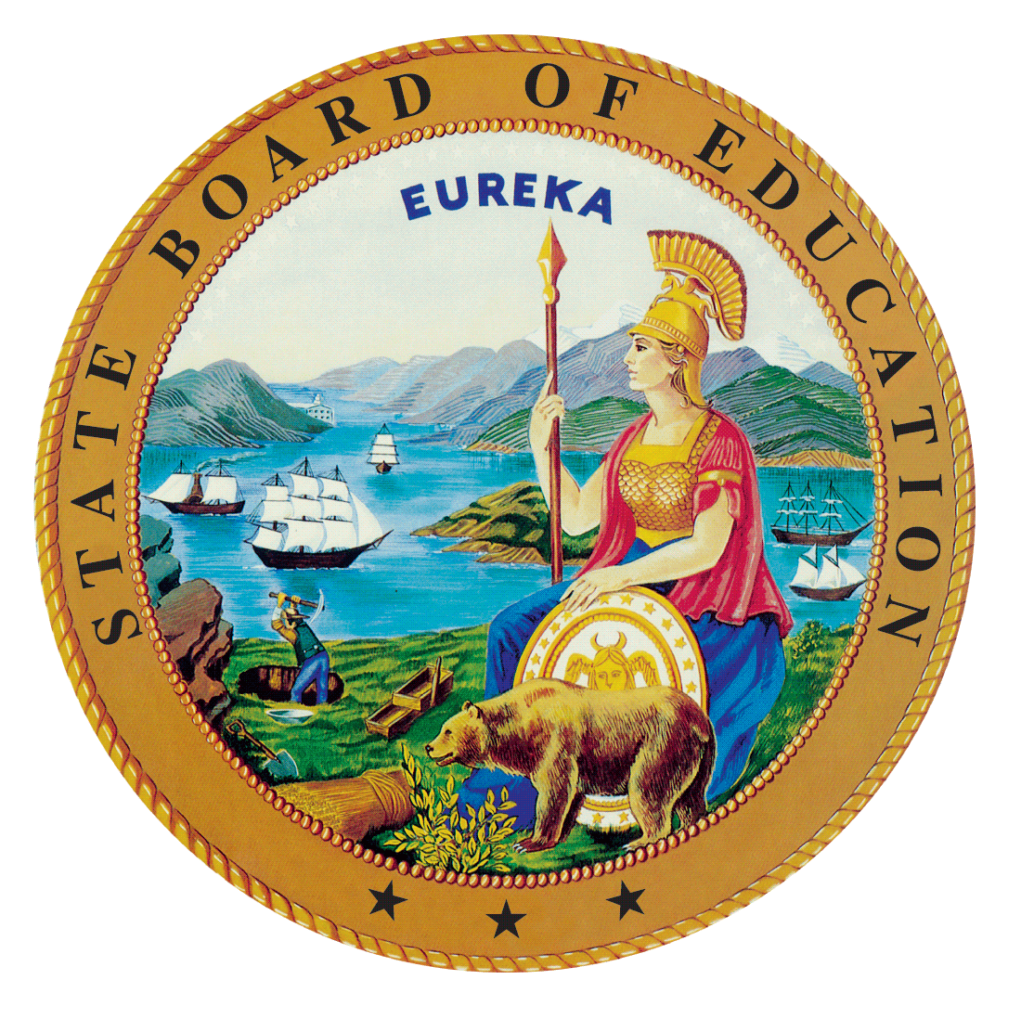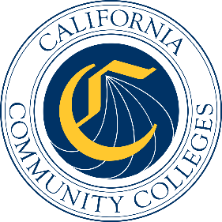

California Workforce Pathways
Joint Advisory Committee
October 2019
Agenda Item 02
Posted by the California Department of Education

Subject
Update and review on the development of the California State Plan for Career Technical Education (CTE), including requirements for the federal Strengthening Career and Technical Education for the 21st Century Act (Perkins V).

Type of Action
Action, Information

Summary of the Issue(s)
An update of the California State Plan for CTE will be presented. What will be described is two sections of the Plan, one of which is the State Plan for CTE, and the other is the federal application for meeting the requirements for fulfilling the state’s obligation for receiving annually the over $127 million dollars in federal funds for CTE. The information provided is a chapter by chapter review that provides content overview, status update, plan for completion, and comments from the California Workforce Pathways Joint Advisory Committee (CWPJAC) members. In addition, a project timeline describes what tasks have been completed, and what tasks need completion in the near future. Also, the process for how the state will summarize the stakeholder information received, incorporate public comment feedback, and delineate the final steps before submitting the California State Plan for CTE to the US Department of Education on or before April 15, 2020.

Recommendation
To complete the work on the State Plan for CTE, staff from the State Board of Education (SBE), the California Department of Education (CDE), and the California Community Colleges Chancellor’s Office (CCCCO) are working jointly to develop, validate and complete the new State Plan for CTE. The SBE, the CDE, and the CCCCO staff jointly recommends that the California Workforce Pathways Joint Advisory Committee (CWPJAC) review and provide input into the California State Plan for CTE. A draft version of the State Plan for CTE has been provided as a separate attachment, which shows the work to date. Please keep in mind additions and refinements will be occurring for the next several weeks, with a Draft Plan (referred to as Draft Plan A) brought forward for full discussion at the CWPJAC November 8, 2019 meeting.

Brief History of Key Issues
In 2008, the SBE approved the 2008-2012 California State Plan for Career Technical Education. This comprehensive plan, which the CDE and the CCCCO created collaboratively, was developed to not only meet the federal Carl D. Perkins Career and technical Education Act of 2006 (Perkins IV) requirements, but also to establish a vision and direction for CTE across California.
Staff from the CDE and the CCCCO have been working closely with staff from the SBE since spring 2017 to reconvene the CWPJAC, as required by California Education Code Section 12503, in preparation for developing a California State Plan for CTE.
On July 31, 2018, the federal Perkins V was signed into law which reauthorized the federal Perkins IV. As part of the transition to Perkins V, California elected to submit a one-year transition plan in May 2019, with the full State Plan due in April 2020. In April 2019, the Office of Career, Technical, and Adult Education (OCTAE) released the final guidance for the Perkins V, which can be found at the following web link, https://s3.amazonaws.com/PCRN/docs/1830-0029-Perkins_V_State_Plan_Guide-Expires_4-30-22.pdf.
The 2019–20 transition plan was approved by the State Board of Education (SBE) at its May 8, 2019 meeting, and the Board of Governors of the California Community Colleges received an update at its May 21, 2019 meeting. The CDE submitted the approved transition plan to the United States Department of Education (ED) on May 24, 2019. On July 2, 2019, the CDE received notification from the ED that the 2019-20 transition plan was approved and Perkins funding for California was made available starting July 1, 2019. (https://www.cde.ca.gov/ci/ct/gi/workpathjac.asp)
Given that there is a short timeframe in developing, validating, and finalizing the State Plan for CTE, and after many conversations between the CDE, the CCCCO, and the SBE staff, three options were considered: (1) to only complete a Perkins V state plan, (2) to complete a comprehensive state plan for CTE, including the Perkins V requirements, or (3) to focus on the State Plan for CTE and continue working on the federal Perkins V requirements, making it become a fully comprehensive California State Plan for CTE. Staff presented the third option to the state advisory committee at its May 2019 meeting as a way to develop a comprehensive plan including all state CTE programs administered by both CDE and the CCCCO, and to ensure alignment to the Local Control Accountability Plans submitted by local educational agencies as well as the Student-Centered Funding Formula.
Throughout the state plan development process, staff anticipates adjustments and will be updating the CWPJAC, the SBE, and BOG members. The purpose here is to keep CWPJAC, the SBE, and BOG members abreast of any changes that are deemed necessary as a result of public response, stakeholder input, and member comments serving on the CWPJAC, the SBE, BOG, and the Governor’s Office.

Summary of Previous California Workforce Pathways Joint Advisory Committee Discussion(s) and Action(s)

September 2019: A draft State Plan for CTE (as of the end of August 2019) has been provided to the CWPJAC members as well as a proposed draft timeline was provided.

July 2019: The CWPJAC staff introduced an updated draft timeline and planned activities for completing a new California State Plan for CTE.

May 2019: The CWPJAC staff introduced a draft timeline and planned activities for completing a new California State Plan for CTE.
March 2019: The CDE and CCCCO staff presented the Draft 2019–20 Perkins V State Transition Plan to the CWPJAC. The CWPJAC members provided feedback for staff to consider while continuing to work on the transition plan.
February 2019: The CDE and CCCCO staff presented responses to the Programs of Study, Special Populations, and Fiscal Responsibility sections of the transition plan to the CWPJAC. The CWPJAC members provided extensive feedback for staff to consider while continuing to work on the transition plan.
January 2019: The CDE and CCCCO staff presented the current requirements for the state’s 2019–20 transition plan for the new Perkins V legislation.
December 2018: The CDE and CCCCO staff presented a draft timeline to the CWPJAC that outlined when items need to be completed in order to meet the deadline for submission of the State’s 2019–20 transition plan to the United States Department of Education.
November 2018: The CDE staff provided a brief update on the activities around the new Perkins V legislation.
September 2018: Michael Brustein, Brustein & Manasevit, PLLC, Attorneys at Law, provided an overview of the new Perkins V legislation, known as the Strengthening Career and Technical Education for the 21st Century Act.
March 2008: On March 12, 2008, the SBE unanimously approved the 2008–2012 California State Plan for Career Technical Education, as required by the Perkins IV, which had been previously approved by the BOG on March 3, 2008. The State Plan was subsequently approved by the ED on July 1, 2008.

January 2008: The SBE held a public hearing on the 2008–2012 California State Plan for Career Technical Education, as was required by the Perkins IV.

Fiscal Analysis (as allocated)
In 2018–19 the Perkins IV allocation was $120,196,084; for 2019–20, the Perkins V allocation is $127,058,834.

Attachment(s)
Attachment 1: Draft – California State Plan for Career Technical Education

