Mathematics Framework
Adopted by the State Board of Education on July 12, 2023
Page 1 of 134

Mathematics Framework
Chapter Six: Mathematics: Investigating and Connecting, Transitional Kindergarten through Grade Five

Mathematics Framework Chapter Six: Mathematics: Investigating and Connecting, Transitional Kindergarten through Grade Five 1
Introduction 3
Investigating and Connecting Mathematics 3
Teaching the Big Ideas 9
Designing Instruction to Investigate and Connect the Why, How, and What of Math 10
Investigating and Connecting, Transitional Kindergarten Through Grade Two 18
Content Connections Across the Big Ideas, Transitional Kindergarten Through Grade Two 19
The Big Ideas, Transitional Kindergarten Through Grade Two 40
Investigating and Connecting, Grades Three Through Five 49
Content Connections Across the Big Ideas, Grades Three Through Five 51
Content Connections, Grades Three Through Five 53
The Big Ideas, Grades Three Through Five 116
Transition from Transitional Kindergarten Through Grade Five to Grades Six Through Eight 124
How Does Learning in Transitional Kindergarten Through Grade Five Lead to Success in Grades Six Through Eight When Students Reason with Data? 124
How Does Learning in Transitional Kindergarten Through Grade Five Lead to Success in Grades Six Through Eight When Students Are Exploring Changing Quantities? 124
How Does Learning in Transitional Kindergarten Through Grade Five Lead to Success in Grades Six Through Eight When Students Are Taking Numbers Apart, Putting Parts Together, Representing Thinking, and Using Strategies? 125
How Does Learning in Transitional Kindergarten Through Grade Five Lead to Success in Grades Six Through Eight When Students Are Discovering Shape and Space? 126
Conclusion 126
Long Descriptions for Chapter Six 127

Introduction
Focused on transitional kindergarten through grade five (TK–5), this chapter is the first of three (chapters six, seven, and eight) that discuss how this framework’s approach to mathematics instruction unfolds throughout elementary, middle, and high school. The framework envisions mathematics in transitional kindergarten through grade five as a vibrant, interactive, student-centered endeavor of investigating and connecting the big ideas of mathematics. From transitional kindergarten through fifth grade, children experience enormous growth in maturity, reasoning, and conceptual understanding. They develop an understanding of such concepts as place value, arithmetic operations, fractions, geometric shapes and properties, and measurement. Students who have gained an understanding of math taught in the elementary grades and enter sixth grade viewing themselves as mathematically capable are positioned for success in middle school and beyond.
Looking separately at transitional kindergarten through grade two and grades three through five, this chapter examines in depth how teachers can organize early-grade instruction around the Content Connections, which connect the mathematical big ideas. Teachers use meaningful math activities that nourish students’ curiosity and develop their reasoning skills, at the same time connecting math content and mathematical practices within and across grade levels.

Investigating and Connecting Mathematics
The goal of the California Common Core State Standards for Mathematics (CA CCSSM) is for students at every grade level to make sense of mathematics. To achieve that goal, the framework recommends that teachers take a “big ideas” approach to math instruction (see full discussion in chapter one). It encourages teachers to think about math as a series of big ideas that enfold clusters of standards and that connect concepts. And it encourages them to teach these ideas in multidimensional ways that meet the broad range of student learning needs. Starting in transitional kindergarten through grade five, teachers organize and design instruction in the spirit of investigating the big ideas and connecting both content and mathematical practices within and across grade levels and mathematical domains. This approach emphasizes students’ active engagement in the learning process, offering frequent opportunities for students to engage with one another in connecting the big ideas.
Mathematical investigations promote understanding (Sfard, 2007), language for communicating about mathematics (Moschkovich, 1999), and mathematical identities (Langer-Osuna and Esmonde, 2017). Teachers create a supportive climate for investigations by providing frequent opportunities for mathematical discourse—that is, opportunities to construct mathematical arguments and attend to, make sense of, and respond to the mathematical ideas of others. Throughout, teachers also attend to equitably involving and engaging all students.
Ensuring frequent opportunities for mathematical discourse. Mathematical discourse can center student thinking through such tasks as offering, explaining, and justifying mathematical ideas and strategies. Discourse includes communicating about mathematics with words, gestures, drawings, manipulatives, representations, symbols, and other helpful learning tools. In the early grades, for example, students might explore geometric shapes, investigate ways to compose and decompose them, and reason with peers about attributes of objects. Teachers’ orchestration of mathematical discussions (see Stein and Smith, 2018) involves modeling mathematical thinking and communication, noticing and naming students’ mathematical strategies, and orienting students to one another’s ideas.
Opportunities for mathematical discourse can emerge throughout the school day, even for the youngest learners. When pencils are needed at each table of students, the teacher can ask, how many at each table? What is the total number of pencils needed? When more milk cartons are needed from the cafeteria, the teacher asks, how many more? Other questions arise along the way. How many minutes until lunch time? How can you tell? How many more cotton balls are needed for this activity? How do you know? Solving these and other problems in classroom conversation allows children to see how mathematics is an indelible aspect of daily living.
As young students participate in mathematical discussions, they begin to develop their mathematical communication skills. Prompted by further questions—“How did you get that?” “Why is that true?”—they explain their thinking to others and respond to others’ thinking. Teachers can also help students adopt and use such questions as learning tools. For example, teachers can post sentence frames or charts on the wall. Especially if they reflect work generated by the class, such language support tools help build activities that support students’ long-term engagement with mathematics. The tools are effective for all students and especially important for those who are English learners.
Other math discourse prompts include activities such as Compare and Connect (Kazemi and Hintz, 2014). Students compare two mathematical representations (e.g., place value blocks, number lines, numerals, words, fraction blocks) or two methods (e.g., counting up by fives, going up to 30 and then coming back down three more). Teachers then might ask the following:
- Why did these two different-looking strategies lead to the same results?
- How do these two different-looking visuals represent the same idea?
- Why did these two similar-looking strategies lead to different results?
- How do these two similar-looking visuals represent different ideas?
Another activity, Critique, Correct, Clarify (Zweirs et al., 2017), provides students with incorrect, ambiguous, or incomplete mathematical arguments (e.g., “Two hundreds is more than 25 tens because hundreds are bigger than tens”) and asks them to practice respectfully making sense of, critiquing, and suggesting revisions together.
As students engage in mathematical discourse, they begin to develop the ability to reason and analyze situations as they consider questions such as, “Do you think that would happen all the time?” and, “I wonder why…?” These questions drive mathematical investigations. Students construct arguments not only with words, but also using concrete referents, such as objects, pictures, drawings, and actions. They listen to one another’s arguments, decide if the explanations make sense, and ask appropriate questions. For example, to solve 74 - 18, students might use a variety of strategies to discuss and critique each other’s reasoning and strategies.
As students progress through the elementary and into the middle grades, authentic opportunities for mathematical discourse increase and become more complex. Engaging and meaningful mathematical activities (described in chapter two) encourage students to explore and make sense of numbers, data, and space and to think mathematically about the world around them. The process of using student discourse and argumentation to drive learning is explored further in chapter four.
Providing experiences with rich, open-ended activities. Through math centers, collaborative tasks, and other rich, open-ended math experiences, young students learn ways to use appropriate tools purposefully and strategically—that is, they begin to consider available tools when solving a mathematical problem and make decisions about when certain tools might be helpful. In environments that support this, a kindergartner may decide to use available linking cubes to represent two quantities and then compare the two representations side by side—or, later, make math drawings of the quantities. In grade level two, while measuring the length of a hallway, students are able to explain why a yardstick is more appropriate to use than a ruler. Tools such as counters, place-value (base-ten) blocks, hundreds number boards, concrete geometric shapes (e.g., pattern blocks or three-dimensional solids), and virtual representations support conceptual understanding and mathematical thinking. Depending on the problem or task, students decide which tools to use, then reflect on and answer questions such as, “Why was that tool helpful?”
From early on, the environment should support children’s interest in looking for and making use of mathematical structure. For instance, students recognize that 3 + 2 = 5 and 2 + 3 = 5. Students use counting strategies—such as counting on, counting all, or taking away—to build fluency with facts to 5. They notice the written pattern in the “teen” numbers—that the numbers start with 1 (representing one 10) and end with the number of additional ones. While decomposing two-digit numbers, students realize that any two-digit number can be broken up into tens and ones (e.g., 35 = 30 + 5, 76 = 70 + 6). They use structure to understand subtraction as an unknown addend problem (e.g., 50 – 33 = [blank], can be written as 33 + [blank] = 50 and can be thought of as, “How much more do I need to add to 33 to get to 50?”).
Children also thrive when they have opportunities to look for regularity and repeatedly express their reasoning. In the early grades, they notice repetitive actions in counting, computations, and mathematical tasks. For example, the next number in a counting sequence is one more when counting by ones and 10 more when counting by tens (or one more group of 10). Students should be encouraged to answer questions based on, “What would happen if …?” and “There are 8 crayons in the box. Some are red and some are blue. How many of each could there be?” Kindergarten students realize eight crayons could include four of each color (8 = 4 + 4), 5 of one color and 3 of another (8 = 5 + 3), and so on. Students in first grade might add three one-digit numbers by using strategies such as “make a 10” or doubles.
Students recognize when and how to use strategies to solve similar problems. For example, when evaluating 8 + 7 + 2, a student may say, “I know that 8 and 2 equals 10, then I add 7 to get to 17. It helps if I can make a ten out of two numbers when I start.” The process of using student discussion and argumentation to drive learning is explored further in chapter 4.
Teaching for equity and engagement. Research shows that students achieve at higher levels when they are actively engaged in the learning process (Boaler, 2016; CAST, n.d.). Educators can increase student engagement by selecting challenging mathematics problems that invite all learners—including English learners, students from differing cultural backgrounds, and those with learning disabilities—to engage and succeed. Such problems
- involve multiple content areas;
- highlight contributions of diverse cultural groups;
- invite curiosity;
- allow for multiple approaches, collaboration, and representations in multiple languages; and
- carry the expectation that students will use mathematical reasoning.
Students who are learning English face a dual challenge in English-only settings as they endeavor to acquire mathematics content and the language of instruction simultaneously. Teachers can support their progress, in part, by drawing on students’ existing linguistic and communicative ability and making language resources available, particularly during small-group work. Children’s ability to use their home language in these early years can ensure they are able to express their knowledge and thinking and not be limited by their level of English proficiency. Teachers can also highlight specific vocabulary as it arises in context or revoice students’ mathematical contributions in more formal terms, describing how the precise mathematical meaning might differ from the common use of the same word (e.g., words like “yard,” “difference,” or “area”).
All students, including those with learning differences, will benefit from these and similar attentions during whole-class, small-group/partner, or independent work periods. (Additional discussion of equity-based shifts in the teacher’s role are found in chapter two.)
As teachers come to know their students, families, and communities well, they can increase the cultural relevance of mathematics instruction by connecting classroom mathematics to features of the community (Bartell and Flores, eds., 2014; Ferlazzo, 2020). A photo of prices posted at a local store, for example, could initiate a mathematics lesson. If students’ cultures have strong associations with music, dance, or other forms of artistic expression, mathematics instruction can incorporate these elements. (Chapter one provides guidance on supporting the academic growth of English learners and students with learning disabilities. Chapter two discusses in detail the value of teaching with open tasks as a means of engaging all learners at levels of challenge appropriate to them.)
Equitable instruction also means ensuring students’ access to rich mathematics, preparing them for what they will learn in grade six and beyond. Tracking—which often manifests as early as the elementary grades—can limit current and later options for many students if it denies them access to meaningful mathematics. Research has identified successful alternatives to this kind of early tracking in mathematics, including the use of Complex Instruction for teaching heterogeneous groups in which all students grow in their understanding and achievement (Lotan and Holthuis, 2021; see also Featherstone et al., 2011). Teachers can use guidance provided throughout this document to support the participation of all learners in rich mathematical activity.
The hypothetical vignette Comparing Numbers and Place Value Relationships—Grade Four, Integrated English Language Development reflects the research about supporting students who are English learners in mathematical activities and highlights ways that teachers can build on students’ existing knowledge and support their developing understandings.

Teaching the Big Ideas
Teaching big ideas is one of the five main components of teaching for equity and engagement. This is discussed at length in chapter 2, where TK through grade five teachers will find much of value, including the vignette Productive Partnerships in which students in grade four engage in and strengthen their capacity for several mathematical practices as they are challenged by an open task of creating equations using four 4s.
Big ideas are central to the learning of mathematics and link numerous mathematics understandings into a coherent whole (Charles, 2005). In this framework, the big ideas are delineated by grade level and are the core content of each grade. For example, in grade one there are seven big ideas that form an organized network of connections; the ideas are measuring with objects, clocks and time, equal expressions, reasoning about equality, tens and ones, make sense of data, and equal parts inside shapes. The big ideas and their connections for each grade are diagramed in the sections below that cover transitional kindergarten through grade two and grades three through five, respectively.
In the classroom, teachers teach the big ideas by designing instruction around student investigations of intriguing, authentic experiences relevant to students’ grade level, backgrounds, and interests. Teachers in transitional kindergarten through grade five initiate and guide explorations that engage young children and pique their curiosity. To understand mathematics, even the youngest students must be doers of math—the ones who do the thinking, do the explaining, and do the justifying. In this paradigm, teachers support learning by recognizing, respecting, and nurturing their students’ ability to develop deep mathematical understanding (Hansen and Mathern, 2008). As teachers plan for instruction, they too are doers of mathematics. Teachers work through the tasks themselves in order to anticipate the approaches students may take, partial understandings students may have, and challenges students may encounter in their explorations.
Investigations may motivate students and contribute to their ability to learn focused, coherent, and rigorous mathematics. They may also help teachers to focus instruction on the big ideas. Far from haphazard, investigations as envisioned in the framework are guided by a conception of the why, how, and what of mathematics—a conception that makes connections across different aspects of content and also connects content with mathematical practices.

Designing Instruction to Investigate and Connect the Why, How, and What of Math
To help teachers design instruction using the big-ideas approach, figure 6.1 maps out the interplay at work when this conception is used to structure and guide student investigations (see chapter one). Three Drivers of Investigation (DIs)—sense-making, predicting, and having an impact—provide the why of an activity. Eight Standards for Mathematical Practice (SMPs) provide the how. And four Content Connections (CCs), which ensure coherence throughout the grade levels, provide the what.
Figure 6.1 The Why, How and What of Learning Mathematics
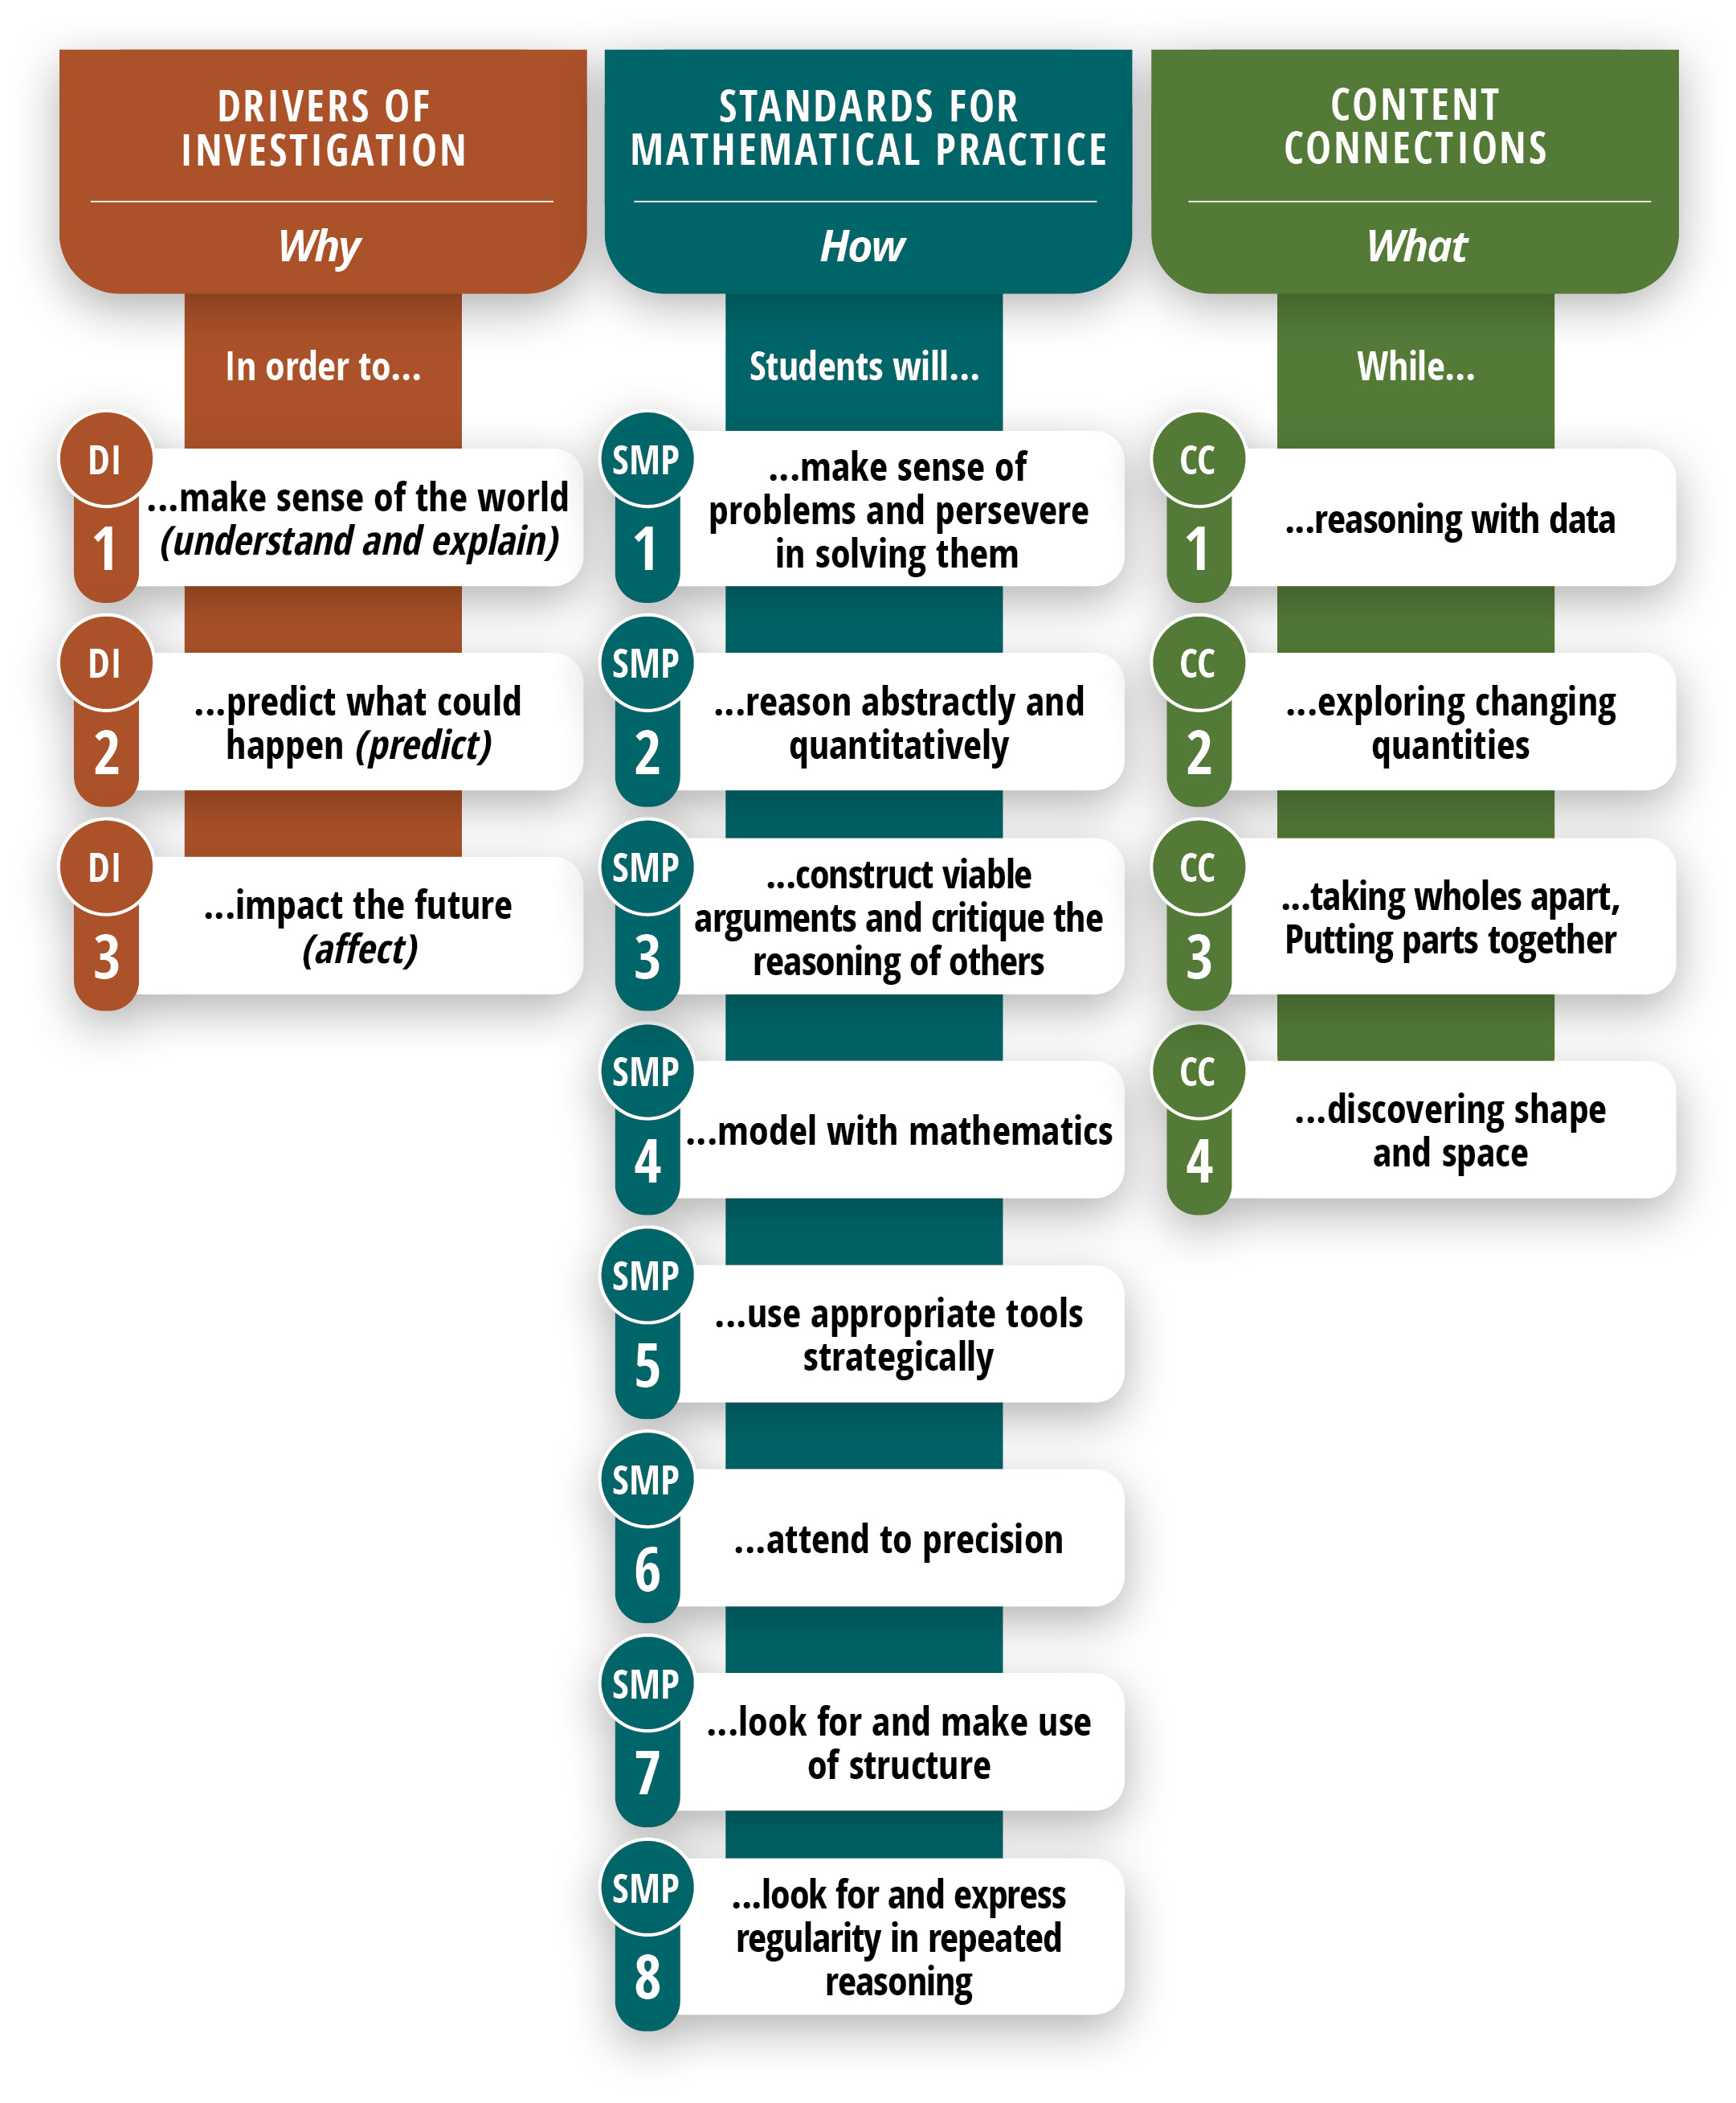
Long description of figure 6.1
Note. The activities in each column can be combined with any of the activities in the other columns.
The following diagram (figure 6.2) is meant to illustrate how the Drivers of Investigation can propel the ideas and actions framed in the Standards for Mathematical Practice and the Content Connections.
Figure 6.2 Drivers of Investigation, Standards for Mathematical Practice, and Content Connections
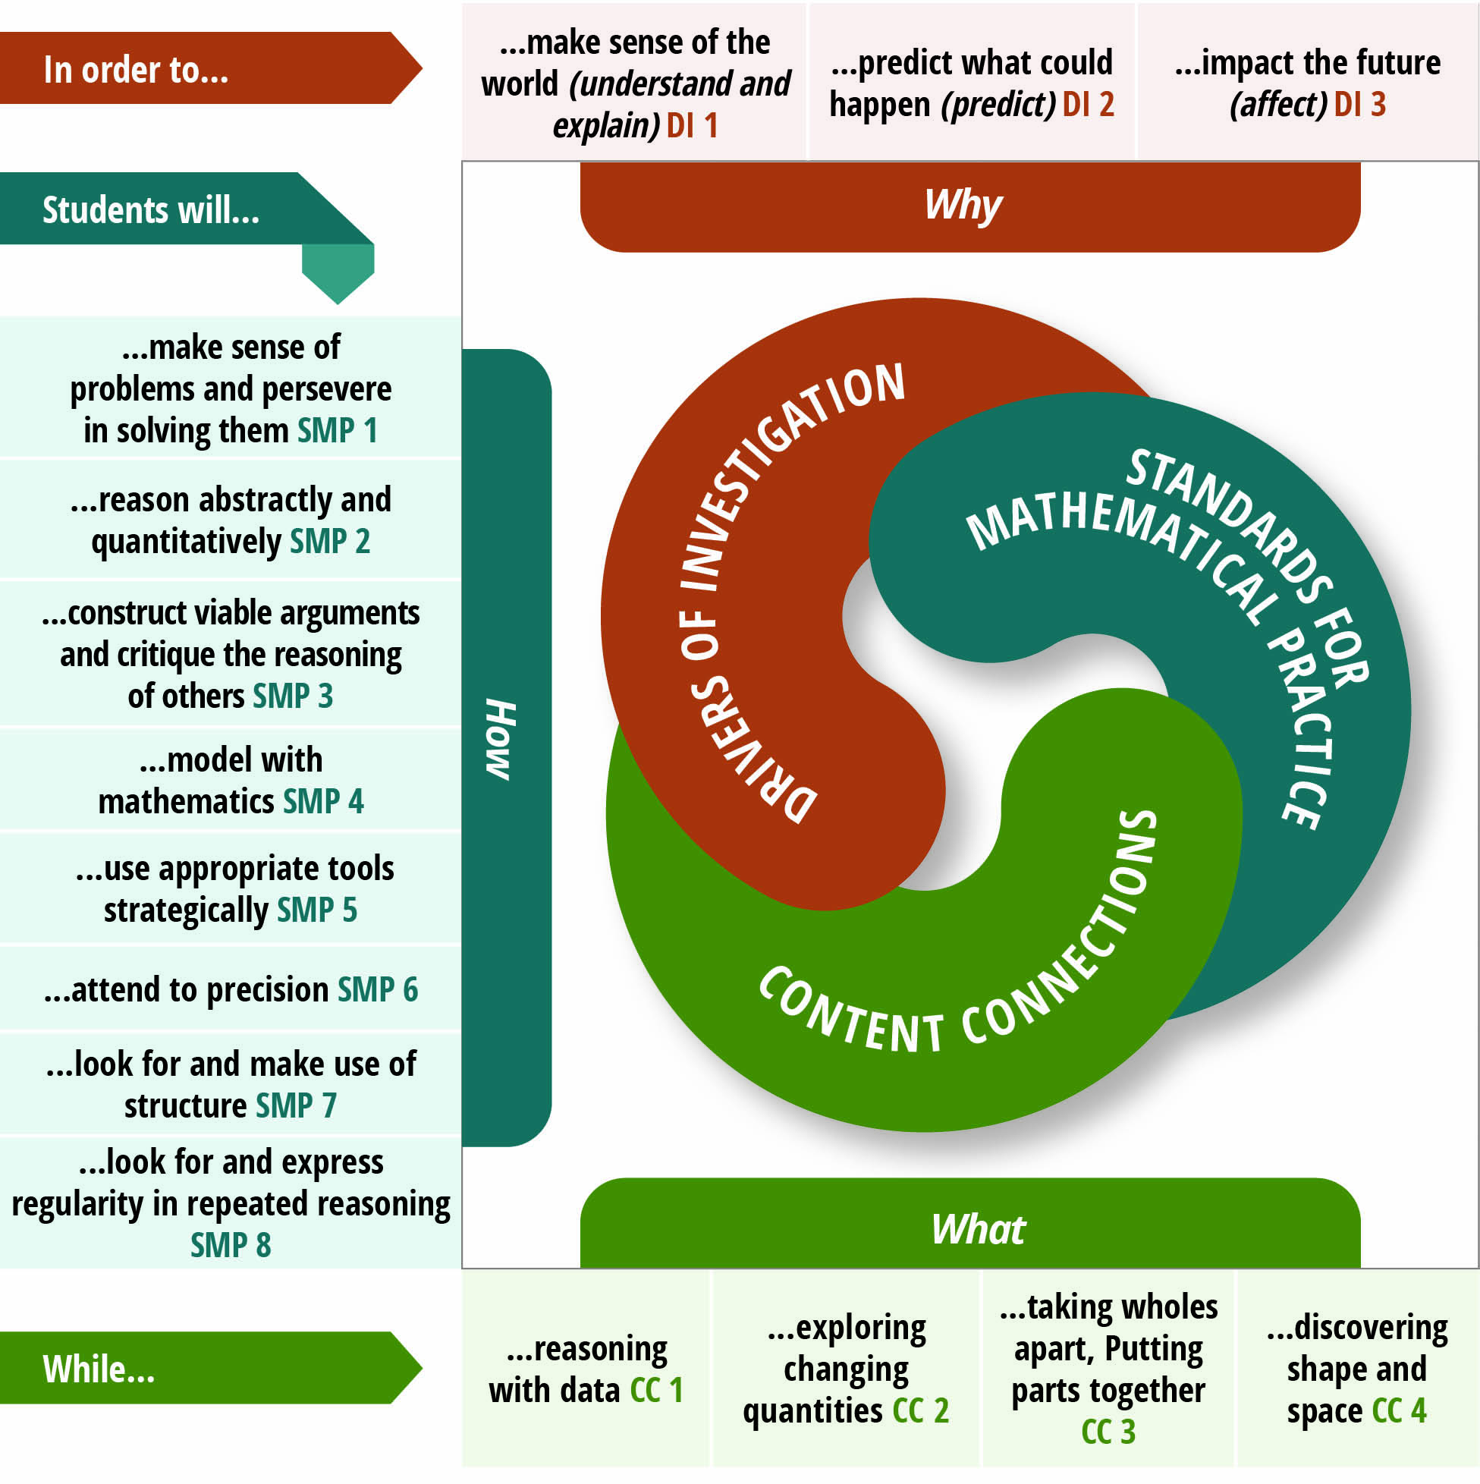
Long description of figure 6.2

The Importance of Drivers of Investigation and Content Connections
While chapter five focuses on the SMPs, this chapter and chapter seven (middle school) are organized around the Drivers of Investigation and the Content Connections. The three DIs aim to ensure that there is always a reason to care about mathematical work and that investigations allow students to make sense of, predict, and/or affect the world. The four CCs organize content and connect the big ideas—that is, provide mathematical coherence—throughout the grade levels.
Drivers of Investigation
DI1: Make Sense of the World (Understand and Explain)
DI2: Predict What Could Happen (Predict)
DI3: Impact the Future (Affect)
To teach the grade level’s big ideas, a teacher will design instructional activities that link one or more of the CCs with a DI—for example, link reasoning with data (CC1) to predict what could happen (DI2), or link exploring changing quantities (CC2) to impact the future (DI3). Because students actively engage in learning when they find purpose and meaning in the learning, instruction should primarily involve tasks that invite students to make sense of the big ideas through investigation of questions in authentic contexts.
An authentic activity or problem is one in which students investigate or struggle with situations or questions about which they actually wonder. Lesson design should be built to elicit that wondering. For example, environmental issues on the school campus or in the local community provide rich contexts for student investigations and mathematical analysis, which, concurrently, help students develop their understanding of California’s Environmental Principles and Concepts. An activity or task can be considered authentic if, as they attempt to understand the situation or carry out the task, students see the need to learn or use the mathematical idea or strategy.
The four CCs are of equal importance; they are not meant to be addressed sequentially. There is considerable crossover between and among the practice standards and the content connections. For example, content standard 4.NF.2 (compare two fractions with different numerators and different denominators) may be addressed during an investigation in which students reason with data (CC1) and the same standard might also be addressed by lessons in which students take wholes apart and/or put parts together (CC3).
The content involved over the course of a single investigation cuts across several CA CCSSM domains—for example, it may involve both Measurement and Data, Number and Operations in Base Ten (NBT), as well as Operations and Algebraic Thinking (OA). Students simultaneously employ several of the SMPs as they conduct their investigations.

The Importance of the Standards for Mathematical Practice
The CA CCSSM offer grade-level-specific guidelines for what mathematics topics are considered essential to learn and for how students should engage in the discipline using the SMPs. The SMPs reflect the habits of mind and of interaction that form the basis of math learning—for example, reasoning, persevering in problem solving, and explaining one’s thinking.
To teach mathematics for understanding, it is essential to purposefully cultivate students’ use of the practices. The introduction to the CA CCSSM is explicit on this point. Identifying content standards and practice standards as two halves of a powerful whole, it says effective mathematics instruction requires that the SMPs be taught as carefully and intentionally as the content standards and must be practiced by students just as carefully and intentionally (CA CCSSM, 3). The SMPs are designed to support students’ development across the school years. Whether in the primary grade levels or high school, for example, students make sense of problems and persevere to solve them (SMP1).

Standards for Mathematical Practice
SMP1. Make sense of problems and persevere in solving them
SMP2. Reason abstractly and quantitatively
SMP3. Construct viable arguments and critique the reasoning of others
SMP4. Model with mathematics
SMP5. Use appropriate tools strategically
SMP6. Attend to precision
SMP7. Look for and make use of structure
SMP8. Look for and express regularity in repeated reasoning
The importance of the SMPs is discussed at length in chapter four, which provides additional guidance on how teachers can cultivate students’ skillful use of the SMPs. Using three interrelated SMPs for illustration, chapter four demonstrates how teachers across the grade levels can incorporate key mathematical practices and integrate them with each other to create powerful math experiences centered on exploring, discovering, and reasoning. Such experiences enable students to develop and extend their skillful use of these practices as they move through the progression of math content in the coming grade levels.
The SMPs are central to the mathematics classroom. From the earliest grades, mathematics involves making sense of and working through problems. In kindergarten, first, and second grades, students begin to understand that doing mathematics involves solving problems, and they begin to discuss how they can solve them through a range of approaches (SMP 1). Young students also reason abstractly and quantitatively (SMP 2). They begin to recognize that a number represents a specific quantity and connect the quantity to written symbols. For example, a student may write the numeral 11 to represent an amount (e.g., number of objects counted), select the correct number card 17 to follow 16 on a calendar, or build two piles of counters to compare amounts of five and eight.
Young students begin to draw pictures, manipulate objects, or use diagrams or charts to express quantitative ideas (SMP 4). Modeling and representing is central to students’ early experiences with “mathematizing” their world. (See box below, “What is a Model?”) In the early grades, students begin to represent problem situations in multiple ways—by using numbers, objects, words, or mathematical language; acting out the situation; making a chart or list; drawing pictures; or creating equations, and so forth. While students should be able to adopt these representations as needed, they need opportunities to connect the different representations and explain the connections. For example, a student may use cubes or tiles to show the different number pairs for 5, or place three objects on a 10-frame and then determine how many more are needed to “make a 10.” Students rely on manipulatives and other visual and concrete representations while solving tasks and record an answer with a drawing or equation. In all cases, students need to be encouraged to explain how they came up with an answer. Doing so reinforces their reasoning and understanding and helps them develop mathematical language.
What is a Model?
Modeling, as used in the CA CCSSM, is primarily about using mathematics to describe the world. In elementary mathematics, a model might be a representation, such as a math drawing or a situation equation (operations and algebraic thinking), line plot, picture graph, bar graph (measurement), or building made of blocks (geometry). In grades six and seven, a model could be a table or plotted line (ratio and proportional reasoning) or box plot, scatter plot, or histogram (statistics and probability). In grade eight, students begin to use functions to model relationships between quantities. In high school, modeling becomes more complex, building on what students have learned in kindergarten through grade eight.
Representations such as tables or scatter plots often serve as intermediate steps in developing a model rather than serving as models themselves. The same representations and concrete objects used as models of real-life situations are used to understand mathematical or statistical concepts. The use of representations and physical objects to understand mathematics is sometimes referred to as “modeling mathematics,” and the associated representations and objects are sometimes called “models.”
Readers are encouraged to review current information about modeling in the CCSS progressions.
Because SMPs are linguistically demanding, as students learn and use them they develop not just skill in the practices but the language needed for fully engaging in the discipline of mathematics. Regularly using the SMPs gives students opportunities to make sense of the specific linguistic features of the genres of mathematics, and to produce, reflect on, and revise their own mathematical communications. That being said, educators must remain aware of and provide support for students who may grasp a concept yet struggle to express their understanding. For students who are English learners, as well as for students with other special learning needs, small-group instruction can be useful for helping students develop the language needed for engaging with the mathematical concepts and standards for an upcoming lesson. (See chapter five for further discussion.)
SMPs also offer teachers opportunities to engage in formative assessment and provide students with real-time feedback. Students may demonstrate understanding in multiple ways: they may express an idea in their own words, build a model, illustrate their thinking pictorially, and/or provide examples and possibly counter examples. A teacher might observe them making connections between ideas or applying a strategy appropriately in another related situation (Davis, 2006). Many useful indicators of deeper understanding are actually embedded in the SMPs themselves. For example, teachers can note when students analyze the relationships in a problem so that they, the students, can understand the situation and identify possible ways to solve the problem (SMP.1). Other examples of observable behaviors specified in the SMPs include students’ abilities to use mathematical reasoning to justify their ideas (SMP.3); draw diagrams of important features and relationships (SMP.4); select tools that are appropriate for solving the particular problem at hand (SMP.5); and accurately identify the symbols, units, and operations they use in solving problems (SMP.6).
Students who regularly use the SMPs in their mathematical work develop mental habits that enable them to approach novel problems as well as routine procedural exercises, and to solve them with confidence, understanding, and accuracy. Specifically, recent research shows that an instructional approach focused on mathematical practices may be important in supporting student achievement on curricular standards and assessments (Boaler and Sengupta-Irvin, 2016; Brenner et al., 1997) and that it also contributes to students’ positive affect and interest in mathematics (Sengupta-Irving and Enyedy, 2014).

Investigating and Connecting, Transitional Kindergarten Through Grade Two
Most young learners come to school with rich mathematical knowledge and experiences. Studies suggest that children enter the world prepared to notice and engage in it quantitatively. Research shows that babies demonstrate an understanding about numbers essentially from birth (National Research Council, 2001), and their knowledge base develops as they move into the toddler years. Some infants and most young children show that they can understand and perform simple addition and subtraction by at least three years of age, often using objects (National Research Council, 2001).
As discussed above, students in the early grades spend much of their time exploring, representing, and comparing whole numbers with a range of different kinds of manipulatives. For a student interested in dinosaurs, the opportunity to sort pictures or toy dinosaurs into categories, such as herbivores and carnivores, and then count the number of dinosaurs in each category can be a highly engaging activity. Other students enjoy recreating structures with building blocks that connect or snap together or erecting structures with magnetic builders—which other students duplicate, describe, and analyze.
A classroom atmosphere that nurtures such math exploration and discovery helps students see themselves as capable of solving problems and learning new concepts. Discovering repeating digits in a hundred chart can be powerful for a young student and spark new curiosities about numbers that can be investigated. Students might be astonished to realize that one added to any whole number equals the next number in the counting sequence.
Students develop and learn at different times and rates. For this or other reasons, some arrive in the early elementary grades with unfinished learning from earlier levels (e.g., transitional kindergarten and kindergarten). In such cases, teachers should not automatically assume these students to be low achievers, require interventions, or need placement in a group that is learning standards from a lower grade level. Instead, teachers need to identify students’ learning needs and provide appropriate instructional support before considering interventions or any change in standards taught.
While some students, indeed, lag in math mastery, for others, what appears to be lack of understanding may be attributable, at least in part, to their inability to adequately communicate their understanding. Here, too, providing appropriate instructional support—in this case for language development—is essential. Implementation of mathematics routines that encourage students to use language and discuss their mathematics work are of benefit to all students, particularly those who are learning English or who are otherwise challenged by the demands of academic language for mathematics. Such routines also allow educators to help students strengthen understandings that may have been weak or incomplete in their previous learning without a formal intervention program. When more support is warranted, teachers can access California’s Multi-Tiered System of Support (MTSS) (California Department of Education, n.d.), which is designed to provide the means to quickly identify and meet the needs of all students.

Content Connections Across the Big Ideas, Transitional Kindergarten Through Grade Two
The big ideas for each grade level define the critical areas of instructional focus. Through the Content Connections (CCs), the big ideas unfold in a progression across transitional kindergarten through grade two in accordance with the CA CCSSM principles of focus, coherence, and rigor. Figure 6.3 identifies a sampling of big ideas for these grade levels and indicates the CCs with which they are most readily associated. The figure is followed by discussion of each CC, highlighting specific SMPs and content activities associated with it.
Later in this section, each of figures 6.5, 6.7, 6.9, and 6.11, respectively, shows a grade-specific network diagram of the big ideas for transitional kindergarten through grade two. Immediately following each of those figures is a second one (figures 6.6, 6.8, 6.10, and 6.12, respectively) that reiterates the big ideas for that grade level, identifies the related CCs and content standards, and provides some detail on how content standards can be addressed in the context of the CCs described in this framework.
Figure 6.3 Progression of Big Ideas, Transitional Kindergarten Through Grade Two
Content Connections | Big Ideas: Transitional Kindergarten | Big Ideas: Kindergarten | Big Ideas: Grade One | Big Ideas: Grade Two
Reasoning with Data | Measure and Order | Sort and Describe Data | Make sense of Data | Represent  Data
Reasoning with Data | Look for Patterns | n/a | Measuring with Objects | Measure and Compare Objects
Exploring Changing Quantities | Measure and Order | How Many? | Measuring with Objects | Dollars and cents
Exploring Changing Quantities | Count to 10 | Bigger or Equal | Clocks and Time | Problem solving with measures
Exploring Changing Quantities | n/a | n/a | Equal Expressions | n/a
Exploring Changing Quantities | n/a | n/a | Reasoning about Equality | n/a
Taking Wholes Apart, Putting Parts Together | Create Patterns | Being flexible within 10 | Tens and Ones | Skip Counting to 100
Taking Wholes Apart, Putting Parts Together | Look for Patterns | Place and position of numbers | n/a | Number Strategies
Taking Wholes Apart, Putting Parts Together | See and use Shapes | Model with numbers | n/a | n/a
Discovering shape and space | See and use shapes | Shapes in the world | Equal parts inside shapes | Seeing fractions in shapes
Discovering shape and space | Make and measure shapes | Making shapes from parts | n/a | Squares in an array
Discovering shape and space | Shapes in space | n/a | n/a | n/a

CC1: Reasoning with Data
In the early grades, students describe and compare measurable attributes, classify objects, and count the number of objects in each category. As they progress through the early grades, students represent and interpret data in increasingly sophisticated ways. Chapter five offers greater detail about how data can be explored across the grades through meaningful mathematical investigations. This content connection invites students to:
- Describe and compare measurable attributes (K.MD.1, K.MD.2)
- Classify objects and count the number of objects in each category (K.MD.3)
- Measure lengths indirectly and by iterating length units (1.MD.1,1.MD.2)
- Tell and write time (1.MD.3)
- Represent and interpret data (1.MD.4, 2.MD.9, 2.MD.10)
- Measure and estimate lengths in standard units (2.MD.1, 2.MD.2, 2.MD.3, 2.MD.4)
- Relate addition and subtraction to length (2.MD.5, 2.MD.6)
- Work with time and money (2.MD.7, 2.MD.8)
Children are curious about the world around them and might wonder about their classmates’ favorite colors, kinds of pets, or number of siblings. Young learners can collect, represent, and interpret data about one another. They can use graphs and charts to organize and represent data about things in their lives. Having data represented in these ways naturally leads students to ask and answer questions about the information they find in charts or graphs and can allow them to make inferences about their community or other aspects of their world. Charts and graphs may be constructed by groups of students as well as by individual students.
Students learn that many attributes—such as lengths and heights—are measurable. Early learners develop a sense of measurement and its utility using non-standard units of measurements. Through explorations, students then discover the utility of standard measurements.
This Content Connection can serve as the foundation for mathematical investigations around measurement and data. In an activity on comparing lengths, called Direct Comparisons, students place any three items in order, according to length:
- Pencils, crayons, or markers are ordered by length.
- Towers built with cubes are ordered from shortest to tallest.
- Three students draw line segments and then order the segments from shortest to longest.
In an activity on Indirect Comparisons, students model clay in the shape of snakes. With a tower of cubes, each student compares their snake to the tower. Then students make statements such as, “My snake is longer than the cube tower, and your snake is shorter than the cube tower. So, my snake is longer than your snake.” (Both activities adapted from ADE 2010.)

CC2: Exploring Changing Quantities
Young learners’ explorations of changing quantities support their development of meaning for operations, such as addition, subtraction, and early multiplication or division. This Content Connection can serve as the basis for mathematical investigations about operations. Students build on their understanding of addition as putting together and adding to and of subtraction as taking apart and taking from. Students use a variety of models—including discrete objects and length-based models (e.g., cubes connected to form lengths)—to model add-to, take-from, put-together, and take-apart and to compare situations in order to develop meaning for the operations of addition and subtraction and to develop strategies for solving arithmetic problems with these operations. Students understand connections between counting and addition and subtraction (e.g., adding two is the same as counting on two). They use properties of addition to add whole numbers and to create and use increasingly sophisticated strategies based on these properties (e.g., “making 10s”) to solve addition and subtraction problems within 20. By comparing a variety of solution strategies, children build their understanding of the relationship between addition and subtraction. By second grade, students use their understanding of addition to solve problems within 1,000 and they develop, discuss, and use efficient, accurate, and generalizable methods to compute sums and differences of whole numbers. Students in the primary grades become proficient in addition and subtraction using methods that make sense to them. This proficiency helps students prepare for fluency (defined here as not using any physical meaning-making supports) in using a standard algorithm in grade level four. See also figure 6.16 Development of Fluency with Standard Algorithms, Elementary Grades, later in this chapter.
Investigating mathematics by exploring changing quantities invites students to:
- Know number names and the count sequence (K.CC.1, K.CC.2., K.CC.3).
- Count to tell the number of objects (K.CC.4, K.CC.5).
- Compare numbers (K.CC.6, K.CC.7).
- Understand addition as putting together and adding to, and understand subtraction as taking apart and taking from (K.OA.1, K.OA.2, K.OA.3, K.OA.4, K.OA.5).
- Represent and solve problems involving addition and subtraction (1.OA.1, 1.OA.2, 2.OA.1).
- Understand and apply properties of operations and the relationship between addition and subtraction (1.OA.3, 1.OA.4).
- Add and subtract within 20 (1.OA.5, 1.OA.6, 2.OA.2).
- Work with addition and subtraction equations (1.OA.7, 1.OA.8).
- Work with equal groups of objects to gain foundations for multiplication (2.OA.3, 2.OA.4).
- Look for and make use of structure (SMP.7).
- Look for and express regularity in repeated reasoning (SMP.8).
Young learners benefit from ample opportunities to become familiar with number names, numerals, and the count sequence. While mathematical concepts and strategies can be explored and understood through reasoning, the names and symbols of numbers and the particular count sequence is a convention to which students become accustomed. Conceptually, students come to develop the particular foundational ideas of cardinality and one-to-one correspondence through experiences with early counting.
In transitional kindergarten, many opportunities arise for conversations about counting. Consider the exchange below:
Nora: “Sami isn’t being fair. He has more trains than I do.”
Teacher: “How do you know?”
Nora: “His pile looks bigger!”
Sami: “I don’t have more!”
Teacher: “How can we figure out if one of you has more?”
Nora: “We could count them.”
Teacher: “Okay, let’s have both of you count your trains.”
Sami: “One, two, three, four, five, six, seven.”
Nora: “One, two, three, four, five, six, seven.” (Fails to tag and count one of her eight trains.)
Sami: “She skipped one! That’s not fair!”
Teacher: “You are right; she did skip one. We can count again and be very careful not to skip. But can you think of another way that we can figure out if one of you has more?”
Sami: “We could line them up against each other and see who has a longer train.”
Teacher: “Okay, show me how you do that. Sami, you line up your trains, and Nora, you line up your trains.”
Opportunities to count and represent the count as a quantity, whether verbally or symbolically, allow students to recognize that, in counting, each item is counted exactly once and that each count corresponds to a particular number. Using manipulatives or other objects to count, students learn to organize their items to facilitate this one-to-one correspondence. Students also learn that the number at the end of the count represents the full quantity of items counted (i.e., the total) and that each subsequent number represents an additional one added to the count. In Counting Collections (DREME TE, n.d.), teachers ask young children to:
- Count to figure out how many items are in a collection of objects (e.g., a set of old keys, manipulatives like teddy bear counters, rocks from the yard, arts and crafts materials); and
- Make a written representation of what they counted and how they counted it. There are many benefits to providing younger learners with opportunities to represent quantities with number words and numerals, as well as to represent number words and numerals as quantities.
To highlight the concept of representing quantities with number words, teachers of transitional kindergarten can ask questions about numbers as opportunities come up during class reading activities. For instance, in a book about dogs with a page showing a picture of two dogs, a teacher can ask how many dogs there are and can follow up with related questions, such as:
- How many legs does one dog have?
- How many legs do two dogs have?
- If one dog left the page, how many legs would be left?
To support participation by all learners, including students who are English learners, teachers can align their math instruction with proven English language development strategies, such as communicating through gestures, facial expressions, and other non-verbal movement; using sentence frames; and revoicing student answers.
To integrate the representation of number words as quantities, teachers can show students how to use their fingers to represent the addends in a story problem. Individual students can then explain to their classmates how they decided how many fingers to choose. For example, a teacher can say, “One day, two baby dinosaurs hatched out of their eggs. The mama triceratops was so excited that she called her auntie to come and see. Then four more baby dinosaurs hatched! How many dinosaurs hatched all together? Marisol, can you show me how many fingers you used?” This kind of activity can be effective during small- or whole-group time. Note that children across different communities of origin learn to show numbers on their fingers in different ways. Children may start with the thumb, the little finger, or the pointing finger. Teachers need to support all of these ways of using fingers to show numbers.
In Feet Under the Table (Confer, 2005a), a group of children sit at a table with counters, pencils, and paper. Without investigating or looking, students figure out how many feet are under the table. They can use mathematical tools that will help them, such as cubes or drawings, and then represent their number on paper. Students then share how they represented the feet on their paper and how many feet they think there are altogether. When all the students are finished, they peek under the table to check their answers.
Developmentally, children become more efficient counters through experiences that support early addition and subtraction and occur over time. Young learners can build on what they know about counting to add on to an original count. For example, tasks from Cognitively Guided Instruction (Carpenter et al., 2014) ask students to create a set of a particular amount, say five cubes, and to then add three more cubes. Students can draw on what they already know to first count out five cubes. They might then use different strategies to add on three more. Some students might count out three more cubes separately, then start from one again and count out all eight cubes. Other students might count on from five, naming the numbers as they go along—six, seven, eight cubes. Or students could also use other strategies instead, as Maria does when given a problem related to her own experience:
Maria has 28 Pokémon cards in her collection. Her mom gives her some more cards for her birthday. Now Maria has 61 cards. How many cards did her mom give her for her birthday?
As shown in figure 6.4, Maria uses hash, or tally, marks to count the difference between the number of cards she started with and the number she ended up with after receiving her birthday present. Although Maria ultimately miscounts the number of her own marks, coming up with 34 rather than 33, her counting approach was sound.
Figure 6.4 Counting with Hash Marks
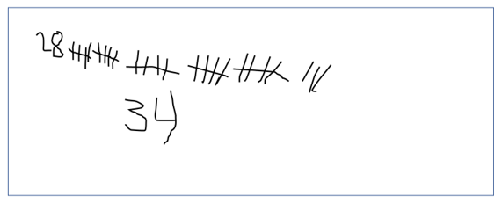
Teachers can notice and use student strategies as formative assessment, recognizing how their young learners become increasingly efficient counters.
Young learners also draw on their counting strategies to develop early subtraction sense. Cognitively guided instruction tasks might prompt students, for example, to begin with eight cookies, then note that three cookies were eaten. Students might count out eight cookies with manipulatives like counting cubes, and then employ a range of strategies to figure out how to “take away” three cookies. Students might remove three cubes from the original set and then count the remaining cubes to figure out how many remain. Other students might count backwards from the original set of eight cookies.
Figure 6.5 below, included in the CA CCSSM glossary, is meant to help teachers identify and use different kinds of addition and subtraction problems in their instruction to support students’ ability to flexibly represent and solve such problems.
Figure 6.5.a Common Addition and Subtraction Situations
Common Addition and Subtraction Situations | Result Unknown | Change Unknown | Start Unknown
Add to | Two bunnies sat on the grass. Three more bunnies hopped there. How many bunnies are on the grass now?  2 + 3 = □ | Two bunnies were sitting on the grass. Some more bunnies hopped there. Then there were 5 bunnies. How many bunnies hopped over to the first two?  2 + □ = 5 | Some bunnies were sitting on the grass. Three more bunnies hopped there. Then there were 5 bunnies. How many bunnies were on the grass before?  □ + 3 = 5
Take from | Five apples were on the table. I ate 2 apples. How many apples are on the table now?  5 - 2 = □ | Five apples were on the table. I ate some apples. Then there were 3 apples. How many apples did I eat?  5 - □ = 3 | Some apples were on the table. I ate 2 apples. Then there were 3 apples. How many apples were on the table before?  □ - 2 = 3
Figure 6.5.b Common Addition and Subtraction Situations
Common Addition and Subtraction Situations | Total Unknown | Addend Unknown | Both Addends Unknown†
Put together/Take apart‡ | Three red apples and 2 green apples are on the table. How many apples are on the table?  3 + 2 = □ | Five apples were on the table. Three are red, and the rest are green. How many apples are green?  3 + □ = 5 | Grandma has 5 flowers. How many can she put in her red vase and how many in her blue vase?  5 = 0 + 5, 5 = 5 + 0  5 = 1 + 4, 5 = 4 + 1  5 = 2 + 3, 5 = 3 + 2
Figure 6.5.c Common Addition and Subtraction Situations
Common Addition and Subtraction Situations | Difference Unknown | Bigger Unknown | Smaller Unknown
Compare* | (“How many more?” version):  Lucy has 2 apples. Julie has 5 apples. How many more apples does Julie have than Lucy?  (“How many fewer?” version):  Lucy has 2 apples. Julie has 5 apples. How many fewer apples does Lucy have than Julie?  2 + □ = 5, 5 - 2 = □ | (Version with more):  Julie has 3 more apples than Lucy. Lucy has 2 apples. How many apples does Julie have?  (Version with fewer):  Lucy has 3 fewer apples than Julie. Lucy has 2 apples. How many apples does Julie have?  2 + 3 = □, 3 + 2 = □ | (Version with more):  Julie has 3 more apples than Lucy. Julie has 5 apples. How many apples does Lucy have?  (Version with fewer):  Lucy has 3 fewer apples than Julie. Julie has five apples. How many apples does Lucy have?  5 - 3 = □, □ + 3 = 5
Source: CDE, 2013
Note. Adapted from Boxes 2–4 of Mathematics Learning in Early Childhood: Paths Toward Excellence and Equity (National Research Council, Committee on Early Childhood Mathematics 2009, 32–33).
‡Either addend can be unknown, so there are three variations of these problem situations. “Both Addends Unknown” is a productive extension of this basic situation, especially for small numbers, that is, less than or equal to 10.
†These take-apart situations can be used to show all the decompositions of a given number. The associated equations, which have the total on the left of the equal sign (=), help children understand that the equal sign does not always mean makes or results in, but does always mean is the same number as.
*For the “Bigger Unknown” or “Smaller Unknown” situations, one version directs the correct operation (the version using more for the bigger unknown and using less for the smaller unknown). The other versions are more difficult.
Students will use different strategies to solve problems when teachers provide the time and space to do so. The 5 Practices for Orchestrating Productive Mathematical Discussions (Smith and Stein, 2011) offers teachers the following useful strategies that can help ensure productive lessons by providing students with needed time and space to try different problem-solving methods:
- Anticipating likely student responses
- Monitoring students’ actual responses
- Selecting particular students to present their mathematical work during the whole-class discussion
- Sequencing the student responses
- Connecting different students’ responses—to each other and to key mathematical ideas
Smith and Stein recommend that before offering students a problem to discuss and solve together, teachers should work through the problem on their own, to anticipate what strategies students might use, as well as what struggles and misconceptions the problem might prompt. Teachers should also explore the various methods students might use as they work to understand general properties of operations. For example, in a number talk on the problem 8 + 7, students might come up with and share the following computation strategies:
Student 1: (Making 10 and decomposing a number) “I know that 8 plus 2 is 10, so I decomposed—broke up—the 7 into a 2 and a 5. First, I added 8 and 2 to get 10, and then I added the 5 to get 15.”
This explanation could be represented as: 8 + 7 = (8 + 2) + 5 = 10 + 5 = 15.
Student 2: (Creating an easier problem with known sums) “I know 8 is 7 + 1. I also know that 7 and 7 equal 14. Then I added 1 more to get 15.”
This explanation could be represented as: 8 + 7 = (7 + 7) + 1 = 15.
In addition to using the 5 Practices recommended by Smith and Stein to strategically consider how to incorporate student thinking and different solutions into lessons, teachers can also offer a variety of games and activities that help students develop understanding of math concepts. The game “Pig” can be played to practice addition. The game involves students using dice (or an app to simulate a dice roll) in a competition to be the first player to roll results that reach 100. Students take turns rolling the dice and determine the sum. Students can either stop and record the sum after each roll, or they can continue rolling and adding the new sums together in their heads. When they decide to stop, they record the current total and add it to their previous score. Note that students should build understanding through activities that draw on concrete and representational approaches to operations before engaging in abstract fluency games. Resources for addition activities include the National Council of Teachers of Mathematics’ (NCTM) Illuminations and Illustrative Mathematics.
Classroom activities can also support students in developing understanding that the equal sign means the quantity on one side of the equal sign must be the same as the quantity on the other side of the sign. For example, the “Moving Colors” task (Youcubed, n.d.a), explores equality as students move around the room. Students are given red- or yellow-colored circles (or other shapes), after which teachers ask, “How many students have red circles and how many have yellow circles?” Students are encouraged to move around the room to work this out. Once students have made their respective counts, teachers ask, “How can we show that we have an equal number of each color or more of one color than the other color?”

Methods for Solving Single-Digit Addition and Subtraction Problems

Level 1: Direct Modeling by Counting All or Taking Away
Represent the situation or numerical problem with groups of objects, a drawing, or fingers. Teachers can model the situation by composing two addend groups or decomposing a total group. Count the resulting total or addend.

Level 2: Counting On
Embed an addend within the total (the addend is perceived simultaneously as an addend and as part of the total). Count this total but abbreviate the counting by omitting the count of this addend; instead, begin with the number word of this addend. The count is tracked and monitored in some way (e.g., with fingers, objects, mental images of objects, body motions, or other count words). For example, a representation of counting on for the equation 8+6=14 might look like this:
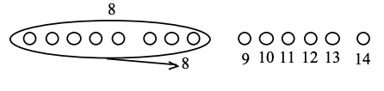
For addition, the count stops when the amount of the remaining addend has been counted. The last number word is the total. For subtraction, the count is stopped when the total occurs in the count. The tracking method indicates the difference (seen as the unknown addend).

Level 3: Converting to an Easier Equivalent Problem
Decompose an addend and compose a part with another addend, such as combining the 9 and 1 to make 10 (e.g., 9 + 1 + 3 = 10 + 3).
Source: Adapted from Common Core Standards Writing Team. 2022.

CC3: Taking Wholes Apart, Putting Parts Together
Children enter school with experience at taking wholes apart and putting parts together, a task that occurs in everyday activities such as slicing pizzas and cakes and building with blocks, clay, or other materials. Breaking challenges, problems, and ideas into manageable pieces, that is decomposing them, and assembling one’s understanding of the smaller parts into an understanding of a larger whole, are fundamental aspects of using mathematics. Often these processes are closely tied with SMP.7 (Look for and make use of structure). In the early grades, such investigations might include using manipulatives to decompose the number 5 into parts, such as 1 and 4 or 2 and 3, then compose the parts into the whole. This Content Connection spans and connects many clusters of content standards that are typically taught separately. It also connects with other CCs. For example, students might also decompose shapes, which connects to CC4.
Understanding numbers, including the fundamental structure of our number system—that is, place value and base 10—and the relationships between numbers, begins with counting and cardinality and extends to a beginning understanding of place value. Young learners use numbers, including written numerals, to represent quantities and to solve quantitative problems; they do so in such activities as counting objects in a set, counting out a given number of objects, comparing sets or numerals, and modeling simple joining and separating situations with sets of objects. As students progress through the early grades, they develop, discuss, and use strategies to compose and decompose numbers, noticing the other numbers that exist within them. The seeds for this understanding might be planted when they use manipulatives to decompose the number 5 into parts, such as 1 and 4 or 2 and 3, then compose the parts into the whole. Through activities like this one that build number sense, they come to understand how numbers work and how they relate to one another.
Investigating mathematics by taking wholes apart and putting parts together invites students to:
- Work with numbers 11–19 to gain foundations for place value (K.NBT.1).
- Extend the counting sequence (1.NBT.1).
- Understand place value (1.NBT.2, 1.NBT.3, 2.NBT.1, 2.NBT.2, 2.NBT.3, 2.NBT.4).
- Use place value understanding and properties of operations to add and subtract (1.NBT.4, 1.NBT.5, 1.NBT.6, 2.NBT.5, 2.NBT.6, 2.NBT.7, 2.NBT.8, 2.NBT.9).
- Look for and make use of structure (SMP.7)
Understanding the concept of a ten is critical to young students’ mathematical development. That concept is the foundation of the place-value system, which can be productively investigated through this Content Connection. Young children often see a group of 10 cubes as 10 individual cubes. It’s helpful to plan activities that support students in developing the understanding of 10 cubes as a bundle of 10 ones, or a ten. Students can demonstrate this concept by counting 10 objects and “bundling” them into one group of 10, a ten, as shown in figure 6.6. Working with numbers between 11 and 19 is an early way to build the idea of numbers structured as a bundle of 10 and remaining ones.
Figure 6.6 Bundling 10 Ones into a Ten
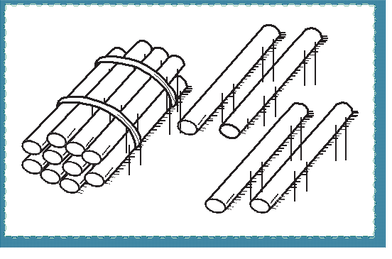
In The Pocket Game (Confer, 2005b; Youcubed, n.d.b), children explore the smaller numbers inside larger numbers. Using number cards, they determine which of two numbers is larger, then place both numbers in a paper pocket labeled with the larger number. After playing the game, students are grouped to discuss what they notice about the numbers inside the different pockets, ultimately seeing that each pocket number contains all the smaller numbers within (e.g., if the numbers 4 and 5 are in the pocket, that 5 “includes” 4). After the discussion, teachers can prompt students to predict which numbers they will find in the paper pocket labeled “3” and rationalize their predictions, encouraging them to examine the paper pockets one by one and talk about what they notice (and see if their predictions were accurate). Conversation should focus on why those numbers were inside each pocket and why other numbers were not.
After the game is played periodically over a number of weeks, teachers can facilitate a discussion about why the pockets look the way they do at the end of a game. For example, while viewing a pocket labeled 2, students might be asked which numbers they think will be inside. With predictions recorded, teachers can facilitate an examination of the pocket and discuss why there are only a 1 and a 2 in the pocket. This continues as students question why some numbers are not in the pocket.
When students finish the game, they will have figured out which paper pocket has the most cards. Teachers can revisit the game later in the year to give students more opportunities to develop their number fluency.
In another activity, a place-value game called Race for a Flat, two teams of two players each roll number cubes. The intention of the game is to reinforce addition and subtraction skills within 100. The players find the sum of the numbers they roll and take units cubes to show that number. Then they put their units on a place-value mat (shown as the bottom row of the table below) to help keep track of their total. When a team gets 10 or more units, they trade 10 units for one rod (a manipulative representing a 10 x 1 array or 10 ones). As soon as a team gets blocks worth 100 or more, they make a trade for one flat (a manipulative representing a 10 x 10 array, 10 tens, or 100 ones). The first team to obtain a flat wins the game. Figure 6.7 shows the shift from single units to tens to hundreds.
Figure 6.7 Place-Value Mat Example for Tracking Race for a Flat Sums
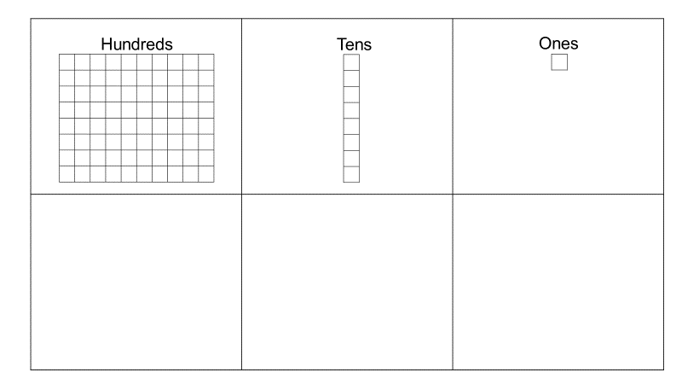
Students in the early grades will be working with whole numbers, and linear representations are important. While number lines are commonly used in the early elementary grades as a central representational tool that can be used across grade levels (Siegler et al., 2010), teachers in grades TK-2 may want to consider the benefits of using number paths as well (Gardner, 2013). For example:
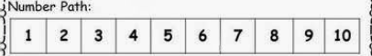
As Gardner explains,
“A number line uses a model of length. Each number is represented by its length from zero. Number lines can be confusing for young children. Students have to count the “hops” they take between numbers instead of counting the numbers themselves. Students' fingers can land in the spaces between numbers on a number line, leaving kids unsure which number to choose. A number path is a counting model. Each number is represented within a rectangle and the rectangles can be clearly counted. A number path provides a more supportive model of numbers, which is important as we want models that consistently help students build confidence and accurately solve problems.”
The Learning Mathematics through Representations project (University of California, Berkeley, n.d.) also offers activities for early and upper elementary grades that prepare students to make later connections to fractions. Problems about fair sharing also support children’s developing understanding of fraction concepts through explorations with grouping (Empson, 1999; Empson and Levi, 2011).

CC4: Discovering Shape and Space
Young learners possess natural curiosities about the physical world. In the early grades, students learn to describe their world using geometric ideas (e.g., shape, orientation, spatial relations). They identify, name, and describe basic two-dimensional shapes, such as squares, triangles, circles, rectangles, and hexagons, presented in a variety of ways (e.g., with different sizes and orientations). They engage in this process with three-dimensional shapes as well, such as cubes, cones, cylinders, and spheres. They use basic shapes and spatial reasoning to model objects in their environment and to construct more complex shapes. As they progress through the early grades, students compose and decompose plane or solid figures (e.g., put two triangles together to make a quadrilateral) and begin understanding part-to-whole relationships as well as the properties of the original and composite shapes. As they combine shapes, they recognize them from different perspectives and orientations, describe their geometric attributes, and determine how they are alike and different, thus developing the background for measurement and for initial understandings of such properties as congruence and symmetry.
Investigating mathematics by discovering shape and space invites students to:
- Identify and describe shapes (K.G.1, K.G.2, K.G.3).
- Analyze, compare, create, and compose shapes (K.G.4, K.G.5, K.G.6)
- Reason with shapes and their attributes (1.G.1, 1.G.2, 1.G.3, 2.G.1, 2.G.2, 2.G.3).
Young learners can begin to explore the idea of classifying objects in relation to particular attributes, i.e., characteristics or properties such as color, size, and shape. Students can build on these early experiences to identify geometric attributes at a fairly early age. In grades one and two, many teachers introduce terms like vertex, side, and face. Especially because young learners often recognize shapes by their appearance, they need ample time to explore these attributes and make sense of the ways they relate to one another and to particular geometric shapes.
Teachers can provide opportunities for young learners to compose and decompose shapes around characteristics or properties and to explore typical examples of shapes, as well as variants, and both examples and non-examples of particular shapes. Classroom discussions can also surface and address common misconceptions students have about shapes—for example, the misconception that triangles always rest on a side and not on a vertex or that a square is not a rectangle.
In one activity on sorting shapes, students sort a pile of different-size and -color squares and rectangles into two groups. They discuss how the shapes of rectangles and squares are alike and how they are different. After students demonstrate an understanding of the differences, the teacher gives each student one square or rectangle cutout. The teacher then creates two groups, one with students who have the squares, the other with students who have the rectangles. The differences in the rectangle and square cutouts (size and color) allow the students to focus on the shape attributes as they compare in and across groups.
Another activity, based on the popular board game Guess Who?, offers students the opportunity to reason about the relationship between geometric shapes and their attributes. Each player is given a card with a different shape on it, and the objective is for students to guess their opponent’s mystery shape before the opponent guesses theirs. Players take turns asking “yes” or “no” questions about attributes of the opponent’s shape (e.g., “Does your shape have angles?”). The first player to correctly guess the other player’s mystery shape wins.
Students can also use pattern blocks, plastic shapes, tangrams, or online manipulatives to compose new shapes. Teachers can provide students with cutouts of shapes and ask them to combine the cutouts to make a particular shape or to create shapes of their own. Peers can then work together to recreate or decompose one another’s shapes. When students work in pairs, it is helpful if those who are English learners work with someone who is bilingual and speaks their home language so that the student who is an English learner can use either language as a resource in developing the concepts and mathematical language.
Classroom discourse is an important aspect of such activities. It is valuable to ask students to test their ideas about shapes, using a variety of shape examples and asking open-ended questions, such as:
- What do you notice about your shape?
- What happens if you try to draw a shape with just one side?
Mathematics conversations are important, even for the youngest learners. Teachers can scaffold these conversations with question stems or prompts, as needed. Transitional kindergarten teachers can take up students’ own questions and curiosity as an opportunity to explore shapes, as in the following exchange:
Mae: Is this a triangle? (Holds up a square.)
Teacher: What do you think? (Asks other students in the small group to contribute.)
Students (in unison): No!
Teacher: Why not? Can you share how you can tell?
Zahra: Because a triangle doesn’t have four sides.
Teacher: I heard you say that a triangle doesn’t have four sides. How many sides does a triangle have?
Mae: Three!
Teacher: So, Mae, what do you think? Is your shape a triangle?
Mae: No, it’s not a triangle.
Teacher: How can you tell?
Mae: Because it has four sides and triangles have three sides.
Teacher: I heard you say that your shape is not a triangle because it has four sides and triangles have three sides. Is that right?
Mae: Yes.
Teacher: Class, do you agree with Mae?
Students (in unison): Yes.
Teacher: Mae, see if you can find a triangle, and I’ll come back to check what you found.
Open-ended questions, such as, “What do we know about triangles?” or, “How did you figure that out?” encourage students to think and speak like mathematicians. Teachers can use responses to facilitate an organic conversation, as in the excerpt above, that allows students to collaborate, provide feedback, and build on one another’s reasoning.
The vignette Alex Builds Numbers with a Partner illustrates how an activity where students work with a partner to build numbers can help students see and understand the meaning of number, patterns, and addition.

The Big Ideas, Transitional Kindergarten Through Grade Two
The foundational mathematics content—that is, the big ideas—progresses through transitional kindergarten through grade twelve in accordance with the CA CCSSM principles of focus, coherence, and rigor. As students explore and investigate the big ideas, they will engage with many different content standards and come to understand the connections between them.
Each grade-level-specific big-idea figure that follows (figures 6.8, 6.10, 6.12, and 6.14) shows the ideas as colored circles of varying sizes. A circle’s size indicates the relative importance of the idea it represents, as determined by the number of connections that particular idea has with other ideas. Big ideas are considered connected to one another when they enfold two or more of the same standards; the greater the number of standards one big idea shares with other big ideas, collectively, the more connected and important the idea is considered to be.
Circle colors correspond to colors used in the big-ideas column of the figure that immediately follows each big-idea figure. These second figures (figures 6.9, 6.11, 6.13, and 6.15) reiterate the grade-specific big ideas and, for each idea, show associated content connections and content standards, as well as providing some detail on how content standards can be addressed in the context of the CCs described in this framework.
Figure 6.8 Transitional Kindergarten Big Ideas
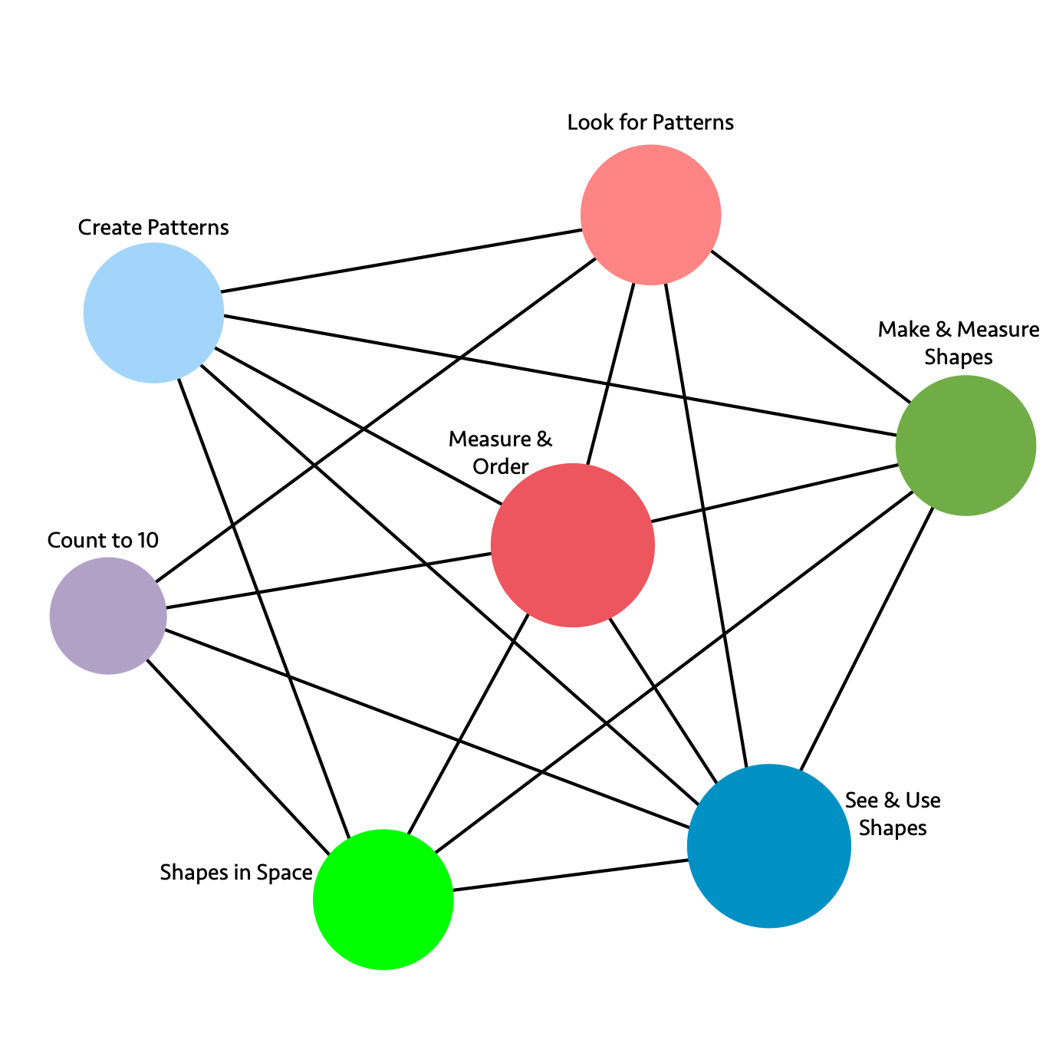
Long description of figure 6.8
Figure 6.9 Transitional Kindergarten Content Connections, Big Ideas, and Content Standards
Content Connections | Big Ideas | Transitional Kindergarten Content Standards
Reasoning with Data  and  Exploring Changing Quantities | Measure and Order | AF1.1, M1.1, M1.2, M1.3, NS2.1, NS2.3, NS1.3, G 1.1, G2.1 NS1.4, NS1.5, MR1.1, NS1.1, NS1.2: Compare, order, count, and measure objects in the world. Learn to work out the number of objects by grouping and recognize up to four objects without counting.
Reasoning with Data  and  Taking Wholes Apart, Putting Parts Together | Look for patterns | AF2.1, AF2.2: NS1.3, NS1.4, NS1.5, NS2.1, NS2.3, G1.1, M1.2: Recognize and duplicate patterns - understand the core unit in a repeating pattern. Notice size differences in similar shapes.
Exploring Changing Quantities | Count to 10 | NS1.4, MR1.1, AF1.1, NS2.2: Count up to 10 using one to one correspondence. Know that adding or taking away one makes the group larger or smaller by one.
Taking Wholes Apart, Putting Parts Together | Create patterns | AF2.2, AF2.1, M1.2, G1.1, G1.2, G2.1: Create patterns - using claps, signs, blocks, shapes. Use similar shapes to make a pattern and identify size differences in the patterns.
Taking Wholes Apart, Putting Parts Together  and  Discovering Shape and Space | See and use shapes | G1.1, G1.2, NS2.3, NS1.4, MR1.1: Combine different shapes to create a picture or design and recognize individual shapes, identifying how many shapes there are.
Discovering Shape and Space | Make and measure shapes | G1.1, M1.1, M1.2, NS1.4: Create and measure different shapes. Identify size differences in similar shapes.
Discovering Shape and Space | Shapes in space | G2.1, M1.1, MR1.1: Visualize shapes and solids (2-D and 3-D) in different positions, including nesting shapes, and learn to describe direction, distance, and location in space.
Note. This figure includes Preschool Foundations in mathematics for students at around 60 months of age. The related kindergarten standards for transitional kindergarten are identified in the next section.
Figure 6.10 Kindergarten Big Ideas
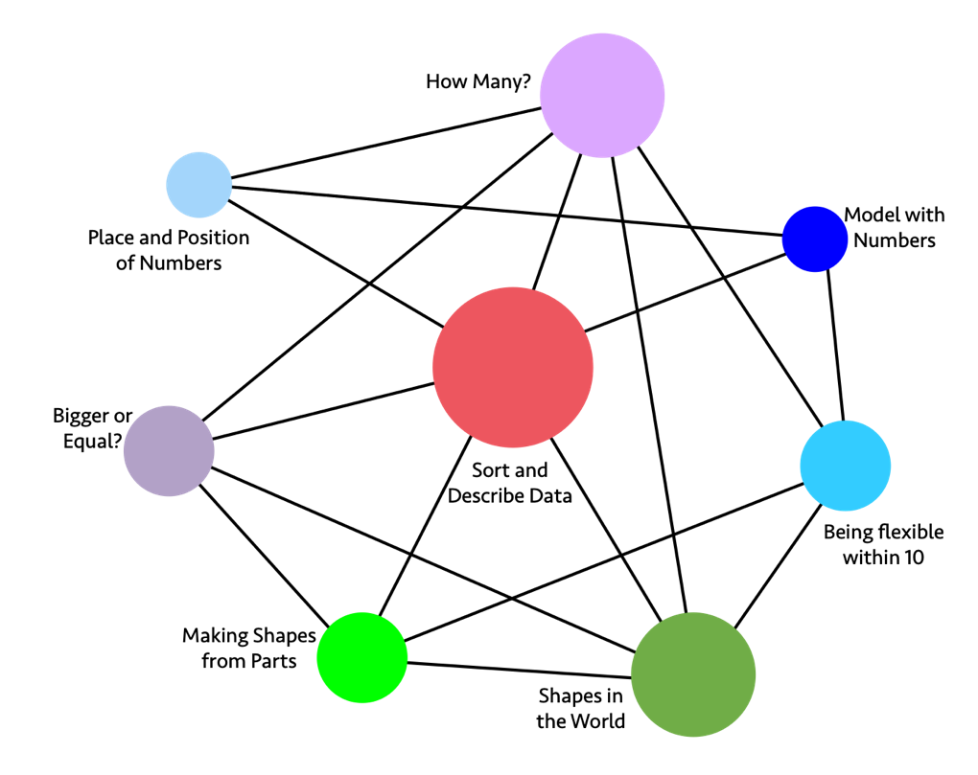
Long description of figure 6.10
Figure 6.11 Kindergarten Content Connections, Big Ideas, and Content Standards
Content Connections | Big Ideas | Kindergarten Content Standards
Reasoning with Data | Sort and Describe Data | MD.1, MD.2, MD.3, CC.4, CC.5, G.4: Sort, count, classify, compare, and describe objects using numbers for length, weight, or other attributes.
Exploring Changing Quantities | How Many? | CC.1, CC.2, CC.3, CC.4, CC.5, CC.6, CC.7, MD.3: Know number names and the count sequence to determine how many are in a group of objects arranged in a line, array, or circle. Fingers are important representations of numbers. Use words and drawings to make convincing arguments to justify work.
Exploring Changing Quantities | Bigger or Equal? | CC.4, CC.5, CC.6, MD.2, G.4: Identify a number of objects as greater than, less than, or equal to the number of objects in another group. Justify or prove your findings with number sentences and other representations.
Taking Wholes Apart, Putting Parts Together | Being Flexible within 10 | OA.1, OA.2, OA.3, OA.4, OA.5, CC.6, G.6: Make 10, add and subtract within 10, compose and decompose within 10 (find two numbers to make 10). Fingers are important.
Taking Wholes Apart, Putting Parts Together | Place and position of numbers | CC.3, CC.5, NBT.1: Get to know numbers between 11 and 19 by name and expanded notation to become familiar with place value, for example: 14 = 10 + 4.
Taking Wholes Apart, Putting Parts Together | Model with numbers | OA.1, OA.2, OA.5, NBT.1, MD.2: Add, subtract, and model abstract problems with fingers, other manipulatives, sounds, movement, words, and models.
Discovering Shape and Space | Shapes in the World | G.1, G.2, G.3, G.4, G.5, G.6, MD.1, MD.2, MD.3: Describe the physical world using shapes. Create 2-D and 3-D shapes, and analyze and compare them.
Discovering Shape and Space | Making shapes from parts | MD.1, MD.2, G.4, G.5, G.6: Compose larger shapes by combining known shapes. Explore similarities and differences of shapes using numbers and measurements.
Figure 6.12 Grade One Big Ideas
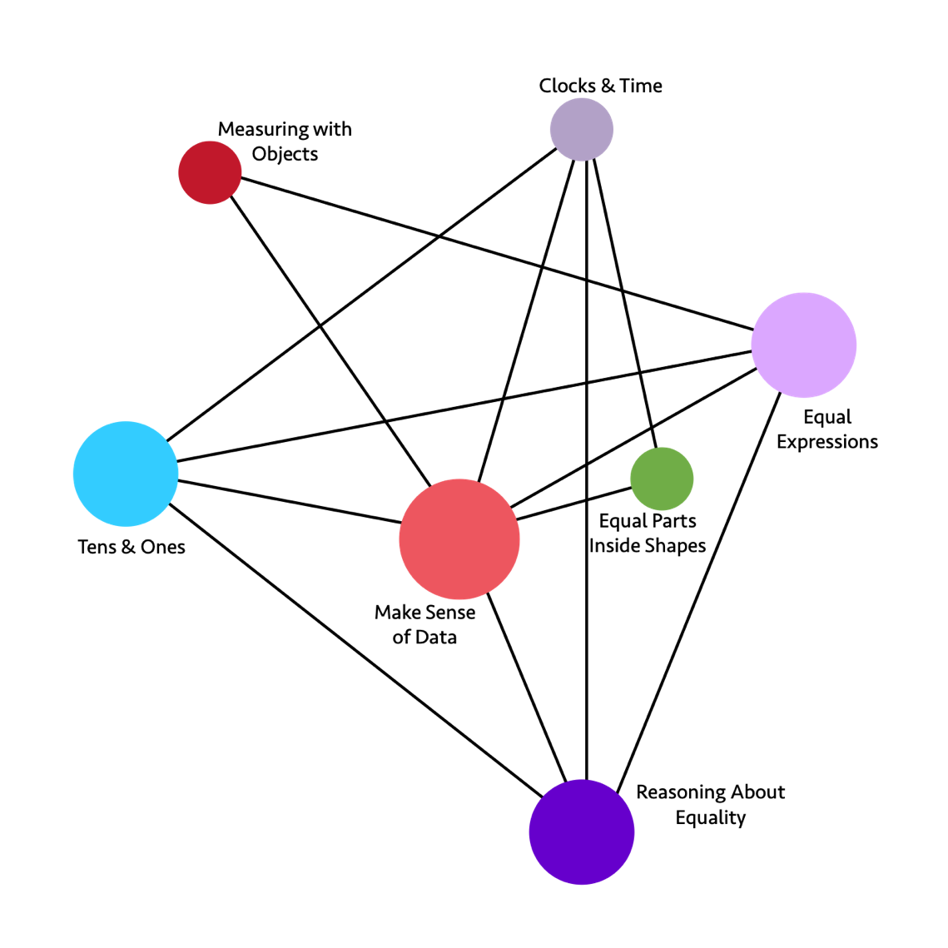
Long description of figure 6.12: grade one big ideas
Figure 6.13 Grade One Content Connections, Big Ideas, and Content Standards
Content Connections | Big Ideas | Grade One Content Standards
Reasoning with Data | Make Sense of Data | MD.2, MD.4, MD.3, MD.1, NBT.1, OA.1, OA.2, OA.3: Organize, order, represent, and interpret data with two or more categories; ask and answer questions about the total number of data points, how many are in each category, and how many more or less are in one category than in another.
Reasoning with Data  and  Exploring Changing Quantities | Measuring with Objects | MD.1 MD.2, OA.5: Express the length of an object by units of measurement e.g., the stapler is five red Cuisenaire rods long, the red rod representing the unit of measure. Understand that the measurement length of an object is the number of units used to measure.
Exploring Changing Quantities | Clocks & Time | MD.3, NBT.2, G.3: Read and express time on digital and analog clocks using units of an hour or half hour.
Exploring Changing Quantities | Equal Expressions | OA.6, OA.7, OA.2, OA.1, OA.8, OA.5, OA.4, OA.3, NBT.4: Understand addition and subtraction, using various models, such as connected cubes. Compose and decompose numbers to make equal expressions, knowing that equals means that both sides of an expression are the same (and it is not simply the result of an operation).
Exploring Changing Quantities | Reasoning about Equality | OA.3, OA.6, OA.7, NBT.2, NBT.3, NBT.4: Justify reasoning about equal amounts, using flexible number strategies (e.g., students use compensation strategies to justify number sentences, such as 23 - 7 = 24 - 8).
Taking Wholes Apart, Putting Parts Together | Tens and Ones | NBT.4, NBT.3, NBT.1, NBT.2, NBT.6, NBT.5: Think of whole numbers between 10 and 100 in terms of tens and ones. Through activities that build number sense, students understand the order of the counting numbers and their relative magnitudes.
Discovering Shape and Space | Equal Parts inside Shapes | G.3, G.2, G.1, MD.3: Compose 2D shapes on a plane as well as in 3D space to create cubes, prisms, cylinders, and cones. Shapes can also be decomposed into equal shares, as in a circle broken into halves and quarters defines a clock face.
Figure 6.14 Grade Two Big Ideas
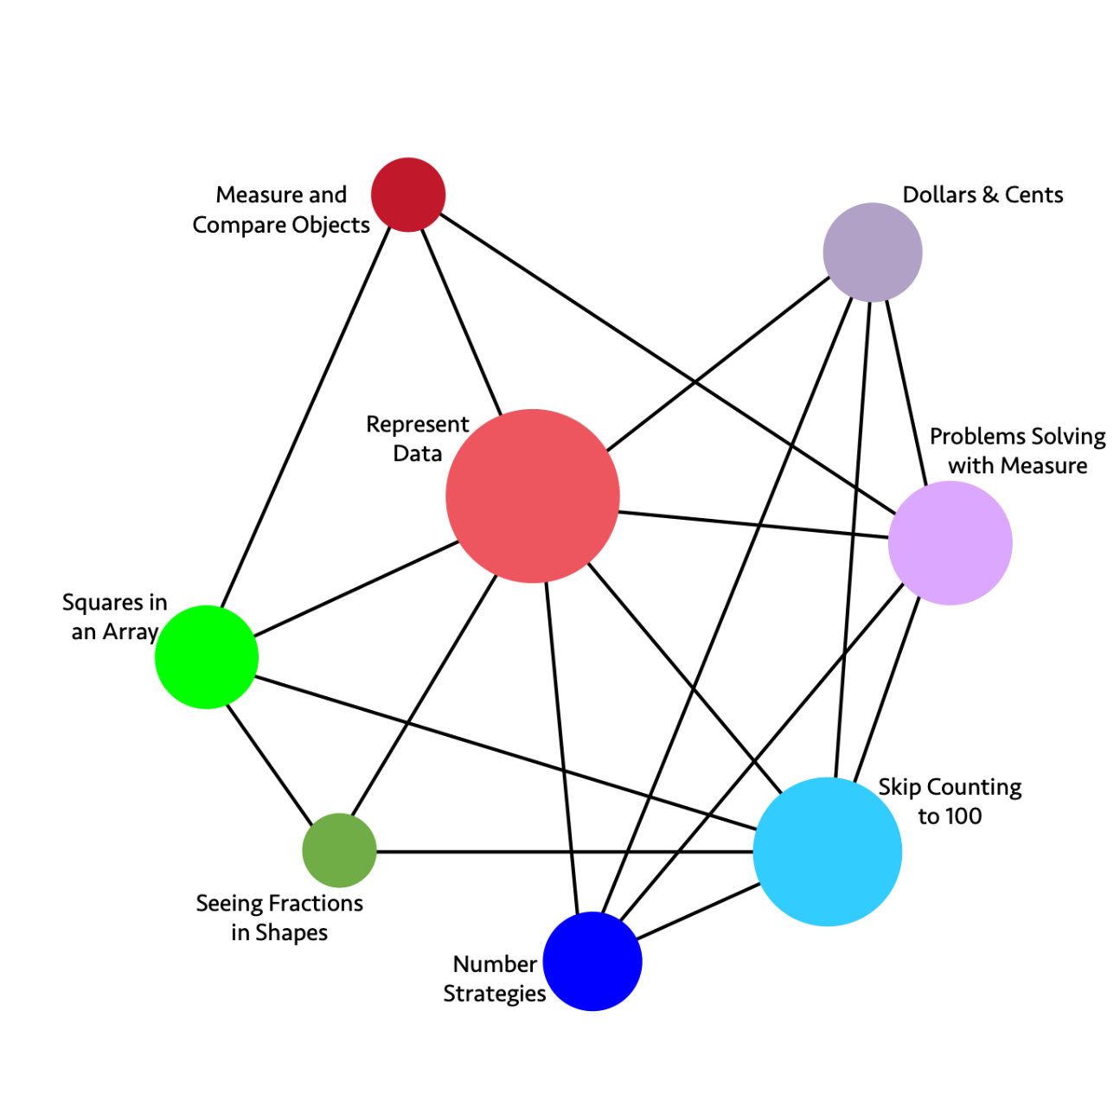
Long description of figure 6.14
Figure 6.15 Grade Two Content Connections, Big Ideas, and Content Standards
Content Connections | Big Ideas | Grade Two Content Standards
Reasoning with Data | Measure and Compare Objects | MD.1, MD.2, MD.3, MD.4, MD.6, MD.9: Determine the length of objects using standard units of measures, and use appropriate tools to classify objects, interpreting and comparing linear measures on a number line.
Reasoning with Data | Represent Data | MD.7, MD.9, MD.10, G.2, G.3, NBT.2: Represent data by using line plots, picture graphs, and bar graphs, and interpret data in different data representations, including clock faces to the nearest 5 minutes.
Exploring Changing Quantities | Dollars and Cents | MD.8, MD.5, NBT.1, NBT.2, NBT.5, NBT.6, NBT.7, NBT.9: Understand the unit values of money and compute different values when combining dollars and cents. Connect these money values to place values and to 2-digit and 3-digit methods of adding and subtracting and explain such methods using drawings as needed.
Exploring Changing Quantities  and  Discovering Shape and Space | Problem Solving with Measure | NBT.7, NBT.1, MD.1, MD.2, MD.3, MD.4, MD.5, MD.6, MD.9, OA.1: Solve problems involving length measures using addition and subtraction.
Taking Wholes Apart, Putting Parts Together | Skip Counting to 100 | NBT.1, NBT.3, NBT.7, NBT.9, OA.4, G.2: Use skip counting, counting bundles of 10, and expanded notation to understand the composition and place value of numbers up to 1,000. This includes ideas of counting in fives, tens, and multiples of hundreds, tens, and ones, as well as number relationships involving these units, including comparing. Use these place values to develop understanding with 3-digit adding and subtracting.
Taking Wholes Apart, Putting Parts Together | Number Strategies | MD.5, NBT.5, NBT.6, NBT.7, OA.1, OA.2: Add and subtract two-digit numbers, within 100, without using algorithms—instead encouraging different strategies and justification. Compare and contrast the different strategies using models, symbols, and drawings.
Discovering Shape and Space | Seeing Fractions in Shapes | G.1, G.2, G.3, MD.7: Divide circles and rectangles into equal shares and know them to be standard unit fractions. Identify and draw 2D and 3D shapes, recognizing faces and angles.
Discovering Shape and Space | Squares in an Array | OA.4, G.2, G.3, MD.6: Partition rectangles into rows and columns of unit squares to find the total number of square units in an array.

Investigating and Connecting, Grades Three Through Five
California’s mathematics content standards were built on progressions of topics across grade levels, informed by both research on children’s cognitive development and by the logical structure of mathematics. The content of grades three, four, and five is conceptually rich and multi-faceted, building on the concepts developed in the earlier grades, where students explore numbers, operations, measurement and shapes. In those grades, students develop efficient, reliable methods for addition and subtraction within 100. They learn place value and use methods based on place value to add and subtract within 1,000. In grade three, students continue developing efficient methods, and in grade four, they learn the standard algorithms for addition and subtraction (4.NBT.4).
Standard algorithm
Standard algorithm is defined in this framework as a step-by-step approach to calculating, decided by societal convention and developed for efficiency. Flexible and fluent use of standard algorithms requires conceptual understanding. (See CC3: Taking Wholes Apart and Putting Parts Together – Whole Numbers, below, for more on standard algorithms.)
In the earlier grades, students also work with equal groups and with the array model, preparing the way for understanding multiplication. They use standard units to measure lengths and to describe attributes of geometric shapes. As described above, students’ mathematical investigations of core content—that is, the grade-level big ideas in mathematics—can be productively approached using the SMPs.
When students in grades three, four, and five are able to connect this previous learning to make sense of current grade-level concepts, new mathematics challenges become exciting and meaningful. Students build on their early mathematical foundation as, through grades three, four, and five, they develop understanding of the operations of multiplication and division, concepts and operations with fractions, and measurement of area and volume.
Students develop and learn at different times and rates. For this or other reasons—as noted in the section above on transitional kindergarten through grade two—some arrive in the early elementary grades with unfinished learning from earlier grade levels (e.g., transitional kindergarten and kindergarten). In such cases, teachers should not automatically assume these students to be low achievers who need placement in a group that is learning standards from a lower grade level. Instead, teachers should identify students’ learning needs and provide appropriate instructional support before considering any change in standards taught.
While some students lag in math learning, for others, what appears to be lack of understanding is attributable, at least in part, to their inability to adequately communicate their understanding. Here, too, providing appropriate instructional support—in this case for language development—is essential.
Because students encounter significant new mathematics vocabulary in grades three through five, all of them, not just those learning English, benefit from instruction that specifically supports language facility. Graphic displays of terms and properties, choral responses, partner talk, and the use of gestures can all be helpful in doing so. Both manipulative tools (e.g., two- or three-dimensional geometric figures and straws, other straight objects that can be used to construct and compare geometric figures) and technological tools that allow students to illustrate figures with specified properties can support students as they make sense of the necessary vocabulary.
Achieve the Core (2018) lists a variety of mathematical language and instructional routines that benefit all students, particularly those who are learning English or who are challenged by the demands of academic language for mathematics. One example is the “Collect and Display” routine in which teachers listen for and note the language students use as they engage in mathematics, whether with a partner, in a small group, or as a whole class. Students’ language is then documented and displayed, serving as a collective record or reference for students as they continue to develop their mathematical language. Other Achieve the Core instructional routines, such as “Contemplate Then Calculate” and “Connecting Representations,” help students apply the SMPs and deepen their involvement in the study of mathematics.
The Understanding Language/Stanford Center for Assessment, Learning, and Equity (SCALE) project at Stanford University (Zweirs et al., 2017) describes eight specific math language routines designed to support and develop students’ academic language. These include student-centered routines that are readily implemented in the classroom. One example is “Convince Yourself, a Friend, a Skeptic,” a routine that calls for students to justify their mathematical argument as a way to
- satisfy themselves;
- convince a friend (who asks questions and encourages further verbal or written explanation, or perhaps an illustration); or
- convince a student skeptic, who will challenge and offer counter-arguments to help refine the student’s own argument.

Content Connections Across the Big Ideas, Grades Three Through Five
The big ideas for each grade level define the critical areas of instructional focus. Through the Content Connections, the big ideas unfold in a progression across grades three through five in accordance with the CA CCSSM principles of focus, coherence, and rigor. Figure 6.16 Progression of Big Ideas, Grades Three Through Five identifies a sampling of the big ideas for these grades and indicates the CCs with which they are most readily associated. The figure is followed by discussion of each CC, highlighting specific SMPs, content standards, and activities associated with it. Later in this section on grades three through five, each of figures 6.52, 6.54, and 6.56, respectively, shows a grade-level-specific network diagram of the big ideas for grades three through five. Immediately following each of those figures is a second one (figures 6.53, 6.55, and 6.57, respectively) that reiterates the big ideas for that grade, identifies the related CCs and content standards, and provides some detail on how content standards can be addressed in the context of the CCs described in this framework.
Figure 6.16 Progression of Big Ideas, Grades Three Through Five
Content Connections | Big Ideas: Grade Three | Big Ideas: Grade Four | Big Ideas: Grade Five
Reasoning with Data | Represent Multivariable data | Measuring and plotting | Plotting patterns
Reasoning with Data | Fractions of shape and time | Rectangle Investigations | Telling a data story
Reasoning with Data | Measuring | n/a | n/a
Exploring Changing Quantities | Patterns in four operations | Number and shape patterns | Telling a data story
Exploring Changing Quantities | Number flexibility to 100 for all four operations | Factors and area models | Factors and groups
Exploring Changing Quantities | n/a | Multi-digit numbers | Modeling
Exploring Changing Quantities | n/a | n/a | Fraction connections
Exploring Changing Quantities | n/a | n/a | Shapes on a plane
Taking Wholes Apart, Putting Parts Together | Square tiles | Fraction flexibility | Fraction connections
Taking Wholes Apart, Putting Parts Together | Fractions as relationships | Visual fraction models | Seeing Division
Taking Wholes Apart, Putting Parts Together | Unit fraction models | Circles, fractions and decimals | Powers and place value
Discovering shape and space | Unit fraction models | Circles, fractions and decimals | Telling a data story
Discovering shape and space | Analyze quadrilaterals | Shapes and symmetries | Layers of cubes
Discovering shape and space | n/a | Connected problem solving | Shapes on a plane

Content Connections, Grades Three Through Five

CC1: Reasoning with Data
In these upper elementary grades, students acquire important foundational concepts involving measurement and increase the degree of precision to which they measure quantities as they engage in solving interesting, relevant problems. They measure various attributes, such as time, length, weight, area, perimeter, and volume of liquids and solid figures (3.MD.1–4; 4.MD.1–4; 5.MD.1–5). Third-grade students develop an understanding of area, focusing on square units in rectangular configurations, and they build concepts of liquid volume and mass. As fourth-grade students solve problems in measurement, they discover and apply a formula to calculate areas of rectangles. They solve measurement problems involving time, money, distance, volume and mass. In fifth grade, students apply all of these skills as they focus on concepts of volume and use multiplicative thinking to calculate volumes of right rectangular prisms.
Measurement problem contexts are well suited to connect with data science concepts. Students can gather and analyze measurement data to answer relevant questions. Chapter five offers guidance as to how to integrate these content areas. Students apply reasoning and their growing understanding of multiplication and fractions to gather, represent, and interpret data in culturally meaningful contexts (SMP.1, 4, 7). While mathematical skills are necessarily in play when working with data, the emphasis is on representation and analysis; students need to be statistically literate in order to interpret the world (Van de Walle et al., 2014, 378).
Students create and examine stories told by measurement and data as they
- solve problems involving measurement (3.MD.1, 2; 4.MD.1–3; 5.MD.1–5); and
- represent and interpret data (3.MD.3, 4; 4.MD.4; 5.MD.2).
In their work with measurement and data, students use the SMPs to
- make sense of data and interpret results of investigations (SMP.1, 3, 6);
- construct arguments based on context as they reason about data (SMP.2, 3); and
- select appropriate tools to model their mathematical thinking (SMP.4, 5, 6).
Key to creating lessons that promote student discourse, curiosity, and active learning is the nature of the question being investigated: The more tightly a question connects to students’ natural interests—themselves, their peers, and issues that are going to directly affect their lives—the more likely the question is to engage and motivate students. Science, history–social science, and California’s Environmental Principles and Concepts (EP&Cs) are all prime topic areas to integrate into mathematics lessons because they can be easily connected to what students most care about. Questions related to these topic areas offer a wide array of opportunities for collection and analysis of real-world data. (See, for example, the vignette Habitat and Human Activity in which a teacher works with students to deepen their knowledge and skills of mathematics, science, the California EP&Cs, and English language arts (ELA)/literacy through an investigation of habitats on or near the school campus).
Referencing phenomena in students’ lives and experiences, including in their communities, is an important access point for all students, but especially for students who are English learners, a linguistically and culturally diverse group. This approach supports concept development more effectively than examples that have minimal meaning to the learners and, thus, can increase the difficulty of the exploration.
The internet provides access to almost unlimited sources of current data of interest to students. Some possible “about us” investigations might include the following:
- Minutes spent traveling to school each day
- Minutes of screen time in the past week
- Numbers of pets in the family
Other investigations may center on questions such as:
- What are typical temperatures in our area over the course of a year?
- What traffic patterns can we observe on nearby street(s)?
- What is the most common car color where we live?
- How far do players run during various professional sports games (e.g., soccer, basketball, baseball)?
- How far do people have to travel to the nearest hospital in different counties of the state?
- How long does it take for various seeds to germinate? (Van de Walle et al., 2014)
As students make decisions about what data to gather and how to gather it, teacher guidance will likely be necessary. The question under investigation must be clearly defined and stated so that all data gatherers will be consistent as they collect and record it. “Data Clusters and Distributions,” a lesson for upper elementary grade levels (PBS Learning Media, 2008), focuses on the importance of consistency in data collection. The video portion of the lesson demonstrates how inconsistent data gathering led to incorrect findings; the characters in the video then collaborate to remedy the problem and begin to analyze the data. The lesson poses additional questions highlighting the value of interpreting the results of a study in order to gain knowledge and make decisions or recommendations.
Investigations of data allow for integration and purposeful practice of the four concepts of operations and fractions, both of which—operations and fractions—are major content areas in these grades. Third-grade students use multiplication when they draw picture graphs in which each picture represents more than one object or draw bar graphs in which the height of a given bar in tick marks must be multiplied by the scale factor to yield the number of objects in the given category. Fourth- and fifth-grade students convert measures within a given measurement system and use fractional values as they create and analyze line plots of data sets.
To understand the stories told by measurement and data, students must go beyond collecting and presenting data; they must be actively engaged in analyzing and interpreting data as well.
One approach, called “Turning the Task Around,” allows students to study a mystery graph that illustrates some unknown topic, as shown in figure 6.17. After looking at the unlabeled line plot, students can describe what they notice about the values shown and make suggestions as to what this graph could reasonably represent.
Figure 6.17 Example of a Mystery Graph
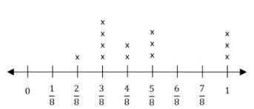
Some possibilities might include
- the lengths in inches of various insects;
- the widths in inches of people’s fingers;
- what fraction of a pizza different people ate;
- what distance in miles students ran during physical education class; or
- weights in grams of rocks in the class collection.
In a PBS Learning Media task called “What’s Typical, Based on the Shape of Data Charts?” (n.d.) students analyze two sets of data (collected by two different students) showing the heights of all members of the school band. Both students have measured the heights of the same 21 band members, yet the respective numbers reported in the two data sets do not match. Preliminary tasks invite students to find the range of the data (4.MD.4) and the mode (which students will learn about formally in grade six) for each set. Students then consider and offer explanations as to why the two data sets might differ. Finally, students recommend how many band uniforms the band director should order in sizes small, medium, and large.
“Button Diameters,” from Illustrative Mathematics (Illustrative Mathematics, 2016a) emphasizes measurement skills by having students measure buttons to the nearest fourth and eighth inch. After creating line plots of the data, students describe the differences between the two line plots they created, and they consider which line plot gives more information and which is easier to read.

CC2: Exploring Changing Quantities
Upper elementary grade students extend their understanding of operations to include multiplication and division. They study several ways of thinking about these operations, represent their thinking with tools, pictures, and numbers, and make connections among the various representations. Full understanding of the meanings of multiplication and division is essential, as students will need to apply the same thinking strategies when they begin operations with fractions. The development of solid understanding of these operations also prepares students for mathematics in middle school and beyond.
In grade levels three through five, students advance their algebraic thinking as they
- understand properties of multiplication and the relationship between multiplication and division (3.OA.; 4.OA.2, 5, 6; 5.NF.3, 4, 7);
- use the four operations to solve problems with whole numbers (3.OA.8, 9; 4.NBT.4, 5; 5.NBT.5, 6); and
- use letters to stand for unknowns in equations (3.OA.8; 4.OA.3).
Simultaneously, they expand their use of all the SMPs. For example, they
- think quantitatively and abstractly using multiplication and division;
- model contextually based problems using a variety of representations;
- communicate thinking using precise vocabulary and terms; and
- use patterns they discover as they develop meaningful, reliable and efficient methods to multiply and divide (SMP.2, 4, 6, 8) numbers within 100.

Meanings of Multiplication and Division
In previous grades, students worked with the operations of addition and subtraction; now they develop an understanding of the meanings of multiplication and division of whole numbers. They recognize how multiplication is related to addition (it can sometimes call for repeatedly adding equal-sized groups), how it is distinct from addition, and how it serves as a more efficient way of counting quantities.
Students engage initially in multiplication activities and problems involving equal-sized groups, arrays, and area models (NGA/CCSSO, 2010c). Later (in grade four) they also solve comparison problems and use the terms factor, multiple, and product. Students who hear teachers consistently and intentionally using precise mathematics terms during instruction become accustomed to the vocabulary. Over time, as they gain experience and as their confidence increases, students begin to incorporate the language themselves.
The most common types of multiplication and division word problems for grades three, four, and five (from the 2013 Mathematics Framework, Glossary) are summarized in figure 6.18. The various problem situations illustrate how the language associated with each type of problem might be confusing for a student who is learning English, and how teachers can support their students in acquiring precise mathematical language as students investigate mathematical content.

Figure 6.18 Common Multiplication and Division Situations
Common Multiplication and Division Situations | Unknown Product  × 6 = □ | Group Size Unknown  3 × □ = and ÷ 3 ₌ □ | Number of Groups Unknown  □ × 6 = and ÷ ₌ □
Equal Groups | There are 3 bags with 6 plums in each bag. How many plums are there altogether?  Measurement example:  You need 3 lengths of string, each 6 inches long. How much string will you need altogether? | If 18 plums are shared equally and packed in 3 bags, how many plums will be in each bag?  Measurement example:  You have 18 inches of string, which you will cut into 3 equal pieces. How long will each piece of string be? | If 18 plums are to be packed, with 6 plums to a bag, then how many bags are needed?  Measurement example:  You have 18 inches of string, which you will cut into pieces that are each 6 inches long. How many pieces of string will you have?
Arrays†, Area‡ | There are 3 rows of apples with 6 apples in each row. How many apples are there?  Area example:  What is the area of a rectangle that measures 3 centimeters by 6 centimeters? | If 18 apples are arranged into 3 equal rows, how many apples will be in each row?  Area example:  A rectangle has an area of 18 square centimeters. If one side is 3 centimeters long, how long is a side next to it? | If 18 apples are arranged into equal rows of 6 apples, how many rows will there be?  Area example:  A rectangle has an area of 18 square centimeters. If one side is 6 centimeters long, how long is a side next to it?
Compare | A blue hat costs $6. A red hat costs 3 times as much as the blue hat. How much does the red hat cost?  Measurement example:  A rubber band is 6 centimeters long. How long will the rubber band be when it is stretched to be 3 times as long? | A red hat costs $18, and that is three times as much as a blue hat costs. How much does a blue hat cost?  Measurement example:  A rubber band is stretched to be 18 centimeters long and that is three times as long as it was at first. How long was the rubber band at first? | A red hat costs $18 and a blue hat costs $6. How many times as much does the red hat cost as the blue hat?  Measurement example:  A rubber band was 6 centimeters long at first. Now it is stretched to be 18 centimeters long. How many times as long is the rubber band now as it was at first?
General | × b = □ | × □ = and ÷ a = □ | □ × b = p and p ÷ b= □
Source. CDE, 2013
Note. The first example in each cell focuses on discrete things. These examples are easier for students and should be given before the measurement examples.
† The language in the array examples shows the easiest form of array problems. A more difficult form of these problems uses the terms rows and columns, as in this example: “The apples in the grocery window are in 3 rows and 6 columns. How many apples are there?” Both forms are valuable.
‡ Area involves arrays of squares that have been pushed together so that there are no gaps or overlaps; thus, array problems include these especially important measurement situations

Views and Interpretations of the Operation of Multiplication
When students focus on the equal-groups interpretation of multiplication, they find the total number of objects in a particular number of equal-sized groups (3.OA.1). This references their understanding of addition, but it is important that instructional approaches include repeated addition as one of several distinct and necessary interpretations of multiplication. As they continue, students will use multiplication to solve contextually relevant problems involving arrays, area, and comparison using a variety of representations to show their thinking (SMP.4, 5, 6, 3; OA.3; 4.OA.2, 4; NBT.5).
Moving beyond the equal-groups interpretation of multiplication can prove challenging for students. Arrays can serve as a likely next step because they can be seen as the familiar equal-sized groups, but now with the objects arranged into orderly rows. The example in figure 6.19 shows, in each case, that when there are two groups of three cubes, there are six cubes, and 2 × 3 = 6.
Figure 6.19 Multiplication Representations for the Number Six
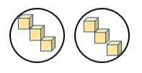
Two Equal-sized Groups of three cubes
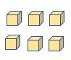
Array of two rows (of equal size) with three cubes in each row
The instructional goal is to move students beyond counting and re-counting items singly to determine the total; instead, students will recognize the groups or rows as the quantities that comprise the total. In the example above, as students find the product, six, they should be counting by threes (three in each row) rather than counting single cubes.
To solve a problem such as, “If there are 20 rows of seats in our multi-purpose room and each row has 16 seats, how many seats are there?” students can think about and represent the problem with an array. Some students may use the distributive property to simplify the problem, perhaps realizing that 10 + 10 = 20, multiplying 10 × 16 = 160 and adding 160 + 160 = 320. Others might take the 16 apart, thinking 16 = 10 + 6. They can then apply the distributive property: 10 × 20 + 6 × 20 = 200 + 120 = 320.
Students begin to view multiplication as area by building rectangles using sets of square tiles, which allows them to connect the now familiar array models with the newer idea of the area of a rectangle, as shown in the left to right progression of images in figure 6.20 Once students learn various ways to solve contextual story problems through creating, representing, and interpreting arrays, introducing the area interpretation of multiplication makes sense.
Figure 6.20 Using Arrays to Understand Area of a Rectangle
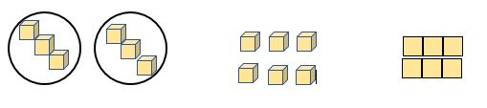
In grade level three, students develop an understanding of area and perimeter by using visual models. Fourth-graders extend their work with area and use formulas to calculate area and perimeter of rectangles. Students in grade five will continue to apply the equal-sized groups and area models to multiply whole numbers but will gradually drop using these models as they develop fluency with the standard algorithm. Fifth-graders use their understanding of whole number multiplication, along with concrete materials and visual models, to multiply fractions (4.NBT.5; 5.NBT.6, 5.NF.6). The interpretation of multiplication as area connects two categories of investigation—Exploring Changing Quantities and Stories told by Measurement and Data. Further discussion and illustration of these topics are found below.
Third-grade students use square tiles, like those shown in figure 6.21, to build rectangles and find the area by multiplying the side lengths (3.MD.7):
Figure 6.21 Using Square Tiles to Build a Rectangle
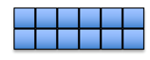
In grade four, students apply the area and perimeter formulas for rectangles to solve problems (4.MD.3), such as
"What is the width of a swimming pool that has a length of 12 units and an area of 60 square units?"
Fifth grade students find the areas of rectangles with fractional side lengths (5.NF.4b).
Figure 6.22 Rectangle with Fractional Side Lengths
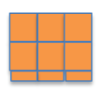
Beginning in fourth grade, students solve comparison problems in multiplication and division (4.OA.1). Comparison multiplication requires students to engage in thinking about some number of “times as many.” Expressing multiplicative relationships can necessitate the use of complex sentence structures, a challenge for all students, and perhaps especially for those who are English learners. Teachers can support students by teaching and modeling the language of mathematics, as well as giving students opportunities to practice that language.
The vignette Grade Four: Multiplication in chapter three shows how students struggle for understanding as they encounter multiplication as comparison. That vignette includes the teacher’s analysis of the experience and decisions about plans for the next lesson.
Comparison multiplication is particularly important in setting a foundation for scaling reasoning (5.NF.5) in grade five and, thus, demands careful introduction. The fifth-grade study of multiplication as scaling likewise sets the foundation for identifying scale factors and making scale copies in seventh grade and subsequent work with dilations and similarity (7.RP.1, 2, 3; 7.G.1). Presenting problems in familiar, culturally relevant contexts can help students to develop understanding and come to distinguish when multiplicative reasoning rather than additive reasoning is called for. They can compare quantities in the classroom (e.g., five times as many whiteboard pens as erasers, three times as many windows as doors, four times as much water as lemonade concentrate). Money can be a meaningful context, as seen in the following example, “Comparing Money Raised,” from Illustrative Mathematics (Illustrative Mathematics, 2016b): Luis raised $45 for the animal shelter, which was 3 times as much money as Anthony raised. How much money did Anthony raise?
In fifth grade, students prepare for middle school work with ratios and proportional reasoning by interpreting multiplication as scaling. They examine how numbers change as the numbers are multiplied by fractions. Based on their previous work with whole number multiplication, students may overgeneralize, and believe that multiplication “always makes things bigger.” Teachers can anticipate such misconceptions and plan investigations to allow for exploration of various multiplicative situations (DI1, 2; CC2, 3). Students should have ample opportunities to examine the following cases:
- When multiplying a number greater than one by a fraction greater than one, the number increases.
- When multiplying a number greater than one by a fraction less than one, the number decreases. This is a new interpretation of multiplication that needs extensive exploration, discussion, and explanation by students.
Examples:
- “I know $\frac{3}{4}× 7$ is less than 7, because I make 4 equal shares from 7 but I only take 3 of those shares (3/4 is a fractional part less than one). If I’m taking a fractional part of 7 that is less than 1, the answer should be less than 7.”
- “I know that $2\frac{2}{3}×8$ should be more than 8, because 2 groups of 8 is 16 and $2\frac{2}{3}>2$. Also, I know the answer should be less than 24 = 3 × 8, since $2\frac{2}{3}<3$.”
- “I can show by equivalent fractions that $\frac{3}{4}=\frac{3 × 5 }{4 ×5}$. But I also see that $\frac{5}{5}=1$, so the result should still be equal to $\frac{3}{4}.$”
Story contexts matter greatly in supporting students’ robust understanding of the operations. Multiplication and division situations move beyond whole numbers as students develop understanding of fractions and measure lengths to the quarter inch in third grade (3.MD.4), and as they later calculate area of rectangles with fractional side lengths. As noted in chapter three, historically, the majority of story problems and tasks children experienced in the younger grades tended to rely on contexts in which things are counted rather than measured to determine quantities (e.g., how many apples, books, children, etc. versus how far did they travel, how much does it weigh). Students should have experience with measurement as well as count situations for multiplication and division. Note that figure 6.18 Common Multiplication and Division Situations, above, includes examples that call for measurement as well as examples that call for counting.

Views and Interpretations of the Operation of Division
As students work with division alongside multiplication, they develop the understanding that these are inverse operations. They come to recognize division in two different situations: partitive division, which requires equal sharing (e.g., how many are in each group?) and quotitive division, which requires determining how many groups (e.g., how many groups can you make?) (3.OA.2).
Partitive Division (also known as fair share, equal share, or group size unknown division)
In partitive division situations, the number of groups or shares to be made is known, but the number of objects in (or size of) each group or share is unknown, such as in the following example and figure 6.23:
Discrete (counting) Example: There are 12 apples on the counter. If you are sharing the apples equally in three bags, how many apples will go in each bag?
Figure 6.23 Partitive Division Example
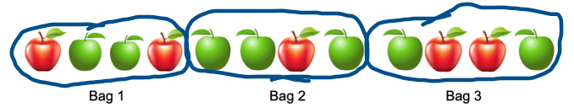
Measurement Example: There are 12 quarts of milk. If you are sharing the milk equally among three classes, how much milk will each class receive?
Quotitive Division (also known as repeated subtraction, measurement or number of group unknown division)
In quotitive division situations, the number of objects in (or size of) each group or share is known, but the number of groups or shares is unknown, as in the following example and illustration 6.24.
Discrete (counting) Example: There are 12 apples on the counter. If you place three apples in each bag, how many bags will you fill?
Figure 6.24 Quotitive Division Example
Measurement Example: There are three gallons of milk. If you give three quarts to each class, how many classes will get milk?
Both interpretations of division should be explored because they both have important uses for whole number and for fraction situations. The sample problems above illustrate that the action called for in a quotitive situation typically differs from the action called for in a comparable problem posed in a partitive context. Representations of the actions will differ, and attention to how and why this occurs supports understanding of these two interpretations of division. In these grades, teachers use the language of equal sharing, number of shares (or groups), repeated subtraction, and the size of each group, with students rather than the more formal terms, partitive or quotitive. Again, teachers need to support students as they acquire the language of mathematics by teaching and modeling precise language and by giving students opportunities to practice that language.
Students use the inverse relationship between multiplication and division when they find the unknown number in a multiplication or division equation relating three whole numbers. Viewing division as the inverse of multiplication presents a natural opportunity for introducing the use of a letter to stand for an unknown quantity (SMP.4, 6; 3.OA.4; 4.OA.3). Students may be asked to determine the unknown number that makes the equation true in equations such as 8 × n = 48, 5 = n + 3, and 6 × 6 = n (3.OA.4, 3.OA.8). Acquiring understanding of variables is an ongoing process that begins in grade three and increases in complexity through high school mathematics.
The following is an example of a problem that asks students to consider variables: There are four apples in each bag on the counter, and there are 12 apples altogether. How many bags must there be? Students can write the equation n × 4 and solve for n by thinking, “What times 4 makes 12?” This missing-factor approach to solving the problem utilizes the inverse relationship between multiplication and division.
In grade three, students learn and develop the concept of division and build an understanding of the inverse relationship between multiplication and division (3.OA.5, 6, 3.OA.7). Grade-four students find whole number quotients, limited to single-digit divisors and dividends of up to four digits (4.NBT.6). Students in grade five extend this understanding to include two-digit divisors and solve division problems (5.NBT.6). In grades four and five, students benefit from using methods based on properties, on the relationship between multiplication and division, and on place value to solve, illustrate, and explain division problems (Carpenter et.al., 1997; Van de Walle et al., 2014). Fluency with the standard algorithm for division of multi-digit numbers is a focus for grade six (6.NS.2).
Figure 6.25 details the development of the operation of division, grades three to six. Grade six information is included here to help grade five teachers understand the mathematical progressions as students move into the next grade.
Figure 6.25 Development of the Operation of Division, Grades Three Through Six
Grade 3 | Grade 4 | Grade 5 | Grade 6
Understand division as the inverse of multiplication (3.OA.6) | Solve division word problems (4.OA.2) | Use strategies based on place value, properties of operations and/or the relationship between multiplication and division to find quotients in division problems with two-digit divisors and up to 4-digit dividends; illustrate and explain the results (5.NBT.6) | Apply and extend previous understandings of multiplication and division to divide fractions by fractions and use visual fraction models and equations to represent the problem (6.NS.1)
Divide within 100 using the inverse relationship between multiplication and division (3.OA.7) | Use strategies based on place value, properties of operations and/or the relationship between multiplication and division to find quotients in division problems with one-digit divisors and up to 4-digit dividends; illustrate and explain the results (4.NBT.6) | Divide decimals to hundredths using strategies based on place value, properties of operations and/or the relationship between multiplication and division. Use a written method and explain reasoning (5.NBT.7) | n/a
n/a | n/a | Apply and extend previous understandings of division to divide unit fractions by whole numbers and whole numbers by unit fractions (5.NF.B7) | n/a

CC3: Taking Wholes Apart and Putting Parts Together – Whole Numbers
Elementary students come to understand the structure of the number system by building numbers and taking them apart; they make sense of the system as they explore and discover numbers inside numbers. A significant part of students’ mathematical work in grades three, four, and five is the development of efficient methods for each operation with whole numbers—methods they understand and can explain. By engaging in meaningful activities and explorations, students gain fluency with multiplication and division with numbers up to 10. They discover ways to apply the commutative and associative properties to solve multiplication problems. They use their understanding of place value and the distributive property to simplify multiplication of larger numbers.
Students use place value, take wholes apart, put parts together, and find numbers inside numbers when they
- use the four operations with whole numbers to represent and solve problems (3.OA.3, 3.OA.7, 3.OA.8; 3.NBT.2; 4.OA.2, 4.OA.3, 4.OA.4.; 4.NBT.4, 4.NBT.5, 4.NBT.6; 5.NBT.5, 5.NBT.6);
- use place value understanding and properties of operations to perform multi-digit arithmetic (3.OA.7, 3.OA.8; 4.NBT.4, 4.NBT.5; 5.NBT.5, 5.NBT.6);
- build fluency for products of one-digit numbers (3.OA.7);
- gain familiarity with factors and multiples (3.OA.6; 4.OA.4); and
- identify, generate, and analyze patterns and relationships (3.OA.9; 3.NBT.1; 4.OA.5, 4.NBT.1, 4.NBT.3).
Development of students’ use of the SMPs continues as they
- apply the mathematics they already know to solve multiplication and division problems (SMP.1, 4);
- use pictures and/or concrete tools to model contextually based problems (SMP.4, 5);
- communicate thinking using precise vocabulary and terms (SMP.3, 6); and
- use patterns they discover as they develop meaningful, reliable and efficient methods to multiply and divide (SMP.2, 4, 6, 8) numbers within 100.

Strategies and Invented Methods for Multiplication and Division
Students need opportunities to develop, discuss, and use efficient, accurate, and generalizable computation methods. Explicit instruction in making reasonable estimates, along with ample practice with situations that call for estimation, strengthen students’ ability to compute accurately, to explain their thinking, and to critique reasoning. The goal is for students to use general written methods for multiplication and division that they can understand and explain using visual models and/or place-value language (SMP.2, 6, 8; 3.OA.1; 3.OA.7; 4.NBT.5). In grade five, students become fluent with the standard algorithm for multiplying multi-digit numbers, connecting this abstract method to their understanding of the operation of multiplication. However, there is merit in fostering students’ use of informal methods before teaching algorithms: “The understanding students gain from working with invented strategies will make it easier for you to meaningfully teach the standard algorithms” (Van de Walle et al., 2014). Exposing students to multiple problem-solving strategies can improve students’ procedural flexibility (Woodward et al., 2012; Star et al., 2015); in contrast, pushing them too quickly to use a standard algorithm before they have fully grasped conceptual understanding may result in mathematical errors, such as the incorrect use of arithmetical operations (Fischer et al., 2019), or an inability to apply understanding in novel situations (Siegler et al., 2010).
Children often invent ways to take numbers apart to find an easier way to solve a problem. Students who know some but not all multiplication facts use invented strategies to calculate 7 × 8, as in the example that follows:
Student A: I know that 5 × 8 = 40, and then there are two more eights, so that makes 16. And then I add 40 + 16 = 56, so 7 × 8 = 56.
Student A is using the distributive property. To help the class recognize the usefulness of the property, the teacher draws an array of stars: eight rows of stars with seven stars in each row. As shown in figure 6.26, the teacher separates the columns to represent the student’s thinking, showing eight rows with five (red) stars in each row and eight rows with two (black) stars in each row. The teacher invites Student A to show the class how this drawing represents their thinking.
Figure 6.26 Teacher’s Representation of Student Thinking on Distributive Property Problem
Student A uses the pen to write “40” below the red part of the drawing, and 16 below the black part, then explains:
The red part is 8 × 5, and then the black part is 8 × 2, so it’s 40 + 16.
Student B adds: I knew that 7 × 7 = 49, and then there’s one more seven, so I added 49 + 7 = 56.
The teacher invites Student B to show the class the equations they used. Student B writes: 7 × 7 = 49, and 49 + 7 = 56.
The teacher checks with the class for understanding of what Student B did and calls on two other students to re-explain Student B’s strategy.
The teacher then asks the class to consider whether Student B used the distributive property and how they could illustrate Student B’s thinking. With input from classmates, Student B illustrates their thinking as follows:
Student B’s illustration shows two rectangles, one a 7 × 7 unit rectangle (i.e., a square) and, beside it, a 7 × 1 unit rectangle. The corresponding multiplication (7 × 7 = 49) and addition (49 + 7 = 56) are included in the illustration. The teacher notes that if the 1-unit width of the smaller rectangle were indicated, it would make the multiplication 7 × 1 = 7 evident (the teacher’s suggestion is noted in a contrasting color in the diagram).
As students begin to multiply two-digit numbers using strategies based on place value and properties of operations (SMP.2, 7, 8; 3.OA.B.5, 3.OA.C.7; 4.NBT.B.5, 6), they find and explain efficient methods. Fourth-grade students record their processes with pictures and manipulative materials, as well as with numbers.
To multiply 36 × 94, three students (A, B, and C) use place-value understanding and the distributive property, yet they use three different strategies to solve the problem.
As shown in figure 6.27, student A labels the partial products within each of the four rectangles in the picture: 2700, 540, 120, and 24, and calculates the final sum beside the sketch.
Figure 6.27 Documentation of Student A’s Process for Multiplying Two-digit Numbers
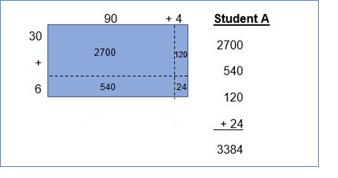
Student B calculates the four partial products and shows the thinking for each, as in figure 6.28.
Figure 6.28 Documentation of Student B’s Process for Multiplying Two-digit Numbers
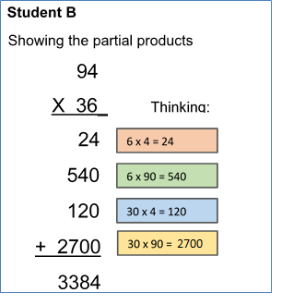
While it is essential that students understand and can explain the methods they use, variations in how they record their calculations are acceptable at this stage (Fuson and Beckmann, 2013). The recording method shown by Student C (below), for example, reflects the same thinking as that of Student D (below), but the locations where the students show the regroupings are different.
Student C uses the standard algorithm with the regroupings shown above the partial products rather than above the “94” in the problem, as shown in figure 6.29, which documents their process.
Student C’s thinking:
6 × 4 = 24. The 4 is recorded in the ones place and the 2 tens are recorded in the tens column.
6 × 90 = 540. The 40 is shown by the 4 in the tens place; the 5 hundreds are recorded in the hundreds column.
30 × 4 = 120. The 20 is recorded in the tens and ones places; the 1 hundred is recorded in the hundreds column.
30 × 90 = 2700. The 7 hundreds are recorded in the hundreds place; the 2 thousands are recorded in the thousands place.
Figure 6.29 Documentation of Student C’s Process
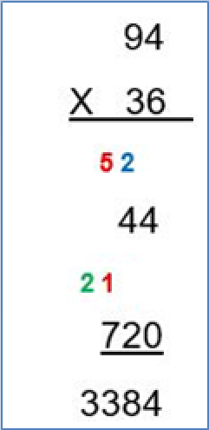
Student D uses this common version of the standard algorithm with the regroupings shown above the factor, as shown in figure 6.30, which documents their two-stage process for solving the problem. Commonly the first step would be to multiply the rightmost number on the top row (4) by the 6 in the ones place on the second row, and then carry the 2 to above the 94. A second step would be to multiply the leftmost number in the bottom row (3, but since it is in the tens place, 30) by the rightmost number in the top row (4). So, in the illustration, the
2 – The 2 represents two 10s in 6 × 4 = 24
1 – This 1 represents the 100 in 30 × 4 = 120
Figure 6.30 Documentation of Student D’s process
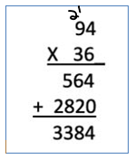
During thoughtfully guided class discussion, perhaps on several occasions, the connections among the pictorial representation (A), the partial products method (B), and the standard algorithm (C and D) become clear.
To multiply using the standard algorithm successfully and with understanding in grade level five (5.NBT.5), students will need guidance in making connections between the increasingly abstract methods of multiplying two-digit numbers. Building understanding with concrete materials (e.g., base ten blocks) and visual representations (e.g., more generic rectangular sketches) allows students to build the necessary foundation for this formal algorithm. Students will rely on these skills and understandings for years to come as they continue to multiply and divide multi-digit whole numbers and to add, subtract, multiply, and divide rational numbers.
The table below indicates the grade levels at which the CA CCSSM call for students to use each of the standard algorithms with fluency, which means without any drawings or physical supports (as described across the grade levels for the NBT domain of the standards). In general, the standards support the use of invented strategies and recording methods as students acquire early understanding of each operation and develop general methods. Students explain written methods and use drawings or objects to develop meanings when they are first using general methods. One longitudinal study compared groups of students who used invented algorithms before they used standard algorithms with students who used standard algorithms from the beginning. The researchers (Carroll, 1997) concluded that “Students taught with curriculum that encouraged invented strategies outperformed comparison students on nearly all problems (e.g., related to multiplication and division and to fractions).” Some parents and guardians may express discomfort with the CA CCSSM expectation that instruction in standard algorithms should follow, rather than initiate, students’ computation efforts. Indeed, in the past, standard algorithms were typically taught as the primary and perhaps the only way to solve mathematics problems. Educators can share with families what research has revealed about the many benefits of invented strategies, including
- students make fewer computation errors;
- less re-teaching is needed;
- students develop number sense and increase their flexibility with numbers; and
- students gain agency as doers and owners of mathematics (Van de Walle et al., 2014).
The CA CCSSM do not call for fluency with standard algorithms in grades TK–3, so there is time to develop meanings for accessible standard algorithms with drawings in these grades. The CA CCSSM do say that first-grade “Students develop, discuss, and use efficient, accurate, and generalizable methods to add within 100 and subtract multiples of 10.” (CDE 2013, 14). And second-grade students “solve problems within 1000 by applying their understanding of models for addition and subtraction, and they develop, discuss, and use efficient, accurate, and generalizable methods to compute sums and differences of whole numbers in base-ten notation, using their understanding of place value and the properties of operations.” (CDE 2013, 18). The CA CCSSM place fluent use of standard algorithms at the grades indicated below in the table.
Figure 6.31 Development of Fluency with Standard Algorithms, Elementary Grades
Addition and Subtraction | Multiplication | Division | Operations with Decimals
Grade 2: 2.NBT.5  Fluently add and subtract within 100 using strategies based on place value, properties of operations, and/or the relationship between addition and subtraction.  2.NBT.7 Add and subtract within 1000, using concrete models or drawings and strategies based on place value, properties of operations, and/or the relationship between addition and subtraction; relate the strategy to a written method. Understand that in adding or subtracting three-digit numbers, one adds or subtracts hundreds and hundreds, tens and tens, ones and ones; and that sometimes it is necessary to compose or decompose tens or hundreds. | Grade 3: 3.NBT.3  Multiply one-digit whole numbers by multiples of 10 in the range 10–90 (e.g., 9 × 80, 5 × 60) using strategies based on place value and properties of operations. | Grade 4: 4.NBT.6  Find whole-number quotients and remainders with up to four-digit dividends and one-digit divisors, using strategies based on place value, the properties of operations, and/or the relationship between multiplication and division. Illustrate and explain the calculation by using equations, rectangular arrays, and/or area models. | Grade 5: 5.NBT.7  Add, subtract, multiply, and divide decimals to hundredths, using concrete models or drawings and strategies based on place value, properties of operations, and/or the relationship between addition and subtraction; relate the strategy to a written method and explain the reasoning used.
Grade 3: 3.NBT.2  Fluently add and subtract within 1000 using strategies and algorithms based on place value, properties of operations, and/or the relationship between addition and subtraction. | Grade 4: 4.NBT.5  Multiply a whole number of up to four digits by a one-digit whole number, and multiply two two-digit numbers, using strategies based on place value and the properties of operations. Illustrate and explain the calculation by using equations, rectangular arrays, and/or area models. | Grade 5: 5.NBT.6  Find whole-number quotients of whole numbers with up to four-digit dividends and two-digit divisors, using strategies based on place value, the properties of operations, and/or the relationship between multiplication and division. Illustrate and explain the calculation by using equations, rectangular arrays, and/or area models. | n/a
Grade 4: 4.NBT.4  Fluently add and subtract multi-digit whole numbers using the standard algorithm. | Grade 5: 5.NBT.5  Fluently multiply multi-digit whole numbers using the standard algorithm. | Grade 6: 6.NS.2  Fluently divide multi-digit numbers using the standard algorithm. | Grade 6: 6.NS.3  Fluently add, subtract, multiply, and divide multi-digit decimals using the standard algorithm for each operation.
Source: CDE, 2013
Pattern investigation is a powerful means of building understanding, and can provide access for students with visual strengths and any students who lack confidence with numerical tasks. Investigating patterns helps students develop facility with multiplication and supports them on their path to fluency. There are many patterns to be discovered by exploring the multiples of numbers. As students explore patterns visually, they find and, in number charts, describe and color what they have found. They engage in partner and/or class conversations in which they notice and wonder, explain their discoveries, and listen to and critique others’ discoveries. Examining and articulating these mathematical patterns is an important part of the work to understand multiplication and division.
The following problem is an example of one aspect of pattern investigation. As shown in figure 6.32, on a multiplication table, each student colors in the multiples of a designated factor (in this case, multiples of 4).
Figure 6.32 Example of Student’s Marked-up Multiplication Table Used in Pattern Investigation
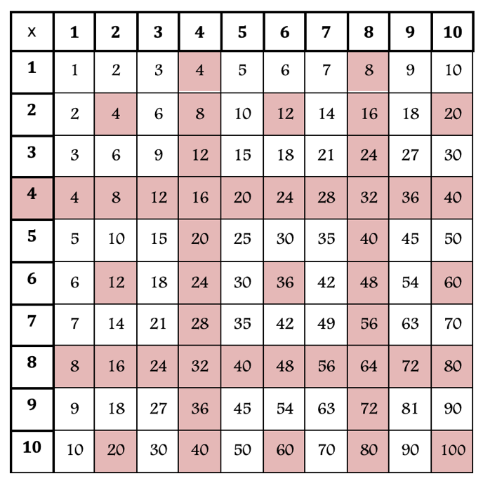
The teacher poses questions, prompting students to notice and wonder why the pattern they see occurs and what all these multiples of four have in common.
On the same chart, students then circle all the multiples of four that are also multiples of 5 (20, 40, 60, 80, 100) and analyze why only those 5 multiples coincide, where they are located on the table, what those numbers have in common.

Attaining Fluency
Fluency is an important component of mathematics, contributing to a student’s success through the school years and remaining useful in the math many adults use in their daily lives.
What does fluency mean in elementary grade mathematics? Content standard 3.OA.7, for example, calls for third graders to “fluently multiply and divide within 100, using strategies such as the relationship between multiplication and division … or properties of operations.” Fluency means that students use strategies that are flexible, efficient, and accurate to solve problems in mathematics. Students who are comfortable with numbers and who have learned to compose and decompose numbers strategically develop fluency along with conceptual understanding. They can use known facts, including those drawn from memory, to determine unknown facts. They understand, for example, that the product of 4 × 6 will be twice the product of 2 × 6, so that if they know 2 × 6 = 12, then 4 × 6 = 2 × 12, or 24.
In the past, fluency has sometimes been equated with speed, which may account for the common but counterproductive use of timed tests for practicing facts (Henry & Brown, 2008). Fluency involves more than speed, however, and requires knowing, efficiently retrieving, and appropriately using facts, procedures, and strategies, including from memory. Achieving fluency builds on a foundation of conceptual understanding, strategic reasoning, and problem solving (NGA Center and CCSSO, 2010; NCTM, 2000, 2014). To develop fluency, students need to have opportunities to explicitly connect their conceptual understanding with facts and procedures (including standard algorithms) in ways that make sense to them (Hiebert and Grouws, 2007).
Attaining fluency with multiplication and division within 100 accounts for a major portion of upper elementary grade students’ work. Some additional suggestions to support fluency and increase efficiency in learning multiplication and division facts include:
- Focus most heavily on the types of multiplication and division problems shown in figure 6.31 that students understand but in which they are not yet fluent.
- Continue meaningful practice—and extra support as necessary—for those students who need it to attain fluency.
- Encourage students to use, work with, and explore numbers.
When practice is varied, playful, and tailored to student needs, students enjoy and readily learn more mathematics (Boaler, 2016; Kling and Bay-Williams, 2014, 2015). Interesting, worthwhile facts practice can be accomplished by engaging students in number talks/strings and games. Familiar card games, such as Concentration or War, are easily adapted to provide fact practice (Kling and Bay-Williams, 2014, 493). For example, pairs of students can use a deck of playing cards (with the face cards removed) to practice multiplication facts: The cards are shuffled and four cards are turned face up between the players. The remaining cards are placed face down in a stack. Player A selects two of the face-up cards, calculates the product, and explains the strategy they used. Player B confirms or challenges the product and may ask for further explanation of Player A’s strategy. If Player A came up with the right product, the student claims those two cards. Player B turns over two more cards from the stack to replace those taken by Player A and then takes their own turn. For further discussion of fluency and additional resources, see chapter three.
Acquiring fluency with multiplication and division of whole numbers begins in third grade and development continues in grades four and five. Fluency gained in these two grades establishes the foundation for work with ratios and proportions in grades six and seven. To support this development, teachers must provide students with learning opportunities that are enjoyable, make sense, and connect to previous learning about the meanings of operations and the properties that apply. They must also avoid any temptation to conflate fluency and speed. Research shows that when students are under time pressure to memorize facts devoid of meaning, working memory can become blocked. Such stressful experiences tend to defeat learning, and for many students can lead to persistent, generalized anxiety about their ability to succeed in mathematics (Boaler, Williams, and Confer, 2015).
The following general strategies can help students establish all products of two one-digit numbers (3.OA.7; SMP.2, 4, 8) in their memory:
- Multiplication by zeros and ones
- Doubles (twos facts), doubling twice (fours), doubling three times (eights)
- Tens facts (relating to place value, 5 × 10 is 5 tens, or 50)
- Fives facts (knowing that the fives facts are half of the tens facts)
- Know the squares of numbers (e.g., 6 × 6 = 36)
- Patterns—for nines, for example: (6 × 9) = 6 × (10-1) = (6 × 10) – (6 × 1) = 10 groups of 6 – 1 group of 6 = 60 – 6 = 54)

Investigating and Applying Properties of Multiplication
As students develop strategies for solving multiplication problems, they naturally use properties of operations to simplify the tasks. Students are expected to strategically apply the operations throughout these grades as they calculate quantities (SMP.5, 7; 3.OA.5, 3.OA.7; 4.NBT.4, 6; 5.OA.1, 2; 5.NBT.4, 5.NBT.5). They are also expected to use precise mathematical language at all grades (SMP.6). Since students acquire language most readily when it is used consistently and in context, teachers will want to encourage students’ use of the names of the properties involved in the mathematics they are doing. Teachers support students’ facility with the operations of arithmetic by providing students with frequent opportunities to explore and discuss various multiplication strategies and properties (SMP.3, 4, 5, 8; ELD.PI.9), and by highlighting the efficacy of the strategies as they are used (Kling and Bay-Williams, 2015).
In the vignette Students Examine and Connect Methods of Multiplication, the teacher challenges students to multiply 7 × 24 and to explain their strategies. The goal is to promote their critical examination of several methods and to have students look for connections among the methods.
Commutative Property: As students in grades 3–5 work with equally sized groups, arrays, and area, they have many opportunities to employ the commutative property of multiplication. They may notice that they also use commutativity to solve addition problems. In story contexts, they may encounter the difference between “two groups of three objects each” (e.g., pencils, ants, pounds, quarts) and “three groups with two objects each.” Students discover the commutative property by noticing that the result in both cases is a total of six objects. This also supports their ability to become fluent with multiplication within 100: If a student knows 4 × 6 = 24, then they know that 6 × 4 also is equal to 24.
Associative Property: Experiences in which students must multiply three factors, such as 3 × 5 × 2, provide opportunities to apply the associative property. A student can first calculate 3 × 5 = 15, then multiply 15 × 2 to find the product 30. Another student may find 5 × 2 = 10 first, then multiply 3 × 10 to find the same product, 30. Again, students can observe that the associative property applies to both addition and multiplication.
Distributive Property: Students frequently use the distributive property to discover products of whole numbers (such as 6 × 8) based on products they can find more easily. A student who knows that 3 × 8 = 24 can use that to recognize that since 6 = 3 + 3, then 6 × 8 = (3 + 3) × 8 = 3 × 8 + 3 × 8, and that 3 × 8 + 3 × 8 = 24 + 24 = 48.
Another student may use knowledge that 6 × 8 = 6 × (4 + 4) to solve: 6 × 8 = 6 × (4 + 4) = 6 × 4 + 6 × 4 = 24 + 24 = 48.
The distributive property may also involve subtraction. A student may solve 6 × 8 by beginning with the familiar 6 × 10: 6 × 8 = 6 × (10 – 2) = 6 × 10 – (6 × 2) = 60 – 12 = 48.

CC3: Taking Wholes Apart and Putting Parts Together–Fractions
In grades one and two, students partition circles and rectangles into two, three, and four equal shares and use fraction language (e.g., halves, thirds, half of, a third of). Their experiences with fractions are concrete and related to geometric shapes. Starting in grade three, important foundations in fraction understanding are established, and the topic calls for careful development at each grade level.
The fact that there are several ways to think about fractions increases the complexity and significance of this body of learning. Children begin formal work with fractions in third grade, with a focus on unit fractions and benchmark fractions. Fourth and fifth grade students move on to fraction equivalence and operations with fractions. Fifth grade mathematics includes the development of the meaning of division of fractions, a sophisticated idea which needs careful attention and preparation in prior grades. Students often struggle with key fraction concepts, such as “Understand a fraction as a number on the number line…” (3.NF.2) and “Apply and extend previous understandings of division to divide unit fractions by whole numbers and whole numbers by unit fractions” (5.NF.7). It is imperative to present fractions in meaningful contexts and to allow ample time for the careful development of fraction concepts at each stage.
Proficiency with rational numbers written in fraction notation is essential for success in more advanced mathematics such as percentages, ratios and proportions, and algebra.
To develop fraction concepts, upper elementary students should
- develop understanding of fractions as numbers (3.NF.1, 2);
- understand decimal notation for fractions, and compare decimal fractions (4.NF.5, 6, 7);
- extend understanding of fraction equivalence and ordering (3.NF.3; 4.NF.1, 2); and
- apply and extend previous understandings of operations to add, subtract, multiply and divide fractions (4.NF.3, 4; 5.NF.1–7).
As students work with fractions, they use the SMPs. For example:
- Think quantitatively and abstractly, connecting visual and concrete models to more abstract and symbolic representations of fractions (SMP.2).
- Model contextually based problems mathematically, and using a variety of representations (SMP.4, 5).
- Select and use tools such as number lines, fraction squares, or illustrations appropriately to communicate mathematical thinking precisely (SMP.5, 6).
- Make use of structure to develop benchmark fraction understanding (SMP. 7).

Understanding Fractions as Numbers, Equivalence, and Ordering Fractions
Grade three students begin with unit fractions (any fraction whose numerator is 1), building on the idea of partitioning wholes into equal parts, and become familiar with benchmark fractions, such as one half. In fourth grade, the emphases are on equivalence, ordering, and beginning operations with fractions and decimal fractions. In fifth grade, students apply their previous understandings of the operations to add, subtract, multiply, and divide fractions (in limited situations). Figure 6.33 shows how students’ understanding and use of fractions develops through these grades.
Figure 6.33 Development of Fraction Concepts, Grades Three Through Five
Development of Fraction Concepts: Grade Three | Development of Fraction Concepts: Grade Four | Development of Fraction Concepts: Grade Five
Understand unit fractions as equal parts of a whole (3.NF.1) | Explain equivalence of fractions and generate equivalent fractions (4.NF.1) | Solve addition and subtraction fraction problems by finding equivalent fractions, using visual models or equations (5.NF.1, 2)
Understand fractions as numbers on a number line (3.NF.1) | Compare fractions with unlike numerators and denominators by finding equivalent fractions (4.NF.2) | Use benchmark fractions and number sense to estimate with fractions and determine reasonableness (5.NF.2)
Use unit fractions as building blocks (3.NF.2) | Apply previous understandings of addition and subtraction to solve fraction problems using visual models and/or equations (4.NF.3) | Apply previous understandings of multiplication to multiply fractions by a whole number or a fraction, and view multiplication of fractions as scaling (5.NF.3, 4, 5)
Understand equivalence and compare fractions in limited cases (3.NF.3) | Apply previous understandings of multiplication to multiply a fraction by a whole number (4.NF.4) | Use visual fraction models or equations to represent and solve fraction multiplication problems (5.NF.6)
n/a | Understand decimal notation and compare decimal fractions to the hundredths place (4.NF.6,7) | Use visual models to solve story problems involving division of fractions by whole numbers and whole numbers by unit fractions in limited situations (5.NF.7)
An important goal is for students to see unit fractions as the basic building blocks of all fractions, in the same sense that the number 1 is the basic building block of whole numbers. Students make the connection that, just as every whole number is obtained by combining a sufficient number of ones, every fraction is obtained by combining a sufficient number of unit fractions (adapted from Common Core Standards Writing Team, 2022). The idea of 3/4 as a number may be difficult for students to grasp initially; “putting together three one-fourths” is a more readily accessible concept. To develop the concept, students can use concrete materials to build a number and then see the connections between the concrete model and the representational, more abstract approaches.
Students might, for example, use fraction bars (in this case, one orange rectangle is identified as one fourth of the whole) to physically put together three one-fourth pieces. They can illustrate this rectangular representation on paper and can record it symbolically as 1/4 + 1/4 + 1/4 = 3/4. Teachers support students in making these connections by asking that they record their thinking in several ways, giving opportunities for discussion and comparison of various representations, and being explicit about how the representations express the same idea.
Figure 6.34: Representing Fractions
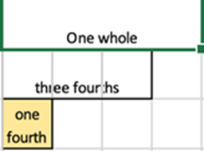
At the beginning stages of fraction work, students need considerable experience exploring various concrete and visual materials in order to build understanding of fractions as equal parts of a whole (3.NF.1,3; ELD.PI.7). It is natural for students, using their understanding of whole numbers, to think that if a whole is split into four parts, regardless of whether those parts are of equal size, then each part must be one fourth of the whole. The example lesson that follows addresses this misconception in a concrete way using a square made from tangram pieces:
A teacher shares with the class a multi-colored square, like the one in figure 6.35, posing the question, “What fraction of this square is the blue triangle?”
Figure 6.35 Multi-colored Square
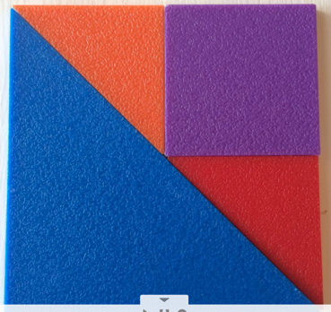
Akiko and Parker study the square arrangement of four tangram pieces. Akiko says, “The blue triangle is 1/4, because there are four pieces.” Parker says, “I don’t think that’s 1/4, but I’m not sure what it is.” As they worked with their tangram pieces, Parker put two of the small triangles together, forming a square. Akiko comments, “The two little triangles make a square just like the purple square. What if we build our own square like this one?” They used tangram pieces to build their own four-piece square. Once they have finished building the square, Parker picks up the large triangle and flips it over to cover the three smaller pieces (two triangles and square). Akiko exclaims, “I get it! The big triangle is half of the square, not 1/4!”
In third through fifth grade, students explore fractions with concrete tools and develop the more abstract understanding of fractions on the number line (SMP.2, 4, 5; 3.NF.2, 4.NF.2, 3, 4; 5.NF.3, 4, 6). Round fraction pieces, which are commonly available, serve well for helping establish such ideas as 1/4 being half of one half; 1/6 being a smaller size fraction piece than 1/2 and three sixths pieces together making a half circle equal to 1/2. Using multiple models for fractions can help to solidify and enlarge concepts. As with other tools used for building mathematical concepts, each fraction manipulative has advantages as well as limitations. For example, while a fraction circle is helpful in letting students see the relative sizes of unit fractions, a number line or fraction bar might be a better choice for finding the sum of 1/2 and 1/3.
Other useful manipulatives for fractions include
- fraction bars;
- fraction squares or rectangles;
- tangrams;
- pattern block pieces;
- Cuisenaire rods;
- fraction strips, for folding halves, fourths, thirds, etc.;
- rulers/meter sticks;
- number lines; and
- geoboards.
The process of preparing some of their own fraction tools is also valuable for young students (Burns, 2001). It increases their understanding of fractions as parts of a whole and supports recognition of the relative sizes of fractional parts. For example, they can create fraction strips from construction paper. As they cut halves, fourths, and eighths of the whole, students discover that 1/4 is half of 1/2, and 1/8 is half of 1/4, leading to the generalization that whenever a whole is partitioned into more equal shares, the parts become progressively smaller.
Alternatively, students can fold paper strips to create fractional parts, as in the following examples and figures 6.36 and 6.37:
- When asked to make a fraction bar that shows the fraction 1/4 by folding the piece of paper into equal parts, students think: “I know that when the number on the bottom is 4, I need to make four equal parts. By folding the paper in half once and then again, I get four parts and each part is equal. Each part is worth 1/4.”
Figure 6.36 Fraction Bar Showing Four Equal Parts
- When asked to shade 3/4 using the fraction bar they created, students think: “My fraction bar shows fourths. The 3 tells me I need three of them, so I’ll shade them. I could have shaded any three of them, and I would still have 3/4."
Figure 6.37 Fraction Bar Showing Shading of Three of the Four Quarters
When given a number line and asked to use their fraction bar to locate the fraction ¾ on the number line, as shown in figure 6.38, and then explain how they know they are marking the right place on the line, students think: “When I use my fraction bar as a measuring tool, it shows me how to divide the unit interval into four equal parts (since the denominator is four). Then I start from the mark that has ‘0’ and I measure off three pieces of 1/4 each. I circle the pieces to show that I marked three of them. This is how I know I have marked three 1/4s, or 3/4.”
Figure 6.38 Number Line with Fraction Bar Used to Locate Three Quarters on the Line
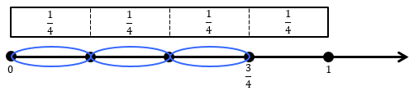
If students rely on their whole number thinking, they often expect that a unit fraction with a smaller denominator will be less than a unit fraction with a larger denominator (e.g., they think one fourth must be less than one sixth (Van de Walle et al., 2014).
Ordering fractions from least to greatest provides opportunity for students to reason about this and other issues related to the relative sizes of fractions. Students can determine how to put fractions such as 5/3, 2/5, and 5/4 in order from least to greatest, using reasoning along with concrete materials or drawings. They can explain verbally how they know that 5/3 is greater than 5/4: “There are five thirds and five fourths, but thirds are bigger pieces than fourths, so 5/3 is bigger than 5/4.” Benchmark reasoning (i.e., using more common numbers or fractions like 1 or 1/2) is also useful here: “I know that 2/5 is less than one and it’s even less than 1/2$.$ And 5/3 and 5/4 are both more than 1. So, 2/5 is the smallest.”
Comparing and ordering fractions can be challenging for upper elementary students. Ordering fractions requires that each fraction refers to the same unit or whole (i.e., it may be difficult for students to accurately order 6/7 and 5/6 from least to greatest without first understanding how the 1/7 and 1/6 units compare). Students need repeated experiences reasoning about fractions and justifying their conclusions using a variety of visual fraction models to develop benchmark reasoning (SMP.1, 2, 4, 5, 7; ELD I6, P9). Students in these grades who are overly reliant on their understanding of whole numbers may have greater difficulty than other students in recognizing the relationship between the numerator and denominator of a fraction. Frequent, sustained discussion of math ideas in both small groups and whole-class settings will be necessary, as in the following example in which three students are discussing how to order the fractions 1/3, 3/5, and 1/2 from smallest to largest.
Alana is an English learner with strong problem-solving skills, yet she is reluctant to share her ideas with the whole class. As is true for many students who are learning English, Alana is more confident expressing their thinking in small-group settings. The teacher has paired Alana with Miriam, who helps Alana practice expressing ideas in English, and Gus, who often uses visual representations to make sense of mathematics situations. Their discussion starts with Miriam explaining her own reasoning about how to order the fractions:
- Miriam: “One third and 3/5 are equal because you just add 2 to 1 (the numerator of 1/3) to get 3 (the denominator of 1/3) and you add 2 to 3 (the numerator of 3/5) to get 5 (the denominator of 3/5). So, they’re the same.”
- Alana: “Wait! That doesn’t make sense! One third is less, isn’t it? Because 3/5 is more than half and 1/3 is not as big as 1/2.”
- Gus: “Let’s do it with our fraction pieces.”
Together, they build 1/3, 3/5, and 1/2 with their fraction pieces. They compare and find that 1/3 is less than 1/2 and 1/2 is less than 3/5. The conversation continues.
- Miriam: “Why didn’t my way work?”
- Alana: “I think because the thirds pieces are not the same size as the fifths pieces.”
- Gus: “But we only had one third, and there are three 1/5ths, so when you put them together to make 3/5, that’s bigger than just one third.”
- Alana: “Isn’t 1/2 a benchmark fraction? I can tell that 1/3 is less than 1/2 because when a fraction is the same as 1/2, the denominator is always two times as big as the numerator. Like, 1/2, 2/4, 3/6, 4/8 and 5/10.”
- Miriam: “Oh yeah—I remember we talked about how 1/2 can have lots of names. But would you tell me again how you know that 3/5 is bigger than 1/3?”
Alana explains again, pointing to the fraction pieces. The teacher, observing the conversation, is pleased to note Alana’s involvement and notes that Alana has used the word “benchmark.” In several groups, some confusion remains; the teacher decides to conduct a whole-class discussion to develop this idea further.
The fourth-grade task, “Doubling Numerators and Denominators,” from Illustrative Mathematics (Illustrative Mathematics, 2016c), provides the opportunity for such reasoning and class discussion of fraction concepts.
The task is based on the following:
- How does the value of a fraction change if you double its numerator? Explain your answer.
- How does the value of a fraction change if you double its denominator? Explain your answer.
As students are developing fraction concepts and beginning to use fractional notation, they need to recognize $\frac{a}{b}$ as a quantity that can be placed on a number line, and that it may be located between two whole numbers or may be equivalent to a whole number (where a is equal to or a multiple of b). Students develop an understanding of order in terms of position on a number line, following the mathematical convention that the fraction to the left is said to be smaller and the fraction to the right is said to be larger.
The use of precise mathematical terms is essential in order to support all students’ understanding: 3/4 is read as “three fourths.” Casual language such as “three over four” or “three out of four” (except when discussing ratios or probability situations) undermines fragile understanding of fractions, interferes with academic language acquisition, and may lead to misapplication of whole-number reasoning in fraction situations. Students who are English learners, in particular, need explicit teaching of precise mathematical language and benefit from its consistent use in mathematics classes.
The number line reinforces the analogy between fractions and whole numbers (Dyson et al., 2018; Geary et al., 2008; Lannin et al., 2020). Just as 5 is the point on the number line reached by marking off five times the length of the unit interval from 0 to 1 (i.e., “jumps” on the number line), so is 5/3 the point obtained by marking off 5 times the length of a unit interval as the basic unit of length, just a different unit interval, namely the interval from 0 to 1/3.
Locating fractions on the number line calls for reasoning about relative sizes of fractions and whole numbers (SMP.2, 5, 7). In this context, familiarity and comfort with the use of benchmark fractions is of great value. Where, for example, does 3/8 belong on the number line pictured in figure 6.39? Because a student may quickly recognize that 3/8 is less than half (or 4/8), a student who uses benchmark reasoning can begin by place another benchmark fraction of 1/4 midway between 0 and 1/2, and then place 3/8 midway between 1/4 and 1/2$.$
Figure 6.39 Using Benchmark Numbers on a Number Line
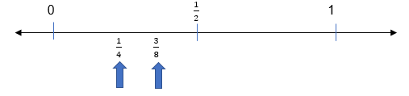
In the process of labelling locations on the number line in relation to benchmark numbers such as 1/2, students expand their understanding of equivalence. For example, by looking at the fraction line with the 2/4 labeled, they may be able to see the location marked 1/2 is double the length of the interval from 0 to 1/4, or is 2/4. Such observations can lead to powerful insights; students need time to think and talk about fraction ideas, including that all these fractions are based on the same unit (i.e., 2/4 is double the unit fraction of 1/4).
The following snapshot, “Grade Three Fractions,” illustrates how teachers can choose lessons and strategies that enable the teacher to provide appropriate prompts and supports as students work on problems.

Snapshot: Grade Three Fractions
At any given moment in most classrooms, students vary considerably in their skill levels, enthusiasm, and willingness to persevere. Teachers are regularly challenged to meet the needs of all learners simultaneously. The use of math problems that are accessible and can be extended to allow greater depth and exploration, along with the teacher’s strategic student pairings and careful attention to student thinking, makes it possible for a teacher to provide appropriate prompts and supports as students work on problems.
In this classroom episode from the third grade, two students work together as partners, combining their strengths. Since the beginning of the year, Desmond has repeatedly announced a love of mathematics, saying more than once, “I like to think about numbers in my head just for fun.” Desmond shows evidence of advanced thinking in classwork, often choosing to extend problems beyond what is expected at the grade level. For her part, Ellie is a capable thinker, is curious, and is very verbal. Ellie loves to draw and uses pictures to help make sense of mathematics.
The teacher has chosen this task so students can use their understanding of the relationship between 1/2 and 1/4 to build a fraction of greater value from unit fractions (3.NF.1, 2, 3; SMP.2, 3, 5, 8). The following conversation between these two third grade students and their teacher takes place as the students work to locate 1/4 and 3/4 on a number line on which only the locations for 0 and 1 are currently marked:
Desmond: We found 1/2 on the number line; that was easy. Then, half of 1/2 is one-fourth, so we marked 1/4 on the number line.
Ellie: Yes, because 1/4 $\frac{1}{4}$is half of 1/2, $\frac{1}{2},$like with our fraction pieces! See? It takes 2 of these (pointing to the distance from 0 to 1/4 $\frac{1}{4}$on the number line) to get to 1/2.
Desmond: And then this is 2/4 (pointing to 1/2), too.
Ellie: What do you mean? That’s already 1/2$\frac{1}{2}$, right?
Desmond: Yes, but it can be 1/2 $\frac{1}{2}$and also be 2/4$\frac{2}{4}$; you just said so, really, because you said it takes two 1/4$\frac{1}{4}$’s to make 1/2.
Ellie: Wait. Let’s get the fraction pieces and build 2/4. Okay, I think you’re right that 1/2 $\frac{1}{2}$is the same as 2/4$\frac{2}{4}$.
Teacher: How can that place on the number line be both 2/4 and 1/2? $\frac{2}{4} and \frac{1}{2}?$Does that make sense?
Ellie: Yes; I built it and I can draw 2/4 and it makes 1/2. So, that’s 1/4$\frac{1}{4}$, then 2/4$\frac{2}{4}$, and then that will be 3/4$\frac{3}{4}$!
Teacher: What about this place, then? (pointing to 1). How does that fit in here?
Desmond: It’s four fourths. So, 1 can be 1 whole or it can be four fourths! Hey, we can do 3/4 and then 4/4$\frac{6}{4}$; and keep going! Can we make the number line longer? Or, wait! We can do half of a fourth, can’t we? Like fractions in between the fourths?
Teacher: Sure; it sounds like you have an idea about finding more fraction locations. See what you can find, and then shall we ask the class to investigate what other names we can find for one half and for one?
(end snapshot)
Fractions can be described as less than 1, equal to 1, or greater than 1, but students may have trouble understanding this when they encounter so-called improper fractions, in which the numerator is greater than the denominator. The term “improper” suggests that these fractions must be rewritten in a different format, such as a mixed number; but fractions greater than 1, such as 5/2, are simply numbers in themselves and are constructed in the same way as other fractions. Further, depending on the context of a math problem, re-naming a fraction greater than one as a mixed number may cause a problem to be less readily understood and/or solved.
For example, to construct 5/2, students might use a fraction strip as a measuring tool to mark off lengths of 1/2$.$Then they count five of those halves to get 5/2, as shown in figure 6.40.
Figure 6.40 Representations of the Improper Fraction 5/2, Using 1/2 Unit Fractions
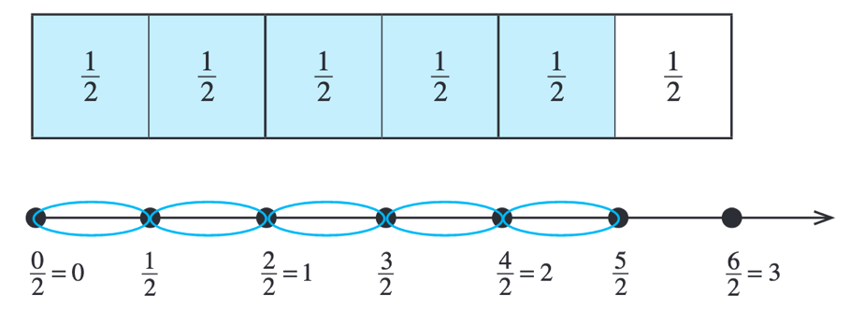
Some important concepts related to understanding fractions include
- fractional parts must be equal sized;
- the number of equal parts tells how many make a whole;
- as the number of equal pieces in the whole increases, the size of the fractional pieces decreases;
- the size of the fractional part is relative to the whole;
- when a shape is divided into equal parts, the fraction’s denominator represents the number of equal parts in the whole (e.g., a whole divided into one fourth sized pieces is made up of four one-fourth sized pieces) and its numerator is the count of the demarcated congruent, or equal, parts in a whole (e.g., 3/4 means that there are 3 one fourths); and
- common benchmark numbers, such as 0, 1/2, 3/4, and 1, can be used to determine if an unknown fraction is greater or smaller than a benchmark fraction.

Understanding Decimal Notation for Fractions, and Comparing Decimal Fractions
In fourth grade, students use decimal notation for fractions with denominators 10 or 100 (4.NF.6), understanding that the number of digits to the right of the decimal point indicates the number of zeros in the denominator. This lays the foundation for performing operations with decimal numbers in grade five. Students learn to add decimal fractions by converting them to fractions with the same denominator (SMP.2; 4.NF.5). For example, students express 3/10 as 30/100 before they add 30/100 + 4/100 = 34/100. Students can use graph paper, base-ten blocks, and other place-value models to explore the relationship between fractions with denominators of 10 and 100 (adapted from Common Core Standards Writing Team. 2022).
Students make connections between fractions with denominators of 10 and 100 and place value. They read and write decimal fractions, and it is important that teachers encourage students to read decimals in ways that support developing understanding (Van de Walle et al., 2014). When decimals are read using precise language, students learn to write decimals flexibly (e.g., by writing 32 hundredths as both 0.32 and 32/100. Conversely, imprecise reading of decimals, such as “0 point 32” rather than as “32 hundredths,” undermines sense-making and obscures the connection between fraction and decimal values. Correct use of language around decimals is particularly important in supporting students who are English learners.
As shown in figure 6.41, students can represent values such as 0.32 or 32/100 on a number line. They reason that 32/100 is a little more than 30/100 (or 3/10) and less than 40/100 (or 4/10). It is closer to 30/100, so students would need to place it on the number line near that value (SMP.2, 4, 5, 7).
Figure 6.41 Number Line for the Decimal .32
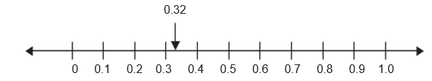
Students compare two decimals to hundredths by reasoning about their size (SMP.3, 7; 4.NF.7). They relate their understanding of the place-value system for whole numbers to fractional parts represented as decimals. Students compare decimals using the meaning of a decimal as a fraction, making sure to compare fractions with the same denominator and ensuring that the wholes are the same. For example, it is helpful to understand that the number line in figure 6.42 shows the whole length demarcated into 10 fractional pieces (or tenths). Knowing this, if a student also knows that the number 0.36 is located as indicated by the blue arrow, they may more easily locate the numbers 0.67 and 0.92 between the corresponding tenth demarcations (e.g., that .67 is between .60 and .70). Expressing one’s ideas about how numbers are related can be difficult. All students, and particularly those who are English learners, benefit from direct instruction on the use of compare-and-contrast language. A student’s weak response may indicate insufficient language to express the relationship between decimals and fractions rather than a lack of understanding of the concept.
Figure 6.42 Number Line Demarcated into 10 Fractional Pieces
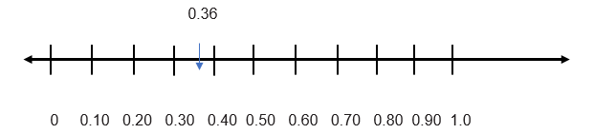
In grade three, students begin to develop an understanding of benchmark fractions. Fourth grade students extend this understanding to connect familiar benchmark fractions with corresponding decimals. The two examples below show how teachers can help them do so:
- The teacher asks the students to write the number “five tenths.” Some write it as a decimal, and others use the fraction form. To help students recognize that 0.5 is equivalent to 1/2, the teacher calls for students to name the benchmark fraction equal to 5/10, highlighting this connection.
- On a 10 x 10 square grid, students color in 25 small squares to illustrate the decimal 0.25. On a comparable grid, students color 1/4 of the whole grid, and discover that 1/4 of the grid is the same number of small squares, 25. They can use this visual model to see that 1/4 = 0.25 (Van de Walle et al., 2014). This exercise can also be done with other familiar fractions, such as 1/2, 3/5, or 75/100.

Applying and Extending Previous Understanding of Operations to Add, Subtract, Multiply and Divide Fractions
Students are expected to apply and extend previous understandings to operate with fractions. To do so, they must deeply understand the meanings of the four operations and be supported in their efforts to make connections between operations with whole numbers and operations with fractions (SMP.2, 4, 7; 4.NF.3, 4; 5.NF.1–7). In grades four and five, students begin operating with fractions; the algorithms for operations with decimals are addressed in grade six (6.NS.3). In an active learning environment, where students explore, challenge ideas, and make connections among various topics, they experience mathematics as a coherent, understandable body of knowledge and come to expect that previous learning will support their acquisition of new concepts.
A solid understanding of the relationship between addition and subtraction helps a fourth grader solve a problem such as this: The recipe calls for 2-1/4 cups of rice. Ravi already has 3/4 cup of rice. How much more rice does Ravi need? While the story problem can be solved using subtraction, the context does not suggest a take-away situation. As shown in figure 6.43, this problem is more logically interpreted as comparison subtraction (2-1/4 – 3/4 to find the difference between the quantities or as missing addend addition (3/4 + … = 2-1/4 cups), with the intention of finding how much more is needed. Students can represent the situation with visual fraction models as they have done in whole-number problem situations. The problem can be modeled quite literally, using measuring cups filled with rice (or a substitute for rice, such as sand), or with fraction tools (fraction bars, for example), a number line, or a bar diagram, as shown below. Class conversation, paired with written recordings of the various actions, representations, and equations, support students in making the necessary connections between the concrete, representational, and abstract expressions of the problem.
The problem follows:
The recipe calls for 2 1/4 cups of rice. Ravi already has 3/4 cup of rice. How much more rice does Ravi need?
Figure 6.43 Representation of 2 1/4 Cups Compared to 3/4 Cup
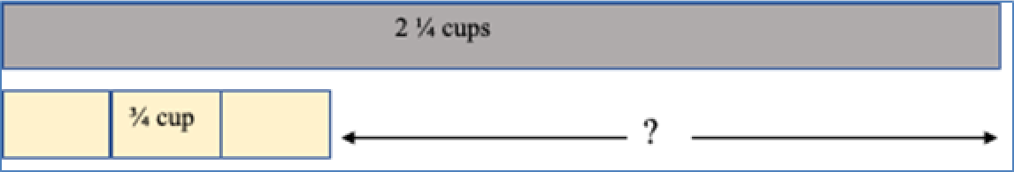
The longer bar, labeled 2 1/4 cups, is compared to a shorter bar, representing 3/4 cup. The unknown in the problem is represented by the gap between the two lengths.
Intentional, guided class discussion of how these subtraction strategies and illustrations work equally well to solve whole-number problems can help students to make necessary connections (SMP.2, 7; 4.NF.4, 5.NF.6, 7; ELD.II.C.6). This is what the teacher is doing, below, when asking students to substitute whole numbers for the fractions in the problem:
Teacher: What if the problem involved whole numbers rather than fractions? What if the recipe calls for five cups of rice? Ravi already has two cups of rice. How much more rice does Ravi need? How would you solve it and illustrate it?
Students describe to their partners how the two problems are alike.
Teacher: Would the same approach and a similar diagram work to solve the whole-number problem? Show us!
Students respond, sharing the thinking and diagrams they used in each case, and make connections between the two.
Multiplication of a fraction by a whole number can be seen as parallel to multiplication of one whole number by another whole number. Asking students to switch a whole number for a fraction in a multiplication problem gives them an opportunity for reflection on whole-number strategies and for active investigation and discussion of how whole-number strategies apply when working with fractions. If 5 × 4 is understood as “five groups of four,” “a rectangle with dimensions of five meters by four meters,” or “five copies of the quantity four,” then 5 × 1/4 can be understood as “five groups of 1/4,” “a rectangle with dimensions of 5 × 1/4 meters,” or “five copies of the quantity 1/4.” The strategies and representations used with whole number multiplication—repeated addition, jumps on the number line, or area—can be used with fractions. Tasks and problems presented in contexts that make sense to students make learning accessible, even without direct instruction on “how to multiply fractions.”
Whether a student represents the problem solution with fraction manipulatives (five one-fourth pieces), or perhaps five jumps of the distance 1/4 on a number line, the reasoning is the same as would be used with whole-number multiplication (SMP.2, 4, 5, 6; 4.NF.4). The problems below represent four different ways to focus students on the concept of multiplying 5 × 4, with four different ways of considering how to solve the problem.
- The recipe says to bake the pan of cookies for 1/4 of an hour. How long will it take to bake five pans of cookies, one pan at a time?
- Dean and Jean ran the 1/4-mile track five times. How far did they run?
- At our party, we will have five friends and we will give each friend 1/4 pound of candy. How much candy do we need?
- We are painting a line on the playground to mark the starting point for the runners. The line will be five feet long and 1/4 foot wide. If the paint we have will cover four square feet, will that be enough?
To solve the whole-number multiplication 5 × 4, one can use an area interpretation, illustrating the problem with a rectangle of dimensions five units by four units, as shown in figure 6.44. In the rectangle below, there are five rows of squares, with four squares in each row, for a total of 20 square units.
Figure 6.44 An Area Interpretation for Use with the Multiplication Problem 5 × 4
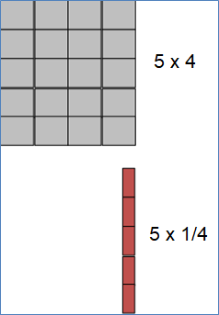
Using the same reasoning and a comparable illustration, one can use an area interpretation to solve 5 × 1/4. In this example, the rectangle will have a height of five units and a width of 1/4 unit. The area of this figure can then be seen as five 1/4-unit pieces, or 1/4 + 1/4 + 1/4 + 1/4 + 1/4 = 5/4 square units.
When both factors in a problem are fractions less than one, students may expect that multiplication will result in a product that is greater than either factor, as is often the case with whole-number multiplication. It can be helpful to remind students that with whole numbers, the product is not always greater than the factors. Multiplying any number (n) by 1 results in a product equal to that number (e.g., 1 × 14 = 14). Students can then reason about how the product of two fractions that are less than one can be less than either of the factors (e.g., 1/4 × 2/5 = 2/20 [SMP.1, 6, 7]).
Students sometimes lose sight of what the whole is as they multiply fractions. The understanding that they are finding a part of a part of a whole underlies fraction multiplication and requires emphasis and thoughtful discussion. Illustrations can often mitigate the difficulty of making sense of these situations and can support English learners by providing a visual of an abstract concept. Again, the illustrations correspond to the ways used for representing whole number multiplication.
- After the party, there was 1/3 of the cake left. Bren ate 1/4 of the remaining 1/3 cake. How much of the whole cake did Bren eat?
There was 1/3 of the cake left. Bren ate 1/4 of the remaining 1/3 cake.
- Zack had 2/3 of the lawn left to cut. After lunch, Zach cut 3/4 of the grass that was left. How much of the whole lawn did Zack cut after lunch? (Van de Walle et al., 2014, 243)
Figure 6.45 Model for Finding Part of a Part – Example 1
Long description of figure 6.45
- The milk carton is labelled 1/2 gallon. If Idalia drank 3/8 of the full carton, what fraction of a gallon did Idalia drink?
Figure 6.46 Model for Finding Part of a Part – Example 2
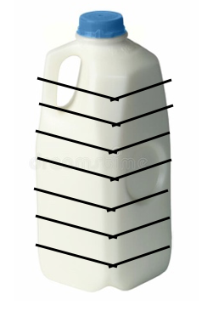
- Jack ran 1/3 of the distance along the 3/4-mile track. What fraction of a mile did Jack run?
Figure 6.47 Model for Finding Part of a Part – Example 3
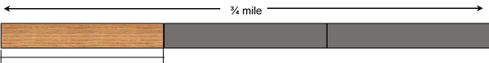
Jack ran 1/3 of the distance.
Solidly establishing the meaning of multiplication with fractions is essential if students in fifth grade are to develop the concept of division with fractions. Identifying how fraction division relates to previous work with whole-number division supports students in making sense of the concept of fraction division. The goal in fifth grade is for students to understand what it means to divide with fractions, with applications limited to instances involving a unit fraction and a whole number (SMP.2, 7; 4; 5.NF.3, 7). Developing their conceptual understanding merits thoughtful attention because that understanding prepares students to continue with proportional relationships in later grades. As with whole-number operations, students who develop and discuss methods that make sense to them as they begin to calculate with fractions will be more capable of applying reasoning in new situations than if they are prematurely taught an algorithm for solving division problems that have fractions. Use of algorithms for fraction calculation, such as the common denominator method, is reserved for middle school grades.
In partitive division, where a number is divided into a known number of groups, a problem dividing a unit fraction by a whole number can be related to a comparable problem using only whole numbers. For the fraction question If there is 1/3 gallon of juice to share equally among four people, how much juice can each person have? (1/3 ÷ 4), a whole-number question that calls for the same reasoning is If there are three cups of soup to share equally among four people, how much soup will each person have? (3 ÷ 4).
Students in fifth grade also divide a whole number by a unit fraction, such as 4 ÷ 1/3, using measured or quotitive division to divide a number into groups of a measured quantity. Here, too, ensuring that students understand the operation when working with whole numbers and putting problems in a meaningful context support students in making sense of problems like this one: If there are 4 cups of soup and each serving is 1/3 cup, how many servings of soup are there?
When a fraction problem is presented in a familiar context, students can illustrate the problem in ways that make sense to them and can solve the problem using logic and invented strategies. While it may not always be obvious to the student which operation is involved, the solution is accessible, as shown in the snapshot Dividing by a Unit Fraction.

Snapshot: Dividing by a Unit Fraction
A fifth-grade teacher has selected the Illustrative Mathematics grade-five task, “Dividing by One-Half” (Illustrative Mathematics, n.d.a) as a means for students to grapple with the idea of dividing a whole number by a fraction. Student partners will solve four fraction problems using their own illustrations and strategies. Then the class will work together to determine which of the four problems can be solved by calculating 3 ÷ 1/2 and explain how they know. The problems are:
- Shauna buys a 3-foot-long sandwich for a party, then cuts the sandwich into pieces, each piece being 1/2-foot long. How many pieces does Shauna get?
- Phil makes three quarts of soup for dinner. The family eats half of the soup for dinner. How many quarts of soup does Phil’s family eat for dinner?
- A pirate finds three pounds of gold. To protect the riches, the pirate hides the gold in two treasure chests, with an equal amount of gold in each chest. How many pounds of gold are in each chest?
- Leo uses half of a bag of flour to make bread. If Leo uses three cups of flour, how many cups were in the bag to start?
Once students have found the solutions, they will discuss with their partners which operation is involved and write the equation that could be used to calculate the answer. During subsequent whole-class discussion, students will focus on reaching consensus on which of the four problems calls for the division calculation 3 ÷ 1/2 = 6 and justifying their conclusions. Their solutions follow:
- Number 1 is easily solved using an illustration (figure 6.47) of a 3-foot long sandwich. The corresponding calculation is 3 ÷ 1/2, and the question being asked in this case is, “how many 1/2-foot pieces of sandwich are there in a 3-foot long sandwich?” This is an example of measurement, or quotitive division.
Figure 6.47 Three-foot sandwich marked in 1-foot segments
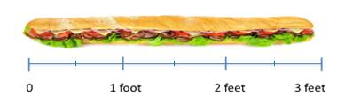
- Number 2 is a multiplication situation, in which the question calls for finding part of a whole. It can be solved by the calculation 1/2 × 3 = 1 1/2.
- Number 3 calls for partitive division using the calculation 3 ÷ 2 = 1 1/2. It is a division problem, but is not solved by dividing 3 by the 1/2 given in the problem.
- Number 4 is another division situation and can be calculated using the equation 3 ÷ 1/2 or the equation 3 = 1/2 × [blank]? This can be thought of as partitive division or as a missing factor situation that asks the question, “three cups of flour is half of what amount of flour?”
The teacher then facilitates a whole-class discussion during which students justify their conclusions and find consensus. For this task, teachers will likely find that
- most (if not all) student pairs will solve at least three of the four problems correctly; and
- students will find it challenging to justify which operation is used for each problem.
In some cases, students will disagree about which operation was used. Students’ careful analysis of the meaning of the operations, particularly for division by a fraction, will be necessary; the teacher’s questioning and prompts will play a vital role in ensuring that students conduct that analysis.
(end snapshot)

CC4: Discovering Shape and Space
Students in second grade work in one-dimensional space, using rulers to measure length. Students’ understanding of two- and three-dimensional space develops in grades three through five. Younger grade students learn to identify common geometric figures and to count the numbers of sides and corners. In grades three through five, students deepen their understanding of the properties of shapes and apply their understanding to organize shapes into categories and analyze hierarchical relationships.
Students explore shape and space in the upper-elementary grades as they develop the following:
- Strategies for solving problems involving measurement and conversion of measurements from larger to smaller units (4.MD.1; 5.MD.1)
- Understanding of concepts of area, perimeter, and volume of solid figures (3.MD.6; 4.MD.3; 5.MD.3, 4, 5)
- Understanding of concepts and measurement of angles; draw and identify lines and angles (4.MD.5, 6, 7; 4.G.1, 2)
- Ability to reason with shapes and their attributes; categorize shapes by their properties and recognize the hierarchical relationships among two-dimensional shapes (3.G.1, 2; 4.G.2; 5.G.3, 4)
In their work with shapes and space concepts, students use the SMPs to
- think quantitatively and abstractly, connecting visual and concrete models to more abstract and symbolic representations;
- select appropriate tools to model their mathematical thinking;
- communicate their ideas clearly, specifying units of measure accurately; and
- discern patterns and structural commonalities among geometric figures.
Students begin exploration of area concepts by covering rectangles with square tiles and learning that these can be described as square units. Two-dimensional measure is a significant advance beyond students’ previous experience with linear measure, and it merits reflection and careful instruction. Initially, students count the number of square units used to find the area.
Students can use one-inch square tiles to cover the surface of a book’s cover or the surface of their desks. As students work, the teacher looks for organization in their arrangements of the tiles, wondering, “Are they creating rows? Do they start by forming a frame around the edge of the surface?” Based on observation of various approaches, the teacher asks students to share strategies that enabled them to cover the whole surface without leaving any gaps. By posing questions and inviting comparison of results, the teacher can guide students’ development of accurate and efficient methods of measuring area: I see that this group has six rows of tiles. How many tiles are in each row? What do we notice about the number of tiles in each row? How can that help us to figure out the area of this rectangle?
Explorations of area need not be limited to one-inch tiles as the unit of measure. Large squares cut from cardboard or other sturdy materials can be used to measure area of larger areas, such as rectangular regions on the playground.
With further tiling experience, students discover that they can multiply the side lengths (the number of rows of tiles × how many tiles are in each row) to find the area more efficiently, and they no longer need to count square units singly. They make sense of this by connecting to their prior work with the array model of multiplication. In third grade, students measure only areas of rectangles with whole-number-length sides as they develop these understandings. They will apply this thinking in grades four and five, when rectangles involve fractional-length sides (SMP.2, 5, 6, 7; 3.OA.3; 3.MD.5, 6, 7; 4.MD.3, 5.NF.4). Students should understand and be able to explain why multiplying the side lengths of a rectangle yields the same measurement of area as counting the number of tiles (with the same unit length) that fill the rectangle’s interior, and to explain that one length tells how many rows there are and the other length tells the number of unit squares in a row (3.MD.7; 4.MD.3).
Along with developing area concepts, upper elementary students come to recognize perimeter as an attribute of plane figures. Although the concept of perimeter is introduced in grade three, confusion between the terms area and perimeter is common throughout grades three through five—a reminder that the distinction between linear and area measurement needs to be explored and emphasized at this stage of learning. (See the following snapshot, Highlighting the Linear Nature of Perimeter.)

Snapshot: Highlighting the Linear Nature of Perimeter
As students find the perimeter of a 4 x 6 rectangle, one student offers: “I added 4 + 6 + 4 + 6 (pointing to each of the four sides of the rectangle in turn), and that was 10 + 10, so 20 cm.” Another student reports, “I added the sides like this: 4 + 4 = 8 and 6 + 6 = 12, so 8 + 12 = 20 cm.” A third student explains, “I added 4 + 6 and that was 10, so it’s 2 × 10 = 20 cm.” The teacher displays these examples and asks the class to describe how the methods are alike and how they differ, and whether they will all work for finding the perimeter of other rectangles. In the discussion that follows, the class observes that the methods all use addition to find the perimeter, and that one method uses both addition and multiplication. The students agree the methods all work because the opposite sides of a rectangle have the same lengths. The teacher draws attention to this idea to highlight the linear nature of perimeter, and invites a student to outline with a colorful pen the perimeter of the rectangle under discussion.
(end snapshot)
Questions about how students can measure the length of the perimeter (add the four side lengths) versus how they can find the area of the interior of the rectangle (multiply the number of rows by the number of tiles in a row) give students a chance to deepen their understanding of how and why area and perimeter are measured differently and are identified by different types of units (with area being measured in square units). To develop genuine understanding, instruction must focus on the concepts of perimeter and area, having students study the mathematics rather than just apply formulas (e.g., 2 [l + w] and l × w) for purposes of what has been called “answer-getting,” as described by Phil Daro in the video Against Answer-getting (SERP, 2014).
The vignette Santikone Builds Rectangles to Find Area presents a multi-day lesson incorporating many of the space and measurement concepts developed in grades three through five.
In “Garden Design,” a grade three performance assessment found at Inside Mathematics (The University of Texas at Austin, n.d.), students find and compare areas of rectilinear figures. The task explores the idea that figures with different dimensions can contain the same area.
Students in fifth grade expand on their understanding of two-dimensional area measurement to develop concepts of volume of solid figures, with a particular focus on the volume of rectangular prisms (5.MD.C.3, 4, 5). Students need concrete experiences building with three-dimensional cubes to reach understanding of the concept and eventually to derive a formula for calculating volume (SMP.2, 4, 6, 7). When students build rectangular prisms from cubes, they find they will make layers of cubes and can recognize how each layer represents the area of the corresponding two-dimensional rectangle.
Fifth-grade students also explore the ideas of volume and scaling with a focus on rectangular solids (5.MD.3, 4, 5). They might investigate what happens when, for example, they double the length, width, and height of a rectangular prism. They find that the volume increases not by two or by four, but by a factor of eight, since 2 × 2 × 2 = 8. This discovery is often quite surprising to students. Before they get to the point of generalizing this phenomenon, they should think about the effects of scaling the different dimensions by different factors.
The task “Box of Clay” (Illustrative Mathematics, n.d.b), below, challenges students’ understanding of volume and scaling, as well as whether they recognize how length × width × height can be used to calculate volume (5.MD.3, 4, 5).
A box 2 centimeters high, 3 centimeters wide, and 5 centimeters long can hold 40 grams of clay. A second box has twice the height, three times the width, and the same length as the first box. How many grams of clay can it hold?
Tasks such as this help students understand what happens when they scale the dimensions of a right rectangular prism (SMP.2, 5, 7; 5.MD.3, 4, 5). In this case, the volume is increased by a factor of six: the height is doubled, the width is tripled, and the length remains the same (2 × 3 × 1), so the volume of the larger box is 240 grams of clay.
Exploring angles, the space between two rays that have a common endpoint, begins in grade four (4.MD.5, 6, 7). Students have had previous experience identifying and counting the corners of plane figures, and they often assume that an angle is that point where two line segments join. It is important that students come to understand an angle as some portion of a 360-degree rotation around the point where two rays meet. Students in this grade are expected to sketch and measure angles using a protractor. As shown in the snapshot, Creating Protractors to Understand Angles, below, students can make their own protractors as a means of deepening understanding of an angle as a measure of rotation around the center of a circle (4.MD.6,7; SMP.1, 3, 5, 7).

Snapshot: Creating Protractors to Understand Angles
Grade four teacher Mr. Flores has noticed that some of the students still exhibit confusion about angles, often identifying the point at which two rays or line segments meet as an angle. Mr. Flores decides to engage them in building protractors to increase their ownership and understanding of the concept. After several guided steps, students will investigate methods of finding angle measures independently. Mr. Flores provides each student (or pair of students) with
- a set of fraction circles;
- a square of cardstock (larger than the diameter of the whole-fraction circle); and
- a straightedge ruler.
The teacher guides students through the following steps to label a circle with angles of 0º, 90º, 180º and 360º (as shown in figure 6.48):
- Outline the whole-fraction circle on the cardstock square.
- Align the 1/2 fraction piece within the circle; draw a line across the circle to create a diameter.
- Label one end of the diameter as 0º, and the opposite end as 180º.
- Place the right angle of the 1/4-fraction piece at the origin to find and mark 90º angle.
- Place a second 1/4-fraction piece adjacent to the first (180º is already marked), and a third 1/4-fraction piece adjacent to that second piece, which allows the marking of 270º.
Figure 6.48 Circle with Marked Angles of 0º, 90º, 180º and 270º
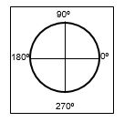
When students place the final 1/4-fraction piece, the full circle is complete, and the marking 360º coincides with the 0º spot, as shown in the image above.
Students continue to explore independently with other fraction pieces (e.g., 1/8, 1/3, 1/12), figuring and marking as many degree measures as the fraction pieces permit. Students are likely to discover additional measures to mark on the protractor by aligning a fraction piece alongside a previously marked angle measure (e.g., after labeling a 30º angle using the twelfths, a student may align an eighth piece beside it and discover they can mark a 75º angle, reasoning that 30º + 45º = 75º).
Mr. Flores allows time for the students to collaborate, explain their thinking to a partner, and make additional discoveries.
Once students’ protractors are completed, Mr. Flores engages the class in an academic conversation to compare their results. To support the discussion, Mr. Flores displays the vocabulary words and terms collected when listening to students as they worked through the lesson. Students share their discoveries and report how they found any measures that others may not have discovered. Students discuss the use of the protractor as a tool. Several report that they have seen commercially made protractors, and some have them at home, but they are proud of the protractors they have made.
Mr. Flores is satisfied that students are growing in their understanding of angle concepts and angle measures, as well as gaining skill in using a protractor (4.MD.6,7). In subsequent lessons, students will demonstrate how they measure angles on various polygons or other available objects and justify the measurements they identify.
(end snapshot)
The growth of students’ reasoning about geometric shapes across grades three to five is considerable. See figure 6.49 for an overview of the grades three through five progression of student’s learning about shapes.
Figure 6.49 Development of Shape Concepts, Grades Three Through Five
Grade Three | Grade Four | Grade Five
Categorize shapes by attributes and recognize that different shapes may share certain attributes (3.G.1) | Classify shapes based on properties of their lines and angles, including symmetry, parallel and perpendicular lines (4.G.2, 3) | Understand that attributes found in a category of two-dimensional figures are shared by all figures in sub-categories of that category. For example, they verify that, based on properties, squares are a sub-category of rectangles (5.G.3).
Be familiar with several sub-categories of quadrilaterals: rhombus, rectangle, square; draw non-examples of quadrilaterals that do not fit into any of these sub-categories (3.G.1) | Categorize special triangles: equilateral, isosceles, right, and scalene; and special quadrilaterals: rhombus, square, rectangle, parallelogram, trapezoid (4.G.2) | Analyze and diagram the hierarchical relationships of properties among two-dimensional figures (5.G.4)
Presenting multiple examples of regular and irregular shapes in various sizes and orientations can help students recognize the similarities and differences among properties of geometric figures. Note that “regular” is a word that has one meaning in everyday usage and a distinct, specific meaning as it applies to geometric figures. Multi-meaning terms often present a challenge to English learners and, also, to any student with learning disabilities; teachers may want to provide additional supports and/or time to help clarify such terms. Thoughtful attention to student partners/groups, non-verbal cues, or verbal prompts (e.g., “You can tell this shape is regular because …”) can help a student develop both the concept and the related academic language.
- Third grade students categorize shapes by attributes and recognize that different shapes may share certain attributes. Vocabulary includes rhombus, rectangle, square, and quadrilateral.
- Fourth grade students gain familiarity with additional attributes and shape names, including symmetry, parallel and perpendicular lines, parallelograms, and trapezoids. They identify angles and specific types of triangles: acute, obtuse, right, isosceles, equilateral and scalene.
- In fifth grade, a greater degree of analysis is demanded as students describe and diagram the hierarchical relationships of properties among two-dimensional figures. For example, they verify that, based on properties, squares are a sub-category of rectangles.
Research on the development of geometric thought describes a progression in the elementary grades from simple recognition of how a shape looks through analysis and informal deduction. Progress is sequential; a student must work through each level to move to the next higher stage, and experiences rather than age determine when a student is ready to advance (Van de Walle et al., 2014, 246–361; Breyfogle and Lynch, 2010). Consequently, instruction at any grade must account for students who are progressing at various rates. Activities that have multiple entry points, call for hands-on, active learning, and invite student discourse enable all students to contribute and to advance their thinking. When justification of conclusions is an expectation in a classroom, students have opportunity to evaluate results and to recognize and to challenge claims that are not sufficiently supported by mathematical reasoning (SMP.3). The vignette Polygon Properties Puzzles in chapter eleven, offers a glimpse into a classroom as grade four students apply mathematical practices (SMP.1, 3, 5, 6, 7) and show understanding of the properties of various polygons by illustrating polygons and defending their reasoning.
Overgeneralization of geometric ideas often occurs in these grades, as students attempt to integrate the new concepts with previous knowledge. For example, students may come to believe that all rectangles have two longer and two shorter pairs of parallel sides and, thus, that squares are not rectangles. Or they may believe that a triangle that is “tilted,” like the first triangle in the figure 6.50, is not a triangle. Instruction must include examples of geometric figures in many orientations and with unusual dimensions, such as the second triangle below and the trapezoid to its right.
Figure 6.50 Geometric Figures in Multiple Orientations and with Unusual Dimensions
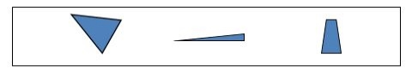
Students need repeated opportunities to examine and discuss examples and non-examples to strengthen a concept. Some tasks that provide such opportunities follow:
- Pointing to the shape below (figure 6.51), my friend said that this is not a square: Is my friend right? Why/why not?
Figure 6.51 Is This a Square?
- Draw an example of a quadrilateral that is a parallelogram and another quadrilateral that is not a parallelogram. Explain why the second one is not a parallelogram.
- Cut two paper squares diagonally to create four congruent right triangles. Then, using the four triangles, how many different shapes can you make? We will use the rule that touching sides must be the same length. Draw each shape you made, and be ready to share and explain your thinking.
- On a page, using a straight edge, draw five lines, no two of which may be parallel. Convince your partner that your drawing matches the requirements (Sullivan and Lilburn, 2002).
- I drew a shape with four sides but none of the four sides were the same length. Draw what my shape might have looked like (Sullivan and Lilburn, 2002, 81). Afterward, compare your shape with your partner’s.
- A shape is made of two smaller shapes that are the same shape and the same size and that are not rectangles. What might the larger shape look like (Sullivan and Lilburn, 2002, 83)? Convince your group members that your shape fits the requirements. How many different shapes did your group find? How can we know if others are possible?
When fifth grade students organize two-dimensional shapes in a hierarchical structure, they are demonstrating the informal deduction stage of growth. At higher grade levels, students move to formal deduction and rigor.
The concepts of perimeter and area as well as the operations of multiplication and division and are pivotal concepts in grades three to five. The third-grade vignette, Santikone Builds Rectangles to Find Area illustrates how lessons that integrate multiple concepts in a meaningful context are more effective than addressing single concepts in isolation.

The Big Ideas, Grades Three Through Five
As noted earlier, the foundational mathematics content, or big ideas, across transitional kindergarten through grade twelve progresses in accordance with the CA CCSSM principles of focus, coherence, and rigor. As students explore and investigate the big ideas, they will engage with many content standards and come to understand the connections between and among them.
Each grade-specific big-idea figure that follows (figures 6.52, 6.54, and 6.56) shows the ideas as colored circles of varying sizes. A circle’s size indicates the relative importance of the idea it represents, as determined by the number of connections that particular idea has with other ideas. Big ideas are considered connected to one another when they enfold two or more of the same standards; the greater the number of standards one big idea shares with other big ideas, collectively, the more connected and important the idea is considered to be.
Circle colors correspond to colors used in the big-ideas column of the figure that immediately follows each big-idea figure. These second figures (figures 6.53, 6.55, and 6.57) reiterate the grade-specific big ideas and, for each idea, show associated content connections and content standards, as well as providing some detail on how content standards can be addressed in the context of the CCs described in this framework.
Figure 6.52 Grade Three Big Ideas

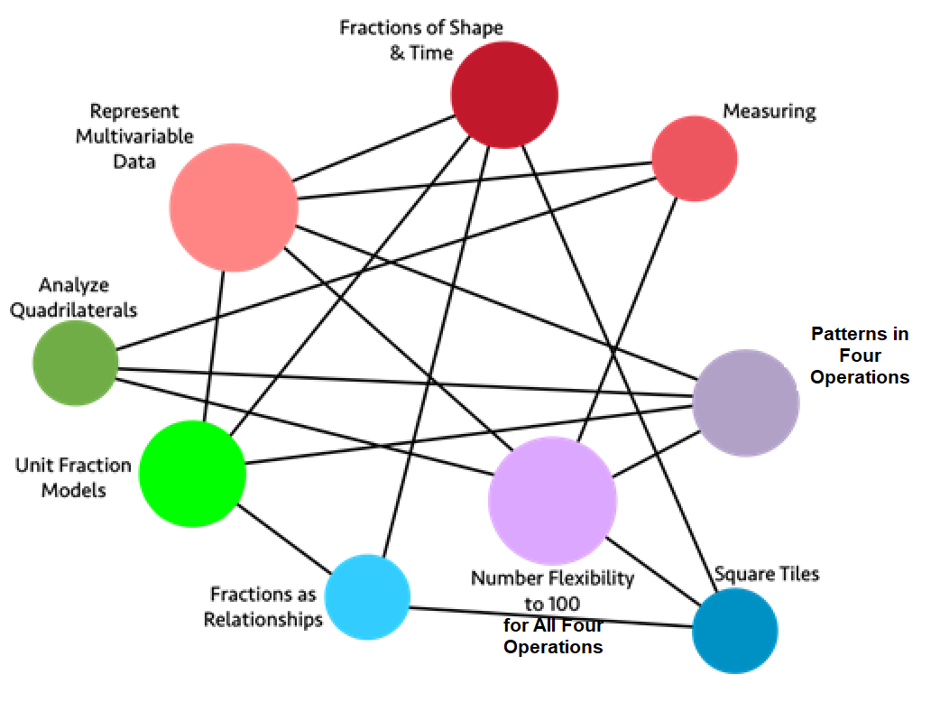
Long description of figure 6.52
Figure 6.53 Grade Three Content Connections, Big Ideas, and Content Standards
Content Connections | Big Ideas | Grade Three Content Standards
Reasoning with Data | Represent Multivariable Data | MD.3, MD.4, MD.1, MD.2, NBT.1: Collect data and organize data sets, including measurement data; read and create bar graphs and pictographs to scale. Consider data sets that include three or more categories (multivariable data) for example, when I interact with my puppy, I either call her name, pet her, or give her a treat.
Reasoning with Data  and  Taking Wholes Apart, Putting Parts Together  and  Discovering Shape and Space | Fractions of Shape and Time | MD.1, NF.1, NF.2, NF.3, G.2: Collect data by time of day, show time using a data visualization. Think about fractions of time and of shape and space, expressing the base unit as a unit fraction of the whole.
Reasoning with Data | Measuring | MD.2, MD.4, NBT.1: Measure volume and mass, incorporating linear measures to draw and represent objects in two-dimensional space. Compare the measured objects, using line plots to display measurement data. Use rounding where appropriate.
Exploring Changing Quantities | Patterns in Four Operations | NBT.2, OA.8, OA.9, MD.1: Add and subtract within 1000 - Using student generated strategies and models, such as base 10 blocks. e.g., use expanded notation to illustrate place value and justify results. Investigate patterns in addition and multiplication tables, and use operations and color coding to generalize and justify findings.
Exploring Changing Quantities | Number Flexibility to 100 for All Four Operations | OA.1, OA,2, OA.3, OA.4, OA.5, OA.6, OA.7, OA.8, NBT.3, MD.7, NBT.1: Multiply and divide within 100 and justify answers using arrays and student generated visual representations. Encourage number sense and number flexibility - not “blind” memorization of number facts. Use estimation and rounding in number problems.
Taking Wholes Apart, Putting Parts Together | Square Tiles | MD.5, MD.6, MD.7, OA.7, NF.1: Use square tiles to measure the area of shapes, finding an area of n squared units, and learn that one square represents 1/nth of the total area.
Taking Wholes Apart, Putting Parts Together | Fractions as Relationships | NF.1, NF.3: Know that a fraction is a relationship between numerators and denominators – and it is important to consider the relationship in context. Understand why 1/2=2/4=3/6.
Taking Wholes Apart, Putting Parts Together  and  Discovering Shape and Space | Unit Fraction Models | NF.2, NF.3, MD.1: Compare unit fractions using different visual models including linear models (e.g., number lines, tape measures, time, and clocks) and area models (e.g., shape diagrams encourage student justification with visual models).
Discovering  Shape and Space | Analyze Quadrilaterals | MD.8, G.1, G.2, NBT.1, OA.8: Describe, analyze, and compare quadrilaterals. Explore the ways that area and perimeter change as side lengths change, by modeling real world problems. Use rounding strategies to approximate lengths where appropriate.
Figure 6.54 Grade Four Big Ideas
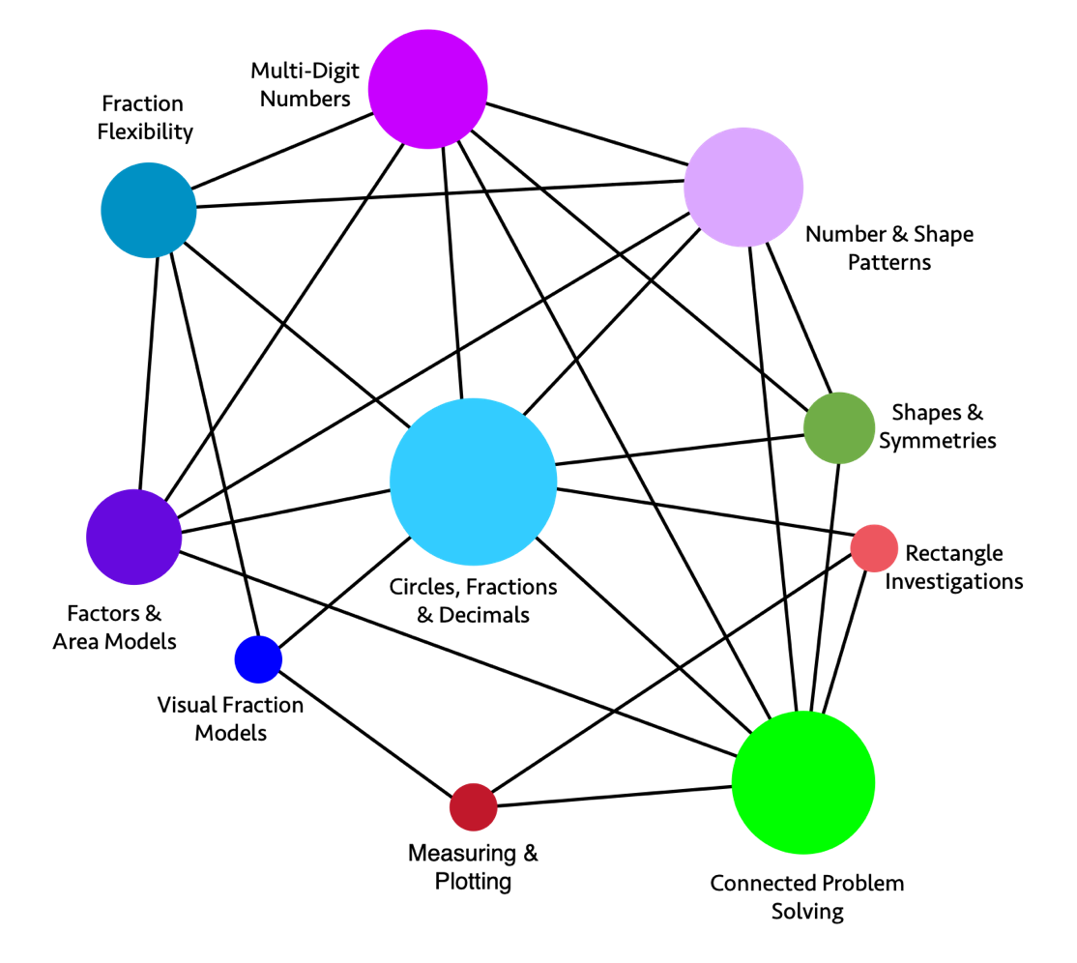
Long description of figure 6.54
Figure 6.55 Grade Four Content Connections, Big Ideas, and Content Standards
Content Connections | Big Ideas | Grade Four Content Standards
Reasoning with Data | Measuring and Plotting | MD.1, MD.4, NF.1, NF.2: Collect data consisting of distance, intervals of time, volume, mass, or money. Read, interpret, and create line plots that communicate data stories where the line plot measurements consist of fractional units of measure. For example, create a line plot showing classroom or home objects measured to the nearest quarter inch.
Reasoning with Data | Rectangle Investigations | MD1, MD2, MD3, MD5, MD6: Investigate rectangles in the world, measuring lengths and angles, collecting the data, and displaying it using data visualizations.
Exploring Changing Quantities | Number and Shape Patterns | OA.5, OA.1, OA.2, NBT.4: Generalize number and shape patterns that follow a given rule. Communicate understanding of how the pattern changes in words, symbols, and diagrams - working with multi-digit numbers.
Exploring Changing Quantities | Factors and Area Models | OA.1, OA.2, OA.4, NBT.5, NBT.6: Break numbers inside of 100 into factors. Illustrate whole-number multiplication and division calculations as area models and rectangular arrays that illustrate factors.
Exploring Changing Quantities | Multi-Digit Numbers | NBT.1, NBT.2, NBT 3, NBT.4, OA.1: Read and write multi-digit whole numbers in expanded form and express each number component of the expanded form as a multiple of a power of ten.
Taking Wholes Apart, Putting Parts Together | Fraction Flexibility | NF.3, NF.1, NF.4, NF.5, OA.1: Understand that addition and subtraction of fractions as joining and separating parts that are referring to the same whole. Decompose fractions and mixed numbers into unit fractions and whole numbers, and express mixed numbers as a sum of unit fractions.
Taking Wholes Apart, Putting Parts Together | Visual Fraction Models | NF.2, NF.1, NF.3, NF.5, NF.6, NF.7: Use different ways of seeing and visualizing fractions to compare fractions using student generated visual fraction models. Use >, < and = to compare fraction size, through linear and area models, and determine whether fractions are greater or less than benchmark numbers, such as ½ and 1.
Taking Wholes Apart, Putting Parts Together  and  Discovering Shape and Space | Circles, Fractions and Decimals | NF.5, NF.6, NF.7, OA.1. MD2, MD5, MD7: Understand, compare, and visualize fractions expressed as decimals. Recognize fractions with denominators of 10 and 100, e.g., 25 cents can be written as 0.25 or 25/100. Connect a circle fraction model to the clock face. Example 3/10 + 4/100 = 30/100 + 4/100 = 34/100
Discovering Shape and Space | Shapes and Symmetries | MD.5, MD.6, MD.7, G.1, G.2, G.3, NBT.3, NBT.4, Draw and identify shapes, looking at the relationships between rays, lines, and angles. Explore symmetry through folding activities.
Discovering Shape and Space | Connected Problem Solving | MD.1, MD.2, MD.3, NBT.3, NBT.4, NBT.5, NBT.6, OA.2, OA.3, G.3: Solve problems with perimeter, area, volume, distance, and symmetry, using operations and measurement.
Figure 6.56 Grade Five Big Ideas
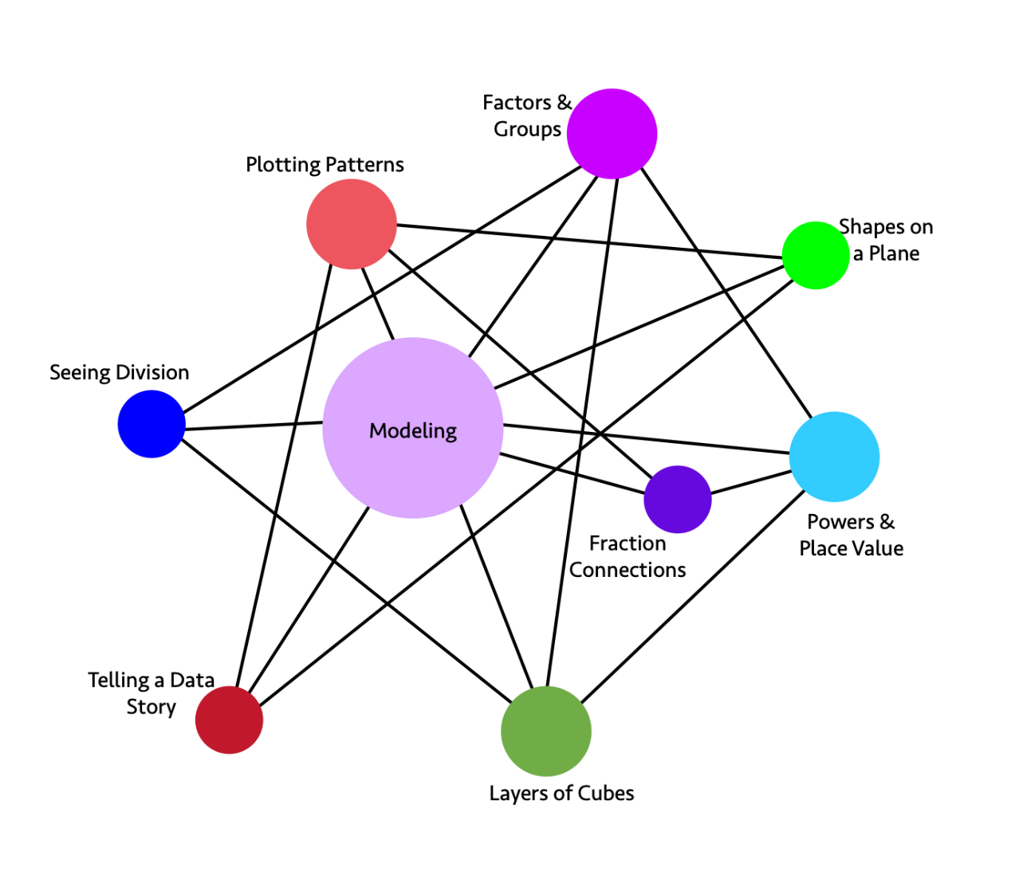
Long description of figure 6.56
Figure 6.57 Grade Five Content Connections, Big Ideas, and Content Standards
Content Connections | Big Ideas | Grade Five Content Standards
Reasoning with Data | Plotting Patterns | G.1, G.2, OA.3, MD.2, NF.7: Students generate and analyze patterns, plotting them on a line plot or coordinate plane, and use their graph to tell a story about the data. Some situations should include fraction and decimal measurements, such as a plant growing.
Reasoning with Data  and  Exploring Changing Quantities  and  Discovering Shape & Space | Telling a Data Story | G.1, G.2, OA.3: Understand a situation, graph the data to show patterns and relationships, and to help communicate the meaning of a real-world event.
Exploring Changing Quantities | Factors and Groups | OA.1, OA.2, MD.4, MD.5: Students use grouping symbols to express changing quantities and understand that a factor can represent the number of groups of the quantity.
Exploring Changing Quantities | Modeling | NBT.3, NBT.5, NBT.7, NF.1, NF.2, NF.3, NF.4, NF.5, NF.6, NF.7, MD.4, MD.5, OA.3: Set up a model and use whole, fraction, and decimal numbers and operations to solve a problem. Use concrete models and drawings and justify results.
Exploring Changing Quantities  and  Taking Wholes Apart, Putting Parts Together | Fraction connections | NF.1, NF.2, NF.3, NF.4, NF.5, NF.7, MD.2, NBT.3: Make and understand visual models, to show the effect of operations on fractions. Construct line plots from real data that include fractions of units.
Taking Wholes Apart, Putting Parts Together | Seeing Division | MD.3, MD.4, MD.5, NBT.4, NBT.6, NBT.7: Solve real problems that involve volume, area, and division, setting up models and creating visual representations. Some problems should include decimal numbers. Use rounding and estimation to check accuracy and justify results.
Taking Wholes Apart, Putting Parts Together | Powers and Place Value | NBT.3, NBT.2, NBT.1, OA.1, OA.2: Use whole-number exponents to represent powers of 10. Use expanded notation to write decimal numbers to the thousandths place and connect decimal notation to fractional representations, where the denominator can be expressed in powers of 10.
Discovering Shape and Space | Layers of Cubes | MD.5, MD.4, MD.3, OA.1, MD.1: Students recognize volume as an attribute of three-dimensional space. They understand that a 1-unit by 1-unit by 1-unit cube is the standard unit for measuring volume. They decompose three-dimensional shapes and find volumes of right rectangular prisms by viewing them as decomposed into layers of arrays of cubes.
Discovering Shape & Space  and  Exploring Changing Quantities | Shapes on a Plane | G.1, G.2, G.3, G4, OA.3, NF.4, NF.5, NF.6: Graph 2-D shapes on a coordinate plane, notice and wonder about the properties of shapes, parallel and perpendicular lines, right angles, and equal length sides. Use tables to organize the coordinates of the vertices of the figures and study the changing quantities of the coordinates.

Transition from Transitional Kindergarten Through Grade Five to Grades Six Through Eight
Preparation in the elementary grades is essential for students’ continued development in every area of math in middle school. This foundation for success can be discussed in terms of the four Content Connections (around which chapter seven on the middle grades is similarly organized):
Content Connections
1. Reasoning with Data
2. Exploring Changing Quantities
3.Taking Wholes Apart, Putting Parts Together
4. Discovering Shape and Space

How Does Learning in Transitional Kindergarten Through Grade Five Lead to Success in Grades Six Through Eight When Students Reason with Data?
In the transitional kindergarten through grade five years, students make measurements and gather, represent, and interpret data. They explore such information to see how math is used. Engagement and understanding are enhanced when the question under investigation is of interest and relevance to the students. The ability to analyze and communicate meaning from data developed in the elementary years is essential to students in grades six through eight as they focus on the importance of data as the source of most mathematical situations that students will encounter in their lives.

How Does Learning in Transitional Kindergarten Through Grade Five Lead to Success in Grades Six Through Eight When Students Are Exploring Changing Quantities?
Students in grades six through eight extend their understanding of number types to the set of rational numbers, which includes whole numbers, integers, fractions, and decimals. They make connections among ratios, rates, and percentages, and use proportional reasoning to solve authentic problems. Whole number foundations are established in the primary grades, and fraction and decimal ideas are key elements of math in grades three through five. In grades six through eight, students deepen their understanding of fractions, especially division of fractions. When this concept is introduced with meaning in grade five, it enables students to succeed in later work.
Students in grades six through eight work extensively with expressions and equations, and solve multi-step problems. This new content relies heavily on foundations developed in the earliest grades. Understanding of equality is evident when a kindergartener compares quantities of objects; a first or second grade student expresses a statement of equality with objects, verbally or symbolically; and a third, fourth, or fifth grade student finds and recognizes equivalent fractions or explains equivalence between a decimal and fractional value.

How Does Learning in Transitional Kindergarten Through Grade Five Lead to Success in Grades Six Through Eight When Students Are Taking Numbers Apart, Putting Parts Together, Representing Thinking, and Using Strategies?
Throughout transitional kindergarten through grade five, emphasis is placed on students’ using objects and drawings to illustrate their ways of solving problems, describing their strategies verbally, and developing written methods that make sense within the context of a particular problem. Connections among various representations are an important feature of mathematical discourse, whether this occurs in a small group or in a whole-class setting.
In grades six through eight, students build their ability and inclination to see connections between representations, and to base strategies on different representations in order to gain insight into problem situations. Their efforts to make connections in younger grades will support students as they build representations for, understanding of, and facility in working with ratios, proportions, and percent, and for the new category of rational number.

How Does Learning in Transitional Kindergarten Through Grade Five Lead to Success in Grades Six Through Eight When Students Are Discovering Shape and Space?
Developing mathematical tools to explore and understand the physical world should continue to motivate explorations in shape and space. As in other areas of teaching and learning math, maintaining connection to concrete situations and authentic questions is crucial.
In transitional kindergarten through grade five, students use basic shapes and spatial reasoning to model objects in their environment to establish many foundational notions of two- and three-dimensional geometry. They develop concepts of area, perimeter, angle measure, and volume. Shape and space work in grades six through eight is largely about connecting these notions to each other, to students’ lives, and to other areas of mathematics.
Developing mathematics for true understanding in transitional kindergarten through grade five is pivotal. Students who experience meaningful mathematics that makes sense to them during the elementary grades will be well prepared to increase their mathematical understanding as they advance through middle school and high school.

Conclusion
This chapter envisions investigating and connecting the big ideas of mathematics in transitional kindergarten through grade five as a vibrant, interactive, student-centered endeavor. In an environment rich with opportunities for discourse and meaningful mathematics activities, curiosity and reasoning skills are nourished, and both teachers and students see themselves as thinkers and doers of mathematics. Careful discussion of mathematical ideas supports all learners, particularly students who are English learners, as they acquire the language of mathematics. It is important to note that English learner students need additional support to develop the language necessary both to comprehend content and to express their ideas and understanding. Children experience enormous growth in maturity, reasoning, and conceptual understanding in the span of years from transitional kindergarten through fifth grade. Students who enter grade six viewing themselves as mathematically capable and who have gained an understanding of elementary mathematics are positioned for success in the middle school years. They will be empowered to make choices that will affect all their future mathematics, throughout their school years and beyond.

Long Descriptions for Chapter Six

Figure 6.1 The Why, How and What of Learning Mathematics (accessible version)
Why  Drivers of Investigation | How  Standards for Mathematical Practice | What  Content Connections
In order to…  - Make Sense of the World (Understand and Explain)  - Predict What Could Happen (Predict)  - Impact the Future (Affect) | Students will…  - Make Sense of Problems and Persevere in Solving them  - Reason Abstractly and Quantitatively  - Construct Viable Arguments and Critique the Reasoning of Others  - Model with Mathematics  - Use Appropriate Tools Strategically  - Attend to Precision  - Look for and Make Use of Structure  - Look for and Express Regularity in Repeated Reasoning | While…  - Communicating Stories with Data  - Exploring Changing Quantities  - Taking Wholes Apart, Putting Parts Together  - Discovering Shape and Space
Return to figure 6.1 graphic

Figure 6.2 Content Connections, Mathematical Practices, and Drivers of Investigation
A spiral graphic shows how the Drivers of Investigation (DIs), Standards for Mathematical Practice (SMPs) and Content Connections (CCs) interact. The DIs are listed under “In order to...”: Make Sense of the World (Understand and Explain); Predict What Could Happen (Predict); Impact the Future (Affect). The SMPs are listed under “Students will...”: Make sense of problems and persevere in solving them; Reason abstractly and quantitatively; Construct viable arguments and critique the reasoning of others; Model with mathematics; Use appropriate tools strategically; Attend to precision; Look for and make use of structure; Look for and express regularity in repeated reasoning. Finally, the CCs are listed under, “While...”: Communicating Stories with Data; Exploring Changing Quantities; Taking Wholes Apart, Putting Parts Together; Discovering Shape and Space. Return to figure 6.2 graphic

Figure 6.8 Transitional Kindergarten Big Ideas
The graphic illustrates the connections and relationships of some transitional-kindergarten mathematics concepts. Direct connections include:
- Look for Patterns directly connects to: Create Patterns, Count to 10, Measure & Order, See & Use Shapes, Make & Measure Shapes
- Make & Measure Shapes directly connects to: Look for Patterns, Create Patterns, Measure & Order, Shapes in Space, See & Use Shapes
- See & Use Shapes directly connects to: Make & Measure Shapes, Look for Patterns, Measure & Order, Create Patterns, Count to 10, Shapes in Space
- Shapes in Space directly connects to: See & Use Shapes, Make & Measure Shapes, Measure & Order, Create Patterns, Count to 10
- Count to 10 directly connects to: Shapes in Space, See & Use Shapes, Measure & Order, Look for Patterns
- Create Patterns directly connects to: Look for Patterns, Make & Measure Shapes, See & Use Shapes, Measure & Order, Shapes in Space
- Measure & Order directly connects to: Look for Patterns, Make & Measure Shapes, See & Use Shapes, Shapes in Space, Count to 10, Create Patterns. Return to figure 6.8 graphic

Figure 6.10 Kindergarten Big Ideas
The graphic illustrates the connections and relationships of some kindergarten mathematics concepts. Direct connections include the following:
- How many directly connects to: Being flexible within 10, Shapes in the World, Sort and Describe Data, Bigger or Equal, Place and Position of Numbers
- Model with Numbers directly connects to: Being flexible within 10, Sort and Describe Data, Place and Position of Numbers
- Being Flexible within 10 directly connects to: Model with Numbers, How Many, Making Shapes from Parts, Shapes in the World
- Shapes in the World directly connects to: Being flexible within 10, How Many, Sort and Describe Data, Bigger or Equal, Making Shapes from Parts
- Making Shapes from Parts directly connects to: Shapes in the World, Being flexible within 10, Sort and Describe Data, Bigger or Equal
- Bigger or Equal directly connects to: Making Shapes from Parts, Shapes in the World, Sort and Describe Data, How Many
- Place and Position of Numbers directly connects to: How Many, Model with Numbers, Sort and Describe Data
- Sort and Describe Data directly connects to: How Many, Model with Numbers, Shapes in the World, Making Shapes from Parts, Bigger or Equal, Place and Position of Numbers. Return to figure 6.10 graphic

Figure 6.12: Grade One Big Ideas
The graphic illustrates the connections and relationships of some first-grade mathematics concepts. Direct connections include the following:
- Clocks & Time directly connects to: Equal Parts Inside Shapes, Reasoning About Equality, Make Sense of Data, Tens & Ones
- Equal Expressions directly connects to: Reasoning About Equality, Make Sense of Data, Tens & Ones, Measuring with Objects
- Reasoning About Equality directly connects to: Equal Expressions, Clocks & Time, Make Sense of Data, Tens & Ones
- Tens & Ones directly connects to: Reasoning About Equality, Make Sense of Data, Equal Expressions, Clocks & Time
- Measuring with Objects directly connects to: Equal Expressions, Make Sense of Data
- Equal Parts Inside Shapes directly connects to: Clocks & Time, Make Sense of Data
- Make Sense of Data directly connects to: Reasoning About Equality, Tens & Ones, Measuring with Objects, Clocks & Time, Equal Expressions, Equal Parts Inside Shapes. Return to figure 6.12 graphic

Figure 6.14 Grade Two Big Ideas
The graphic illustrates the connections and relationships of some second-grade mathematics concepts. Direct connections include the following:
- Dollars & Cents directly connects to: Problems Solving with Measure, Skip Counting to 100, Number Strategies, Represent Data
- Problems Solving with Measure directly connects to: Skip Counting to 100, Number Strategies, Represent Data, Measure and Compare Objects, Dollars & Cents
- Skip Counting to 100 directly connects to: Number Strategies, Seeing Fractions in Shapes, Squares in an Array, Represent Data, Dollars & Cents, Problems Solving with Measure
- Number Strategies directly connects to: Skip Counting to 100, Problems Solving with Measure, Dollars & Cents, Represent Data
- Seeing Fractions in Shapes directly connects to: Skip Counting to 100, Represent Data, Squares in an Array
- Squares in an Array directly connects to: Seeing Fractions in Shapes, Skip Counting to 100, Represent Data, Measure and Compare Objects
- Measure and Compare Objects directly connects to: Squares in an Array, Represent Data, Problems Solving with Measure
- Represent Data directly connects to: Measure and Compare Objects, Dollar & Cents, Problems Solving with Measure, Skip Counting to 100, Number Strategies, Seeing Fractions in Shapes, Squares in an Array. Return to figure 6.14 graphic

Figure 6.45 Model for Finding Part of a Part
Model for Finding Part of a Part – Example 1 is on the left. A rectangle is divided vertically into 3 equal parts. The two parts on the right are marked with an indicator.
Example 2 is on the right. The same rectangle is divided vertically into 3 equal parts and horizontally into 4 equal parts. The two rightmost vertical parts and the three uppermost horizontal parts are marked with indicators and shaded. Return to figure 6.45 graphic

Figure 6.52 Grade Three Big Ideas
The graphic illustrates the connections and relationships of some third-grade mathematics concepts. Direct connections include the following:
- Fractions of Shape & Time directly connects to: Square Tiles, Fractions as Relationships, Unit Fractions Models, Represent Multivariable Data
- Measuring directly connects to: Number Flexibility to 100 for All Four Operations, Analyze Quadrilaterals, Represent Multivariable Data
- Patterns in Four Operations directly connects to: Number Flexibility to 100 for All Four Operations, Unit Fraction Models, Analyze Quadrilaterals, Represent Multivariable Data
- Square Tiles directly connects to: Fractions as Relationships, Number Flexibility to 100 for All Four Operations, Fractions of Shape & Time
- Fractions as Relationships directly connects to: Square Tiles, Fractions of Shape & Time, Unit Fraction Models
- Unit Fraction Models directly connects to: Fractions as Relationships, Patterns in Four Operations, Fractions of Shape & Time, Represent Multivariable Data
- Analyze Quadrilaterals directly connects to: Number Flexibility to 100 for All Four Operations, Patterns in Four Operations, Measuring
- Represent Multivariable Data directly connects to: Unit Fraction Models, Number Flexibility to 100 for All Four Operations, Patterns in Four Operations, Measuring, Fractions of Shape & Time
- Number Flexibility to 100 for All Four Operations directly connects to: Square Tiles, Analyze Quadrilaterals, Represent Multivariable Data, Measuring, Patterns in Four Operations. Return to figure 6.52 graphic

Figure 6.54 Grade Four Big Ideas
The graphic illustrates the connections and relationships of some fourth-grade mathematics concepts. Direct connections include the following:
- Number & Shape Patterns directly connects to: Shapes & Symmetries, Connected Problem Solving, Circles Fractions & Decimals, Factors & Area Models, Fraction Flexibility, Multi-Digit Numbers
- Shapes & Symmetries directly connects to: Connected Problem Solving, Circles Fractions & Decimals, Multi-Digit Numbers, Number & Shape Patterns
- Rectangle Investigations directly connects to: Connected Problem Solving, Measuring & Plotting, Circles Fractions & Decimals
- Connected Problem Solving directly connects to: Rectangle Investigations, Shapes & Symmetries, Number & Shapes Patterns, Multi-Digit Numbers, Circles Fractions & Decimals, Factors & Area Models, Measuring & Plotting
- Measuring & Plotting directly connects to: Connected Problem Solving, Rectangle Investigations, Visual Fraction Models
- Visual Fraction Models directly connects to: Measuring & Plotting, Circles Fractions & Decimals, Fraction Flexibility
- Factors & Area Models directly connects to: Connected Problem Solving, Circles Fractions & Decimals, Number & Shape Patterns, Multi-Digit Numbers, Fraction Flexibility
- Fraction Flexibility directly connects to: Factors & Area Models, Circles Fractions & Decimals, Number & Shape Patterns, Multi-Digit Numbers
- Multi-Digit Numbers directly connects to: Number & Shape Patterns, Shapes & Symmetries, Connected Problem Solving, Circles Fractions & Decimals, Factors & Area Models, Fraction Flexibility
- Circles Fractions & Decimals directly connects to: Multi-Digit Numbers, Number & Shape Patterns, Shapes & Symmetries, Rectangle Investigations, Connected Problem Solving, Visual Fraction Models, Factors & Area Models, Fraction Flexibility. Return to figure 6.54 graphic

Figure 6.56 Grade Five Big Ideas
The graphic illustrates the connections and relationships of some fifth-grade mathematics concepts. Direct connections include the following:
- Factors & Groups directly connects to: Powers & Place Values, Layers of Cubes, Modeling, Seeing Division
- Shapes on a Plane directly connects to: Telling a Data Story, Modeling, Plotting Patterns
- Powers & Place Value directly connects to: Layers of Cubes, Fraction Connections, Modeling, Factors & Groups
- Layers of Cubes directly connects to: Powers & Place Value, Factors & Groups, Modeling, Seeing Division
- Telling a Data Story directly connects to: Shapes on a Plane, Modeling, Plotting Patterns
- Seeing Division directly connects to: Layers of Cubes, Modeling, Factors & Groups
- Plotting Patterns directly connects to: Telling a Data Story, Modeling, Fraction Connections, Shapes on a Plane
- Fraction Connections directly connects to: Powers & Place Value, Modeling, Plotting Patterns
- Modeling directly connects to: Plotting Patterns, Factors & Groups, Shapes on a Plane, Powers & Place Value, Fraction Connections, Layers of Cubes, Telling a Data Story, Seeing Division. Return to figure 6.56 graphic
California Department of Education, October 2023

5 Practices for Orchestrating Productive Mathematical Discussions (Smith and Stein, 2011) offers a structure for planning and implementing mathematical tasks and orchestrating the discourse that emerges in the class.
Unlike kindergarten and higher grade levels, transitional kindergarten in California does not have grade-level-specific content standards. Thus, for this grade level, the chapter draws from the California Preschool Learning Foundations (for children at age 60 months).
Teachers should use their professional judgment in considering what attributes to measure, practicing particular sensitivity to any physical attributes.
Pig is a dice game of folk origin described by John Scarne in 1945. It was an ancestor of the modern game Pass the Pigs® (originally called PigMania®); Scarne, J. (1945). Scarne on Dice. Harrisburg, Pennsylvania: Military Service Publishing Co.

