California Department of Education, February 2020

Accessing Data Publicly Available on the CDE Webpage
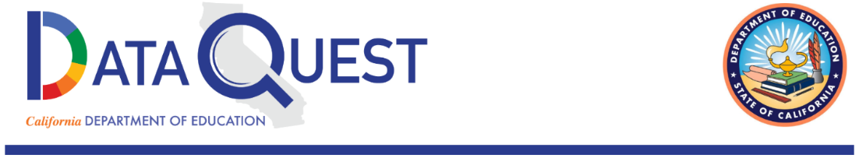

DataQuest
Reports on foster youth can be found on DataQuest, the Department’s data reporting website.
DataQuest can be accessed at https://dq.cde.ca.gov/dataquest/
Instructions on accessing reports on foster youth on DataQuest are listed below.
Once on the DataQuest website, select the level to view the report such as “State” or “County.”
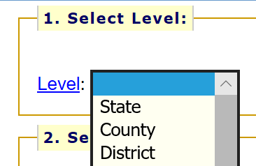
After selecting the level of the report, select the subject of the report such as “Student Demographics” and “Foster Students” and then click the “SUBMIT” button.
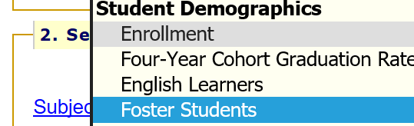
From here, select the school year for the report and then click the “SUBMIT” button.
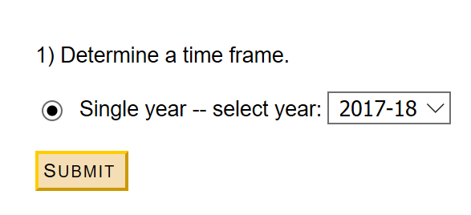

Once on the report page, each report can be further filtered and disaggregated by selecting the “Report Options and Filters” link.
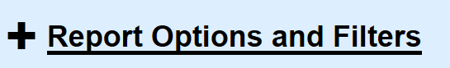
From here, select specific report options, data types, and filters to further narrow the report. (Note that not all options and filters are available for every report due to small n-sizes and for data privacy).
Report Selection allows users to choose from a list of specific reports as well as the county and the school year for which to view the report.
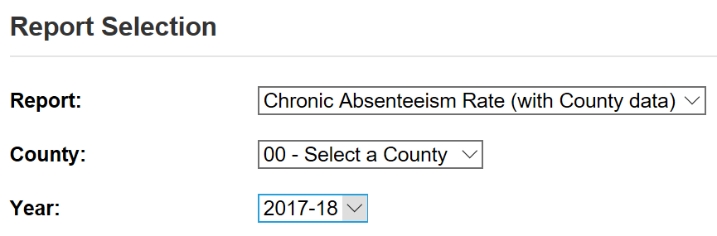

Report Filters allow users to choose specific views and further disaggregation of the data by selecting from multiple options. A detailed description of these options is available in Appendix A on page 5 of this document.
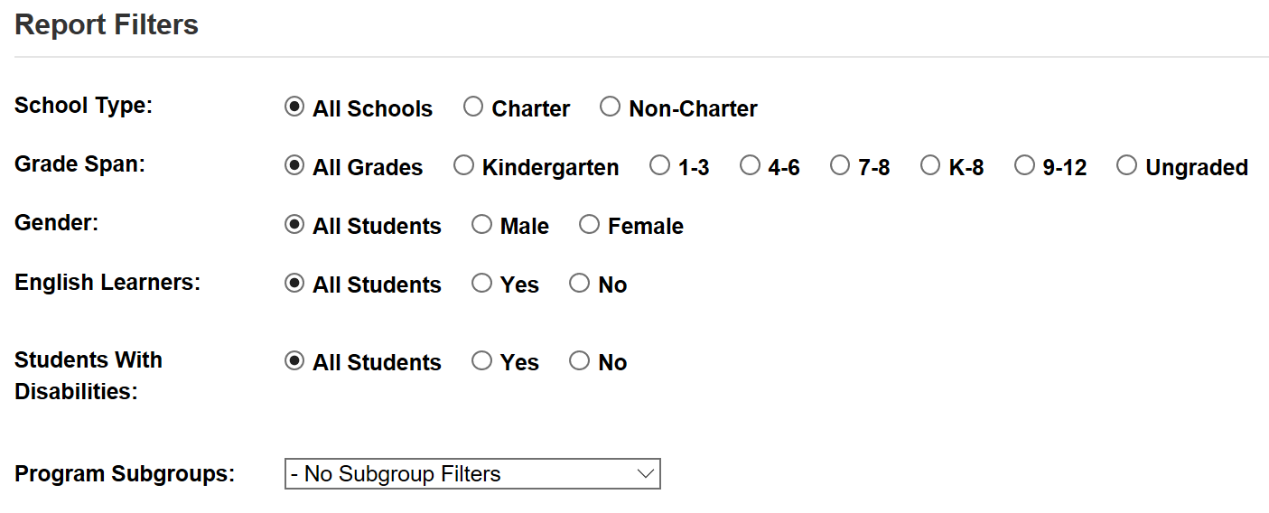

California School Dashboard
Statewide accountability reports on foster youth can be found on the California School Dashboard, California’s educational accountability system. The Dashboard can be accessed at https://www.caschooldashboard.org/reports/ca/2018
Instructions on accessing reports on foster youth on DataQuest are listed below.
Once on the Dashboard website, enter a school or district for which to view outcome data. Then select the accountability report to view such as “Chronic Absenteeism” or “Suspension Rate.”
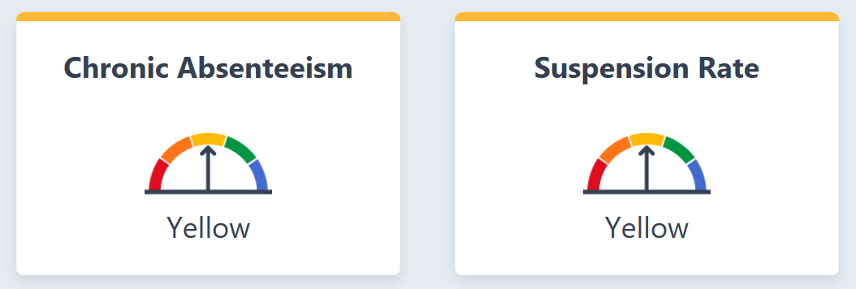
Once on the report landing page, select the “View More Details” option under the specific accountability card.
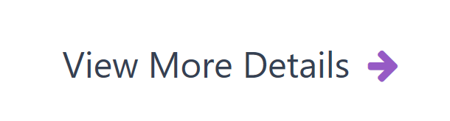
Then scroll down below the “Explore Groups by Performance Level” section to view the statewide performance for foster youth for the indicator selected.
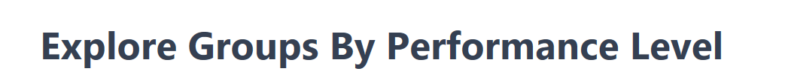

Appendix A for DataQuest Report Filters image
The Report Filters include the following options for most reports on DataQuest. From the School Type filter users can select to view the report for All Schools, Charter schools, or Non-Charter schools. From the Grade Span filter users can select to view the report for All Grades, Kindergarten, grades 1-3, grades 4-6, grades 7-8, grades K-8, grades 9-12, or Ungraded grades. From the Gender filter users can select to view the report for All Students, Male students only, or Female students only. From the English Learners filter users can select to view the report for All Students, yes (which means English Learners), or No (which means students who are not English Learners). From the Students with Disabilities filter users can select to view the report for All Students, yes (which means students with an identified disability), or No (students with no identified disability). From the Program Subgroups dropdown menu users can select to view the report for Socioeconomically Disadvantaged students, Migrant students, Foster students, or Homeless students.

