Fiscal Year 2019–20
Principal Apportionment
Tax Software
Version 19.00

User Guide
October 2019
California Department of Education
School Fiscal Services Division
1430 N Street
Sacramento, CA 95814

Table of Contents
User Guide ii
Introduction 1
Intended Audience 1
Related Documents 1
System Requirements 1
Document Conventions 1
County Auditor Procedures 3
County Auditor Taxes Entry Screen 4
Installing the Principal Apportionment Tax Software 5
Installation Procedures 5
Setting Compatibility Mode 6
Version Checking 6
Basic Operating Procedures 8
Adding a New User 8
Logging On 10
Getting the Latest LEA Updates 11
Accessing Help 11
Navigating Main Menus 12
Entering Data 19
Resizing Windows 26
Correcting Data from a Prior Period 27
Corrected Period Main Menu 27
Correcting Data 30
Saving Data 31
Importing and Exporting 32
Importing Data Files 32
Exporting Data Files 33
Submitting Certified Data Files 37
Uploading Certified Data 37
Printing Data 41
Printing Reports from an Entry Screen 41
Printing Reports from the Main Menu 41

List of Figures
Figure 1: Compatibility Mode Window 6
Figure 2: Sample Version Number on the Logon Screen 7
Figure 3: New User Screen 8
Figure 4: Main Menu 10
Figure 5: Importing data for Get Latest Screen 11
Figure 6: Tax Software 2019–20 web page 12
Figure 7: Sample Entry Screen 17
Figure 8: Sample Notes Window 21
Figure 9: Sample Taxes Entry Screen 23
Figure 10: Sample Add New Record Screen for District 24
Figure 11: Sample Add New Record Screen for County 24
Figure 12: Sample Entry Screen after Adding a New Record 25
Figure 13: Main Menu Screen for Corrected Periods 27
Figure 14: Correction Reason Screen 30
Figure 15: Importing ASCII Data Screen 32
Figure 16: Importing Certified Data Screen 33
Figure 17: Export Certified Window 34
Figure 18: Export Certified Window With All Districts Selected 35
Figure 19: Sample Data Modification Window 36
Figure 20: Submit Datafile Window 37
Figure 21: Select Datafile to Submit Window 37
Figure 22: Please Enter Password Message Box 38
Figure 23: Incorrect Password Message Box 38
Figure 24: Uploading Confirmation Message Box 39
Figure 25: Operation Complete Status Window 40

List of Tables
Table 1: County Auditor Taxes Entry Screens 4
Table 2: New User Screen Fields 9
Table 3: LEA Grid Information 13
Table 4: Entry Screens Grid Information 14
Table 5: File Menu Commands 15
Table 6: Available Tools Menu Commands 16
Table 7: File Menu Commands 20
Table 8: Note Menu Buttons 21
Table 9: Multiple Record Entry Screens Navigation Buttons 22
Table 10: LEA Grid Columns for Corrected Periods 28
Table 11: Entry Screen Grid Columns for Corrected Periods 29
Table 12: Principal Apportionment Software Printed Report Descriptions 42

Introduction

Intended Audience
This document is specific to the Principal Apportionment Tax Software and is intended to help county auditors and county offices of education (COE) quickly become familiar with how to use the Principal Apportionment Tax Software. Understanding basic Windows functions and procedures, such as clicking, double clicking, right clicking, browsing, etc., will assist you in using this document and software.

Related Documents
For step-by-step installation instructions, please refer to the Installation Guide that accompanies this User Guide and is available on the California Department of Education (CDE) web page at https://www.cde.ca.gov/fg/sf/tc/tax1920.asp.
For more information on tax data to be reported in the software, please refer to the Data Reporting Instruction Manual (Tax Software Supplement) located on the CDE Tax Software web page at https://www.cde.ca.gov/fg/sf/tc/tax1920.asp.
For more information on known software problems, please refer to the Known Problems, Fixes, and Workarounds web page located at https://www.cde.ca.gov/fg/sf/tc/tax1920.asp.

System Requirements
The installation of the software requires approximately 10 MB of hard disk space on a Windows based PC.

Document Conventions
This document uses the following conventions to describe functions and procedures in the software:
Window Names | The names of windows, screens, and dialogue boxes use title case, such as:  Save As window  User Information screen
Commands | Commands are operations you must follow in order to perform certain functions in the software. Bold face font is used, such as:  Select Print from the File menu  Click the OK button
Image Names | Images, or pictures, are described as Figures and use Italic face font, such as:  Figure 1: Compatibility Mode Window.
Important Notes | Notes include important statements regarding steps you may need to take. They are highlighted in gray, with a black border on the top and bottom, such as:  Note: Important note here

County Auditor Procedures
The Principal Apportionment Tax Software is used by county auditors to enter county and school district tax data.
Each county auditor has specific procedures that should be followed to accurately report taxes in time for each Principal Apportionment certification.
To report taxes for the county and all school districts:
- Install the Tax Software.
- Add a county auditor user and logon.
- Select the correct reporting period.
- Enter school district and county tax data in each appropriate entry screen by selecting the Tax Type (County or District) from the drop-down box. Refer to the Data Reporting Instruction Manual (Tax Software Supplement) on the CDE Tax Software web page at https://www.cde.ca.gov/fg/sf/tc/tax1920.asp for assistance.
- Export the data to a certified data file.
- Send the certified data file to your COE. The COE will then export the data file to send to CDE.
- Print and sign the certification page and send it to your COE.
Optional tasks include:
- Printing reports for the entry screen.
- Exporting data to an ASCII file for use in other software.
- Printing blank certifications, summaries, or certification exceptions.
The subsequent sections provide detail on how to accomplish the above steps.

County Auditor Taxes Entry Screen
The following table displays the reporting periods the Taxes entry screen is available to users from the county auditor user group.
Entry Screen Name | Data to be Entered | P-1 | P-2 | Annual | Corrected P-2 | Corrected Annual | Multiple Records
Taxes | School district and county taxes. | Yes | Yes | Yes | No | Yes | Yes
Table 1: County Auditor Taxes Entry Screens

Installing the Principal Apportionment Tax Software
This chapter gives an overview of the tasks that must be completed in order to properly install the software. For specific installation instructions, please refer to the Installation Guide available on the CDE Tax Software 2019–20 web page at https://www.cde.ca.gov/fg/sf/tc/tax1920.asp.

Installation Procedures
Installing the software from the internet.
- Download the software for the current fiscal year from the internet at https://www.cde.ca.gov/fg/sf/tc/tax1920.asp to your desktop.
- Find and double-click the software executable file downloaded from the internet.
- The InstallShield Wizard window displays.
- The Preparing to Install window displays.
- The Welcome window displays.
- Click Next. The Customer Information window displays. Enter your information.
- Click Next. The Destination Folder Program window displays.
- Click Next. The Database Folder Program window displays.
- Click Next. The Ready to Install the Program window displays.
- Click Install. The progress meter displays the installation status.
- When the installation is complete, the Installation Completed window displays, and the dialog box shows whether or not the software installed successfully.
- Click Finish.
Note: You may be asked to restart your computer. Click Yes. After the computer restarts, you can start using the Tax Software.

Setting Compatibility Mode
After installing the Principal Apportionment Tax Software, right click on the shortcut on your desktop to set the compatibility mode to Windows XP (Service Pack 3) as shown in Figure 1. If you are using Windows XP your system should already be set to Windows XP. However, if you are using Windows 7, Windows 8, or Windows 10 we strongly recommend you run the Tax Software in this mode to alleviate errors caused by compatibility issues between Windows 7, Windows 8, or Windows 10 and the Tax Software.
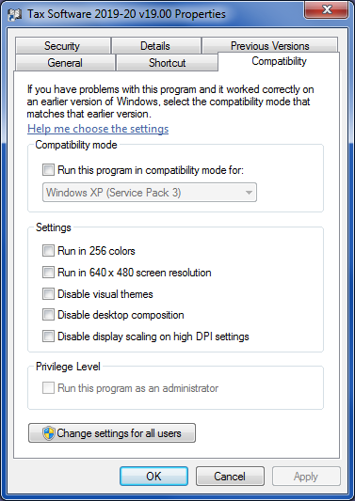
Figure 1: Compatibility Mode Window

Version Checking
Version checking is an important method used to ensure the correct version of the software is being used. When you open the software, the Logon screen displays the version number (Figure 2). Check the version number on the CDE website at https://www.cde.ca.gov/fg/sf/tc/tax1920.asp.
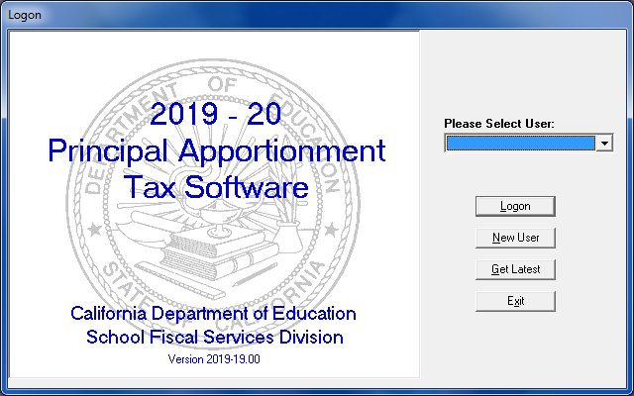
Figure 2: Sample Version Number on the Logon Screen

Basic Operating Procedures

Adding a New User
You can add one or more users to the system. Add a user by clicking the New User button in the Logon screen. After you click the New User button, the New User screen displays (Figure 3).
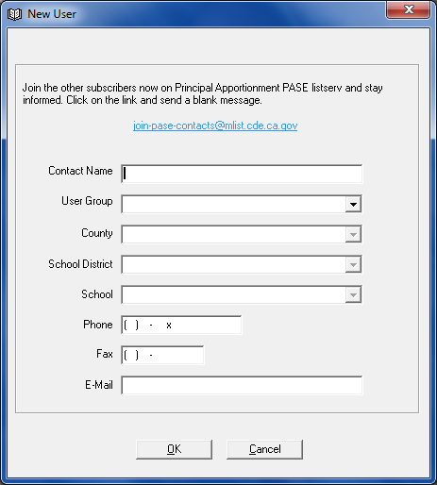
Figure 3: New User Screen
From the New User screen, you can subscribe to the Principal Apportionment PASE Listserv to stay informed of apportionment information. Click on the join-pase-contacts@mlist.cde.ca.gov link and send a blank email.
Some fields are not active until after you select other fields. For example, the County field is not active until you select a user group from the User Group field. You must enter data in the required fields to save the record. These required fields are noted in Table 2.
Field | Description | Notes
Contact Name | Your user logon name. | Required field.
User Group | Select either the County Office or County Auditor user group from the drop-down list. | Required field.
County | Select the county from the drop-down list. | Required field.
School District | N/A | This field is disabled for county office and county auditor user groups.
School | N/A | This field is disabled for county office and county auditor user groups.
Phone | Your telephone number. | Required field.
Fax | Your fax number. | Optional field.
Email | Your email address. | Required field.
Table 2: New User Screen Fields
After you enter your information, click OK. If you did not enter data in a required field, a dialog box displays alerting you to the missing data. If you want to close the New User screen without saving the data you entered, click Cancel.
Once you click OK the Logon screen displays again with the new user you entered in the Please Select User dialog box.

Logging On
To logon and begin using the software after you have added a new user:
- Select the user from the Please Select User drop-down list in the Logon screen.
- Click the Logon button. The Main menu screen displays (Figure 4).
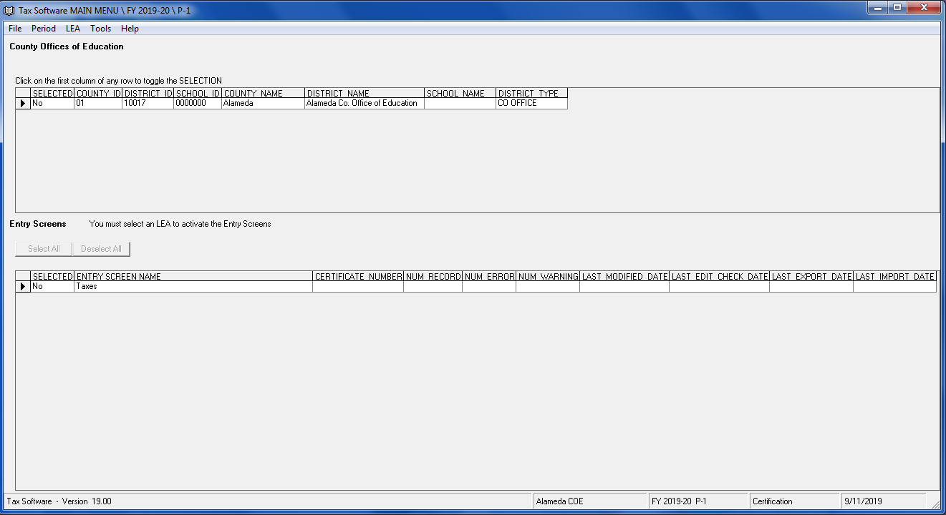
Figure 4: Main Menu

Getting the Latest LEA Updates
You can update local educational agency (LEA) information in the software database with a CDE supplied text data file by clicking the Get Latest button in the Logon screen. The CDE will supply this file upon request. After you click the Get Latest button, the Importing data for Get Latest screen displays (Figure 5).
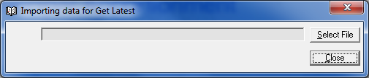
Figure 5: Importing data for Get Latest Screen
To get the updates:
- Click Select File.
Note: You can close the window without importing any data by leaving the field blank and clicking the Close button.
- Select the text file in the Open window.
- Click Open. The Open window closes and the file name and location displays in the text box in the Importing data for Get Latest screen. The import process begins. A message box displays when complete. Click OK to view the Status Report. If you try to import a file with an invalid format, the Status window displays an error message. You can save, print, or close the Status window.
- Click Close.

Accessing Help
Clicking Help or pressing the F1 key from the Main menu or from any entry screen will link the user to the Tax Software Data Collection web page at https://www.cde.ca.gov/fg/sf/tc/tax1920.asp (Figure 6). Under Documentation, the following are available to help a user with the submission of data:
- Known Problems, Fixes, and Workarounds – Information on known problems and fixes for the Tax Software.
- Installation Guide - Information on how to download and install the software.
- User Guide - Information on how to use the software and tips on how to print, save, export/import, etc.
- Data Reporting Instruction Manual (Tax Software Supplement) - Information on how to use the data entry screens, where to report data, and description of data elements for each screen (previously known as the Help File).
Figure 6: Tax Software 2019–20 web page

Navigating Main Menus
The Main menu (Figure 4) is the starting point for entering data into the software.

Main Menu Grids
There are two grids on every Main menu:
- LEA grid
- Entry Screens grid
The LEA grid displays information about the LEA. The columns are described in Table 3.
Column | Description
SELECTED | Denotes selection status for printing reports and/or exporting to an ASCII file. The default selection is “No.” Change the selection to “Yes” by clicking the SELECTED cell in the appropriate LEA row.
COUNTY ID | The county identification number.
DISTRICT ID | The district identification number.
SCHOOL ID | Displays 0000000.
COUNTY NAME | The county name.
DISTRICT NAME | The district name is identified as the COE.
SCHOOL NAME | N/A
DISTRICT TYPE | The district type is identified as the COE.
Table 3: LEA Grid Information

The Entry Screens grid displays a list of entry screens that you can access to enter or view data. Each row contains information about entry screen data. The columns are described in Table 4.
Column | Description
SELECTED | Denotes selection status for printing reports and/or exporting to an ASCII file. The default selection is “No.” Change the selection to “Yes” by clicking the SELECTED cell in the appropriate entry screen row.
ENTRY SCREEN NAME | The entry screen name.
CERTIFICATE NUMBER | A unique number that is generated after data is entered and saved.
NUM RECORD | Number of records in the entry screen.
NUM ERROR | Number of errors in the entry screen.
NUM WARNING | Number of warnings in the entry screen.
LAST MODIFIED DATE | The date and time records in the entry screen were last modified and saved.
LAST EDIT CHECK DATE | The date and time the entry screen data was last saved and checked for errors. Not all screens are checked for errors, but the field still contains date and time information upon saving.
LAST EXPORT DATE | The date and time the entry screen data was last exported to a certified data file.
LAST IMPORT DATE | The date and time that certified data was last imported into the entry screen.
Table 4: Entry Screens Grid Information

Main Menu Commands

File Menu
The File menu contains the following commands shown in Table 5.
Command | Description
Import | The Import sub-menu allows you to import either ASCII (text) files or certified data files.
Export | The Export sub-menu allows you to export data to an ASCII (text) file or to a certified data file.
Print | The Print sub-menu allows you to print various types of reports, depending on the user group selected.
Printer Setup | Opens a standard Windows Printer Setup window. You can select the printer to which you will print reports and the default number of copies you will print each time.
Logout | The Logout command logs the current user out of the application and returns to the Logon screen.
Exit | The Exit command closes the program and returns you to Windows.
Table 5: File Menu Commands

Period Menu
The Period menu allows you to switch between different reporting periods for the current fiscal year and for corrections.
There are three tax reporting periods for each fiscal year in the software (P-1, P-2, and Annual) and one reporting period for corrections (Annual). When you open the software for the first time, the default reporting period selected is P-1. Each time you reopen the software after that, it will always open to the last reporting period used.
Note: A checkmark displays next to the selected period in the Period menu.
When reporting data for the current fiscal year, select a period by selecting P-1, P-2 or Annual from the Period menu. When reporting data for corrections, select Corrected from the Period menu, then select Annual from the sub-menu.

LEA Menu
The LEA menu displays County Auditor.

Tools Menu
The options available in the Tools menu depend on the user group selected. Table 6 displays a summary of the commands available in the Principal Apportionment Tax Software:
Command | Description
User Information | This option is available to the County Office and County Auditor user groups. The User Information screen displays your current user information and allows for modification to the contact name, telephone number, fax number, and email fields. You cannot change your user group, county, school district, or school from this screen. You must create a new account if you want to change this information.
Contact Information | This option is available to the County Office user group only. The Contact Information screen displays the contact information for a County Office user group user submitting a file to another County Office user group user. The screen displays the contact name, user group, county, school district, school, telephone number, fax number, and email fields. You cannot change the information in these fields.
Upload Certified Data | This option is available to the County Office user group only. Sends the final certified data file to the CDE.
Table 6: Available Tools Menu Commands

Help Menu
The Help menu is a useful tool if you need assistance with a particular entry screen or program function. For more information on utilizing help, see the Accessing Help Section.
Clicking About displays the version number of the software, similar to the Logon screen. To return to the Principal Apportionment Tax Software, click OK. If you would like to view your Windows system information, click System Info. The System Information window displays information about your hardware, software, and Windows environment.

Selecting and Opening an Entry Screen
To select and open an entry screen:
- Select the LEA by clicking the far left column of your selected LEA row in the top grid of the Main menu screen.

- Open the entry screen by clicking the far left column of the entry screen row in the bottom grid of the Main menu screen.
Note: If you cannot view the entire entry screen, use the vertical and horizontal scroll bars on the right and bottom sides of the screen, respectively. If your computer has higher video resolution, you may be able to resize your window so more of the entry screen displays.
When you open an entry screen that contains existing data, the data displays in the proper fields.
The data is entered into “cells.” Some cells may be disabled (grayed out). These disabled cells are used to show calculated values or to prevent a user from entering data that does not apply to them. Figure 7 displays a sample entry screen.
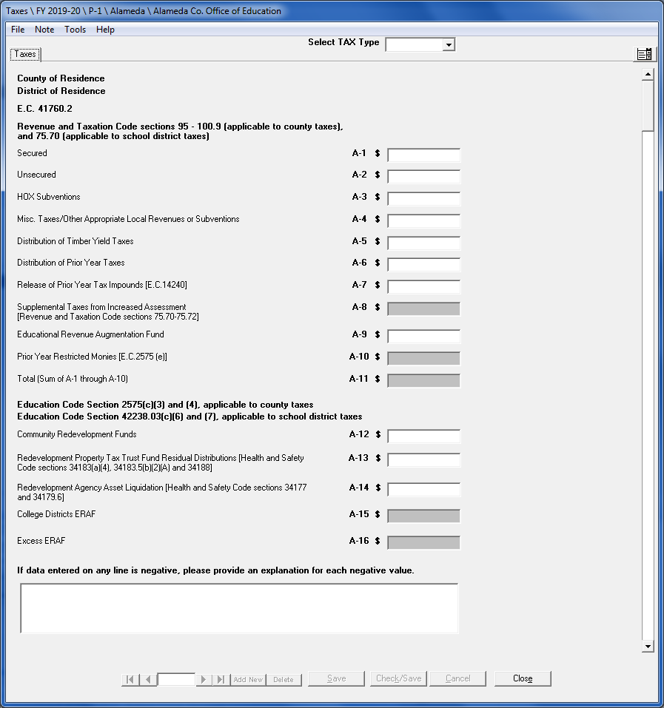
Figure 7: Sample Entry Screen

Selecting LEA and Entry Screen for Printing and Exporting to an ASCII (Text) File
You can choose either all or selected entry screens for printing from the Main menu. You can only choose one entry screen at a time for exporting to an ASCII (text) file from the Main menu.
To select all entry screens for printing:
- Click the SELECTED column cell for the LEA row to change it to “Yes”.
- Click the left arrow in the top grid. The Entry Screens grid (the lower grid in the Main menu) is now active.
- Click the Select All button above the Entry Screens grid. Each row in the Entry Screens grid displays “Yes” in the SELECTED column. You can now print reports for the LEA and entry screens that contain data.
To select specific LEAs and entry screens for printing or exporting to an ASCII (text) file:
- In the top grid of the Main menu, click the SELECTED column cell of the LEA row you want to print or export to an ASCII (text) file. The top grid displays “Yes” in the SELECTED column of the LEA row you click.
- Click the cell to the left of the LEA row in the top grid. The Entry Screens grid (the lower grid in the Main menu) is now active.
- Click the SELECTED column cell of the program you want to print a report for or click the SELECTED column cell of the program to export to an ASCII (text) file. The Entry Screens grid displays “Yes” in the SELECTED column of the entry screen you select. You can now print reports for the selected LEA and entry screen which contain data, or export the selected LEA and entry screen that has data to an ASCII (text) file.
Note: Deselect entry screens by clicking the Deselect All button or by clicking the SELECTED column cell(s) of the LEA or entry screen to change the cell(s) to “No.”

Entering Data
This section explains how to use entry screen commands, and add and delete records in entry screens that contain multiple records.

Entry Screen Commands

File Menu
The File menu displays the options shown in Table 7.
Command | Description
Save | Saves the entered data.  Note: A dialog box is displayed whenever you try to close an entry screen without saving the data. If you click No in the dialog box, the program discards the data and you cannot retrieve it. If you click Yes, the program saves the data and that data displays the next time you open the entry screen.
Check/Save | Not applicable to the Tax Software.
Print | The Print sub-menu allows you to print a report based on the data saved in the entry screen. After selecting Print, a pop-up message will appear to select a report for School District or COE. Select the “School District” or “CDE” radio button in the pop-up message box, then click Print, and a print preview is displayed. From the print preview screen, you can print or export the report. The report will print using the default printer installed in your Windows application. All reports print on standard 8.5" x 11" paper. Each report displays the date and time of printing.
Printer Setup | Opens a standard Windows Printer Setup window. You can select the printer to which you will print reports, and the default number of copies you will print each time.
Close | Closes the entry screen and returns you to the Main menu.
Table 7: File Menu Commands

Note Menu
Selecting Add Note from the Note menu opens a window for creating and saving Notes to entry screens. Figure 8 displays a sample Notes window. Enter any relevant information in the text box provided and click Save.
If you enter text into the Notes dialog box and then try to close the dialog box without saving, a dialog box displays and asks if you want to save the note. If you click No, the program discards the note and you cannot retrieve it. If you click Yes, the program saves the note and that note will display in the Notes dialog box the next time you open the dialog box. After you save your note and then save the data in the associated entry screen, you can view the saved note every time you access the Notes dialog box. The buttons are displayed in Table 8.

Note: Deleting data in the entry screen also deletes your note.
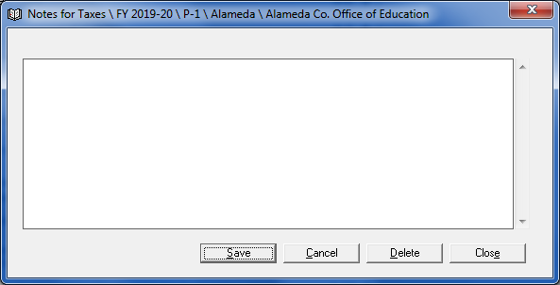
Figure 8: Sample Notes Window
Button | Description
Save | This button saves the note with your data. Every time you open the screen your note displays when you open the Notes dialog box.
Cancel | Removes text that you entered after you opened the dialog box. If you saved text in the dialog box, the program does not remove that saved text.
Delete | Deletes all text in the Notes dialog box. When you click Delete a dialog box displays asking if you want to remove the text; when you click Yes the program deletes the text and you cannot retrieve it.
Close | Closes the Notes dialog box.
Table 8: Note Menu Buttons

Tools Menu
The Tools menu displays additional entry screen functions. For example, in the Principal Apportionment Tax Software, an LEA can use the Copy P-1 to P-2 option of the Taxes entry screen’s Tools menu to copy P-1 tax data to P-2.

Help Menu
The Help menu functions in the same manner as on the Main menu screen. Please refer to the Accessing Help Section for more information on utilizing help.

Entering Data into Multiple Record Entry Screens
The tax entry screens allow multiple records to be created. Select an existing record, add a new record, or delete the currently selected record by clicking on one of the following buttons as shown in Table 9.
Button | Description
Far Left Arrow | Moves to the first record.
Left Arrow | Moves to the previous record.
Right Arrow | Moves to the next record.
Far Right Arrow | Moves to the last record.
Add New Button | Adds a new record.
Delete Button | Deletes the currently selected record.
Table 9: Multiple Record Entry Screens Navigation Buttons

Adding Records
To add a record to the screen:
- Click the dropdown arrow. Select Tax Type (Figure 9).
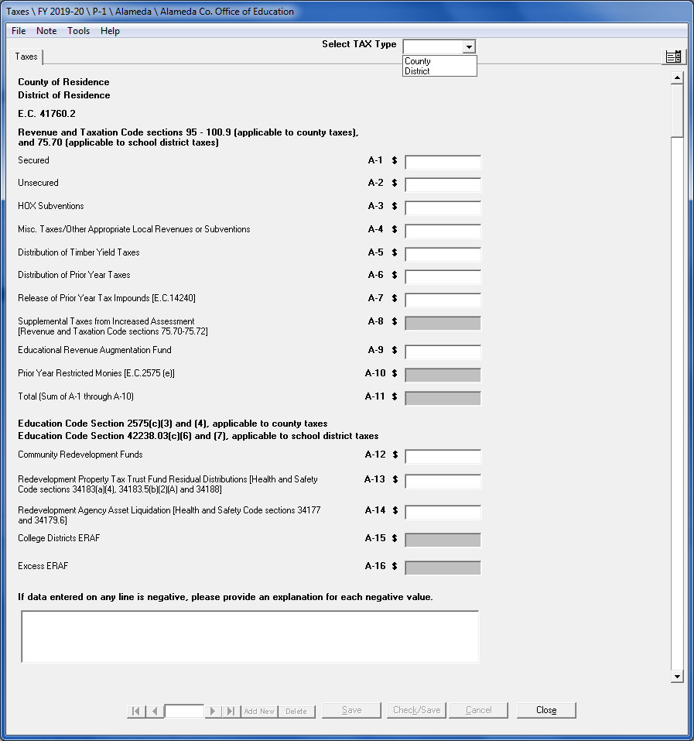
Figure 9: Sample Taxes Entry Screen
- Click on the Add New button. The Add New Record screen displays, similar to the one shown in Figure 10 and Figure 11.
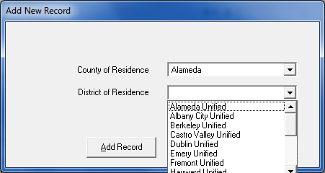
Figure 10: Sample Add New Record Screen for District
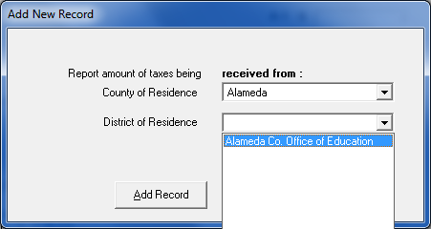
Figure 11: Sample Add New Record Screen for County
- Choose the LEA you want to enter data for, and then click on the Add Record button. You can now enter data for that LEA. Figure 12 shows an entry screen after completing the Add New record entry screen.
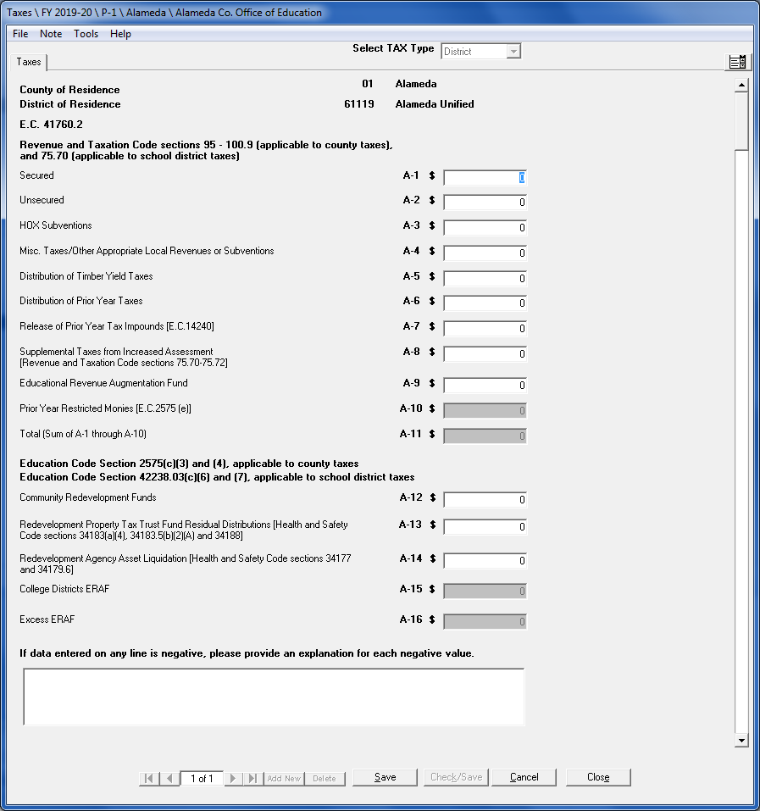
Figure 12: Sample Entry Screen after Adding a New Record
- Click Save to save the record.
Note: A user can change previously saved data in any record. However, the changed data will replace the previously saved data.
- Add additional records by following steps 1–4.

Moving Through Fields
You can move to a different field in two different ways. You can press the TAB key to move the cursor to the next field, or you can move the mouse pointer over the field you want and then click the left mouse button. You can move to the previous field by pressing SHIFT+TAB. The program highlights the value in that field once the cursor displays there. If the next field does not display in the window, the program scrolls up or down the entry screen to display your selected field.

Entering Negative Numbers
Use the minus ( - ) sign after a number to enter a loss, or negative value, in an entry field. The value will then display as a negative number on the entry screen and in parentheses on the entry screen and on the corresponding printed report.

Deleting Records
To delete a record:
- Select the record you want to delete.
- Click on the Delete button.
- Click Yes in the Delete dialog box.

Selecting and Searching for Records
If you want to open a saved record in the entry screen, you can select an existing record by using the arrow buttons described in Table 9.

Resizing Windows
You can resize a window by moving your mouse pointer to an edge or the corner edge of the window. The pointer changes into a two-sided vertical arrow when the pointer is moved over the top or bottom edge, a two-sided horizontal arrow when the pointer is moved over the left or right edge, or a two-sided diagonal arrow when the pointer is moved over a corner edge. Then you can hold down your left mouse button and move the mouse to shrink or enlarge the window size.

Correcting Data from a Prior Period
If you need to submit corrected data for Annual, you can input corrected data by selecting the Period menu, then selecting Annual from the Corrected sub-menu.
If you have not yet submitted data or need to revise data and the reporting deadline has recently passed, contact CDE to determine if an original (non-corrected) file may still be accepted.
Note: You must use the appropriate fiscal year software to make corrections. For example, you would use the 2017–18 software in fiscal year 2018–19 to make the 2017–18 corrections. Any data that is changed replaces previously saved data.

Corrected Period Main Menu
When you log in and select a corrected period from the Period menu, the Main menu displays the CORRECTED columns shown in Figure 13.
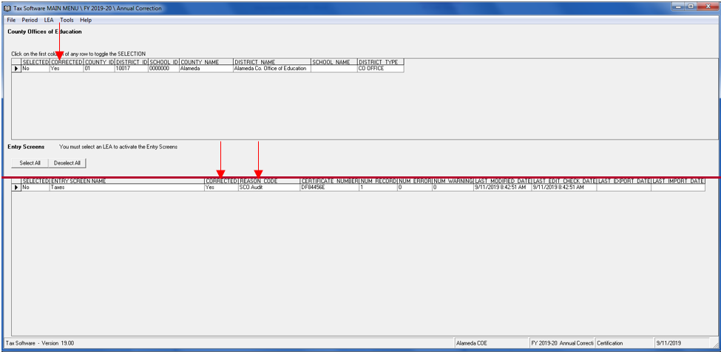
Figure 13: Main Menu Screen for Corrected Periods
The LEA grid columns in a corrected period’s Main menu are described in Table 10.
Column | Description
SELECTED | Denotes selection status for printing reports and/or exporting to an ASCII file. The default selection is “No”. Change the selection to “Yes” by clicking the SELECTED cell in the appropriate LEA row.
CORRECTED | Denotes whether corrections have been made. The default selection is “No”.
COUNTY ID | The county identification number.
DISTRICT ID | The district identification number.
SCHOOL ID | Displays 0000000.
COUNTY NAME | The county name.
DISTRICT NAME | The district name is identified as the COE.
SCHOOL NAME | N/A
DISTRICT TYPE | The district type is identified as the COE.
Table 10: LEA Grid Columns for Corrected Periods

The Entry Screens grid columns for corrected periods are described in Table 11.
Column | Description
SELECTED | Denotes selection status for printing reports and/or exporting to an ASCII file. The default selection is “No”. Change the selection to “Yes” by clicking the SELECTED cell in the appropriate entry screen row.
ENTRY SCREEN NAME | The entry screen name.
CORRECTED | Denotes whether corrections have been made to the data in the entry screen. The default selection is “No”.
REASON CODE | The reason code for the correction.
CERTIFICATE NUMBER | A unique number that is generated after data is entered and saved.
NUM RECORD | Number of records in the entry screen.
NUM ERROR | Number of errors in the entry screen.
NUM WARNING | Number of warnings in the entry screen.
LAST MODIFIED DATE | The date and time the entry screen was last modified and saved.
LAST EDIT CHECK DATE | The date and time the entry screen data was last saved and checked for errors. Not all screens are checked for errors, but the field still contains date and time information upon saving.
LAST EXPORT DATE | The date and time the entry screen data was last exported to a certified data file.
LAST IMPORT DATE | The date and time that certified data was last imported into the entry screen.
Table 11: Entry Screen Grid Columns for Corrected Periods

Correcting Data
To enter corrected data:
- Select Corrected from the Period menu.
- Select Annual from the Corrected submenu.
- Select the LEA in the top grid to activate the Entry Screens grid.
- Open the entry screen to correct and make any necessary changes to the data.
Note: Data entered in the standard Annual reporting periods will be displayed in the entry screen fields.
- Click Save.
- Click Close to close the entry screen.
- Upon closing the entry screen, the Correction Reason dialog box displays as shown in Figure 14.
Note: The Correction Reason screen will not display unless data (original or corrected) has been saved in the entry screen.
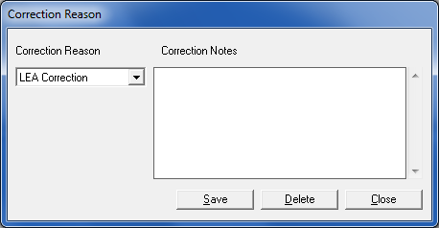
Figure 14: Correction Reason Screen
- Select the reason for the correction from the Correction Reason drop-down list.
- Type correction notes in the Correction Notes text box.
Note: You must enter notes in this text box. Do not leave the text box blank.
- Click Close. The Correction Reason screen closes and the Main menu displays.
Note: In the Entry Screens grid, the CORRECTED column displays Yes” and the correction reason selected is displayed in the REASON CODE column. In the top grid, the CORRECTED column for the LEA row that was corrected displays “Yes.”
Once the CORRECTED column displays “Yes,” you can re-enter the Correction Reason dialog box by clicking the “Yes” in the CORRECTED column cell in the Entry Screens grid if you need to edit the correction reason or notes. Click Save. If Delete is clicked, all notes will be deleted. If a new note is added, you must click Save before Close or the new information will not be saved.

Saving Data
Any data that is changed and saved replaces previously saved data for that period. If you change and save Annual corrected period data, the data changes OVERWRITE the previously saved Annual period data. Conversely, if you change and save Annual data in the “standard” (meaning from the Period menu, not from the Period menu’s corrected sub-menu) reporting period, the saved changes will OVERWRITE any existing Annual corrected period data.

Importing and Exporting
Once data is entered, it can be exported to a file and/or imported to another program. This section describes how to import and export data files and send those files to the CDE.

Importing Data Files

Importing ASCII Files
You can import data into the program from a properly formatted ASCII (text) file. To see the format of the ASCII file, you can open it in Notepad. Data must be in proper sequence and format to be imported.
To import an ASCII (text) file from the Main menu screen:
- Click Import from the File menu.
- Click ASCII File in the submenu. The Importing ASCII Data screen displays (Figure 15).
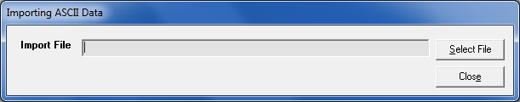
Figure 15: Importing ASCII Data Screen
- Click Select File and select the file you want to import.
- Click Open.
After the program imports the file, the Status window displays the results of the import process showing the number of records skipped, copied, and overwritten. You can save, print, or close the Status window. You can close the Importing ASCII Data screen without importing any data by leaving the field blank and clicking Close.
Note: If the program cannot import the file, a dialog box displays and informs you. If data already exists in the record you are importing data into, one or more dialog boxes display that ask if you want to overwrite the data.
Note: In a multiple record file, the import will overwrite existing like-records and add new records but it will not delete records. If, after you import a file, the Certificate Number and/or Number of Records do not match the expected Certificate Number and/or Number of Records, you must delete the records using the delete button on the data entry screen and import the file again.

Importing Certified Data Files
You can import a certified data file into the program.
To import a certified data file from the Main menu screen:
- Click Import from the File menu.
- Click Certified Data in the submenu. The Importing Certified Data screen displays (Figure 16).
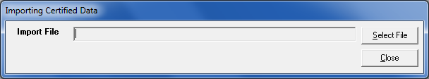
Figure 16: Importing Certified Data Screen
- In the Importing Certified Data screen, click Select File.
- Select the file you want to import.
- Click Open.
After the program imports the file, the Status window displays the results of the import process showing the number of records skipped, copied, and overwritten. You can save, print, or close the Status window. You can close the Importing Certified Data window without importing any data by leaving the field blank and clicking Close.
Note: If the program cannot import the file, a dialog box displays and informs you. If data already exists in the record you are importing data into, one or more dialog boxes display that ask if you want to overwrite the data.
Note: In a multiple record file, the import will overwrite existing like-records and add new records but it will not delete records. If, after you import a file, the Certificate Number and/or Number of Records do not match the expected Certificate Number and/or Number of Records, you must delete the records using the delete button on the data entry screen and import the file again.

Exporting Data Files

Selecting Data to Export
You can export tax entry screen data to an ASCII (text) file or a certified data file, but first you must select data to export. The process for selecting data depends on whether you want to export an ASCII (text) file or certified data file.

Selecting LEA and Entry Screen for Exporting to an ASCII (Text) File
You can export data to an ASCII (text) file for internal distribution.
To export entry screen data into an ASCII file:
- Select the LEA and entry screen you want to export (see the Selecting LEA and Entry Screen for Printing and Exporting to an ASCII (Text) File Section for more information).
- Click Export from the File menu.
- Click ASCII File in the submenu. The Save As window displays.
- Navigate to a folder and enter the file name in the File name field or accept the default folder and file name.
- Click Save. The Status window displays.
- Save, print, or close the Status window.

Selecting LEA and Entry Screen for Exporting to a Certified Data File
You must export the data you entered in the program to a certified data file to send to the CDE by the filing dates.
Access the Export Certified window by selecting Export from the File menu, then selecting Certified Data from the sub-menu.
You can select the LEA and entry screen for data export to a certified data file by using the Export Certified window (Figure 17).
You must export the data you entered in the program to a certified data file to send to the CDE by the filing dates.
To export Certified Data:
- Click Export from the File menu.

- Click Certified Data in the submenu. The Export Certified window displays (Figure 17).
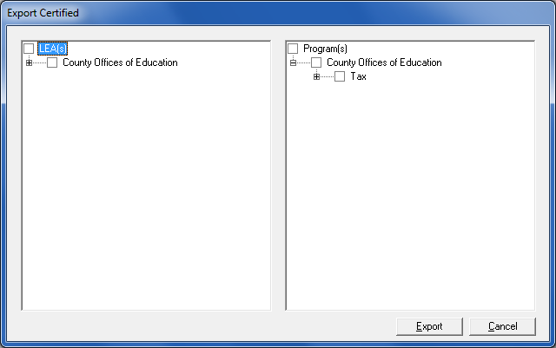
Figure 17: Export Certified Window
Note: The Export Certified window displays two panes. The left pane displays a tree view of all LEAs, and the right pane displays a tree view of all available entry screens.
- Select the checkbox beside the LEA and entry screen you want to export (Figure 18).
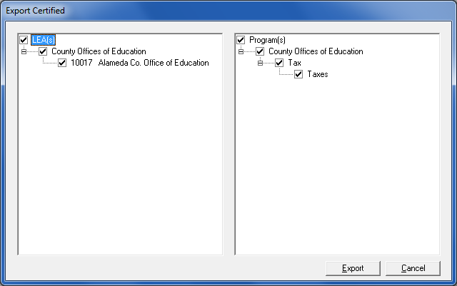
Figure 18: Export Certified Window With All Districts Selected

- Click the “+” sign to view all items in each LEA or program. Click the “-” sign to hide the items.
- To select the county LEA for export, select the checkbox to the left of LEA (at the top of the left pane). To select the county programs for export, select the checkbox to the left of Program(s) (at the top of the right pane).
- Click Export. The Data Modification window displays.
Note: The Data Modification window (Figure 19) must be used to explain any changes you have made to data that you are submitting. The Data Modification window is user group specific, e.g. the questions and certification language are different depending on user group type.
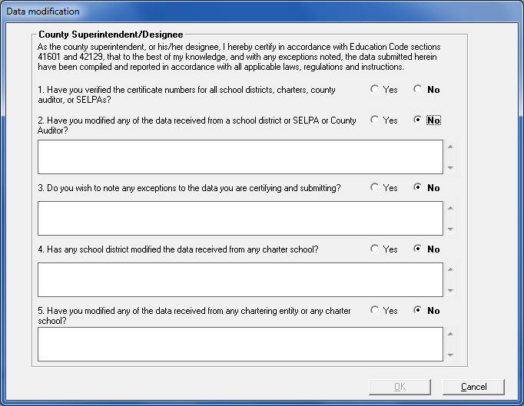
Figure 19: Sample Data Modification Window
- Answer the questions in the Data Modification window. You must select “Yes” for question 1 to enable the OK button. You must provide details in the text boxes immediately below questions 2 through 5 if you select “Yes” for any of those questions.
- Click OK. The Status window displays.
Note: You can save, print, or close the Status window.
- Close the Status window.
- Close the Export Certified window by clicking the Cancel button.
Note: If you get an error in your Export Status window, check the Entry Screens grid to ensure that the date and time in the LAST EDIT CHECK DATE column is the same or later than the date and time in the LAST MODIFIED DATE column. The entry in the LAST MODIFIED DATE column only indicates when you last saved the data, not the last time you checked the data for errors.
- In the Entry Screens grid, the export date and time is displayed in the LAST EXPORT DATE column in the entry screen row.

Submitting Certified Data Files

Uploading Certified Data
This section applies to COEs.
After COEs export their file to a certified data file, COEs must send the certified file to CDE via File Transfer Protocol (FTP). The Principal Apportionment Tax Software contains an FTP component.
Additionally, the County Superintendent must sign the Certification pages submitted from their Auditor and keep them on file at their COE.
To upload a certified data file:
- Select Upload Certified Data from the Tools menu. The Submit Datafile window displays (Figure 20).
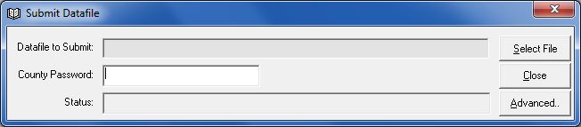
Figure 20: Submit Datafile Window
- Enter the County Password and click Select File. The Select Datafile to Submit window displays (Figure 21).
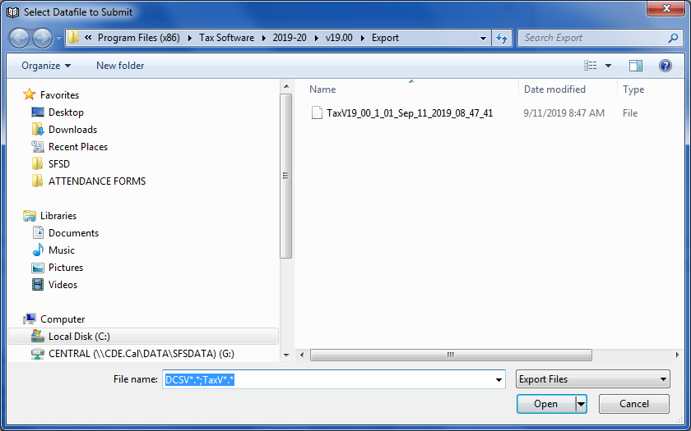
Figure 21: Select Datafile to Submit Window
Note: If you cannot see the Export file, the exported files could be in the Virtual Export folder. To see the files in the Virtual Export folder, navigate to your VirtualStore folder (C:\Users\yourusername\AppData\Local\VirtualStore\) then select the applicable subfolder(s). Example: C:\Users\yourusername\AppData\Local\VirtualStore\Program Files (x86)\Principal Apportionment Data Collection Software\2019-20\v19.00\Export. Then click on “Compatibility files” in the sub-menu bar for the Export folder you want to view. After displaying the Virtual Export folder, you will be able to see the files in the Export folder.
Note: If the password is not entered, the Please Enter Password message box displays (Figure 22).
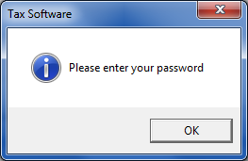
Figure 22: Please Enter Password Message Box
Note: If the incorrect password is entered, the Incorrect Password message box displays (Figure 23).
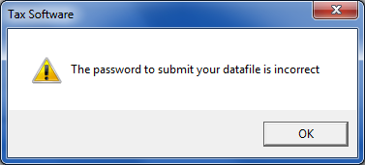
Figure 23: Incorrect Password Message Box
- Select the file to submit and click Open. The Uploading Confirmation message box displays (Figure 24).
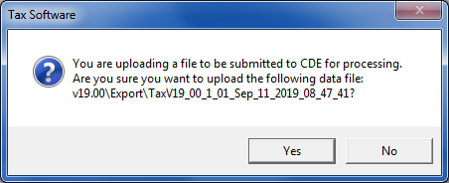
Figure 24: Uploading Confirmation Message Box
- If the correct file name is displayed in the message box, click Yes. When the upload process is complete, a Status window displays showing the results of the upload process (Figure 25).
Note: The data file name must begin with the type of software used to create the file. An example of a valid data file name would be TaxV19_00_1_01_Sep_11_2019_08_47_41.
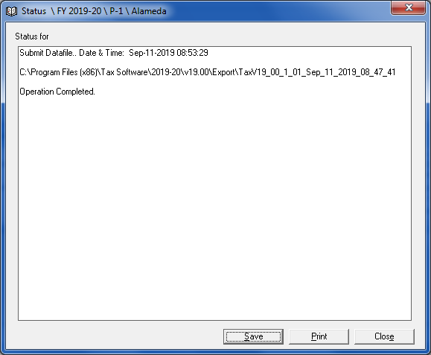
Figure 25: Operation Complete Status Window
- Click Close to close the Status window.
- Click Close to close the Submit Datafile window.

Printing Data
Reports can be printed from the entry screen or the Main menu using the software’s Print utility. Before you print reports, you should set up your printer.
From the File menu, select Printer Setup to open a standard Windows Printer Setup window. You can select the printer to which you will print reports, and the default number of copies you will print each time.

Printing Reports from an Entry Screen
Each individual entry screen has a report associated with it. The reports display in the Print Preview window.
To print an entry screen report:
- Open the entry screen.
- Select Print from the File menu. The Print Preview window opens.
Note: To view more of the report on-screen you can resize the window, or select a zoom percentage from the Zoom drop-down list.
Click the navigation () buttons to scroll through the pages of the report.
- Select the “School District” or “COE” radio button in the pop-up message box.
- Click the Print button (). The Print dialog box opens.
- Click OK. The report is sent to the printer.
- Click the Close button () to close the Print Preview window.

Printing Reports from the Main Menu
Before you print from the Main menu, you must select the LEA and the entry screen to be printed. For more information on selecting LEAs and entry screens, see the Selecting LEA and Entry Screen for Printing and Exporting to an ASCII (Text) File Section.
The File menu lists all software reports you can print from the Main menu for each user group.
The available reports you can print depend on the software application you are using and the user group selected.
Table 12 describes each type of printed report.
Report Type | Description
Reports | Prints data reports for selected LEA(s) (from the top grid) and entry screen(s) (from the Entry Screens grid).
Certification | Prints a certification page for selected LEA(s) and entry screens so you can get the proper signatures.
Blank Certification | A blank certification page can be printed and sent to an LEA that is not using the software to enter their data but is having their school district, COE, or other governing agency enter it for them. In these cases, the governing agency must send a blank certification page to the lower-level LEA so they may sign the certification page.
COE Certification | Prints a single Certification page for a selected program that lists the certification number for each LEA in the county that submitted data for that program rather than printing a separate certification page for each LEA.
Summary Report | Prints a report that includes all data that was entered in an entry screen as well as subtotals and totals for each data entry field.
Certification Exception  (County Auditor available from Sub-Menu depending on user group) | Displays the questions and answers from the Data Modification dialog box that opened when you exported certified data. (For more information on Data Modification, see the Selecting LEA and Entry Screen for Exporting to a Certified Data File Section.)
Table 12: Principal Apportionment Software Printed Report Descriptions
After you print the reports, the Status window displays the success or failure of the printing process. You can save the status report by clicking the Save button, or print the status report by clicking the Print button. Close the Status window by clicking the Close button.

