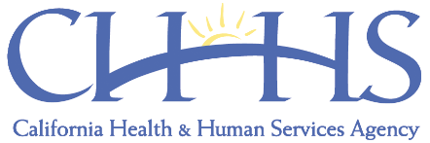
March 17, 2020
This is an uncertain time in California, and we have entered uncharted territory. Local educational agency officials are on the front line in making decisions for the health and safety of students and staff, and school officials have been faced with agonizing and difficult choices.
On behalf of Governor Gavin Newsom, State Superintendent of Instruction Tony Thurmond, State Board of Education President Linda Darling-Hammond, and Health and Human Services Agency Secretary Mark Ghaly, we want to extend our deepest appreciation to all of California’s educators and school staff for the hard work you all are doing on behalf of California’s school children.
Please continue to be guided by federal, state, and local public health authorities in your decision-making. We believe that public health and education officials, in collaboration, are best positioned to measure and balance these very difficult, and often competing, considerations. Continue to collaborate with your city and county officials on how best to work within your community and we encourage all members of the school community, administrators, employees, and families, to communicate and consult with one another as we plan and implement services for students.
It is an understatement to say that it is difficult to plan in this constantly-evolving situation, and regular reassessments are critical as the public health considerations continue to change. Shelter-in-place orders, like those issued in six Bay Area counties on March 16, 2020, significantly alter the considerations and possibilities for continuing to support students and families in affected communities. Please be assured that we will continuously assess the evolving circumstances and update the enclosed guidance as necessary.
The State of California supports you in these efforts. We are confident that, collectively, we will meet this moment on behalf of California's students and families, especially the most vulnerable among us, and that our state will be stronger because of your work. We encourage all members of the school community, including administrators and employees, to communicate and consult with one another as they plan and implement their strategies for serving students and families.
Finally, we know that educators have many questions moving forward. We have heard your questions about state assessments as well as Local Control and Accountability Plan adoptions and budget hearings. We know that you have also heard concerns from students about preparations for college and SAT/ACT and AP exams. Given the impact of COVID-19 on students and school communities, we want to let you know that we will prioritize the mental and socioemotional health of students, and are examining all options for suspending state assessments.
Please know that Superintendent Thurmond, State Board President Darling-Hammond, and California Department of Education staff are working diligently to answer questions as quickly as possible.
The California Department of Education will issue updates to this guidance and others every Friday, in addition to issuing new and updated guidance as the need arises.

