California Department of Education
District Organization Handbook
December 2022

CHAPTER 10
OTHER FUNCTIONS
OF THE COUNTY COMMITTEE
County committees on school district organization have additional responsibilities in processing proposals regarding the structure, membership, and areas of representation of members of school district governing boards. These requirements are unique to county committees and constitute a major portion of their workload. This chapter is particularly important for committee members.
NOTES:
The guidance in this handbook is not binding on local educational agencies or other entities. Except for statutes, regulations, and court decisions that are referenced herein, the handbook is exemplary, and compliance with it is not mandatory (see California Education Code Section 33308.5).
Permission is hereby granted to county offices of education and school districts (and their agents) to reproduce portions of this publication for educational purposes only and not for resale. The source of the material should be acknowledged. Please see the California Department of Education copyright statement at http://www.cde.ca.gov/re/di/cr/.

A. Introduction
A county committee on school district organization serves as central initiator, coordinator, facilitator, and arbitrator for the reorganization of school districts. Most of its activities deal with the reorganization of school district boundaries. Nevertheless, the county committee has other responsibilities empowered by the Education Code relating to trustee areas, membership, and methods of electing governing boards. This chapter identifies and addresses those other functions.
Section B of this chapter is organized as a quick-reference guide similar to that found in Chapter 5. It provides a succinct reference in the form of a one-page chart and accompanying flowchart, which depict the sequence of steps to be followed in each of these seven processes:
- Creating or abolishing trustee areas
- Increasing or decreasing the number of governing board members
- Rearranging trustee areas
- Petition process—after a county committee approves a rearrangement of trustee areas
- Alternative methods of electing governing board members
- Establishing or abolishing common governing boards
- Rearranging trustee areas based on federal decennial census
Section C, “Legal Provisions: Supporting Actions,” provides more detailed information about the steps identified in Section B and addresses several topics related to trustees and trustee areas. It also includes matters pertaining to county board of education trustees and trustee areas.

B. Process: Quick-Reference Chart 10.1
CREATION OR ABOLISHMENT OF TRUSTEE AREAS
(Refer to Flowchart 10.1)

Method 1
- County committee receives request/initiates action to create or abolish trustee areas. (EC 5019)
- County committee calls and conducts at least one public hearing in the district on the matter. (EC 5019)
- At the conclusion of the hearing, the county committee approves/disapproves the proposal. The county committee may include a declaration that the change in the method of electing members of the governing body is being made in furtherance of the purposes of the California Voting Rights Act (CVRA) in its resolution approving the proposal. The resolution shall take effect upon adoption and shall govern all elections for governing board members occurring at least 125 days after the adoption of the resolution. (EC 5020[a][2])
- If the county committee resolution to approve the proposal does not include a declaration that the change in the method of electing members of the governing body is being made in furtherance of the purposes of the CVRA, approval of the proposal constitutes an order of election. (EC 5020)
- If an election is ordered, the proposal is placed on the ballot not later than the next succeeding election for members of the governing board. (EC 5020[a])
- If a majority of those voting approve the establishment or abolishment of trustee areas, any affected board member serves out his or her term, and succeeding board members are elected according to the selected method. (EC 5021)

Method 2
- Petition is filed containing at least 10 percent of the signatures of the district’s registered voters proposing to create or abolish trustee areas. (EC 5020[c])
- Prior to placing the issue on the ballot, the county committee may call and conduct one or more public hearings on the matter. (EC 5020[c])
- Proposal is placed on the ballot at the next succeeding regularly scheduled election, the next succeeding statewide primary or general election, or the next succeeding regularly scheduled election at which the electors of the district are otherwise entitled to vote, provided that there is sufficient time to place the issue on the ballot. (EC 5020[c])
- If a majority of those voting approve the establishment/abolishment of trustee areas, any affected board member serves out his/her term and succeeding board members are elected according to the selected method. (EC 5021)
Note 1: Whenever trustee areas are established in a district, provision must be made for one of the alternative methods of electing governing board members. (EC 5030)
Note 3: The required election in Method 1 to establish trustee areas may be waived by the State Board of Education. A county board of education or a school district governing board seeking to waive this election should contact the Waiver Office of the California Department of Education for information regarding submittal of a waiver request.

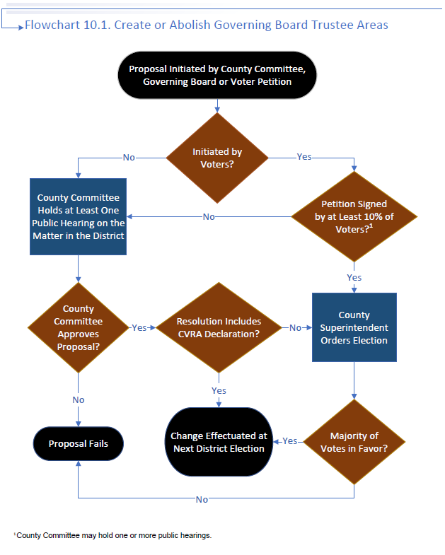

B. Process: Quick-Reference Chart 10.2
INCREASE OR DECREASE IN
NUMBER OF GOVERNING BOARD MEMBERS
(Refer to Flowchart 10.2)

Method 1
- County committee receives request/initiates action to increase or decrease the number of members of the governing board. (EC 5019) A request to decrease the size of the governing board from five to three members may be made only by a district whose average daily attendance during the preceding year was less than 300. (EC 5019[a][2])
- County committee calls and conducts at least one public hearing in the district on the matter. (EC 5019)
- At the conclusion of the hearing, the county committee approves or disapproves the proposal. The approval of the proposal constitutes an order of election. (EC 5020)
- Proposal is placed on the ballot not later than the next succeeding election for members of the governing board. (EC 5020)
- If a majority of those voting approve a proposal to increase the number of members of the governing board, the two additional members of the board must be appointed by the governing board of the district. (EC 5022)
- If a majority of those voting approve a proposal to decrease the number of members of the governing board, the members would continue to serve out their terms. Seats would be eliminated as terms expire, but terms must be staggered. (EC 5021)

Method 2
- Petition is filed containing at least 10 percent of the signatures of the district’s registered voters proposing to increase or decrease the number of members of the governing board. (EC 5020[c])
- Prior to placing the issue on the ballot, the county committee may call and conduct one or more public hearings on the matter. (EC 5020[c])
- Proposal is placed on the ballot at the next succeeding regularly scheduled election, the next succeeding statewide primary or general election, or the next succeeding regularly scheduled election at which the electors of the district are otherwise entitled to vote, provided that there is sufficient time to place the issue on the ballot. (EC 5020[c])
- If a majority of those voting approve a proposal to increase the number of members of the governing board, the two additional members of the board must be appointed by the governing board of the district. (EC 5022)
- If a majority of those voting approve a proposal to decrease the number of members of the governing board, the members would continue to serve out their terms. Seats would be eliminated as terms expire, but terms must be staggered. (EC 5021)
Note 1: The required election in Method 1 may be waived by the State Board of Education. A county board of education or a school district governing board seeking to waive this election should contact the Waiver Office of the California Department of Education for information regarding submittal of a waiver request.

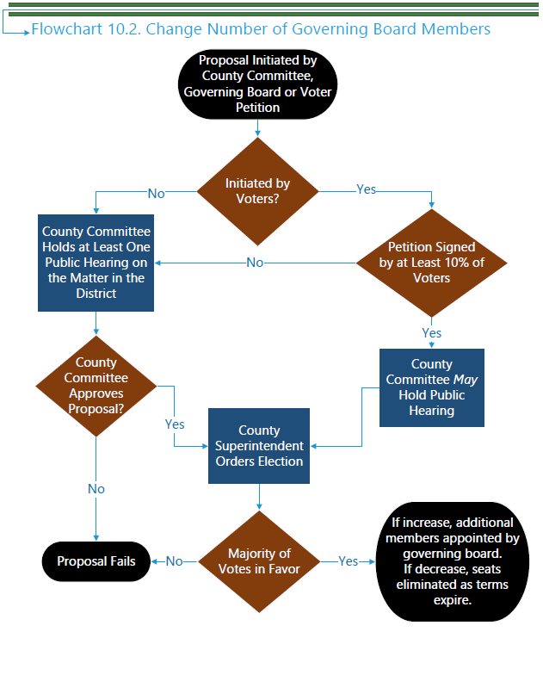

B. Process: Quick-Reference Chart 10.3
REARRANGEMENT OF TRUSTEE AREAS
(Refer to Flowchart 10.3)
- County committee receives request/initiates action to rearrange trustee areas. (EC 5019)
- County committee calls and conducts at least one public hearing in the district on the matter. (EC 5019)
- At the conclusion of the hearing, the county committee shall approve or disapprove the proposal. (EC 5019)
- The rearrangement of trustee areas must be put into effect for the next school district election occurring at least 125 days after its approval. (EC 5019)
Note: The proposal to rearrange trustee areas must go to an election if a petition requesting such an election is signed by five percent of the voters in the district. The following process applies under that scenario:
1. If the county committee approves the rearrangement of trustee areas and a subsequent petition is received, signed by at least five percent of the registered voters of the district, requesting an election on the proposed rearrangement of trustee area boundaries, the county committee must put the proposition to vote. The deadline for receiving the petition is 60 days after the county committee approves the proposal. (EC 5019)
2. The county committee must place the proposal on the ballot not later than the next succeeding regularly scheduled election, the next succeeding statewide primary or general election, or the next succeeding regularly scheduled election at which the electors of the district are entitled to vote, provided that there is sufficient time to place the issue on the ballot (125 days prior to the election date). (EC 5019[d], 5020[b])
3. If a majority of those voting approve the rearrangement of trustee areas, any affected board member serves out his or her term, and succeeding board members are elected according to the selected method and in accordance with the new boundaries. (EC 5021)
(See note on following page)
Note: The county committee cannot rearrange trustee area boundaries in a school district or community college district that has established a hybrid or independent redistricting commission for this purpose pursuant to Section 23003 of the Elections Code, the charter of a city or city and county, or a legal settlement. (EC 5019[a][3])

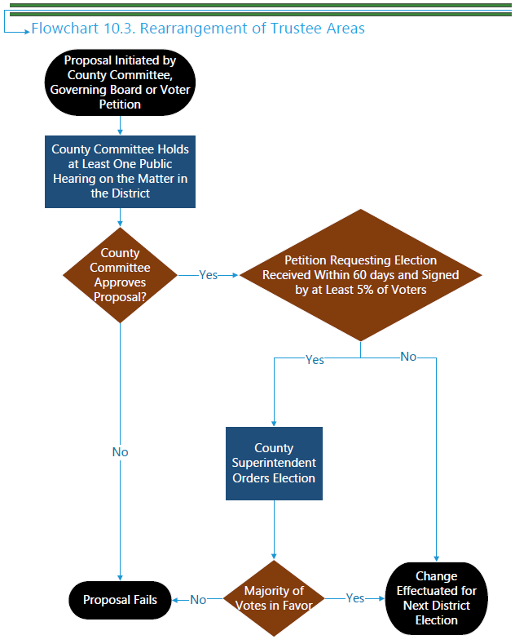

B. Process: Quick Reference Chart 10.4
ALTERNATIVE METHODS OF ELECTING
GOVERNING BOARD MEMBERS
(Refer to Flowchart 10.4)

Method 1
1. County committee receives request or initiates action to select an alternative method of electing governing board members. (EC 5019)
2. County committee calls and conducts at least one public hearing in the district on the matter. (EC 5019)
3. At the conclusion of the hearing, the county committee approves or disapproves the proposal. (EC 5019)
4. Proposal is placed on the ballot not later than the next succeeding election for members of the governing board.
5. If a majority of those voting approve, the proposal takes effect at the next governing board election. (Any affected board member must serve out his or her term.) (EC 5030)

Method 2
1. Petition is filed containing at least 10 percent of the signatures of the district’s registered voters proposing to adopt one of the alternative methods of electing governing board members. (EC 5020[c])
2. Prior to placing the issue on the ballot, the county committee may call and conduct one or more public hearings on the matter (EC 5020[c])
3. Proposal is placed on the ballot at the next succeeding regularly scheduled election at which the electors of the district are otherwise entitled to vote, provided that there is sufficient time to place the issue on the ballot. (EC 5020[c])
4. If a majority of those voting approve a proposal to increase the number of members of the governing board, the two additional members of the board must be appointed by the governing board of the district. (EC 5022)
5. If a majority of those voting approve a proposal to decrease the number of members of the governing board, the members would continue to serve out their terms. Seats would be eliminated as terms expire, but terms must be staggered. (EC 5021)
Note 1: The Education Code does not explicitly state whether the selection of alternative methods of electing governing board members, under Method 1, is required to go to an election or is effectuated for the next board election. It is the opinion of the California Department of Education that an election is required for the following reasons: (1) Method 2 requires an election, (2) Section 5020 contains ballot language for alternative methods of selecting governing board members, and (3) Section 5030 removes the election requirement, specifically in small counties, for county committee proposals for alternative methods of selecting governing board members (i.e., if an election requirement did not exist, there would be no need to remove it under these conditions). Flowchart F and this Quick Reference Chart reflect the opinion that alternative election methods must be presented to voters in both Method 1 and Method 2. However, it is recommended that legal counsel be consulted when county committees approve proposals for alternative methods of selecting governing board members.

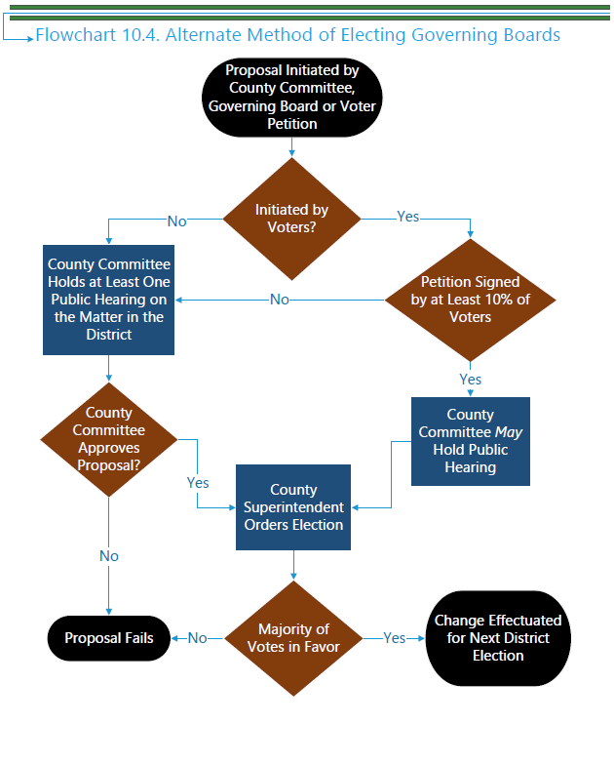

B. Process: Quick-Reference Chart 10.5
ESTABLISHMENT OR ABOLISHMENT
OF COMMON GOVERNING BOARDS
(Refer to Flowchart 10.5)
1. County committee receives request/initiates action to establish or abolish a common governing board for a high school district and an elementary school district within the boundaries of the high school district. (EC 5019)
2. County committee calls and conducts at least one public hearing in the district on the matter. (EC 5019)
3. At the conclusion of the hearing, the county committee approves or disapproves the proposal. (EC 5019)
4. Proposal is placed on the ballot at the next succeeding regularly scheduled election at which the electors of the district are otherwise entitled to vote, provided there is sufficient time to place the issue on the ballot. (EC 5020[d])

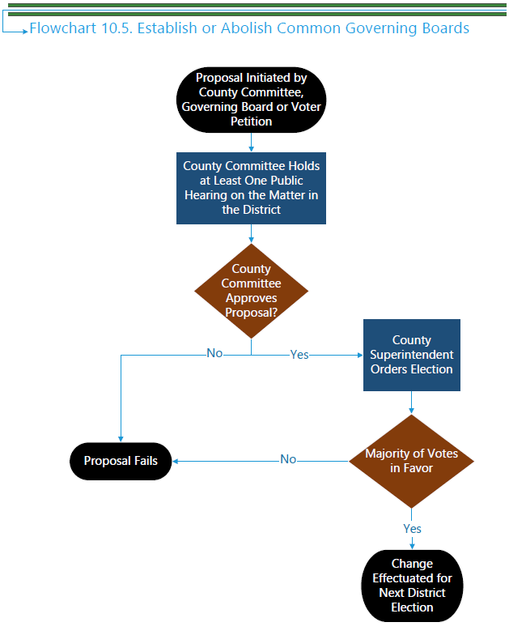

B. Process: Quick-Reference Chart 10.6
REARRANGEMENT OF TRUSTEE AREAS BASED ON
FEDERAL DECENNIAL CENSUS
(Refer to Flowchart 10.6)
1. School and community college districts in which trustee areas have been established and in which each trustee is elected by the residents of the area he/she represents must rearrange the trustee area boundaries before March 1 of the year following the year in which the results of each decennial census are released. (EC 5019.5)
Note: If the school or community college district fails to adjust the boundaries before the deadline date, the county committee must do so before April 30 of the same year. (All costs incurred by the county committee in adjusting the boundaries must be reimbursed by the school district.) (EC 5019.5)
2. A copy of the map outlining the rearranged trustee areas and a legal written description describing the boundaries of the trustee areas must be submitted to the county superintendent of schools and the registrar, recorder, or county clerk. (EC 5031)

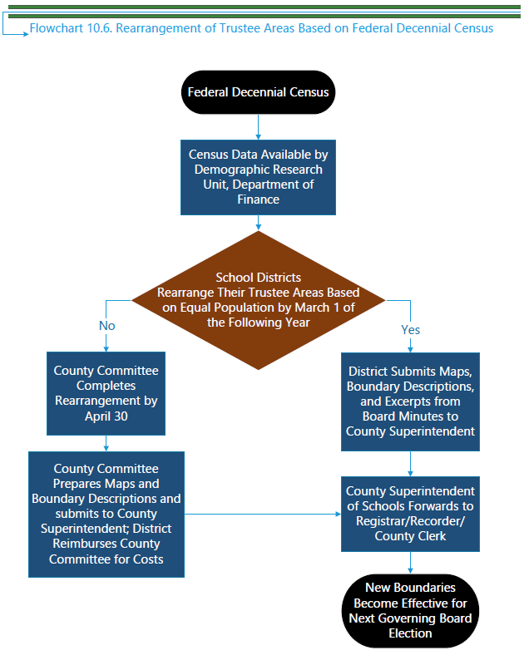
C. Legal Provisions: Supporting Actions

1. Trustee Areas/Trustee Membership/Methods of Election/Common Governing Boards

a. Powers of the County Committee
Except for a school district or community college district governed by a board of education provided for in the city/county charter, the county committee has the power to:
i. Create/abolish trustee areas. (EC 5019)
ii. Rearrange trustee areas. (EC 5019)
iii. Increase/decrease the number of members of the governing board from five to seven or seven to five, respectively. (EC 5019)
iv. Readjust boundaries of trustee areas based on the decennial federal census. (EC 5019.5)
v. Adopt one of the alternative methods of electing governing board members. (EC 5019, 5030)
vi. Establish or abolish a common governing board for a high school district and an elementary school district within the boundaries of the high school district.
Any of the processes noted above, except for item (iv), may be initiated by:
i. County committee
ii. Resolution of the governing board of the district
iii. Voter petition
(a) Signed by 5 percent or 50, whichever is less, of the qualified registered voters residing in a district in which there are 2,500 or fewer qualified registered voters;
(b) Signed by 3 percent or 100, whichever is less, of the qualified registered voters residing in a district in which there are 2,501 to 10,000 qualified registered voters;
(c) Signed by 1 percent or 250, whichever is less, of the qualified registered voters residing in a district in which there are 10,001 to 50,000 qualified registered voters;
(d) Signed by 500 or more of the qualified registered voters residing in a district in which there are 50,001 to 100,000 qualified registered voters;
(e) Signed by 750 or more of the qualified registered voters residing in a district in which there are 100,001 to 250,000 qualified registered voters;
(f) Signed by 1,000 or more of the qualified registered voters residing in a district in which there are 250,001 or more qualified registered voters;
iv. Voter petition containing at least 10 percent of the signatures of the district’s registered voters, except for items (ii) and (vi) cited above (in addition to item [iv] as cited previously) (EC 5020)
Note: The number of qualified registered voters is based on the most recent report submitted by the county clerk to the Secretary of State under Section 2187 of the Elections Code.

b. Procedures and Timelines
Once the county committee has received a proposal, it is required to call and conduct at least one public hearing in the district (no legal time frame specified for conducting hearing). Subsequent to the hearing, the county committee must either approve or disapprove the proposal. (Note: The county committee is not required to conduct a public hearing on a petition signed by 10 percent of the qualified registered voters in the school district.) (EC 5019, 5020)
The subsequent action of the committee to approve a proposal varies, depending on the type of proposal presented to the county committee. For example, approval of the rearrangement of trustee area boundaries requires no further action (unless a petition requesting an election is received), whereas approval of other proposals constitutes an order of election. Additionally, there are instances in which the proposal goes to election automatically without any prior approval by the county committee.
Depending on the type of proposal, any measure that must go to election must be placed on the ballot for an election not later than the next succeeding election for the members of the governing board, the next succeeding statewide primary or general election, or the next regularly scheduled election at which the electors of the district are entitled to vote, provided that there is sufficient time to place the issue on the ballot. (The county superintendent of schools must order the election at least 125 days prior to the election date.) (EC 5019, 5020)

Trustee Areas or Number of Governing Board Members
The resolution of the county committee to establish/abolish trustee areas or to increase/decrease the number of trustees on a governing board, which does not contain a declaration that the change in the method of electing members of the governing body is being made in furtherance of the purposes of the CVRA, constitutes an order of election, which must take place not later than the next succeeding election for members of the governing board. (EC 5020) For a petition signed by at least 10 percent of the district’s registered voters requesting an election on a proposal to establish/abolish trustee areas or to increase/decrease the number of trustees on a governing board, the proposal must be presented to the electors of the district at the next succeeding regularly scheduled election, provided that there is sufficient time to place the measure on the ballot. (EC 5020)
Whenever trustee areas are established in a district, provision must be made for one of the alternative methods of electing governing board members. (EC 5030)
If the number of members of a governing board is increased from five to seven, the two additional members of the board must be appointed by the governing board of the district, with the term of one of the appointees to expire on the first Friday in December of the next succeeding odd-numbered year and the term of the other appointee to expire on the first Friday in December of the second succeeding odd-numbered year. (EC 5022)
For each proposal there must be a separate proposition on the ballot. If more than one proposal appears on the ballot, all must carry in order for any to become effective. The exception to this is a proposal to adopt one of the methods of election of board members pursuant to Education Code Section 5030, which has been approved; it shall become effective unless a proposal inconsistent with that proposal has been approved by a greater number of voters. (EC 5020)
Note: The required election to establish trustee areas, by way of Method 1 in Quick-Reference Chart 10.1, may be waived by the State Board of Education. A county board of education or a school district governing board seeking to waive this election should contact the Waiver Office of the California Department of Education for information regarding submittal of a waiver request.

Rearrangement of Trustee Areas
County committee approval of the rearrangement of trustee areas becomes effective at future elections occurring at least 125 days after the approval, unless at least 5 percent of the registered voters of the district sign a petition requesting an election. The petition must be submitted to the county elections official within 60 days after the adoption of the proposal by the county committee. (EC 5019)
Whenever trustee areas are rearranged in a district, provision may be made for one of the alternative methods of electing trustees. (EC 5030)

Rearrangement of Trustee Areas Based on Federal Decennial Census
The governing board of each school or community college district in which trustee areas have been established and in which each trustee is elected by the residents of the area he/she represents (commonly referred to as a “ward” system) must adjust the boundaries of each trustee area so that each trustee area represents as close to the same proportion of registered voters as possible. (In multimember trustee areas, the proportion of population of each trustee area must be adjusted so that the number of trustees representing each trustee area is proportionate to the total number of trustees of the governing board.) The governing board must use the decennial federal census data and population figures validated by the Demographic Research Unit of the California Department of Finance as a basis. (EC 5019.5)
The rearrangement of boundaries must be completed by March 1 of the year following the release of the decennial federal census. County committee approval is not required when the district completes the realignment of its boundaries prior to March 1.
If a governing board fails to comply with the March 1 deadline, the county committee must comply before April 30 of the same year. The governing board of the school or community college district failing to comply must reimburse the county committee for all reasonable costs associated with realigning the boundaries.
Note: The above provisions do not apply to multiple campus community college districts with campuses in more than one county or to school and community college districts governed by a city charter. (EC 5019.7)

Alternative Methods of Electing Governing Board Members
In any school or community college district that has trustee areas, Education Code Section 5030 provides that the county committee may at any time recommend one of the following alternative methods of electing governing board members:
- That each member of the governing board be elected by the registered voters of the entire district;
- That one or more members residing in each trustee area be elected by the registered voters of that particular trustee area (commonly referred to as a “ward” system); or
- That each governing board member be elected by the registered voters of the entire school or community college district but that the member resides in the trustee area which he or she represents.
The recommendation shall provide that any affected incumbent member must serve out his or her term of office and that succeeding members must be nominated and elected in accordance with the method recommended by the county committee. (EC 5021)
In a county with a population of less than 25,000, the county committee may, at any time, by resolution, with respect to trustee areas established for any school district other than a community college district, amend the provision for election, without additional approval by the electors, to require the use of one of the alternative methods of electing board members. (EC 5030)

Establishment or Abolishment of Common Governing Boards
A county committee also has the authority to establish or abolish a common governing board for a high school district and an elementary school district within the boundaries of the high school district. The proposal, if approved by the county committee, shall be presented to the electors of the school district at the next succeeding regularly scheduled election at which the electors of the district are entitled to vote, provided that there is sufficient time to place the issue on the ballot. (EC 5019, 5020)

Other Changes: Trustees and Trustee Areas

Annexation
Whenever an elementary, high, or unified school district or a portion of any such district is annexed to another school district in which trustee areas have been established, the county committee must study and make recommendations on trustee areas of the annexing district as enlarged. The county committee must call and conduct a hearing in the district on the matter. The recommendation of the county committee constitutes an order of election and, if approved by the electors, must become effective on the same date that the reorganized district becomes effective. (EC 5023)
Note: The county committee may provide for the election of trustees, pursuant to its recommendation to rearrange trustee areas of a district (above), to be held at the same time as the election to effect a change in trustee areas. (EC 5024).

Decreasing Number of Representatives in Trustee Areas
(Note: This provision applies only in conjunction with Education Code sections 5023 and 5024.) If an election is held pursuant to Education Code Section 5020 and there are trustee areas having more than their allotted number of representatives in the membership of the governing board for the next succeeding school year, the county superintendent of schools having jurisdiction shall determine by lot which board members must relinquish their offices either immediately upon the election and qualification of the governing board members who were elected as provided in Education Code Section 5024 or on the first day of April next succeeding the election establishing trustee areas in the district, whichever is the later. (EC 5025)
Members elected to fill vacancies created pursuant to Education Code Section 5025 shall serve out the unexpired term of the office that was terminated. The county committee must designate by lot for each newly formed trustee area the expiring term of office for which a member must be elected. (EC 5026)

Membership from Supervisorial Districts
Whenever the boundaries of a county high school district are coterminous with the boundaries of a county, the board must consist of one member from each supervisorial district in the county elected at large from the district. (EC 5027)

Membership from Community College Districts Having Five Wards
In community college districts that were divided into five wards on or before September 7, 1955, one member of the board must be elected from each ward by the registered voters of the ward. On or before January 1 of a fiscal year, the governing board of the district may rearrange the boundaries of the wards to provide for representation in accordance with population and geographic factors or may abolish the wards. (EC 5028)

Conformance with Precinct Boundaries
When a community college trustee ward boundary line falls upon an election precinct boundary line, and such election precinct boundary line is changed (pursuant to Section 12200 et seq. of the Elections Code), the governing board of the district must, at least 120 days prior to any trustee election, change such ward boundary line to conform to election precinct boundary lines, where possible. (EC 5029)

Transfer of Territory to District Having Trustee Areas
Whenever territory is transferred to another district that has trustee areas, the territory being transferred must become a part of the trustee area to which it is contiguous. If the territory is contiguous to more than one trustee area, the transfer agreement may contain provisions indicating the division of the territory among the contiguous trustee areas. (EC 35544)

Reorganization Proposal Containing Plans for Trustee Areas
If the reorganization plan contains a proposal for trustee areas, such proposal must be considered a part of the reorganization proposition to be voted upon, and the ballot shall include wording to that effect. (EC 35734, 35762)

Incumbent Governing Board Members to Serve Out Terms
If trustee areas are established, any affected board member must serve out his or her term of office. Succeeding board members must be nominated and elected according to the method of election and provisions specified in Education Code Section 5030. If two or more trustee areas are established at an election in which there will be no incumbent board member residing after the next election, the county committee must determine by lot the trustee area from which the nomination and election for the next vacancy on the governing board will be made.
If trustee areas are rearranged and the boundary change affects the board membership, any affected incumbent board member must serve out his or her term, and succeeding board members shall be nominated and elected according to the method of election and provisions specified in Education Code Section 5030.
If trustee areas are abolished, the incumbent board members must serve out their terms of office, and succeeding board members must be nominated and elected at large from the district.

Trustee Area Boundary Requirements
The county superintendent of schools must prepare and keep in his or her office a map showing the boundaries of all trustee areas of the districts under his or her jurisdiction and also a record of all actions taken by the county committee in connection with trustee area boundaries. (EC 5031)

2. Trustee Areas: County Boards of Education.
A county board of education must have either five or seven members to be determined by the county committee. Each member of the board must be an elector of the trustee area that he or she represents and must be elected by the electors of the trustee area. (EC 1000)
In chartered counties, the county charter or the county board of supervisors must prescribe the manner of determining trustee areas for the county board of education. (EC 1000)
Note: The county charter, if one exists, needs to be checked to determine whether it contains provisions prescribing the methods of establishing trustee areas, rearranging boundaries of trustee areas, or increasing or decreasing the number of members of the county board of education.
In a county unified school district or in a unified or elementary school district that includes all the territory over which a county superintendent of schools has jurisdiction, the governing board of the district must serve as the county board of education. (EC 1000)
Upon being so requested by the county board of education, the county committee, by a two-thirds vote of its members, may either change the boundaries of any or all of the trustee areas of the county or propose to increase or decrease the number of members of the county board of education or both. The areas must be as nearly equal in population as is practicable. Proposals must be made in writing and filed with the county board of supervisors not later than the first day of March. When the election of members of county boards of education is required to be held on the same date as that prescribed for the election of members of governing boards of school districts (as provided for in EC 1007), the county committee must fix the boundaries of trustee areas to coincide with the boundaries of school districts, where possible. If the trustee areas are coterminous with those of the supervisorial districts of the county, the election of members of the county board of education must be consolidated with the countywide election. (EC 1002)
When a county committee proposes to reduce from seven to five or increase from five to seven the number of board members, the county committee must call and conduct a hearing on the matter. At the conclusion of the hearing, the county committee must, by resolution, approve or disapprove the proposal. (EC 1003)
The resolution of the county committee approving a reduction or increase in the number of board members must constitute an order of election to be conducted not later than the next succeeding election for members of the board. (EC 1004)
The boundaries of any trustee area must not be changed at any time to affect the term of office of any member of the county board of education who has been elected and whose term of office has not expired. (EC 1005)

Effective January 1, 2022, this 125-day requirement replaced the previous 120-day requirement in EC Section 5019 (Stats. 2021, Ch. 139, Sec. 2. [SB 442]). Note that this legislation did not make corresponding changes to the election timing requirements provided for in EC sections 5322 through 5325.
Effective January 1, 2022, EC Section 5019 requires rearrangement of trustee areas to be effectuated for the next district election occurring at least 125 days after approval of the rearrangement (Stats. 2021, Ch. 139, Sec. 2. [SB 442]). However, this legislative change did not address the 120-day requirement in EC Section 5029.

