2022 California School Dashboard Talking Points
California Department of Education | December 2022

Overview
- The California School Dashboard (Dashboard) is one part of California’s comprehensive accountability system for schools, districts, and county offices of education that reports performance and progress in 13 different areas (six state indicators and seven local indicators). Each area reflects the priorities of California’s Local Control Funding Formula (LCFF) and the metrics required by the federal Every Student Succeeds Act (ESSA).
- The COVID-19 pandemic affected education services and student learning worldwide. In California, the pandemic also interrupted the statewide data collection, assessment, and accountability systems.
- The last Dashboard was produced in 2019 reflecting data from the 2017–18 and 2018–19 school years.
- The 2022 Dashboard is a re-start of California’s accountability system.
- Since the 2022 Dashboard is a re-start, the performance of a school, district or county office of education establishes a new starting point against which future improvements can be gauged for local educational agencies (LEAs), schools, and student groups.
- The 2022 Dashboard will provide valuable information to educators about how the pandemic affected student learning, student engagement, and differences in outcomes for student groups.
- The 2022 Dashboard data should be used in conjunction with other local data on student performance and progress, such as progress reports, student work, and teacher feedback. The combination of state and local data provides educators with a more detailed picture of strengths as well as areas of opportunity.

Dashboard Details
- The 2022 Dashboard will include the following state indicators:
  - Academic Indicators (English language arts/literacy and mathematics)
  - Chronic Absenteeism Rate
  - English Learner Progress
  - Graduation Rate
  - Suspension Rate
- The 2022 Dashboard will not include the College/Career Indicator (CCI). Further details on the reporting of the CCI measures in the Dashboard Additional Report can be accessed through the CCI flyer at https://www.cde.ca.gov/ta/ac/cm/documents/collegecareer22.pdf.

- Prior to the pandemic, LEAs, schools, and student groups received performance colors on the Dashboard (blue, green, yellow, orange, red), where blue indicated the highest performance and red indicated the lowest performance.
- Performance colors were determined based on a combination of Status (current year performance) and Change (current year performance compared with prior year performance).
- Since 2022 is a re-start for school and LEA accountability, only current year performance (Status) will be reported on the 2022 Dashboard.
- No performance colors will be assigned in 2022.
- In 2023, performance colors will return for all state indicators except for the CCI due to the lack of data in 2022 for this indicator. Performance colors for the CCI will return in 2024.
- Instead of performance colors, new “cell phone bar” graphics will represent the five Status levels for 2022: Very Low, Low, Medium, High, and Very High.
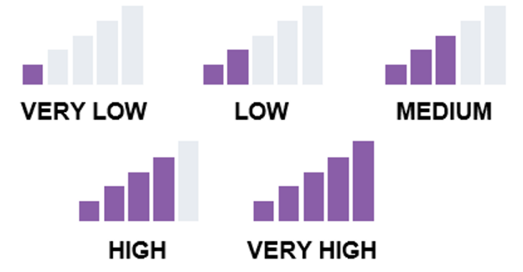
- For all state indicators, more shaded bars indicate stronger performance and fewer bars indicate that attention is needed.
- A note about the Chronic Absenteeism and Suspension Rate indicators:
  - Unlike other indicators where higher rates are desired (e.g., Graduation Rate), lower rates are desirable for Chronic Absenteeism and Suspension Rate. To reflect this difference for these indicators, the labels for the “cell phone bar” graphics are reversed to indicate the goal of low rates.
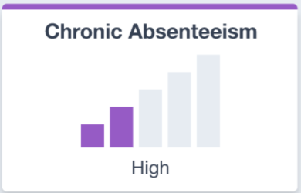
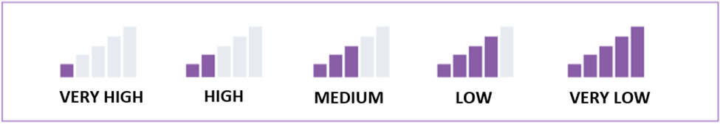

Sample Language to Assist with Discussing the Dashboard Results
- The 2022 Dashboard reflects data from the 2021–22 school year when the educational system was recovering from a variety of challenges related to the COVID-19 pandemic. The data demonstrates the difficulties evident throughout the system in terms of attendance, achievement, and engagement.
- For [insert school/LEA name here], results show that we have work to do to equitably support the success of all students.
- The 2022 Dashboard shows that [insert LEA or school name here] displayed the following Status levels:
  - [Insert Status here] in English language arts and [insert Status here] in mathematics. This year, we are focused on [insert LEA or school activities/initiatives here].
  - [Insert Status here] for Chronic Absenteeism. [Insert percentage here] percent of our students were chronically absent last year and missed at least 10 percent of their school year. When students do not attend school, they do not learn. This year, we are focused on [insert LEA or school activities/initiatives here].
  - [Insert Status here] for the Suspension Rate. [Insert percentage here] percent of our students were suspended last year. We are committed to keeping our students in classrooms where they can focus on learning. This year, we are focused on [insert LEA or school activities/initiatives here].
  - [Insert Status here] for the English Learner Progress Indicator (ELPI). [insert percentage here] percent of our English learner students made progress towards English language proficiency last year. This year, we are focused on [insert LEA or school activities/initiatives here].
  - [Insert Status here] for the Graduation Rate. Our graduation rate for the 2021–22 school year was [insert percentage here]. This percentage includes fourth-year graduates from the Class of 2022 as well as fifth-year graduates from the Class of 2021. [Remove the text about fifth-year graduates if your school did not have any fifth-year graduates.] We know that the pandemic impacted credit accumulation for some students. This year, we are focused on [insert LEA or school activities/initiatives here].
- There are many signs that the system is heading in the right direction.
- We locally monitor data as it is collected for up-to-date information on student attendance, achievement, and engagement. [Insert observations supported by local data here. Examples may include improved attendance rate, improvement on local achievement measures, etc.]
- There are many students who need additional support to learn what is expected for their grade level.
- We have made the following efforts to support student learning:
  - [Describe extra resources being dedicated and list of programs to support students]

Qualifying for Additional Help to Support Student Needs
- Based on results from the Dashboard, California will determine those districts and schools eligible for additional support.
- The additional targeted support and improvement (ATSI) eligibility criteria are based upon the performance of student groups on the state indicators.
- For County Offices of Education:
  - We predict that more school districts will be eligible for differentiated assistance based on the 2022 Dashboard.
  - Our team is poised to provide customized and individualized technical assistance to our school districts that meet their needs.
  - We are already communicating with the school districts in our county about areas that need extra attention and are mobilizing resources to support them.

Additional Resources
- To support use of the 2022 Dashboard, a Dashboard Toolkit is available on the California Department of Education (CDE) Dashboard Communications Toolkit web page at https://www.cde.ca.gov/ta/ac/cm/dashboardtoolkit.asp.
- The CDE annually publishes the School Dashboard Additional Reports with data that expands on the information reported on the Dashboard. These reports can be accessed through the CDE School Dashboard Additional Reports web page at https://www.cde.ca.gov/ta/ac/cm/dbadditionalrpts.asp.
- The Dashboard technical guide is the key to learning the business rules and calculation formulas for each state indicator. Unlock this information by downloading the guide posted on the CDE Dashboard Resources web page at https://www.cde.ca.gov/ta/ac/cm/dashboardresources.asp. The Dashboard Resources web page also contains flyers, archived webinar materials, translations, and frequently asked questions for parents, educators, and those who are new to the Dashboard.

Contact Us!
Still have questions? Contact us at our new Dashboard email address: dashboard@cde.ca.gov
New updates are also posted on our social media pages. Follow us on Twitter at @CDEDashboard.

